Assessing Transition of Security Operations in Afghanistan

Project Proposal

11 February 2010

Kevin Comer
Elizet Escalera
Chris Garlock
James Henry

David Hull
Diego Ugarte

Table of Contents

1 Problem Description 3
1.1 Background 3
1.2 Problem Statement 3
1.3 Stakeholders 4

2 Preliminary Requirements 4
2.1 Group Organization 4
2.2 Values and Metrics 4
2.3 System Design 4

3 Technical Approach 5
3.1 Value Model 5
3.2 System Design 6
3.2.1 System Input 6
3.2.2 System Processing and Storage 6
3.2.3 Analysis Output 7

4 Expected Results 7
4.1 Value Algorithm 7
4.2 Executable System 7

5 Project Plan 8
5.1 Project Schedule 8
5.2 Project Deliverables 8

References 9

1 Problem Description

1.1 Background

On October 7, 2001, a coalition of forces including the United States began combat operations in Afghanistan and eventually removed the Taliban government from power. Combat operations have been conducted since while the coalition attempts to rebuild the nation to govern itself, care for its people and equip it to defend itself from all internal and external threats. A key aspect of that goal is the transition of security operations from the NATO/US led forces to Afghani units.

The mission of the NATO Training Mission-Afghanistan (NTM-A)/Combined Security Transition Command-Afghanistan (CSTC-A), in partnership with the Government of the Islamic Republic of Afghanistan and the international community, is to plan, program and implement structure, organizational, institutional and management reforms of the Afghanistan National Security Forces (ANSF) in order to develop a stable Afghanistan, strengthen the rule of law, and deter and defeat terrorism within its borders.

NTM-A/CSTC-A provides advisors, mentors and trainers to help both the Ministry of Defense and Ministry of Interior organize, train, equip, employ and support the ANSF in order to defeat the insurgency, provide internal security, extend and enforce the rule of law, set conditions for economic development, and gain the trust and confidence of the citizens of Afghanistan.

Mission success for NTM-A/CSTC-A is defined as fielding an ANSF that is professional, literate, ethnically diverse, tactically competent and capable of providing security throughout Afghanistan. ^{[1]}

1.2 Problem Statement

President Obama and U.S. Army General McChrystal, the commander of the International Security Assistance Force (ISAF) in Afghanistan, have announced their goal of transferring the lead for security operations to the Afghan government. In order to support this goal, our study sponsor, the Deputy Director of Force Integration and Training (CJ7), Combined Security Transition Command – Afghanistan (CSTC-A), has defined five requirements, or Lines of Operation (LOO), that support the overall goal of transferring the lead for security operations to the Afghan government. After an initial round of clarification with CJ7 staff, we learned that CJ7 is focusing on two of the five LOOs: 1) accelerate growth of the Afghan National Security Forces (ANSF); and 2) achieve security for the Afghan population. The three remaining LOOs, listed below, are viewed by CJ7 staff as supporting the two main LOOs:

- Marginalize malign actors
- Achieve legitimate, responsive and accountable governance
- Facilitate community development

The objective is to develop metrics to measure progress against each of the 5 goals, or LOOs, and to use these metrics in a model that provides feedback to General McCrystal and other leaders on progress toward the goal of transferring the lead for security operations to the Afghan government.

1.3 Stakeholders

The following stakeholders have been identified:
- Force Integration and Training cell of NTM-A/CSTC-A
- NTM-A/CSTC-A
- Coalition military leadership
- United States governmental leaders

2 Preliminary Requirements

2.1 Group Organization

The scope and complexities of this project requires the formation of two separate groups to handle the various aspects of the problem. One group will focus on value and metric development, elicitation of weights and creation of a value model. The other group will focus on the design and construction of the actual system. As the metrics, value function, and system get closer to their final state the two groups will largely integrate bringing the two halves together into the final system.

2.2 Values and Metrics

A key to understanding the improvement or degradation of progress towards Afghani led security in Afghanistan is understanding what the stakeholders value. A great deal of information is available produced by NTM-A/CSTC-A, various subject matter experts, media, etc. that helps identify what is important for the successful transition of power between the coalition and Afghanistan. Additionally, we'll interview stakeholders as available; however, we don't anticipate being able to talk to the senior most people involved with this project. Once the values and metrics are indentified a value function will be designed to track the movement towards the final goal.

2.3 System Design

There are four primary components of this system: input, storage, processing, and output. The input will be a generalized form that can be disseminated to the lowest echelons of the force structure in Afghanistan and consolidated as the information moves up the chain. Previous data must be stored in order to allow comparison between time periods. The processing unit will use the value function built by the metrics team to compute the overall "value" of one time period to another identifying movement along the LOO towards the final goal. The output portion will take all the analysis completed within the system and condense it into a broad overview of the information so it can be briefed and understood quickly regardless the viewer's familiarity with the inputs, etc.

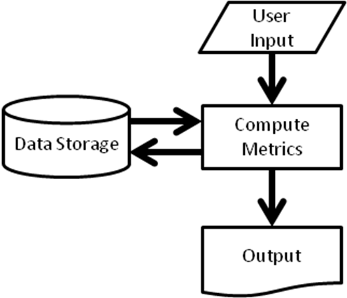

An initial assumption is that a majority of this system must be compatible with software already owned and used by the United States military.

3 Technical Approach

3.1 Value Model

We will develop and implement a Value Model consisting of both a qualitative and quantitative component. The main step in developing the qualitative component of the Value Model is the identification of fundamental objectives and means objectives. Fundamental objectives reflect what the decision maker ultimately wants to accomplish, while means objectives act as components in the achievement of the fundamental objectives. The fundamental objectives and the means objectives are then organized together in a logical fashion with input from the decision maker. The creation of an objective hierarchy, relating means objectives to fundamental objectives, marks the conclusion of the development of the qualitative portion of the Value Model.
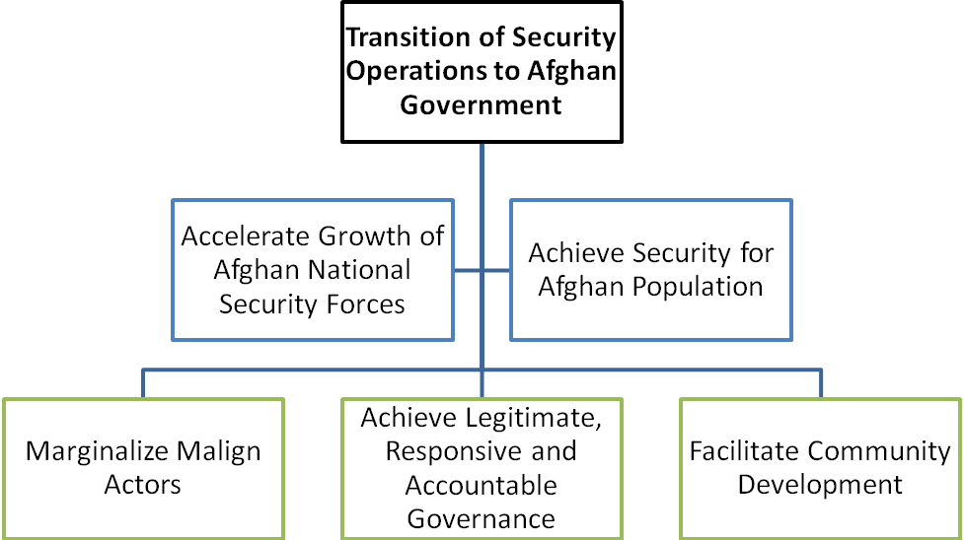

During the development of the quantitative portion of the Value Model, we have two main goals. The first is to articulate the relative importance (i.e. the decision maker’s preferences) for the attributes. The second goal is develop the means for measuring each attribute. Great care will be taken to ensure that the attributes, and their measures, are mutually exclusive, collectively exhaustive, and independent.

The qualitative and quantitative portions of the Value Model will come together in the form of the Objective Function, denoted V(x). We will use an additive Value Model as defined below:

V(x) = Σ w_{i}v_{i}(x_{i}) where:

w_{i} = weight of attribute i
v_{i} = value of attribute i at score x_{i}

The value of the objective function will provide a measure of progress towards the fundamental objectives.

3.2 System Design

Due to the large scale and dynamic nature of the Afghan security problem we envision the development of a decision analysis tool based on the value model described above.

3.2.1 System Input

Once the quantitative portion of the value model is developed it will then be translated into a standardized survey template using software accessible to troops in the field (e.g. Microsoft Excel). This form would be distributed to each unit in the military chain of command to the level, foreign militaries, support organizations, and any other entity desired by the decision maker. The survey templates would be completed, compiled, and provided to the decision maker’s staff at a regular interval as determined by the decision maker.

3.2.2 System Processing and Storage

The completed templates would be ingested into a data repository structured in software already deployed and available (e.g. Microsoft Access). The configuration of the data will be controlled such that the date and geographical location (as determined by the military unit completing the survey) will be recorded and stored. A user interface designed around a query system would be constructed that will allow an individual to access a single survey to get a snapshot of activity in a given unit’s Area of Responsibility (AOR) on a given date or multiple surveys across time and geographic space to discover trends and make comparisons. Using readily available software to construct the model will allow users to add functionality if new requirements are identified after the package is delivered to the user.

3.2.3 Analysis Output

Finally, the analysis will be produced in an available at all levels within the military and federal government (e.g. Power Point). The goal of the output is a condensed and easily understood presentation for senior decision makers. Additionally, a query mechanism that will allow the user to request less refined data in order to conduct additional analysis.

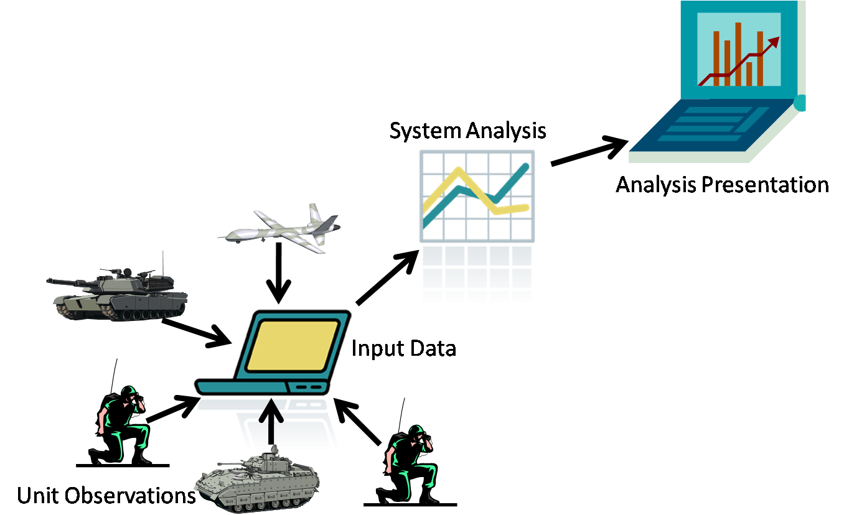

4 Expected Results

4.1 Value Algorithm

At the conclusion of this effort we expect to have a representative algorithm that accounts for the stakeholders values with regards to the transition of security operations to the Afghani government. The value model, consisting of both a qualitative and quantitative component, will identify the attributes and associated measures important to decision makers in assessing the efficacy of the transition of security operations in Afghanistan.

This value model will be reflect the values of the current stakeholders and decision makers, if there is a significant shift in leadership and/or associated policy towards Afghanistan security the developed value function may no longer be valid. Given the anticipated number of values and metrics there is no planned user interface allowing for restructuring of the value function or inclusion/deletion of values.

4.2 Executable System

There will be a functional system at the conclusion of the project that consists of three primary pieces, the metrics input form, primary system, and output form. The NTM-A/CSTC-A team will be able to receive the observed input from various sources, compile and store the data, and produce the results of the users queries and will aid in trend analysis.

5 Project Plan

5.1 Project Schedule

The following task schedule is proposed in order to meet required deadlines.

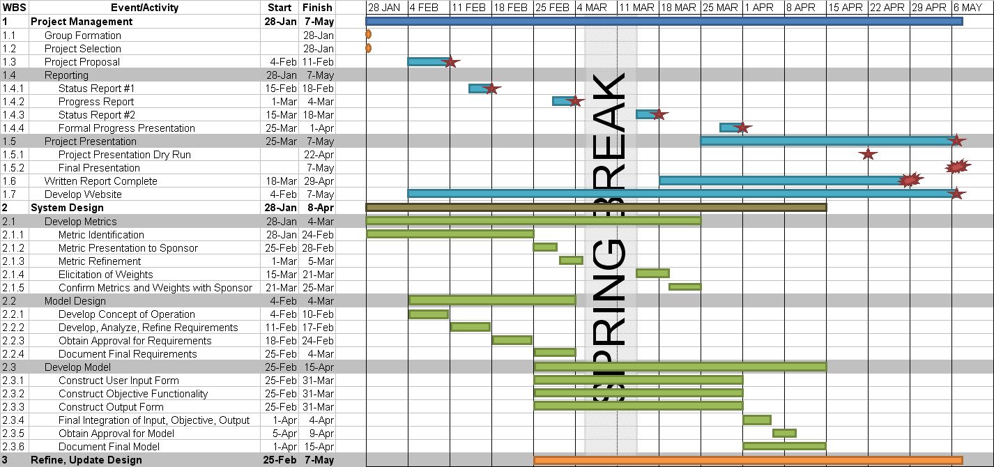
5.2 Project Deliverables

The group's deliverables will include but not be limited to the following deliverables.
Project Proposal | 11-Feb
Status Report | 18-Feb
Model Requirements | 18-Feb
Value and Metric Structure | 25-Feb
Progress Report | 4-Mar
Status Report | 18-Mar
Initial System | 31-Mar
Formal IPR | 1-Apr
Finalized Model | 5-Apr
Written Report | 29-Apr
Final Presentation | 7-May
Project Website | 7-May
REFERENCES

[1] Combined Security Transition Command - Afghanistan website, www.cstc-a.com

