Functional Model Analysis

for the

Unmanned
Control & Tracking System
(UCATS)

DJ³K Team

Kurt Chewning
Jennifer Greene
Dave Manley
Jeanette Smith
John Smith

Sponsors: Dr. Kuo-Chu Chang
&
Ashwin Samant

Department of Systems Engineering & Operations Research
SYST 798 Applied Project Course
Fall 2009

TABLE OF CONTENTS

1.0 Introduction 3
2.0 UCATS Functional Concept 4
2.1 Recommend Intercept Plan 4
2.1.1 Predicting TOI Location 5
2.1.2 Determine Intercept Feasibility 5
2.1.3 Intercept Route Recommendations 5
2.1.4 UAV-to-TOI Assignment Recommendations 5
2.2 Communicate With UAVs 5
2.3 Provide Surveillance Video from UAVs 5
2.4 Accept Operators Requests and Provide Feedback 5
3.0 Evaluation of Proposed Functional Models 6
3.1 Proposed Functional Models 6
3.2 Evaluation Methodology 7
3.3 Functional Model Evaluation 8
3.3.1 Functional Concept 1 8
3.3.2 Functional Concept 2 9
3.3.3 Functional Concept 3 9
3.3.4 Functional Concept 4 9
3.4 Summary 9
APPENDICES 10
APPENDIX A: Acronyms 11

List of Tables
Table 1: UCATS Functional Model Evaluation Criteria and Weighting 9
Table 2: UCATS Functional Concept Evaluation Summary 9

List of Figures
Figure 1: UCATS CONOPs 4
Figure 2: Autonomous Tracking System Functional Summary 5
Figure 3: UCATS Functional Model Concept 1 7
Figure 4: UCATS Functional Model Concept 2 7
Figure 5: UCATS Functional Model Concept 3 7
Figure 6: UCATS Functional Model Concept 4 7

1.0 Introduction
This analysis summarizes how Team DJ³K identified a simple functional concept and developed the functional model for the Unmanned Control and Tracking System (UCATS).
The UCATS is a command and control system designed to route Unmanned Air Vehicles (UAVs) to Targets of Interests (TOIs), monitor the UAV location, and redirect the UAVs when new tasking arrives. The primary mission of the UCATS is to recommend which airborne UAVs should track TOIs and then direct the UAVs on a TOI intercept course, monitor UAV position, and redirect the UAVs as new TOI tasking becomes available. The goal of UCATS is to increase efficiency, save money and resources, and aide in security and homeland defense during urban TOI tracking operations. A single ground C2 center will be responsible for initiating and updating assignments to the UAVs in-flight based on the urban environment and TOI information. The UAV’s will respond to their tasking and track their assigned targets to their destination all with no operator interaction, aside from retasking orders. Figure 1 the Concept of Operations (CONOPs) and Figure 2 summarizes the functional requirements for the Autonomous Targeting System (ATS). This analysis only addresses the UCATS portion of the ATS.
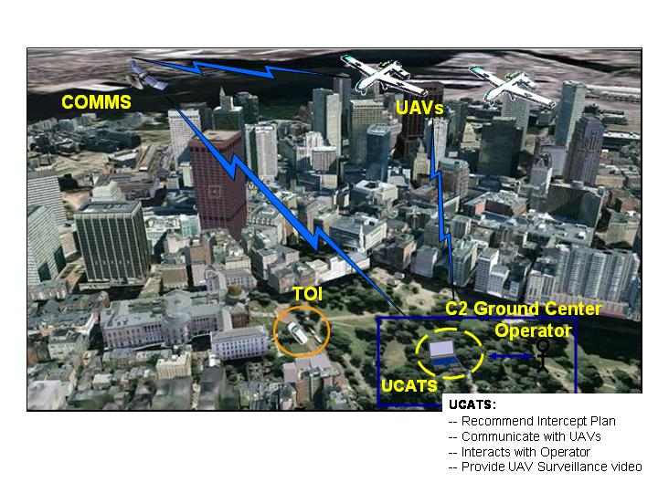
Figure 1: UCATS CONOPs
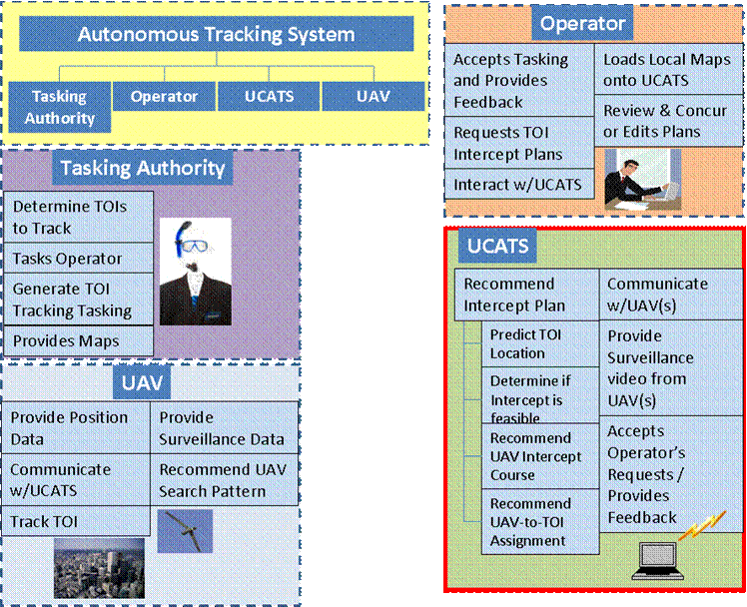
Figure 2: Autonomous Tracking System Functional Summary

2.0 UCATS Functional Concept
As summarized above, the UCATS needs to recommend an intercept plan to the operator, communicate with UAVs, provide surveillance video from the UAVs to the operator, and accept operator’s requests and provide feedback.

2.1 Recommend Intercept Plan
The UCATS needs to recommend an intercept plan to the operator. This includes predicting the TOI location, determining if the intercept is feasible, recommending a UAV intercept course, and recommend a UAV-to-TOI assignment. These functions are distinct but interrelated. For example, UCATS will require assignments of UAVs and determination of the intercept course before it can predict TOI location. Likewise, the UCATS will need to calculate UAV intercept courses before it can predict intercept feasibility.

2.1.1 Predicting TOI Location
The UCATS needs to predict the location of the TOI at the time of the UAV intercept. At a minimum this prediction is based the last known TOI location and a description of the TOI. Additional amplifying information would include TOI heading and speed. The predicted TOI location should provide a likely TOI position (or positions) at the time of the intercept. The time of the intercept is the time required for the UAV to fly the intercept route.

2.1.2 Determine Intercept Feasibility
The UCATS will need to determine if any of the airborne UAVs can intercept the TOI. At a minimum, this prediction is based on the known UAV position, the remaining available flight time, and the communication range limitations.

2.1.3 Intercept Route Recommendations
The UCATS will recommend an intercept route to the operator. This assumes the UCATS has identified the likely UAV or UAVs needed to track the TOI.

2.1.4 UAV-to-TOI Assignment Recommendations
The UCATS will recommend UAV-to-TOI assignments. This is based on selecting the UAVs that can reach the TOI in the minimum amount of time and the operator-provided TOI prioritization.

2.2 Communicate With UAVs
The UCATS must be able to communicate with up to five UAVs. Communications entails receiving UAV position data, sending TOI interception route tasking, and receiving UAV surveillance video.

2.3 Provide Surveillance Video from UAVs
The UCATS must be able to provide the UAV surveillance video to the operator.

2.4 Accept Operators Requests and Provide Feedback
The UCATS shall accept requests from the operator and provide feedback. The operator requests would include requests to generate, edit, or approve an intercept plan; requests to display UAV surveillance video, position or communications status with UCATS; and requests to load local area maps. Operator feedback would include UCATS providing feedback that the operator requests were received, UCATS providing UAV position and communication integrity status, and UCATS providing intercept plans. While providing surveillance video could be considered providing feedback, due to the complexities involved with video, Team DJ³K felt that providing surveillance video was a separate functionality.

3.0 Evaluation of Proposed Functional Models

3.1 Proposed Functional Models
Team DJ³K conducted a brainstorming exercise and identified four proposed functional models shown in Figures 3 through 6.
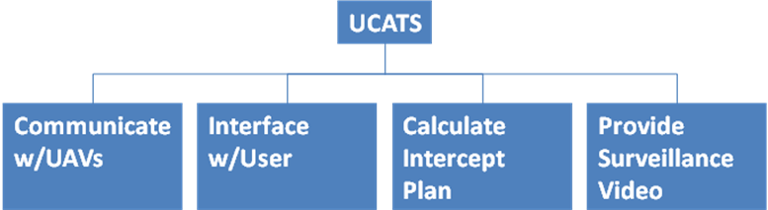
Figure 3: UCATS Functional Model Concept 1

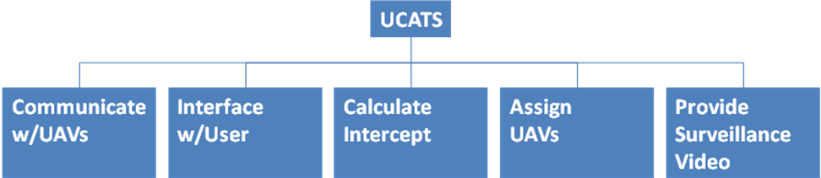
Figure 4: UCATS Functional Model Concept 2

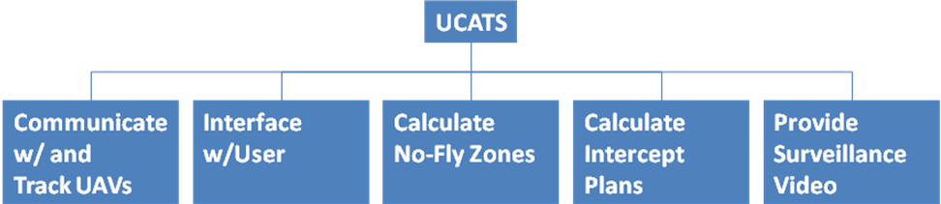
Figure 5: UCATS Functional Model Concept 3
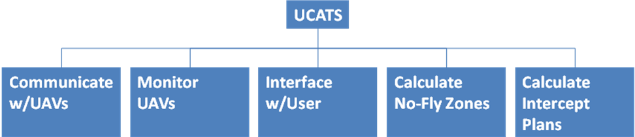
Figure 6: UCATS Functional Model Concept 4

3.2 Evaluation Methodology
Team DJ³K evaluated the proposed UCATS function model concepts by conducting a multi-attribute trade study using a utility model to evaluate the proposed concepts. Table 1 summarizes the evaluation criteria and their respective weighting of the utility model.

Criteria |  | Weighting
Description | Justification for Criteria | Value | Reason for Weighing
Functions Traceable to UCATS Functional Concept | Team DJ³K felt the functional model needed to adequately address all the UCATS functional requirements. | 0.30 | This was the highest weighting. Team DJ³K felt this was the most important criteria.
Simple | Team DJ³K felt that it was important that the functional model be simple. Unnecessary complexity would make the functional decomposition of the UCATS more difficult. | 0.20 | Team DJ³K felt this was the next important criteria for the functional model.
Unique Functionality (i.e., Each function is distinct) | Team DJ³K felt it was important that the functional model have unique functionality. The model should not have functionality that could be shared across several functional elements | 0.20 | Team DJ³K felt this criterion was as important as simplicity.
Minimizes inputs and outputs | Team DJ³K felt it was important that the functionality minimized the inputs and outputs required for each functional element. This would simplify the physical instantiation since it would require fewer interface control documents across each functional element. | 0.15 | Team DJ³K felt this criterion was the least important of all the criteria.
Minimize external input per functional element | Team DJ³K felt this was important because we wanted to limit external inputs to as few of the functional elements as possible. Again, this would help with the physical instantiation because it would limit external interface documents to as few of the UCATS functional elements as possible. | 0.15 | Team DJ³K felt this criterion was as important as minimizing inputs and outputs
Table 1: UCATS Functional Model Evaluation Criteria and Weighting

Team DJ³K then evaluated each concept against each criterion by assigning a score of 0 to 10. A score of 0 meant the concept did not satisfy that criterion. A score of 10 meant that concept best met that criterion. Team DJ³K then multiplied the criterion score by weighting and summed all the weightings / score to obtain a final score for the concept. The highest score was the best concept.

3.3 Functional Model Evaluation
Table 2 summarizes Team DJ³K evaluation of the proposed functional models. In summary, Team DJ³K felt that Concept #1 best met the criteria.

Concept |  | Traceable Functions |  | Simple |  | Unique Functions |  | Minimize Inputs / Outputs |  | Minimize External Inputs |  | Total
 |  | Weighting | Score | Weighting | Score | Weighting | Score | Weighting | Score | Weighting | Score | Total
1 | Eval | 0.30 | 10 | 0.20 | 8 | 0.20 | 7 | 0.15 | 7 | 0.15 | 7 | 8.1
1 | Score | 0.30 | 3 | 0.20 | 1.6 | 0.20 | 1.4 | 0.15 | 1.05 | 0.15 | 1.05 | 8.1
2 | Eval | 0.30 | 8 | 0.20 | 6 | 0.20 | 7 | 0.15 | 6 | 0.15 | 7 | 6.95
2 | Score | 0.30 | 2.4 | 0.20 | 1.2 | 0.20 | 1.4 | 0.15 | 0.9 | 0.15 | 1.05 | 6.95
3 | Eval | 0.30 | 6 | 0.20 | 6 | 0.20 | 7 | 0.15 | 6 | 0.15 | 7 | 6.35
3 | Score | 0.30 | 1.8 | 0.20 | 1.2 | 0.20 | 1.4 | 0.15 | 0.9 | 0.15 | 1.05 | 6.35
4 | Eval | 0.30 | 6 | 0.20 | 6 | 0.20 | 7 | 0.15 | 6 | 0.15 | 7 | 6.35
4 | Score | 0.30 | 1.8 | 0.20 | 1.2 | 0.20 | 1.4 | 0.15 | 0.9 | 0.15 | 1.05 | 6.35
Table 2: UCATS Functional Concept Evaluation Summary

3.3.1 Functional Concept 1
Functional concept 1 provided the best traceability from the UCATS functions to the concept 1 functional model. Additionally, it was a very simple model, with only four elements. All the functions were unique and not duplicative. It minimized inputs and outputs between functional elements. Three of the four elements did have external interfaces.

3.3.2 Functional Concept 2
Functional concept 2 had good traceability to the UCATS functions, but the traceability to all the intercept plan functions did not appear to be adequately captured between the calculate intercept and assign UAVs elements. Concept 2 was more complex than concept 1, with five elements. All the functions were unique and not duplicative. It minimized inputs and outputs between functional elements, but not to the extend Concept 1 did. It probably would require additional inputs and outputs between the calculate intercept and assign UAVs elements. Three of the four elements did have external interfaces.

3.3.3 Functional Concept 3
Functional concept 3 had traceability to most of the UCATS functions, but the calculate no-fly zones was not a UCATS function. Concept 3 was more complex than concept 1, with five elements. All the functions were unique and not duplicative. It minimized inputs and outputs between functional elements, but not to the extend Concept 1 did. It probably would require additional inputs and outputs due to the calculate no-fly zone element. Three of the four elements did have external interfaces.

3.3.4 Functional Concept 4
Functional concept 4 had traceability to most of the UCATS functions, but the calculate no-fly zones was not a UCATS function. Concept 4 was more complex than concept 1, with five elements. All the functions were unique and not duplicative. It minimized inputs and outputs between functional elements, but not to the extend Concept 1 did. It probably would require additional inputs and outputs due to the calculate no-fly zone element. Three of the four elements did have external interfaces.

3.4 Summary
Team DJ³K selected Concept #1 as the UCATS Functional Model. It was the simplest of all the proposed models and it provided the best traceability back to the required UCATS functionality

APPENDICES

APPENDIX A: Acronyms
ATS Autonomous Tracking System
C2 Command and Control
CONOPS Concept of Operations
TOI Target of Interest
UAV Unmanned Aerial Vehicle
UCATS Unmanned Control & Tracking System

