VTOL Physics

Helicopters:
http://www.howstuffworks.com/helicopter.htm
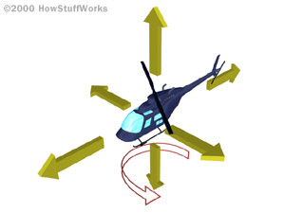
In a helicopter, you can move laterally in any direction or you can rotate 360 degrees. These extra degrees of freedom and the skill you must have to master them is what makes helicopters so exciting, but it also makes them complex.
To control a helicopter, one hand grasps a control called the cyclic, which controls the lateral direction of the helicopter (including forward, backward, left and right). The other hand grasps a control called the collective, which controls the up and down motion of the helicopter (and also controls engine speed). The pilot's feet rest on pedals that control the tail rotor, which allows the helicopter to rotate in either direction on its axis. It takes both hands and both feet to fly a helicopter!
The following video shows a helicopter performing a pirouette, in which it rotates 360 degrees while it travels down a straight line relative to the ground http://static.howstuffworks.com/mpeg/heli-pirouette.mpg
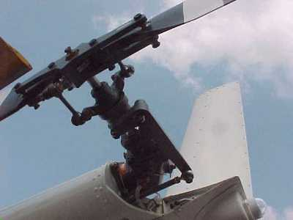
The tail rotor's hub allows the pilot to change the angle of attack of the rotor's wings.

The Main Rotor
A helicopter's main rotor is the most important part of the vehicle. It provides the lift that allows the helicopter to fly, as well as the control that allows the helicopter to move laterally, make turns and change altitude.
To handle all of these tasks, the rotor must first be incredibly strong. It must also be able to adjust the angle of the rotor blades with each revolution of the hub. The adjustability is provided by a device called the swash plate assembly, as shown in this photograph:
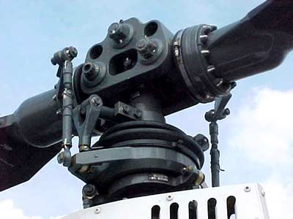
The main rotor hub, where the rotor's drive shaft and blades connect, has to be extremely strong as well as highly adjustable. The swash plate assembly is the component that provides the adjustability.
The swash plate assembly has two primary roles:
- Under the direction of the collective control, the swash plate assembly can change the angle of both blades simultaneously. Doing this increases or decreases the lift that the main rotor supplies to the vehicle, allowing the helicopter to gain or lose altitude.
- Under the direction of the cyclic control, the swash plate assembly can change the angle of the blades individually as they revolve. This allows the helicopter to move in any direction around a 360-degree circle, including forward, backward, left and right.
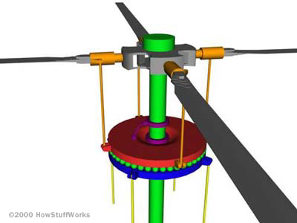
The swash plate assembly consists of two plates -- the fixed and the rotating swash plates -- shown above in blue and red, respectively.
- The rotating swash plate rotates with the drive shaft (green) and the rotor's blades (gray) because of the links (purple) that connect the rotating plate to the drive shaft.
- The pitch control rods (orange) allow the rotating swash plate to change the pitch of the rotor blades.
- The angle of the fixed swash plate is changed by the control rods (yellow) attached to the fixed swash plate.
- The fixed plate's control rods are affected by the pilot's input to the cyclic and collective controls.
- The fixed and rotating swash plates are connected with a set of bearings between the two plates. These bearings allow the rotating swash plate to spin on top of the fixed swash plate.
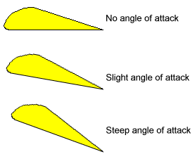
The swash plate assembly changes the angle of attack of the main rotor's wings as the wings revolve. A steep angle of attack provides more lift than a shallow angle of attack.
The collective control changes the angle of attack on both blades simultaneously:
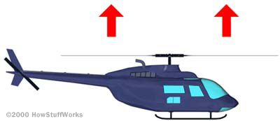
The collective lets you change the angle of attack of the main rotor simultaneously on both blades.
The cyclic control tilts the swash plate assembly so that the angle of attack on one side of the helicopter is greater than it is on the other, like this:
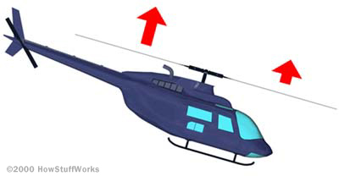
The cyclic changes the angle of attack of the main rotor's wings unevenly by tilting the swash plate assembly. On one side of the helicopter, the angle of attack (and therefore the lift) is greater.
Hovering in a helicopter requires experience and skill. The pilot adjusts the cyclic to maintain the helicopter's position over a point on the ground. The pilot adjusts the collective to maintain a fixed altitude (especially important when close to the ground, as shown in the videos). The pilot adjusts the foot pedals to maintain the direction that the helicopter is pointing. You can imagine that windy conditions can make hovering a real challenge!

Relating the Controls and the Swash Plate
The following videos help you understand the relationship between the cyclic and collective controls and the swash plate assembly. In general:
- The collective control raises the entire swash plate assembly as a unit. This has the effect of changing the pitch of both blades simultaneously.
- The cyclic control pushes one side of the swash plate assembly upward or downward. This has the effect of changing the pitch of the blades unevenly depending on where they are in the rotation. The result of the cyclic control is that the rotor's wings have a greater angle of attack (and therefore more lift) on one side of the helicopter and a lesser angle of attack (and less lift) on the opposite side. The unbalanced lift causes the helicopter to tip and move laterally.

Typical Failures:
- Settling with power, also known as a vortex ring state, is when the aircraft is unable to arrest its descent due to the rotor's downwash interfering with the aerodynamics of the rotor.
- Retreating blade stall is experienced during high speed flight and is the most common limiting factor of a helicopter's forward speed.
- Ground resonance affects helicopters with fully articulated rotor systems having a natural lead-lag frequency less than the blade rotation frequency.
- Low-G condition affects helicopters with two-bladed main rotors, particularly lightweight helicopters.
- Dynamic rollover in which the helicopter pivots around one of the skids and 'pulls' itself onto its side.
- Powertrain failures, especially those that occur within the shaded area of the height-velocity diagram.
- Tail rotor failures which occur from either a mechanical malfunction of the tail rotor control system or a loss of tail rotor thrust authority, called Loss of Tail-rotor Effectiveness (LTE).
- Brownout in dusty conditions or whiteout in snowy conditions.
- Low Rotor RPM, or rotor droop, in which the engine cannot drive the blades at sufficient RPM to maintain flight.
- Wire and tree strikes due to low altitude operations and take-offs and landings in remote locations.^{[36]}

