
GMU SYST 798
Capstone Project
Proposal
“Role of Aviation in Urban Warfare”
By
Michael Bovan, Bryan Driskell
Michael Ingram, Jay Stewart, &
Damian Watson
For
Sikorsky Aircraft Corporation



Background
It is predicted that eighty percent of the world’s population will live in urban environments by 2030. Whether terrorists attack the United States or military forces are deployed to other countries, the urban environment is where terrorists can blend in among the population and have adequate infrastructure to hide within and attack from. In November 2008, Mumbai terrorists laid siege to the Taj Mahal Hotel in India, killing approximately one hundred and fifty people. This is a perfect example of terrorist activities that utilized infrastructure to aid the accomplishment of their mission. Uses for VTOL vehicles in urban environments include rescue, surveillance, and reconnaissance missions. This incorporates troop extraction missions, evacuation scenarios - such as the 9-11 terrorist attack on the World Trade Center, along with enemy surveillance support to track the location and activities of enemy combatants, while providing the opportunity to gather additional intelligence data. With sensor technology maturing rapidly, open architecture will play an important role to ensure that the most accurate enemy detection and precision non-collateral weapons are integrated onto the vehicle platform.

Problem Statement
The battlefield of the future is increasingly urban. The urban environment poses unique challenges as a battlefield, especially for aviation assets. The old model of Red versus Blue simply does not apply to urban warfare. In the future urban combat environment, the role of VTOL aviation in military missions is largely undefined.

Project Objective
The objective of this project is to analyze the role of vertical take off and landing (VTOL) aviation for future military missions in urban environments. To meet this objective, the team will evaluate current aviation platforms such as the Blackhawk and F-22, as well as current prototypes such as the Sikorsky Cipher and X2 platforms. The evaluation will focus on the role of those assets in future urban missions, and seek to identify technology gaps. With a goal of influencing the design of future urban warfare VTOL platforms, the team will develop mission and/or system requirements and conduct trade-off analysis.

Deliverables
The objective stated above implies the delivery of certain products. Those are tentatively listed here, pending sponsor approval:
- Quantitative analysis of relevance of current aviation systems in urban fight
- Requirements for VTOL in urban fight in 2050
- Architecture for urban warfare VTOL aviation

Project Challenges
The problems that urban canyons present must be analyzed due to their affect on the success of the proposed missions. Some examples include the risk of failure (causing damage or death), wind tunnels and turbulence, autonomous navigation without global position systems due to the canyon effect or precise three-dimensional building maps. Urban geometry (tall, closely spaced infrastructure) also presents obvious challenges in the physical design of an aviation asset, affecting size and weight specifications.

Assumptions:
- Focus on military operations and military vehicles. The same concepts of search and rescue can be applied to DHS national emergency and local EMS missions. (Mike I.)
- Focus on VTOL vehicles. Fixed wing, linear flight vehicles will not be the optimal vehicles for within the urban canyon. (Bryan)
- Focus on operations within the urban canyon, which may include dropping a “system” within the canyon. Current operations today include operations above the urban canyon, but have limitations. In-canyon operations are the problems that needs analyzed for future technology to progress. (Bryan)

References & Resources

Conceptual Foundation:

Videos:
To provide inspiration, or artists rendition of the future design and operational scenarios
- Black Hawk Down
http://www.youtube.com/watch?v=9kuu2edvI4Q
- The Fifth Element
http://www.youtube.com/watch?v=nn8y3w9XySY

Concept/Prototype Vehicle Designs:
- Worlds First Flying Car, Terrfugia
http://www.terrafugia.com/aircraft.html
- Aerocopter
http://www.aerocopter.com/
- Gyrocopter
http://en.wikipedia.org/wiki/Autogyro
http://www.youtube.com/watch?v=52EWsrnItmc&feature=related
- Cypher Sikorsky UAV
http://en.wikipedia.org/wiki/Sikorsky_Cypher
http://www.globalsecurity.org/intell/systems/cypher.htm
http://www.spawar.navy.mil/robots/pubs/spie3577.pdf
http://www.youtube.com/watch?v=f1Y3ohmn-OU&feature=related
- X2 Sikorsky helicopter
http://en.wikipedia.org/wiki/Sikorsky_X2
http://www.youtube.com/watch?v=emDlELmXV-I
- Urban Aeronotics
http://www.urbanaero.com/Frame-X-Hawk.htm See films also.
- University of Maryland. 2003. “Urban Disaster Response System”. American Helicopter Society Winning Design sponsored by Sikorsky and NASA
http://www.ahs.umd.edu/design/

Operations Research Articles:

Helicopter Operational Applications in Urban Environments
- Light/Attack Helicopter Operations in the Three Block War. Major Harry J. Hewson. April 1999
http://www.geocities.com/pentagon/6453/mouthelo.html
- Mumbai Terrorist Siege Over, India Says. New York Times. November 2008
http://www.nytimes.com/2008/11/29/world/asia/29mumbai.html
http://news.bbc.co.uk/2/hi/south_asia/7751160.stm
http://www.foxnews.com/story/0,2933,458270,00.html

Population Estimates in Urban Areas
- The world’s largest cities and urban areas in 2020
http://www.citymayors.com/statistics/urban_2020_2.html
- United Nations Population Information Network
http://www.un.org/popin/data.html
GIS open source mapping technologies:
Microsoft’s Bing Bird’s Eye:
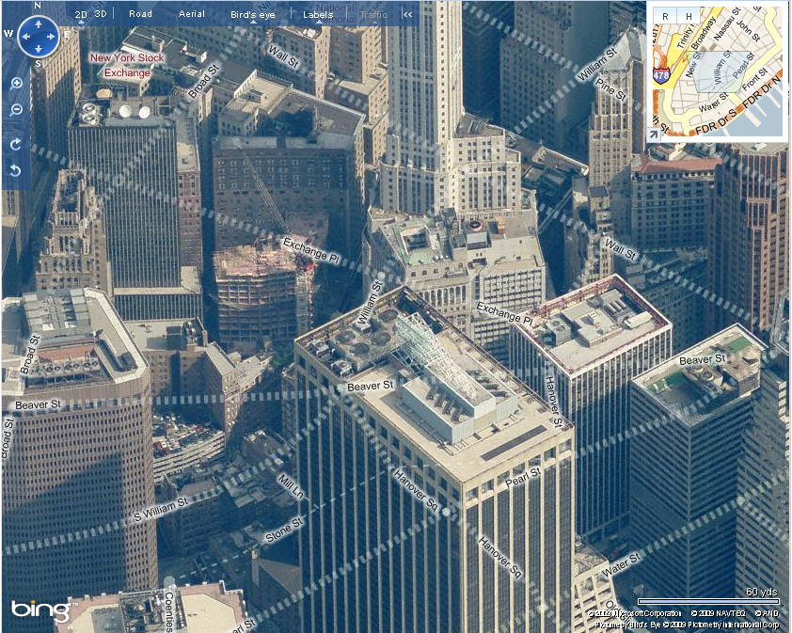
Figure 1: It is clear that there are an unpredictable number of obstacles about the rooftops and architecture of the buildings. In addition, there may be wires and cranes that cause additional obstructions.
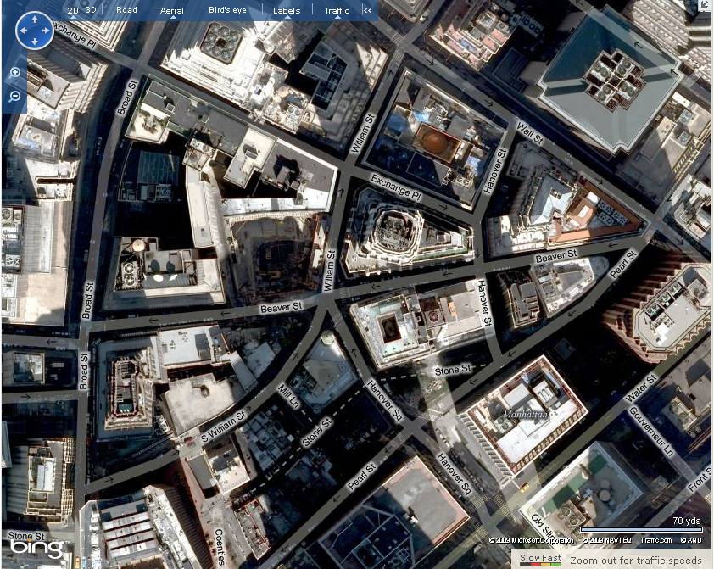
Figure 2: In the Financial District within Manhattan, New York, the one way streets provide enough space for a single vehicle to fit down. The people walking down the streets provide obstacles and slow down the speed of travel to a crawl.

