PATS Architecture
PATS architecture (see OV-1 Diagram) consists of multiple nodes distributed in a disaster site and wirelessly interconnected through a low-power ZigBee mesh network. The PATS ZigBee mesh network uses 2.4 GHz band which operates worldwide, with a maximum data rate of 250 kbps. ZigBee is chosen for PATS because it’s a low power, low cost, and open global standard technology wireless mesh network intended for monitoring and controlling applications. The PATS ZigBee mesh network is a decentralized network (similar to the Internet) consists of three types of nodes: coordinator, router, and end device nodes. The coordinator node initializes a network, and manages network nodes. The router nodes – Signal Posts - are always active and participate in the network by routing messages from the Personnel Locators to the Command Centers.

PATS ZigBee mesh network is formed with the following type of nodes:
Personnel Locator node (Field Agent/End Device): has a minimized user interface, RFID tag, RFID reader, RFID antenna, GPS receiver module, ZigBee RF module, accelorometer and temperature sensor. It is used by the filed agents.
Signal Post node (Data Router): has a minimized user interface, ZigBee RF, battery, and GPS reciever module and it provides location services to the Personnel Locator nodes. It also provides data routing services between the Personnel Locator nodes and the Command Center. PATS requires at least three Signal Post nodes to operate successfully.
Command Center(Mission Coordinator): Personnel data collection node which runs a Accountability and Tracking software that displays the disaster site map with personnel location, enviromental information and is used by the mission coordinators.

PATS System Modeling using SysML
System Modeling Language (SysML) is a general purpose graphing modeling language and is geared toward incrementally refinable description of conceptual design and product architecture. It is an adaptation of UML to System Engineering and supports the specification, analysis, design, verification, and validation of systems that include hardware, software, data, personnel, procedures, and facilities. By modeling the PATS using SysML, we can better understand the requirements, reduce the ambiguity, and validate requirements with the stakeholders to ensure the right problem is being solved.
The following model-based systems engineering approach was taken to address the PATS problem. Note that while the steps below are shown as a sequence, they are often performed in parallel and iteratively:
- Organize the model and identify reuse libraries
- Capture requirements and assumptions
- Model behavior
- Model Structure
  - Capture implied inputs and outputs, and data follow
  - Identify structural components and their interconnections
  - Allocate behavior onto components and behavior flow onto interconnections
- Capture and evaluate parametric constraints
- Model design as required to meet constraints
1.Organizing the Model: 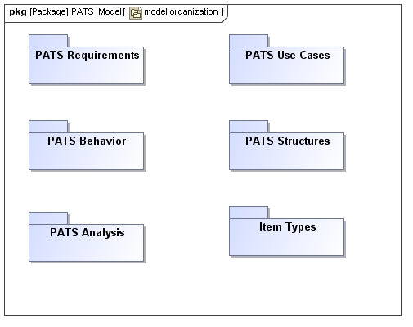
Figure: Package Diagram Documenting the Organization of the PATS Model
The package diagram describes the organization of the PATS model. The packages are organized into requirements, use cases, behavior, structural, and analysis models. The Item Types package captures the types of things that flow in the PATS. Segregating items types into its own package allows the system modeler to concentrate on defining the things that flow and leverage reuse libraries that may exist independent of where they flow or how they are used. For example, a person's location and environment data flow through the PATS.
2. Establishing Requirements:
The PATS requirements were provided by the stakeholders in the form of the problem statement that is captured in the requirements diagram.The diagram's header indicates that the frame represents a package called PATS requirements. The original requirements statement (source requirement 0) is decomposed into individual atomic requirements 1 through 3 which can be individually analyzed and verified.

PATS_Requirements

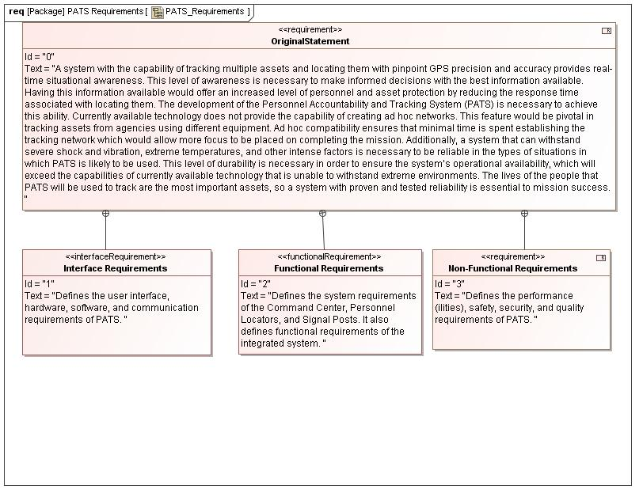
Figure: Original Requirements

List of Requirement
0 Original Statement
1 Interface Requirements
2 Functional Requirements
3 Non-Functional Requirements

0 OriginalStatement
Text
A system with the capability of tracking multiple assets and locating them with pinpoint GPS precision and accuracy provides real-time situational awareness. This level of awareness is necessary to make informed decisions with the best information available. Having this information available would offer an increased level of personnel and asset protection by reducing the response time associated with locating them. The development of the Personnel Accountability and Tracking System (PATS) is necessary to achieve this ability. Currently available technology does not provide the capability of creating ad hoc networks. This feature would be pivotal in tracking assets from agencies using different equipment. Ad hoc compatibility ensures that minimal time is spent establishing the tracking network which would allow more focus to be placed on completing the mission. Additionally, a system that can withstand severe shock and vibration, extreme temperatures, and other intense factors is necessary to be reliable in the types of situations in which PATS is likely to be used. This level of durability is necessary in order to ensure the system’s operational availability, which will exceed the capabilities of currently available technology that is unable to withstand extreme environments. The lives of the people that PATS will be used to track are the most important assets, so a system with proven and tested reliability is essential to mission success.

1 Interface Requirements
Text
Defines the user interface, hardware, software, and communication requirements of PATS.

2 Functional Requirements
Text
Defines the system requirements of the Command Center, Personnel Locators, and Signal Posts. It also defines functional requirements of the integrated system.

3 Non-Functional Requirements
Text
Defines the performance (ilities), safety, security, and quality requirements of PATS.

InterfaceRequirements
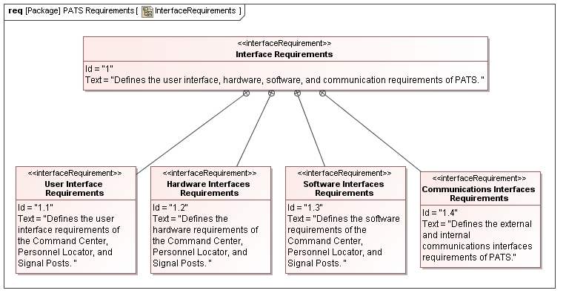
Figure: Interface Requirements

List of Requirement
1 Interface Requirements
1.1 User Interface Requirements
1.2 Hardware Interfaces Requirements
1.3 Software Interfaces Requirements
1.4 Communications Interfaces Requirements

1 Interface Requirements
Text
Defines the user interface, hardware, software, and communication requirements of PATS.

1.1 User Interface Requirements
Text
Defines the user interface requirements of the Command Center, Personnel Locator, and Signal Posts.

1.2 Hardware Interfaces Requirements
Text
Defines the hardware requirements of the Command Center, Personnel Locator, and Signal Posts.

1.3 Software Interfaces Requirements
Text
Defines the software requirements of the Command Center, Personnel Locator, and Signal Posts.

1.4 Communications Interfaces Requirements
Text
Defines the external and internal communications interfaces requirements of PATS.

Interface Requirements Table

ID | Name | Text
1 | Interface Requirements | Defines the user interface, hardware, software, and communication requirements of PATS.
1.1 | User Interface Requirements | Defines the user interface requirements of the Command Center, Personnel Locator, and Signal Posts.
1.1.1 | Command Center
1.1.1.1 | DisplayAcountabilityInfo | The Command Center shall provide personnel accountability information via a color Graphical User Interface (GUI) to operators.
1.1.1.2 | DisplayTrackingInfo | The Command Center shall provide personnel tracking information via a color Graphical User Interface (GUI) to operators.
1.1.1.3 | InputPersonnelInfo | The Command Center shall provide operators the ability to input information via keyboard and mouse.
1.1.2 | Personnel Locator
1.1.2.1 | ProvideGraphicDisplayInterface | The Personnel Locator shall provide a wearer with a graphical display.
1.1.2.2 | DisplayBatteryCharge | The Personnel Locator shall display its battery charge level.
1.1.2.3 | DisplaySignalStrength | The Personnel Locator shall display its signal strength relative to the signal posts.
1.1.2.4 | DisplayGpsData | The Personnel Locator shall display its current GPS coordinates in latitude, longitude, and altitude if it is able to determine its location.
1.1.2.5 | DisplayErrorMessages | The Personnel Locator shall display an error message if it is unable to determine its location.
1.1.2.6 | DisplayDistressAck | The Personnel Locator shall provide a method for a wearer to indicate that they are in distress.
1.1.2.7 | DisplayActiveDistress | The Personnel Locator shall display a distress message if a distress call is currently active.
1.1.3 | Signal Post
1.1.3.1 | DisplayBatteryChargeLevel | Each Signal Post shall display its battery charge level.
1.1.3.2 | DisplayNumGpsSatellites | Each Signal Post shall display the number of GPS satellites in view.
1.2 | Hardware Interfaces Requirements | Defines the hardware requirements of the Command Center, Personnel Locator, and Signal Posts.
1.2.1 | Command Center
1.2.1.1 | USB | The Command Center shall provide a USB 2.0 interface
1.2.1.2 | Ethernet | The Command Center shall provide an Ethernet interface.
1.2.1.3 | RF | The Command Center shall provide an RF communications interface to Signal Posts and Personnel Locators.
1.2.2 | Personnel Locator
1.2.2.1 | RF | The Personnel Locator shall provide an RF communications interface to Signal Posts and Command Center.
1.2.2.2 | Zigbee RF | The Personnel Locator shall provide a Zigbee RF communications interface for wireless mesh networking with other Personnel Locators.
1.2.2.3 | MIL-STD-810 | PL shall be MIL-STD-810 compliant.
1.2.3 | Signal Post
1.2.3.1 | RF | The Signal Posts shall provide an RF communications interface to Personnel Locators and Command Center.
1.3 | Software Interfaces Requirements | Defines the software requirements of the Command Center, Personnel Locator, and Signal Posts.
1.3.1 | Command Center
1.3.1.1 | Link Transmission Status | The Command Center shall receive link transmission status messages from each Signal Posts.
1.3.1.2 | Data Messages | The Command Center shall receive data messages from the Signal Post with the following formats:  a. Personnel Locator GPS coordinate data  b. Signal Post GPS coordinate data  c. Personnel Locator ESN and RFID-embedded data  d. Personnel Locator environment (temperature, acceleration, submersion) data  e. Personnel Locator distress call
1.3.1.3 | Send PL Distress Ack | The Command Center shall send the Personnel Locator a distress call acknowledgement message.
1.3.2 | Personnel Locator
1.3.2.1 | Receive GPS Data | The Personnel Locator shall receive data from the GPS constellation.
1.3.2.2 | Receive SP Data | The Personnel Locator shall receive GPS data from Signal Posts.
1.3.2.3 | Receive SP Alive Message | The Personnel Locator shall receive Signal Posts Alive message.
1.3.2.4 | Receive Distress Ack | The Personnel Locator shall receive panic alert acknowledgement from the Signal Posts.
1.3.2.5 | Transmit Data | The Personnel Locator shall transmit data to the Signal Posts at minimum data rate of 64 Kbps.
1.3.2.6 | Provide Retrieval Services | The Personnel Locator shall provide retrieval services visual aid in locating users.
1.3.3 | Signal Post
1.3.3.1 | Receive GPS Data | The Signal Post shall receive signal from the GPS constellation.
1.3.3.2 | Receive PL Location Data | The Signal Post shall receive Personnel Locator location data from Personnel Locator.
1.3.3.3 | Receive PL Panic Alert | The Signal Post shall receive panic alert signal from the Personnel Locator.
1.3.3.4 | Transit Location Data | The Signal Post shall transmit its location data and Personnel Locator location data to the CC at minimum data rate of 64 Kbps.
1.3.3.5 | Forward Distress Call Message | The Signal Post shall forward Personnel Locator distress call message to the Command Center.
1.3.3.6 | Forward Distress Call Ack Message | The Signal Post shall forward the distress call acknowledgment message from the Command Center to the Personnel Locator.
1.4 | Communications Interfaces Requirements | Defines the external and internal communications interfaces requirements of PATS.
1.4.1 | External Communications
1.4.1.1 | CC: Receive GPS Signals | The Command Center shall receive GPS signals from GPS satellites.
1.4.1.2 | PL: Receive GPS Signals | Each Personnel Locator shall receive GPS signals from GPS satellites.
1.4.1.3 | SP: Receive GPS Signals | Each Signal Post shall receive GPS signals from GPS satellites.
1.4.2 | Internal Communications
1.4.2.1 | SP_PL: Full Duplex RF | The communications link between Signal Posts and Personnel Locators shall be a full-duplex radio frequency link.
1.4.2.10 | SP_CC: Relay SP GPS Data | Signal Posts shall transmit its GPS coordinates to the Command Center
1.4.2.11 | SP__CC: Relay Distress Signal | Signal Posts shall relay a distress message from a Personnel Locator to the Command Center.
1.4.2.12 | SP_CC: Time Stamp Messages | The Command Center shall time stamp all transmitted messages.
1.4.2.13 | CC_PL: PL Identification Info | At the beginning of each mission, the Personnel Locator shall obtain identification information of the wearer from their RFID badge. The Personnel Locator shall send this information to the Command Center.
1.4.2.14 | CC_CC: Communicate With Other CC | Multiple Command Centers within operational range of each other can communicate with one another to augment the number of Personnel Locators tracked.
1.4.2.15 | CC_CC: Full Duplex RF | The communications link between multiple Command Centers shall be a full-duplex radio frequency link.
1.4.2.2 | SP_PL: SP GPS Data | Signal Posts shall communicate their GPS coordinates to the Personnel Locators.
1.4.2.3 | SP_PL: PL GPS Data | Personnel Locators shall communicate their GPS coordinates to Signal Posts.
1.4.2.4 | SP_PL: Distress Signal | Personnel Locators shall transmit a distress message to the Signal Posts if a distress call is activated. The distress message shall indicate whether the distress call was activated manually or autonomously. If the distress call was activated autonomously, the distress message shall specify one of the following reasons: horizontal orientation, temperature out of bounds, submerged, or acceleration out of bounds.
1.4.2.5 | SP_PL: Periodic Distress Signal | The Personnel Locator shall send the distress message periodically every 15 seconds if activated until an acknowledgement from the Command Center is received or the distress call is canceled by the wearer.
1.4.2.6 | SP_PL: Distress Signal Ack | Signal Posts shall relay acknowledgement of a distress message from the Command Center to the Personnel Locator.
1.4.2.7 | SP_PL: Time Stamp Messages | The Personnel Locator shall time stamp all transmitted messages.
1.4.2.8 | SP_CC: Full Duplex RF | The communications link between Signal Posts and the Command Center shall be a full-duplex radio frequency link.
1.4.2.9 | SP_CC: Relay PL GPS Data | Signal Posts shall relay GPS coordinates of Personnel Locators to the Command Center.

FunctionalRequirements
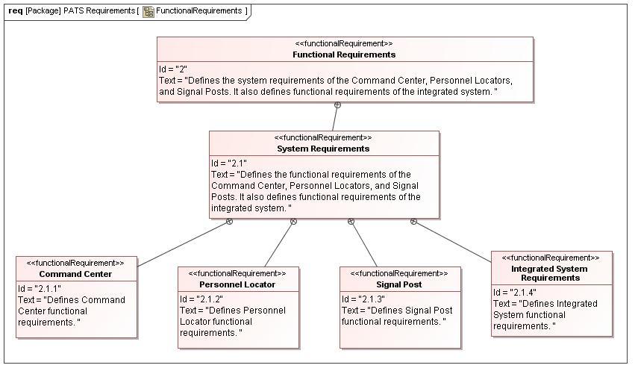
Figure: Functional Requirements

List of Requirement
2 Functional Requirements
2.1 System Requirements
2.1.1 Command Center
2.1.2 Personnel Locator
2.1.3 Signal Post
2.1.4 Integrated System Requirements

2 Functional Requirements
Text
Defines the system requirements of the Command Center, Personnel Locators, and Signal Posts. It also defines functional requirements of the integrated system.

2.1 System Requirements
Text
Defines the functional requirements of the Command Center, Personnel Locators, and Signal Posts. It also defines functional requirements of the integrated system.

2.1.1 Command Center
Text
Defines Command Center functional requirements.

2.1.2 Personnel Locator
Text
Defines Personnel Locator functional requirements.

2.1.3 Signal Post
Text
Defines Signal Post functional requirements.

2.1.4 Integrated System Requirements
Text
Defines Integrated System functional requirements.

Functional Requirements Table

ID | Name |  | Text
2 | Functional Requirements |  | Defines the system requirements of the Command Center, Personnel Locators, and Signal Posts. It also defines functional requirements of the integrated system.
2.1 | System Requirements |  | Defines the functional requirements of the Command Center, Personnel Locators, and Signal Posts. It also defines functional requirements of the integrated system.
2.1.1 | Command Center |  | Defines Command Center functional requirements.
2.1.1.1 | Display Rea lTime Info |  | The Command Center shall display real-time accountability and tracking information.
2.1.1.2 | Provide Personnel And Enviro Info |  | The Command Center shall allow queries to show location, environmental, and distress call status information about a particular Personnel Locator.
2.1.1.3 | Generate Reports |  | The Command Center shall generate reports.
2.1.1.4 | Store Info On Disk |  | The Command Center shall record accountability and tracking information to a disk and stop when the disk is full.
2.1.2 | Personnel Locator |  | Defines Personnel Locator functional requirements.
2.1.2.1 | Unique Id |  | Each Personnel Locator shall be uniquely identifiable by using an electronic serial number (ESN)
2.1.2.2 | Power |  | The Personnel Locator shall operate on battery power.
2.1.2.3 | Display Battery Charge State |  | The Personnel Locator shall display its battery charge state.
2.1.2.4 | Display Panic Alert State |  | The Personnel Locator shall display its panic alert state.
2.1.2.5 |  | Display Location Status |  | The Personnel Locator shall display its location status.
2.1.2.6 | Display Signal Strength |  | The Personnel Locator shall display its signal strength.
2.1.2.7 | PIM Storage |  | The Personnel Locator shall have a Personnel Information Module (PIM) capable of storing personnel information.
2.1.2.9 | Relay Identification Info to CC |  | The Personnel Locator shall relay the information stored in the PIM back to the Command Center. It shall send a message to the Command Center should it lose RFID contact with the PIM indicating that the Personnel Locator has possibly become separated from the wearer.
2.1.2.10 | PL And Wearer Separated Warning Message |  | The Personnel Locator shall send a message to the Command Center should it lose RFID contact with the PIM indicating that the Personnel Locator has separated from the wearer.
2.1.2.11 | Determine Position Via GPS |  | The Personnel Locator shall calculate its position using tri-lateration with information received from GPS satellites.
2.1.2.12 | Determine Position Via Signal Posts |  | The Personnel Locator shall be capable of using the signal posts to determine its position in the event that it cannot receive information from GPS satellites.
2.1.2.13 | Determine Ambient Temp |  | The Personnel Locator shall be able to determine the ambient temperature.
2.1.2.14 | Detect Submerged PL |  | The Personnel Locator shall be able to determine if it is submerged.
2.1.2.15 | Determine Orientation |  | The Personnel Locator shall be able to determine its orientation (horizontal, vertical).
2.1.2.16 | Determine Motion |  | The Personnel Locator shall be able to determine whether it is in motion.
2.1.2.17 | Determine Stationary PL |  | The Personnel Locator shall be able to determine whether it is stationary.
2.1.2.18 | Determine Velocity |  | The Personnel Locator shall determine the velocity (speed and direction).
2.1.2.19 | Determine Acceleration |  | The Personnel Locator shall determine acceleration forces in excess of human capabilities.
2.1.2.20 | Activate Distress Manually |  | The Personnel Locator shall have the ability for the user to manually activate a distress signal.
2.1.2.22 | Distress Signal Threshold |  | The Personnel Locator shall receive from the Command Center the mission specified threshold limits for automatically sending distress signals. This information shall be received upon the Personnel Locators initial connection to the system.
2.1.2.23-26 | Activate Distress Automatically |  | Activate distress signal if temperature exceeds the mission specified threshold limit or if its movement has not changed in the mission specified elapsed time limit or if its orientation has remained horizontal and position static for a duration that exceeds the mission specified threshold limit or if the acceleration forces upon it exceed the mission specified threshold limit.
2.1.2.27 | PIM Storage Min |  | The PIM shall be capable of storing 128 megabytes (MB) of information.
2.1.2.28 | Communicate With PIM |  | The Personnel Locator and PIM shall communicate via RFID.
2.1.3 | Signal Post |  | Defines Signal Post functional requirements.
2.1.3.1 | Determine Position Via GPS |  | Signal Posts shall calculate their GPS coordinates and elevation by using information from GPS satellites.
2.1.3.3 | Relay GPS Data To PL |  | Signal Posts shall relay their GPS coordinates to Personnel Locators
2.1.3.4 | Battery Power |  | Signal Posts shall be capable of operating on battery power.
2.1.3.5 | AC Power |  | Signal Posts shall be capable of operating on alternating current (AC) power.
2.1.3.6 | Operation Of PATS |  | Each instance of PATS shall operate with a minimum of three Signal Posts.
2.1.32 | Acquire SP Elevation |  | Signal Posts shall acquire their elevation by using GPS satellites.
2.1.4 | Integrated System Requirements |  | Defines Integrated System functional requirements.
2.1.4.1 | Acquire Signal |  | PATS shall acquire signal from GPS satellites.
2.1.4.2 | Time Stamp Messages |  | Personnel Locator to Signal Post and Signal Post to Command Center messages shall be time-stamped all received and sent messages.
2.1.4.3 | Encrypt Transmitted Messages |  | Personnel Locator to Signal Post and Signal Post to Comment Center messages shall be encrypted upon transmission.
2.1.4.4 | Decrypt Received Messages |  | Personnel Locator to Signal Post and Signal Post to Comment Center messages shall be decrypted upon receipt.

Non-FunctionalRequirements
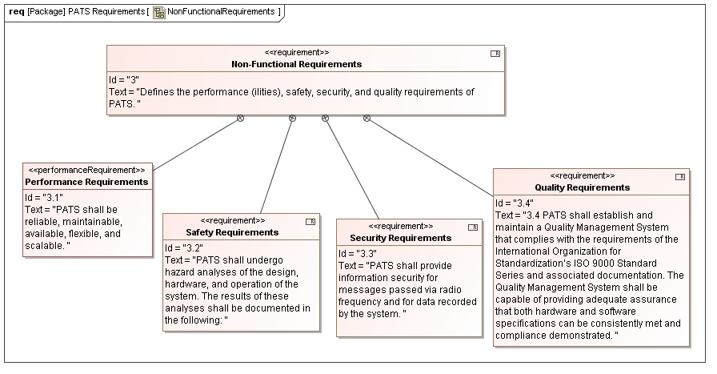
Figure: Non-Functional Requirements

List of Requirement
3 Non-Functional Requirements
3.1 Performance Requirements
3.2 Safety Requirements
3.3 Security Requirements
3.4 Quality Requirements

3 Non-Functional Requirements
Text
Defines the performance (ilities), safety, security, and quality requirements of PATS.

3.1 Performance Requirements
Text
PATS shall be reliable, maintainable, available, flexible, and scalable.

3.2 Safety Requirements
Text
PATS shall undergo hazard analyses of the design, hardware, and operation of the system. The results of these analyses shall be documented in the following:

3.3 Security Requirements
Text
PATS shall provide information security for messages passed via radio frequency and for data recorded by the system.

3.4 Quality Requirements
Text
3.4 PATS shall establish and maintain a Quality Management System that complies with the requirements of the International Organization for Standardization’s ISO 9000 Standard Series and associated documentation. The Quality Management System shall be capable of providing adequate assurance that both hardware and software specifications can be consistently met and compliance demonstrated.

Non-Functional Requirements Table

ID | Name | Text
3 | Non-Functional Requirements | Defines the performance (ilities), safety, security, and quality requirements of PATS.
3.1 | Performance Requirements | PATS shall be reliable, maintainable, available, flexible, and scalable.
3.1.1 | Reliability | The mean time before failure of PATS shall be at least one month of continuous use.
3.1.2 | Maintainability
3.1.2.1 | Automated Updates | The PATS Command Center shall allow automated updates to the operating system software.
3.1.2.2 | Unexpected Downtime Recovery | The PATS Command Center shall be able to recover from an episode of unexpected downtime in less than five minutes.
3.1.2.3 | Software Updates | The PATS Command Center shall allow updates to the PATS software via removable media.
3.1.2.4 | Online Software Updates | The PATS Command Center shall allow updates to the PATS software via Internet.
3.1.2.5 | PL Embedded Software Updates | The PATS Personnel Locator shall allow updates to the embedded system software.
3.1.2.6 | PL Maintenance | he PATS Personnel Locator hardware shall not be end-user maintainable. A malfunctioning unit must be replaced in its entirety.
3.1.2.7 | SP Embedded Software Updates | The PATS Signal Posts shall allow updates to the embedded system software.
3.1.2.8 | SP Battery Replacement | The PATS Signal Posts shall allow for replacement of its battery.
3.1.2.9 | SP Maintenance | The PATS Signal Posts shall not, aside from its power system, be end-user maintainable. A malfunctioning unit must be replaced in its entirety.
3.1.3 | Availability | PATS shall have a minimum availability of 99.99% over a seventy-two hour continuous use period.
3.1.4 | Flexibility
3.1.4.1 | Command Center Technology | The Command Center shall use standard x86 personal computer hardware and operating system, providing a simple technology upgrade path.
3.1.4.2 | Signal Posts Mobility | The Signal Posts shall be moveable by an average human being, providing flexibility in setup and mobility.
3.1.5 | Scalability
3.1.5.1 | Tracking 100 PLs | A PATS Command Center shall allow for tracking of additional Personnel Locators, of up to 100 per Command Center as they arrive on a scene.
3.1.5.2 | Multiple Command Centers | PATS shall allow for multiple Command Centers to work cooperatively in support of tracking more than 100 Personnel Locators, limited to 100 Personnel Locators per Command Center.
3.1.5.3 | Minimum Number Of Signal Posts | PATS shall support the ability to use more than the minimum number of Signal Posts.
3.2 | Safety Requirements | PATS shall undergo hazard analyses of the design, hardware, and operation of the system. The results of these analyses shall be documented in the following:
3.2.1 | PATS Preliminary Hazard Analysis | This analysis shall be completed prior to the preliminary system design review. It is necessary that the results of this study be incorporated, as far as possible into the final detailed design.
3.2.2 | Subsystem Hazard Analysis | This analysis shall be completed prior to the detailed design review.
3.2.3 | Operational Hazard Analysis | This analysis shall commence after design is complete and be delivered prior to the start of the PATS System Integration tests.
3.3 | Security Requirements | PATS shall provide information security for messages passed via radio frequency and for data recorded by the system.
3.3.1 | RF Communications | PATS shall encrypt all personnel data passed through RF messages using the Rivest, Shamir, and Aldeman (RSA) 256-bit or stronger encryption.
3.3.2 | Physical Media / Storage
3.3.2.1 | Encryption | The PATS Command Center shall encrypt all personnel data residing on system hard drives using AES-256 or stronger encryption algorithm.
3.3.2.2 | RAID | The PATS Command Center shall use RAID hard drive redundancy to mitigate against a single hard drive failure.
3.3.2.3 | Authentication | The PATS Command Center shall require a user login to access the system.
3.4 | Quality Requirements | 3.4 PATS shall establish and maintain a Quality Management System that complies with the requirements of the International Organization for Standardization’s ISO 9000 Standard Series and associated documentation. The Quality Management System shall be capable of providing adequate assurance that both hardware and software specifications can be consistently met and compliance demonstrated.
3.4.1 | Hardware Quality | PATS hardware shall undergo factory acceptance, environmental, electrical, and safety testing.
3.4.2 | Software Quality | PATS software shall undergo unit, component, system, integration, and regression testing to ensure. PATS software shall be reviewed and inspected by peers and review packages shall be generated. There shall be a mechanism to correct and document software defects.

3. Modeling Behavior
The PATS behavior is modeled using SysML package, activity, and use case diagrams. The main activity’s (Provide PATS Services) decomposition is represented in the following block definition diagram.
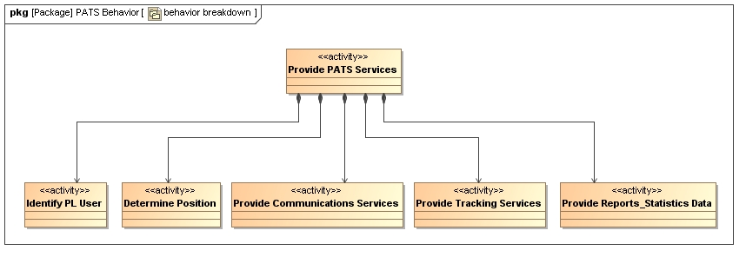
Figure: Provide PATS Services functional hierarchy

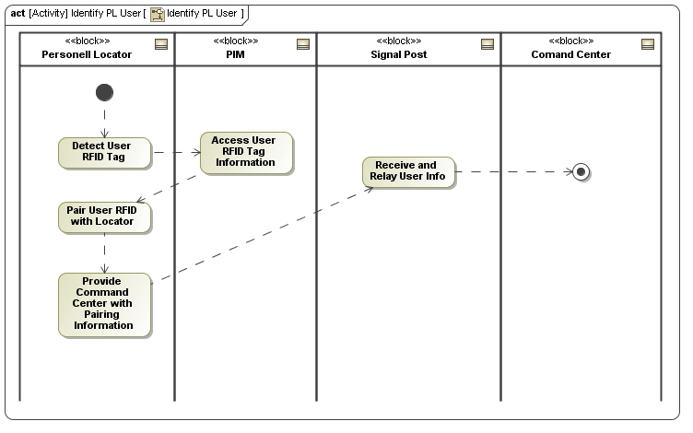
Figure: Identify PL User Activity Diagram
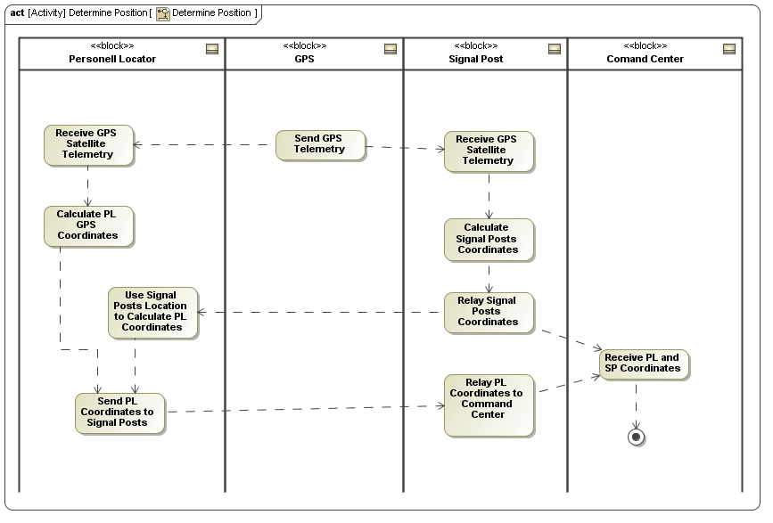
Figure: Determine Position Activity Diagram
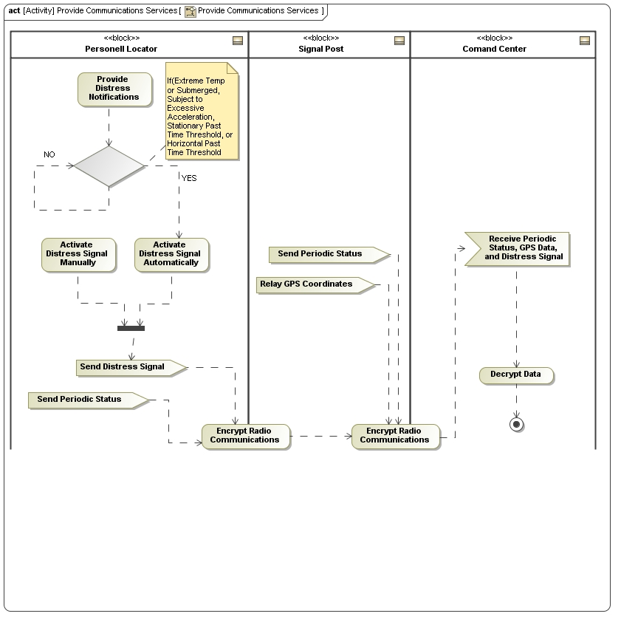
Figure: Provide Communication Services Activity Diagram
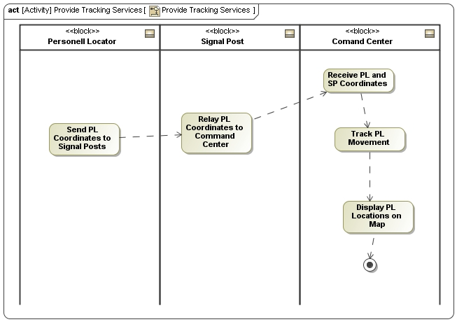
Figure: Provide Tracking Services Activity Diagram
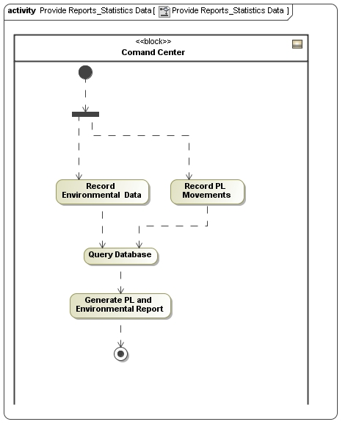
Figure: Provide Reports and Statistics Activity Diagram
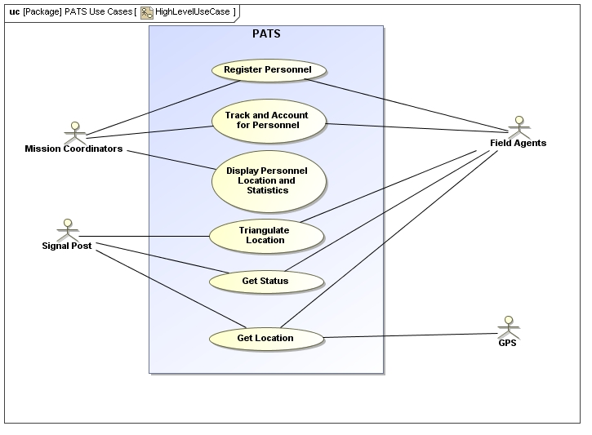
Figure: PATS High Level Use Case Diagram

4. Modeling Structure
PATS consists of three major subsystems: Personnel Locators, Signal Posts, and a Command Center. The following structure diagram shows the components of each subsystem.
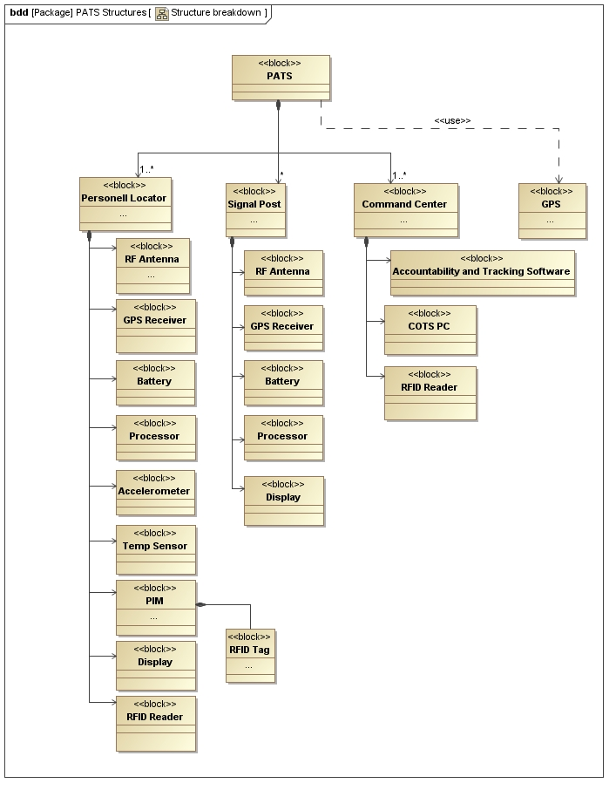
Figure: PATS Block Definition Diagram

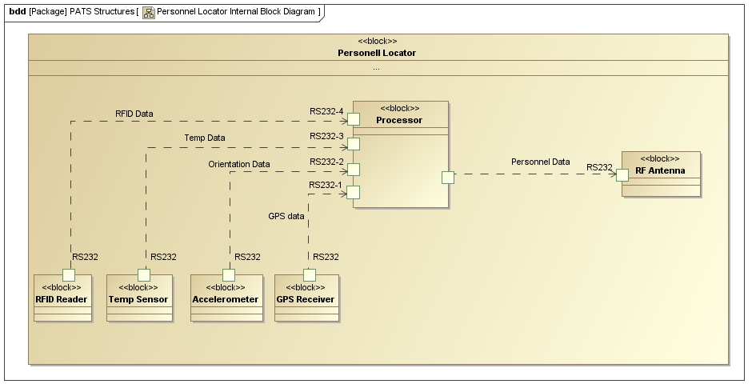
The above diagram shows the internal blocks of the Personnel Locator subsystem. The Personnel Locator’s processor interfaces with the RFID reader, temperature sensor, accelerometer, GPS receiver, and RF Antenna through RS232 Serial Communication.

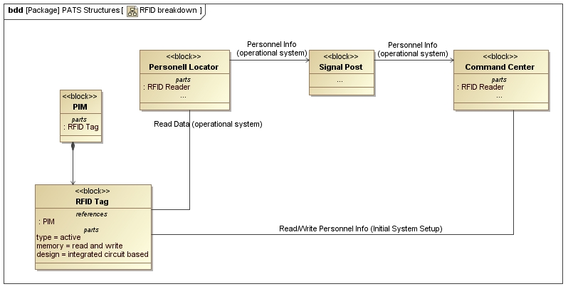
The above diagram shows the RFID data transmission. During initial system setup, the Command Center writes personnel info into the RFID tag. When the system is operational, the Personnel Locator reads the RFID tag periodically and transmits this information back to the Signal Posts which relay this information to the Command Center via RF.

Creating an integrated architecture of PATS using DoDAF
The Department of Defense Architecture Framework (DoDAF) defines a standard way to organize an enterprise architecture(EA) or systems architectureinto complementary and consistent views. While it is clearly aimed at military systems, DoDAF has broad applicability across the private, public and voluntary sectors around the world, and represents only one of a large number of systems architecture frameworks. It is especially suited to large systems with complex integration and interoperability challenges, and is apparently unique in its use of "operational views" detailing the external customer's operating domain in which the developing system will operate. PATS implements the following DoDAF views:
OV-1 : High Level Operational Concept Graphic
OV-5 : Operational Activity Model
SV-1 : System Interface Description
SV-2: Systems Communications Description
SV-4: Systems Functionality Description
TV-1 : Technical Standards Profile
AV-1 : Overview and Summary Information
AV-2 : Integrated Dictionary
PATS consists of many different subsystems which come together to carry out one overall mission, therefore interoperability is not an option. The exchange of information and data between these subsystems are critical in saving lives and completing the mission successfully. The DoDAF defines three architectures; operational (OA), systems (SA) and technical (TA). OA describes the tasks and activities required to accomplish or support system operation. SA describes the system and interconnections providing and supporting system functions. TA is defined as the minimal set of rules governing the arrangement, interaction, and interdependence of system parts or elements, whose purpose is to ensure that a conformant system satisfies a specified set of requirements.
Operational Views:
OV-1: High Level Operational Concept
OV-1 shows the high-level graphical description of the operational concept of PATS.
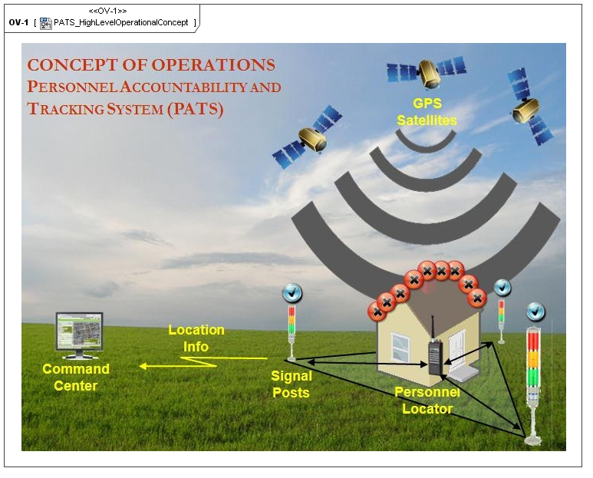
Figure: OV-1 High Level Operational Concept
OV-5: Operational Activity Model
OV-5 shows the capabilities, operational activities, relationships among activities, inputs, and outputs of PATS.
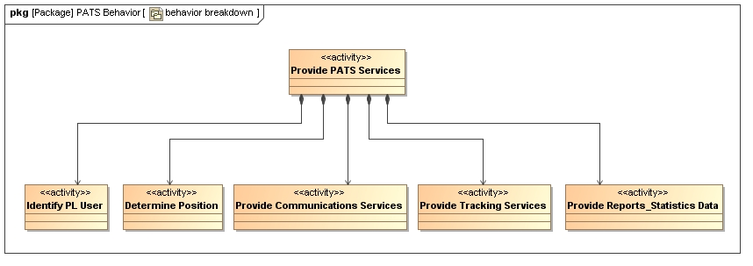
System Views:
SV-1: System Interface Description
SV-1 shows identification of systems nodes, and system items and their interconnections, within and between nodes.
SV-2: Systems Communications Description
SV-2 shows system nodes, systems, and system items, and their related communications lay-downs.
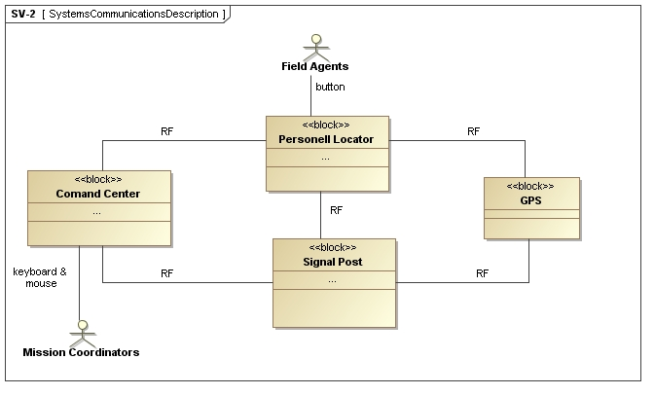
SV-4: Systems Functionality Description
SV-4 shows functions performed by systems and the system data flows among system functions.
Technical Views:
TV-1: Technical Standards Profile
TV-1 shows listing of standards that apply to Systems View elements in a given architecture.
Technology Service Area | Technical Service | Standards
Access Control | Data Encryption | AES-256
Access Control | Authentication | ESN
Environmental Engineering | Packaging | MIL-STD-810F
Database Management System | Data Storage | Oracle RDBMS
System Integration | Data Transfer | ZigBee/ RF
All Views
AV-1 : Overview and Summary Information
AV-1 shows scope, purpose, intended users, environment depicted, and analytical findings of PATS.
AV-1: Overview and Summary Information
Architecture Product Identification
Architecture Product Name | PATS - Systems Engineering Capstone Project
Architect | George Mason University Students
Organization Developing the  Architecture | GMU Systems Engineering Department
Assumptions and Constraints | * GPS will remain available for non-military use.  * No legal issues exist  * No political issues exist
Approval Authority | GMU Systems Engineering Faculty
Date Completed | 15-Dec-09
Scope
Views and Products Developed | AV-1, AV-2, OV-1, OV-2, OV-3, OV-5, SV-1, SV-2, SV-4, TV-1, TV-2
Organizations Involved | * Firefighting Departments  * Maritime Search and Rescue Organizations  * Military  * Natural Disaster Response Organizations  * Multi-Agency Task Force
Purpose and Viewpoint
Purpose | Through the use of existing GPS technologies, combined with an application specific backup radio frequency (RF) triangulation system, PATS will provide a durable, ad hoc scalable, realtime tracking and accountability system. The main function components are a Personnel Locator which is carried by the person to be tracked, a Command Center which provides situational awareness through the display of personnel accounting and tracking information, GPS satellites for global coordinate location information, and Signal Posts that provide a RF-based tracking system as a backup to the GPS system.
Analysis | Refer to:  * Stakeholder Analysis section  * Alternative Analysis section  * Tradeoff Analysis section
Context
Mission | An autonomous, scalable, and durable personnel accountability system with tracking capabilities could be an attractive product in many different domain applications, ranging from civilian to military
Rules, Criteria, and  Conventions Followed | • Architectural Views consistent with DoD Architecture Framework Version 1.5  • System Modeling using SysML
Tools and File Formats Used
Tools | MagicDraw (SysML and DoDAF plugins) - Microsoft Office 2007 – Microsoft Project - Stakeholder Circle – WireframeSketcher – SecureShell Client  *.mdzip: Zipped MagicDraw Project File
Findings
Analysis Results | The results of the alternative, tradeoff, and stakeholder analysis are available in the final report.
Recommendations | Recommendations for further study are provided in the final report

AV-2 : Integrated Dictionary
AV-2 shows architecture data repository with definitions of all terms used in all products.
PL: Peronnel Locator
CC: Command Center
SP: Signal Post
ESN: Electronic Serial Number
GPS: Global Positioning System
GUI: Graphical User Interface
AC: Alternating Current
RF: Radio Frequency
PIM: Personnel Information Module
MIL-STD 810F: Department of Defense Test Method Standard for Environmental Engineering Considerations and Laboratory Tests

PATS RFID Technology

RFID involves detecting and identifying a tagged object through the data it transmits. RFID consists of a tag (transponder), a reader (interrogator) and antenna (coupling devices) located at each end of the system. The data transfer between the tag and the reader is referred to as coupling and in most RFID systems coupling is either electromagnetic (backscatter) or magnetic (inductive).
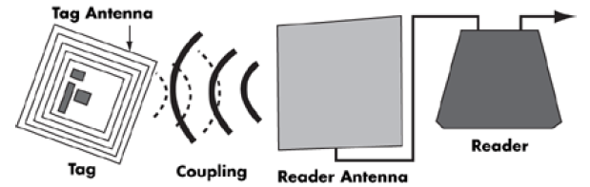
Tag
The tag holds the data that is transmitted to the reader when the tag is interrogated by the reader. The tag used in PATS is an acitve tag that has an integrated circuit (IC) and a memory to store the personnel information.

Reader
The reader is a component that captures and processes tag data. The reader has an interface to the Personnel Locator’s processor. The Command Center also has a reader component that is capable to write data to the tag at anytime in the lifecycle of PATS.

Antenna
The antenna provides the mechanism in which a data communication occurs between the reader and the tag. Both the tag and reader will have an antenna.

Operating Frequency
The operating frequency at which a tag and a reader communicate is a key aspect in RFID technology. Frequency of operation can vary based on the application, standards, and regulations. Data transfer speed depends on the frequency. The higher the frequency, the faster the transfer of data. The following table illustrates some applications and their operating frequencies.

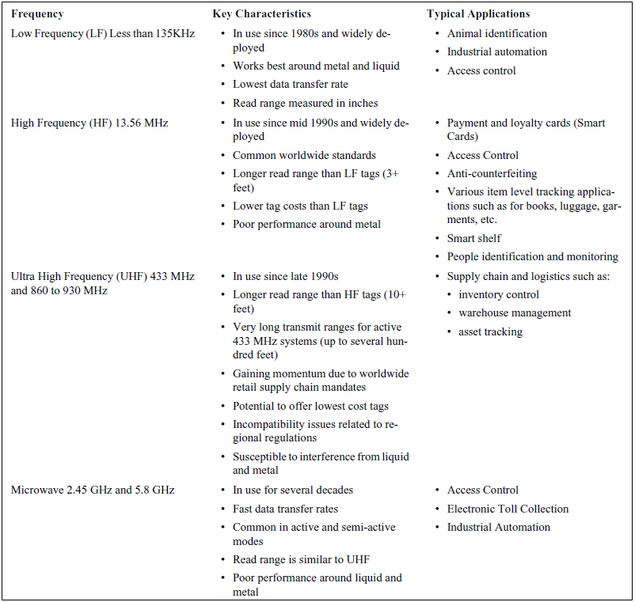
Characteristics and Applications of Most Popular RFID Frequency Ranges

RFID COTS System Software and Middleware
PATS uses commercial of the shelf (COTS) System Software and Middleware. The System Software is reponsible for the interaction between the reader and tag. It allows the reader to read and write tag data and it provides error and collision detection as well as encryption and authentication functions. The Middleware manages RFID data flow between the reader and the tag and it monitors the health and status of the reader.

Command Center COTS PC
The Command Center uses commercial of the shelf personal computer (COTS PC) and it hosts the main sofware application that accounts and tracks personnel.

Command Center Accountability and Tracking Software
The Accountability and Tracking Software leverages the data generated by the Personnel Locators and Signal Posts.

ZigBee RF Module
The Personnel Locators and Signal Posts use a COTS Low-Power RF System-on-Chip ZigBee module that consists of a location engine and a temperature sensor that is capable of achieving several hundred meters of range. This module is IEEE 802.15.4 compliant and has the benefit of adjacent channel rejection capability, shorter location calculation time, lower current consumption, long battery lifetime, and more CPU time for the application. This module is capable of operating in an interference prone environment.

References:
Zig-Bee
Product:
http://www.ti.com/corp/docs/landing/cc2480/

