PEACE
Population and Environment Analysis for
Counter-insurgency Evaluation

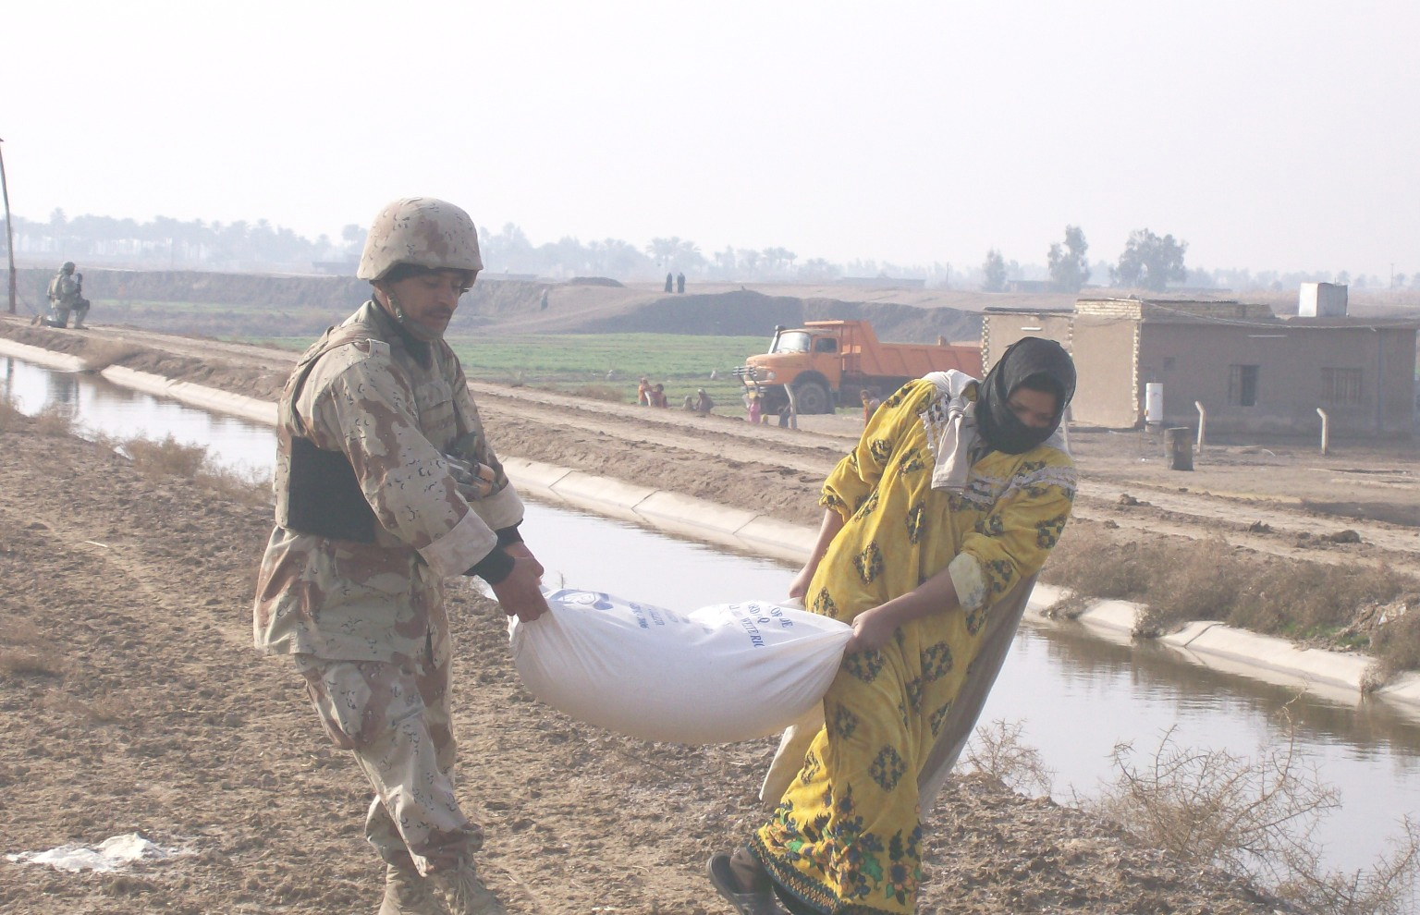
Final Report

Photo by Spc. Terry Self and provided courtesy of the U. S. Department of Defense and the U.S. Army.

Prepared By: For:
Jason Southerland COL Manago
Kevin Neary Center for Army Analysis
Brian Kolstad
Steven Darcy
Table of Contents

PEACE 3
Introduction 4
The Nature of Insurgency 4
The Role of Militaries in Counter-insurgency 5
Evolution of the Project 6
O’Neill Classifications 6
How Many Troops are Needed to Win an Insurgency? 7
How Many Troops are Needed to Provide Security? 8
Knowledge Elicitation to Define the Bayesian Network 9
Data Exploration and Analysis 11
Description of the Dataset 11
Regression and Scatter plot Analysis 16
First Impressions 21
CART Analysis 25
MARS Analysis 29
Observations, Conclusions and Next Steps 35
Appendix A: Work Breakdown and Earned Value Management 38
Bibliography 40

Table of Figures

Figure 1 Network Relating Troop Density to Outcome 8
Figure 2 Network Relating Troops to Violence 9
Figure 3 Network Relating Force Breakout to Violence 11
Figure 4: Scatter plot matrix of troop density and violence incidence data 17
Figure 5: Histogram (Incidents per 1000 Population) 18
Figure 6: Predictions and Residuals 19
Figure 7 Scaled Troop Density & Incidents 22
Figure 8 Mean Change in Violence 23
Figure 9 Maximum Changes in Violence 23
Figure 10 Minimum Changes in Violence 24
Figure 11 Incidents by Insurgency 25
Figure 12 Plot of Estimates vs. Actual Values 32
Figure 13 Plot of Estimates vs. Actual Values 33
Figure 14 Histogram of Errors 33
Figure 15 Q-Q Plot of Residuals 34
Figure 16 Comparison of Residuals 34
Figure 17 Project Tracking 39

PEACE

“Herakles was making his way through a narrow pass. He saw something that looked like an apple lying on the ground and he tried to smash it with his club. After having been struck by the club, the thing swelled up to twice its size. Herakles struck it again with his club, even harder than before, and the thing then expanded to such a size that it blocked Herakles's way. Herakles let go of his club and stood there, amazed. Athena saw him and said, “O Herakles, don't be so surprised! This thing that has brought about your confusion is Aporia (Contentiousness) and Eris (Strife). If you just leave it alone, it stays small; but if you decide to fight it, then it swells from its small size and grows large.”
- Aesop, Fables 534 (from Chambry 129)

“A victorious warrior wins first and then goes to war, while a defeated warrior goes to war first and then seeks to win.” -Sun Tzu, The Art of War

Introduction

The Nature of Insurgency
Counter-insurgency has become increasingly important to the United States Army. In recent years, the U.S. has been involved in conflicts including Operation Desert Shield and Operation Desert Storm in Iraq, Operation Iraqi Freedom, Operation Enduring Freedom in Afghanistan, as well as engagements in Bosnia and Somalia. In Operations Desert Shield and Desert Storm, the conflict was a large scale force on force engagement and the United States won decisively. In the remaining conflicts decisive victory has been elusive.

The recent troop surge in Iraq was followed by a substantial decrease in violence; but, in Afghanistan, a newly resurgent Taliban challenges NATO and Afghan forces. Troops have remained engaged at lower intensity for much longer durations. Despite the increasing number of insurgencies in which the U.S. has become involved, very few tools exist for analyzing these conflicts. These conflicts have been characterized by irregular warfare and asymmetric tactics.

Insurgency is “the pursuit of the policy of a party, inside a country, by every (emphasis added) means” . Insurgency is “a protracted struggle conducted methodically,” with the ultimate goal being “the overthrow of the existing order.” What distinguishes insurgency from other political movements is the use of violence to achieve political goals. It is this violence that has typically encouraged governments to use force, military force to combat the insurgency.

The desired end-state of counter-insurgency is the status quo: those that have political power stay in power. The desired end-state of insurgency is the opposite, a regime change. For either side to achieve success, the “neutral or passive majority” must be won over. Given the desired end-state of counter-insurgency and the requirement to win over the passive majority, how must a counterinsurgency be waged?

For counter-insurgents to win the “hearts and minds” of the neutral majority, the counterinsurgent must convince this majority that its government is legitimate. Since legitimacy is the focus, counter-insurgency is as much, if not more so, a political campaign than strictly a military campaign. Governments that can provide, among other things, security and basic services, are generally viewed more favorably by their people. Insurgents seek to undermine this legitimacy, and thus create opportunities for revolution, by trying to convince the neutral majority that the government cannot provide what it needs, namely security and basic services.

Winning counter-insurgency may require a local government to take social, diplomatic, military, or economic actions. Diplomacy bolsters the notion that a government is legitimate. If the government is recognized by the international community, conventional wisdom holds that its people will view it as being legitimate. Military action should create a secure environment. Economic and social measures may encourage support for the government. Prosperity for the common man may equate to more support for the government.

Given that defeating insurgency requires engaging with all the instruments of national power, the following question arises: “Is military success a sufficient condition for ensuring counter-insurgency victory?” Once the role of the military in fighting insurgency is understood, the next question is: “How much military is needed to successfully execute the military aspect of counter-insurgency?”

The Role of Militaries in Counter-insurgency
Efforts to define the force size required to restore and then maintain order in a failed or failing state have been sporadic and far from complete. To date, it has been a problem with “no simple answers” and, as result, ad-hoc planning has been the norm for military strategists. The recently revised United States Army’s “Field Manual 3-24, Counterinsurgency” states that performing a successful counterinsurgency operation requires one counterinsurgent, at a minimum, for every fifty people in the area where the counterinsurgency is being waged. The manual further goes on to state that this ratio is merely a guideline, with appropriate ratios to be determined as necessary by the environment and the nature of the insurgency. Given this guidance, two questions arise:

- “How do I frame the environment and the nature of the insurgency to determine a troop density?”
- “Given, the framework from the first question, what is an appropriate troop density?”

Perhaps one of the earliest attempts at quantifying the number of troops needed for non-traditional combat operations was published by James Quinlivan in 1995. In his “Force Requirements for Stability Operations,” Quinlivan discusses the troop requirements necessary to successfully execute stability operations. Counter-insurgency operations require both stability operations and offensive operations, though the stability aspects of the operations are primary in counter-insurgency. The size of stabilizing forces is determined by the size of the population.As such, Quinlivan’s analysis focuses on force to population ratios, expressed as stability troops per 1,000 population.

Quinlivan stops short of declaring what constitutes an appropriately sized counter-insurgency force. He illustrates, though does not “prove” his proposition that the force should be sized based on the population of the area of operations.

In 2003, Quinlivan elaborated on his analysis in “Burden of Victory, The Painful Arithmetic of Stability Operations.” Quinlivan suggests that “the British are the most experienced practitioners of the stabilization art.” Building on this point, he recalls two examples, Northern Ireland and Malaya, where the British deployed forces on the order of 20 or more troops per 1,000 population. Going even further, Quinlivan suggests that “successful nation-building usually requires 20 troops per 1,000 population.”

Another analysis of stability operations was performed by John McGrath that looks at not only troop density, but other factors, such as terrain, and the size of local police forces to try and determine an appropriate force to population ratio for counter-insurgency operations. The end result of McGrath’s analysis is a planning factor (recommendation) of 13.26 counter-insurgents per 1,000 population.

Perhaps the most important mention of troop densities resides in the United States Army’s counter-insurgency doctrine, Field Manual 3-24 Counterinsurgency. The Field manual recommends a troop density of at least (emphasis added) 20 troops per 1,000 population. The Manual goes on to caution that “no force level guarantees victory for either side” and that the suggested ratio could vary “dependent upon the situation.”

None of the first three studies mentioned considered the military objectives of counter-insurgency. Rather, the studies focused on overall counter-insurgency outcomes, i.e. counter-insurgent victory. McGrath and the Army Field Manual suggest that factors other than troop density affect outcomes.

This project was intended to serve two purposes: First, to provide an expansion upon the limited scope of counterinsurgency troop density studies by researching and analyzing 83 insurgencies from the 20th century, including cases won by both the insurgent and the counterinsurgent; Second, to provide a means of framing a strategist’s troop density decision by identifying the key variables that define the operating environment.

Evolution of the Project
This project underwent significant evolutions as our research enhanced the understanding of both the project team and our client. We discuss the evolution of this project as well as some of the conversation that informed this evolution.

O’Neill Classifications
The project started as an effort to statistically describe two already existing classification schemes for insurgencies. The first classification concerns the method by which insurgencies execute their campaign. The second classification concerns the goals and objectives of insurgencies, and describes types of insurgencies. These schemes, introduced by Bard E. O’Neill in ‘Insurgency and Terrorism: From Revolution to Apocalypse,” are listed below.

Insurgent Strategies:
- Conspiratorial
- Protracted popular war
- Military-focus
- Urban warfare

Insurgency Types:
- Anarchists
- Egalitarians
- Traditionalists
- Pluralists
- Apocalyptic-utopians
- Secessionists
- Reformists
- Preservationists
- Commercialists

Our goal was to use supervised statistical learning techniques on a selected set of predictor variables to determine a probability distribution of insurgency types given the predictor variables; and, then to repeat the process for strategic approaches. This approach was based on the notion that different types of insurgencies, with their varying goals, and different strategic approaches might have some impact, with respect to the number of counter-insurgent troops, on the overall strategic outcome of a counter-insurgency campaign.

However, when we began, we did not know, nor could we find any research which suggested insurgent goals and tactics affect the overall counter-insurgency outcome. As such, we felt this approach was a bit like “putting the cart before the horse.” Statistically describing various types and approaches of insurgency was certainly an interesting problem, but in and of itself, classifying insurgencies would not shed any light on how various troop densities affect strategic outcomes. Therefore, we decided to transition our efforts from describing insurgencies to predicting insurgency outcomes based on troop densities and insurgency classifications.

How Many Troops are Needed to Win an Insurgency?
After some initial discussions, the team decided that a Bayesian network would provide the best analytical framework to examine strategic outcomes with respect to troop density and other variables. Specifically, if the other variables are known, we could examine how varying troop densities affect the probability of overall strategic counter-insurgency victory. As mentioned earlier, Quinlivan suggests 20 troops per thousand population; and, McGrath’s study recommended 13.26 troops per thousand population. Our goal was to expand upon this analysis using a much larger set of insurgencies. We developed the following Bayesian network to support this analysis:
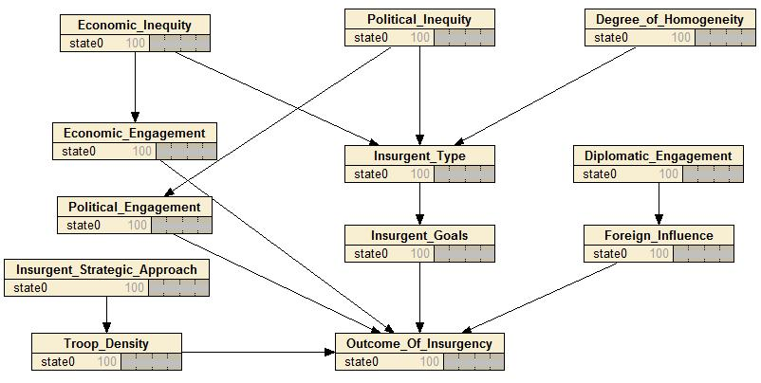
Figure 1 Network Relating Troop Density to Outcome

When the network shown in figure 1 was presented to COL Manago, it became clear the scope of this network greatly exceeded the U. S. Army’s zone of control. Clearly economic, political, and diplomatic factors are critical in deciding the outcome of an insurgency. However, the Army’s area of interest is more focused.

Our discussion with COL Manago regarding this network focused on the Army’s role in counter-insurgency. As mentioned previously, the role of the military in counter-insurgency is to provide security. More specifically, COL Manago suggested that “military force creates the conditions, through improving security, for the diplomatic, political and economic efforts of the counter-insurgency to bear fruit.” To determine how well a military force provides security, we should focus our efforts on violent incidents and the relationship between this violence and various troop levels.

How Many Troops are Needed to Provide Security?
In this iteration, we narrowed our focus to relating troop level to violence. Within this iteration, we executed many sub-iterations. As before, we decided to use Bayesian networks to investigate our problem.

In the first sub-iteration in this line of research, we developed a simple network relating troop densities to varying intensities of violence. Through discussions with subject matter experts, we decided that for troop density, the “high” category would apply to all troop densities greater than 18 troops per 1,000 population; the “medium” category would apply to all troop densities greater than 10, but less than 18 troops per 1,000 population; and the “low” category would apply to all troop densities less than or equal to 10 troops per 1,000 population. Since we had not yet compiled our data, we did not establish a convention for what constituted low, medium, and high violence. This convention on violence would later become a point of contention. The first network we developed is depicted in figure 2.
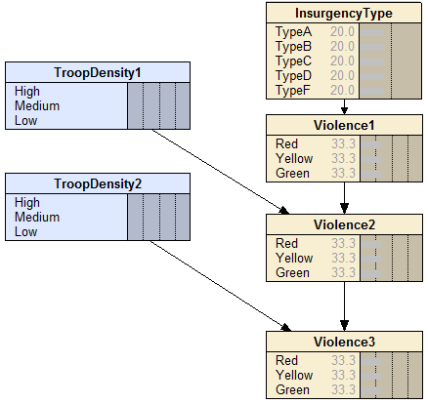
Figure 2 Network Relating Troops to Violence

Knowledge Elicitation to Define the Bayesian Network
After COL Manago had validated the structural assumptions of our model, we attempted to populate it as a prototype. In order to populate our Bayesian Network, we elicited the help of our Subject Matter Experts to provide prior probabilities relating troop density to levels of violence. It is worth noting that at this point, we had not established a standard for determining high, medium and low levels of violence. Eliciting the probability distributions for a node, given its parents, is considered the most difficult part of developing a network model. In order to simplify and reduce the number of expert opinions we had to elicit, we had the SMEs populate a table of probabilities basing the next year’s level of violence on a combination of the current levels of violence and the troop density. Each of these was broken out into a High, Medium, and Low range.

We opted for an Interview approach, as our SMEs were very familiar with statistics and knowledge elicitation methods. We first elicited the most likely violence level for t+1, and set it equal to 1, The other violence levels were then set by using a likelihood ratio, comparing the likelihood of each of them with the most likely violence level. We then converted the likelihood ratios to probabilities, and submitted them back to the SMEs for further refinement. The final results for use in the Bayesian Network Model are displayed below.

 |  | Violence Levels (t+1)
Violence (t) | Troop Density | High | Medium | Low
H | H | 42.11% | 52.63% | 6.00%
H | M | 62.50% | 31.25% | 5.00%
H | L | 68.00% | 25.00% | 7.00%
M | H | 10.00% | 40.00% | 50.00%
M | M | 25.00% | 41.67% | 33.33%
M | L | 47.62% | 38.10% | 14.29%
L | H | 0.90% | 9.01% | 90.09%
L | M | 7.14% | 21.43% | 71.43%
L | L | 11.76% | 29.41% | 58.82%

After reviewing the initial network, COL Manago suggested that we incorporate various types of counter-insurgent forces into our network. He suggested that indigenous forces might have a different magnitude of impact on violence than foreign, intervening forces. Beyond just indigenous forces, he reasoned that within an indigenous force, police and armed military might also have different impacts on violence. After all, “police are supposed to fight the day-to-day crime” while the military role is generally very different.

Given this discussion, we opted to develop a network that incorporated foreign troops, indigenous military forces and indigenous police forces. The network is depicted in figure 3.

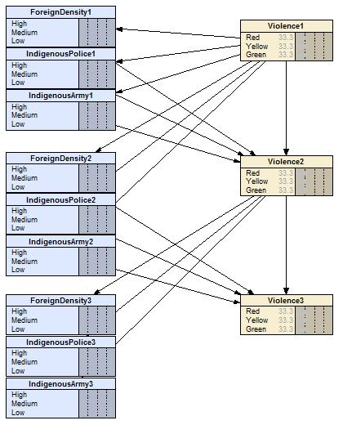
Figure 3 Network Relating Force Breakout to Violence

Data Exploration and Analysis
Note: The data for this analysis was provided by the Center for Army Analysis; our team did not attempt to independently verify all aspects of this data. Based on this project’s resources and prescribed timeline, such a validation effort would have been infeasible.

Description of the Dataset
The dataset we used was provided by the Center for Army Analysis. From this dataset we were able to create a table with the following attributes:

  - I Code – A numeric value unique to each insurgency
  - Case Name – A text description of each insurgency
  - Calendar Year – The calendar year corresponding to the data
  - O’Neill Classification – Type of insurgency (O'Neill classification) is a description of the type of insurgency as described by author-analyst Bard O'Neill. The classification of insurgencies in the database were made using the judgment of subject matter experts.
  - Strategic Approach - (O'Neill classification) is a description of the type of strategy employed by the insurgents to obtain their goals as described by author-analyst Bard O'Neill. The classification of insurgencies in the database were made using the judgment of subject matter experts.
  - Primary Terrain Type - Primary terrain type is the primary terrain type of the country, chosen from the following set of 12 created by TDI, with a bias toward the primary terrain type of the area where the insurgency occurred.
  - Percent Urban Population - Percent urban population is the percentage of urban population of the country as defined by the UN World Population Prospects for the year the insurgency started (data is interpolated between five year reporting periods).
  - Indigenous Government - Only applies if the country where operations take place had a functioning government in place at the start of operations. The indigenous government is defined as to whether or not it was a colonial administration (i.e., was under the governance of another country or was part of another country) with possible answers.
  - Government Type - Government type is the basic form of the government in place at the start of operations according to the list of government types given below. Note that government type is defined for the Intervening Force and Indigenous Force country separately if they are present.
  - Rules of Engagement of Intervening Force - Rules of engagement are the description in general terms of what the rules of engagement employed by the intervening force (or indigenous government if no intervening force is involved) were. In theory rules of engagement in international conflicts are based upon the Laws of Armed Conflict (LOAC, which embody the Geneva and Hague Conventions), but practically
  - Degree of outside support for insurgency - Degree of outside support is a description of the degree of support the insurgency received from foreign governments or factions. Support may include political, financial, logistical, or military aid.
  - Structure of the insurgency - Structure of the insurgency is a description of the type of command, control, and organization employed by the insurgents.
  - Developed Nation - Developed nation is an entry that defines the state of development in the country, broadly following the UN/IMF definitions.
  - Political concept - Political concept is a description of the overall political concept behind the insurgency, although not necessarily the politics of the insurgency.
  - Total # Troops – The total number of counter-insurgency forces
  - Total # Intervening – The number of foreign forces
  - Total # Indigenous - The number of local forces
  - Total # Indigenous Military – The number of local forces who are military
  - Total # Indigenous Police – The number of local forces who are police
  - Population - Population is the population of the country as defined for the operation, considered to be the most accurate known at the start of the insurgency.
  - Incidents – The total number of incidents in a given year

Not all of this data was specified for all insurgencies. Since our proposed Bayesian network analysis was focused on relating counter-insurgency troop strength to violence, we were forced to limit this study to insurgencies where both troop strength and incident data was available. Of the 83 insurgencies only 37 met our criteria. They are listed here:

I Code | Case Name
1 | Aden (1963-1967)
4 | Algerian War (1954-1962)
7 | Argentina & The Dirty War (1969-1983)
8 | Borneo (1963-1966)
9 | Cabanas Insurgency in Mexico (1967-1974)
12 | Chad Civil War, 1965-1969
15 | Colombian Civil War (1964-present)
16 | Contras in Nicaragua (1981-1990)
18 | Cyprus (1955-1959)
20 | El Salvador (1979-1992)
22 | First Intifada (1987-1993)
25 | Guatemala (1960-1996)
26 | Guevara Guerilla Campaign in Bolivia (1966-1967)
27 | Hamas War (2006-present)
28 | Hezbollah War (2006-present)
30 | Indonesia (1945-1949)
33 | Kashmir Insurgency (1988-present)
35 | La Menos Violencia (1958-1964)
37 | Malaya (1948-1960)
39 | Mozambique (1964-1974)
41 | Namibia (1966-1989)
42 | Northern Ireland (1968-1998)
43 | Oman (1957-1959)
46 | Peacekeeping in Lebanon (1990-present)
47 | Peacekeeping in Liberia (1990-1997)
51 | Portuguese Guinea (1963-1974)
52 | Puerto Rican Independence Movement (1950-1954)
53 | Rhodesia I (1966-1970)
55 | Sandinistas in Nicaragua (1967-1979)
57 | Second Intifada (2000-2005)
59 | Shining Path in Peru (1980-1999)
64 | Tupamaro Insurgency in Uruguay (1963-1973)
66 | UK in Palestine (1944-48)
80 | Vietnam I (1957-1960)
81 | Vietnam II (1961-1964)
82 | Vietnam War (1965-1973)
83 | Yemen (1962-1970)

The other 46 insurgencies were not used primarily because the duration was too short, or the incident data was incomplete. The total data points shrunk from over 800 to just slightly more than 300. Instead of treating each of the insurgencies separately, all of those cases with data were pooled and treated as a single data set. Presented here is a statistical summary of the numeric data.

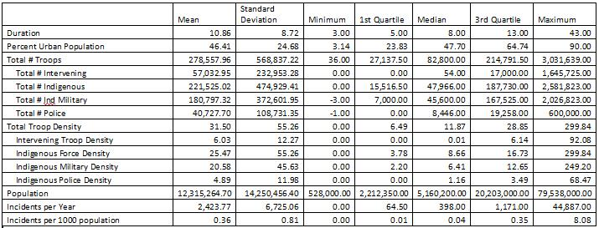

Notice that for both Total Troop Density and Incidents per 1000 population the mean is much greater than the median. Also note, the negative values indicate uncertainty about the completeness of the data. Here is the frequency of occurrence for several major categorization variables:

Occurrences of Terrain Classification
Code | Name | Description | Number of Insurgencies
1 | Desert | An extensive area that is largely uninhabited. Desert emphasizes lack of water; it refers to a dry, barren, treeless region, usually sandy. Deserts may include relatively flat, plain-like areas, or areas of rough or mountainous terrain. | 0
2 | Plains | An extensive, relatively level area of land. Plains are present on all continents except Antarctica and are most often located in the interior regions. Because they can occur at almost any altitude or latitude, plains can be humid and forested, semiarid a | 0
3 | Forested | A dense growth of trees, plants, and underbrush covering a large, relatively level area. | 0
4 | Jungle | A wild land overgrown with dense vegetation, often nearly impenetrable, esp. tropical vegetation or a tropical rain forest. It may be level, rough, or mountainous. | 2
5 | Rough | A steep or uneven area covered with high grass and brush. | 8
6 | Foliated Rough | As for rough; only covered with a dense growth of trees, plants, and underbrush. | 2
7 | Mountains | An area containing many mountains; having hills and crags; "hilly terrain." | 3
8 | Foliated Mountains | As for mountains; only covered with a dense growth of trees, plants, and underbrush. | 2
9 | Urban | An area characterized by extensive built-up areas as in cities, towns, suburbs, and the like. | 9
10 | Mixed | A mixture typically including two or more distinct, major areas consisting of desert, plains, jungle, rough, mountain, urban, and marsh. | 0
11 | Foliated Mixed | Is as for mixed; only covered with a dense growth of trees, plants, and underbrush. | 10
12 | Marsh | Is a tract of low wet land, often treeless and periodically inundated, generally characterized by a growth of grasses, sedges, cattails, and rushes. | 1

Occurrences of each Insurgency Type Classification
Code | Insurgency Type Name | Number of Insurgencies
1 | Anarchists | 0
2 | Egalitarians | 10
3 | Traditionalists | 4
4 | Pluralists | 1
5 | Apocalyptic-utopians | 0
6 | Secessionists | 15
7 | Reformists | 5
8 | Preservationists | 0
9 | Commercialists | 2

Occurrences of each Insurgent Strategic Approach
Code | Strategic Approach Name | Number of Insurgencies
1 | Conspiratorial | 1
2 | Protracted popular war | 15
3 | Military-focus | 13
4 | Urban warfare | 8

After compiling and reviewing our data, an issue arose concerning our chosen method of analysis, Bayesian networks. Our goal with the Bayesian networks was to train the networks using existing data. The result of this training would be a network with probability distributions that could then be used for predictive analysis. Unfortunately, the volume of data we had would not be able to adequately train the networks. The reasons for this are discussed somewhat in our later section on CART analysis, though they are worth mentioning here.

Suppose a child node has two parent needs, each parent having three possible values. The child itself has three possible values. For each combination of the parents, nine in total, a probability distribution would have to be specified. Given that we had just over 300 data points, each probability distribution would be described, on average, by about thirty-five data points. The probability distributions would be very sensitive to new data, the insights gained from using these distributions potentially invalidated due to new knowledge.

Now consider our more complicated networks, three or more parents for each child. The average sample size for each combination gets much smaller, very quickly. The insights from these networks would be even more sensitive to new data. We would not be able to make strong statements concerning the relationship between troops (as well as other variables) and violence.

Given this concern, we opted to turn our attention to exploring the data and trying to find some suitable regression model that we might be able to use for predictive analysis.

Regression and Scatter plot Analysis

The CAA database contains many data elements. Since an objective of the project was to predict how many troops are likely to be needed for a counterinsurgency mission given a particular operating environment, this analysis was an initial step to understand and determine the significant input variables in this data as predictors to violent incidents.

The inputs were of two different measurement types. All except the troop counts and percent urban population were qualitative. As an example, there were four categories representing the different strategic approaches of an insurgency—conspiratorial, protracted popular war, military focus, and urban warfare. These values were coded from 1 through 4. Similar coding was used to differentiate the categories in the other qualitative variables. None of these variables were of the ordered categorical type. The troop measurements were changed from the absolute number to a number per 1000 population similar to the violence variable.

A scatter plot matrix showing every pair wise plot between variables was performed. Given the number of variables it would be unworkable to show all these plots. Instead, only the scatter plot between the troop densities and violence variables are shown in Figure 4.

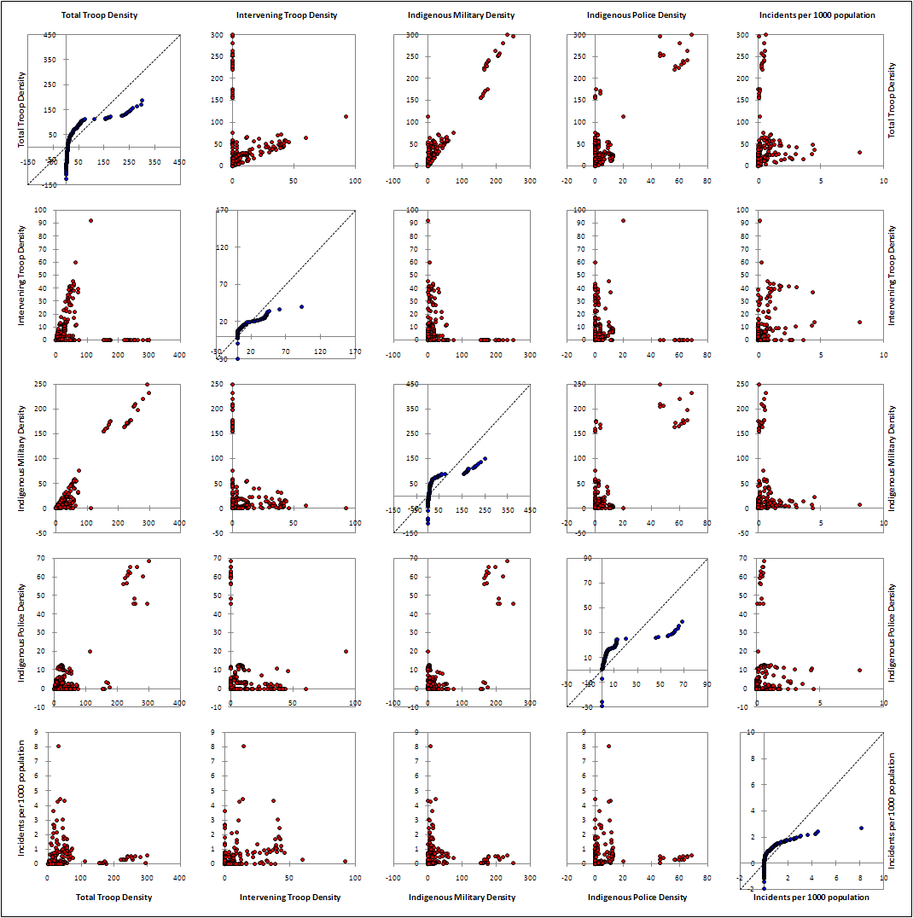
Figure 4: Scatter plot matrix of troop density and violence incidence data

As evidenced in these plots there is not a strong relationship between troop densities, independent of whether the forces are intervening or indigenous, and the incidence of violence. Even in the scatter plot with the categorical variables there did not appear to be any strong relationships with the incidence of violence. Some of this is explained in the preponderance of violent indecent data near 0 as seen in Figure 5.

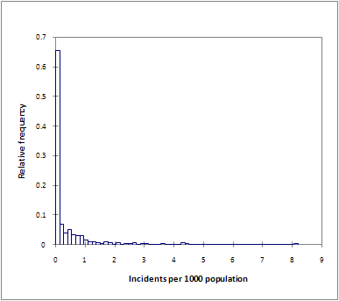
Figure 5: Histogram (Incidents per 1000 Population)

By transforming this variable into its natural logarithm, the data is much better scaled to the input variables and moreover can be described as being normally distributed. Still, as evidenced in the correlation matrix, there are not many strong correlations between the troop densities to the transformed violence incidents variable.

Proximity Matrix (Kendall Correlation Coefficient)
 | Total Troop Density | Intervening Troop Density | Indigenous Force Density | Indigenous Military Density | Indigenous Police Density | LN Incidents
Total Troop Density | 1 | 0.295 | 0.747 | 0.581 | 0.317 | 0.400
Intervening Troop Density | 0.295 | 1 | 0.030 | -0.050 | 0.015 | 0.185
Indigenous Force Density | 0.747 | 0.030 | 1 | 0.738 | 0.448 | 0.325
Indigenous Military Density | 0.581 | -0.050 | 0.738 | 1 | 0.171 | 0.216
Indigenous Police Density | 0.317 | 0.015 | 0.448 | 0.171 | 1 | 0.143
LN Incidents | 0.400 | 0.185 | 0.325 | 0.216 | 0.143 | 1

We broadened our search for variables significant to the prediction of violent incidents to include the qualitative type of data. A stepwise linear regression and analysis of covariance (ANCOVA) on both qualitative and quantitative variables was completed. At this point since it was more data exploration than learning through a linear regression model, the data was not randomly split into a training set and a test set. As noted earlier, all the cases were pooled, although at the risk of further increasing bias in this data set.

By including the qualitative data a much better fit of the data was obtained by applying least squares estimation. The estimates, errors, and upper and lower bounds are shown in Error: Reference source not found. For the variables considered significant, all, other than Primary Terrain Type 11, excluded zero in the bracket between the upper and lower bounds computed to the 95% confidence interval. The t-test can test the hypothesis whether a particular coefficient is zero. In this example, there are about 50 parameters, and the 0.025 tail quintile of the t-distribution with 284 degrees of freedom are plus or minus 1.97. So, a t-test score greater than 2 in absolute value indicates significance to the 5% level. Again, all the significant variables with the exception of the Primary Terrain Type 11 categorical one, have t-test scores greater than 2. The ones with the greatest effect are the categorical variables—Degree of Outside Support (Some Outside Support), O’Neill Classification (Traditionalist), and Primary Terrain Type (Foliated Mountains). The troop densities—Intervening Troops and Indigenous Police—were both considered significant. Lastly, the F statistic tests whether the coefficients of the dummy variables can all be set to zero.

The predicted output and comparing to its actual values, as shown in Figure 6, is quite reasonable. There were 13 instances of the standard residual greater than the absolute value of 2; however, in 307 data points this is within tolerance of 5%. Error: Reference source not found provides the goodness of fit statistics for this model. While this model predicts the output well enough, it does not lend itself to providing any insight into lead or lag variables to the levels of violence. Still, it helped answer the question of framing the environment and the nature of the insurgency with respect to violence in terms of providing a set of key variables for further data exploration and analysis.

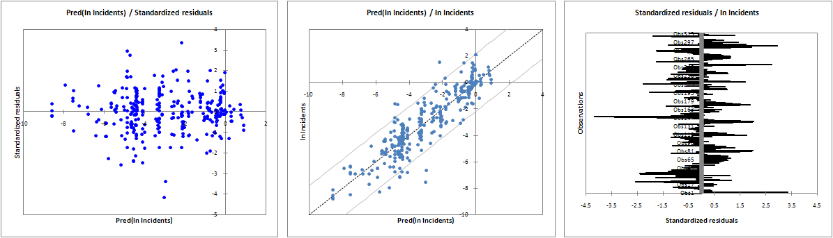
Figure 6: Predictions and Residuals

Model Parameters
Source | Value | Standard error | t | Pr > |t| | Lower bound (95%) | Upper bound (95%)
Intercept | -7.417 | 0.482 | -15.385 | < 0.0001 | -8.366 | -6.468
Total Troop Density | 0.000 | 0.000
Intervening Troop Density | 0.070 | 0.008 | 8.477 | < 0.0001 | 0.054 | 0.086
Indigenous Force Density | 0.000 | 0.000
Indigenous Military Density | 0.000 | 0.000
Indigenous Police Density | 0.067 | 0.010 | 6.647 | < 0.0001 | 0.047 | 0.087
Percent Urban Population | 0.050 | 0.005 | 9.217 | < 0.0001 | 0.040 | 0.061
O'Neill Classification-6 | 0.000 | 0.000
O'Neill Classification-2 | 0.000 | 0.000
O'Neill Classification-7 | 0.000 | 0.000
O'Neill Classification-4 | 0.000 | 0.000
O'Neill Classification-3 | -5.248 | 0.481 | -10.903 | < 0.0001 | -6.196 | -4.301
O'Neill Classification-9 | 0.000 | 0.000
Strategic Approach-4 | 3.924 | 1.512 | 2.595 | 0.010 | 0.948 | 6.900
Strategic Approach-2 | 0.000 | 0.000
Strategic Approach-3 | 0.000 | 0.000
Strategic Approach-1 | 4.848 | 0.701 | 6.916 | < 0.0001 | 3.468 | 6.228
Type of Insurgency (O'Neill classification)-6 | 0.000 | 0.000
Type of Insurgency (O'Neill classification)-2 | 1.156 | 0.283 | 4.083 | < 0.0001 | 0.599 | 1.713
Type of Insurgency (O'Neill classification)-7 | -1.409 | 0.499 | -2.823 | 0.005 | -2.391 | -0.427
Type of Insurgency (O'Neill classification)-4 | 2.752 | 0.683 | 4.027 | < 0.0001 | 1.407 | 4.097
Type of Insurgency (O'Neill classification)-3 | 0.000 | 0.000
Type of Insurgency (O'Neill classification)-9 | 0.000 | 0.000
Primary Terrain Type-9 | -4.406 | 1.471 | -2.995 | 0.003 | -7.301 | -1.510
Primary Terrain Type-5 | 2.156 | 0.464 | 4.649 | < 0.0001 | 1.243 | 3.069
Primary Terrain Type-6 | 2.143 | 0.442 | 4.846 | < 0.0001 | 1.272 | 3.013
Primary Terrain Type-11 | 0.428 | 0.300 | 1.430 | 0.154 | -0.161 | 1.018
Primary Terrain Type-8 | 6.434 | 0.646 | 9.963 | < 0.0001 | 5.163 | 7.705
Primary Terrain Type-7 | 0.000 | 0.000
Primary Terrain Type-4 | -2.208 | 0.388 | -5.697 | < 0.0001 | -2.971 | -1.445
Primary Terrain Type-12 | 0.000 | 0.000
Indigenous Government-2 | 0.000 | 0.000
Indigenous Government-1 | 0.000 | 0.000
Government-3 | 0.000 | 0.000
Government-2 | 0.000 | 0.000
Government-1 | -0.851 | 0.365 | -2.332 | 0.020 | -1.569 | -0.133
Rules of Engagement of Intervening Force-4 | 1.045 | 0.213 | 4.899 | < 0.0001 | 0.625 | 1.465
Rules of Engagement of Intervening Force-5 | 0.000 | 0.000
Rules of Engagement of Intervening Force-0 | 0.000 | 0.000
Rules of Engagement of Intervening Force-3 | 2.817 | 0.701 | 4.021 | < 0.0001 | 1.438 | 4.197
Rules of Engagement of Intervening Force-2 | 0.000 | 0.000
Degree of outside support for insurgency-2 | 3.206 | 0.260 | 12.308 | < 0.0001 | 2.693 | 3.718
Degree of outside support for insurgency-1 | 0.000 | 0.000
Degree of outside support for insurgency-3 | 0.000 | 0.000
Structure of the insurgency-1 | 0.000 | 0.000
Structure of the insurgency-3 | 0.000 | 0.000
Structure of the insurgency-2 | -7.030 | 0.720 | -9.770 | < 0.0001 | -8.446 | -5.614
Developed Nation-1 | 0.000 | 0.000
Developed Nation-2 | -1.322 | 0.263 | -5.037 | < 0.0001 | -1.839 | -0.806
Developed Nation-3 | 0.000 | 0.000
Political concept-2 | 0.000 | 0.000
Political concept-3 | 0.000 | 0.000
Political concept-1 | -2.011 | 0.305 | -6.597 | < 0.0001 | -2.612 | -1.411

Goodness of Fit Statistics
Observations | 307.000
Sum of weights | 307.000
DF | 284.000
R² | 0.800
Adjusted R² | 0.785
MSE | 1.199
RMSE | 1.095
MAPE | 73.137
DW | 0.914
Cp | -38.007
AIC | 77.924
SBC | 163.641
PC | 0.232

First Impressions
When looking at the aggregated troop density and violence by year, we found that the violence, on average, peaked in the 5th year of the insurgency, and the troop densities followed a similar pattern. After year twelve, the data is dominated by one or two cases, so no conclusions could be drawn about any long-term trends. The first year of the insurgency showed a higher troop density than we had anticipated, along with a lower level of violence. The model we (and our SMEs) anticipated was that the insurgency would start strong, with a high level of violence compared with a low troop density level, which would then enable the insurgency to gain traction. Instead we found, on average, that the troop density levels in the first year of the insurgency were higher than the second year, and the violence levels started low and increased until the 5th year of the insurgency.

Figure 7 Scaled Troop Density & Incidents

We found that the violence levels and troop density were roughly correlated, so we tried to determine when the violence was driven by troop density and when troop density was driven by violence. To do this, we measured the average change in violence as a percentage of the previous year’s violence, the maximum change in violence as a percentage of the previous year’s violence, and the minimum change in violence as a percentage of the previous year’s violence.

Figure 8 Mean Change in Violence
Figure 9 Maximum Changes in Violence
Figure 10 Minimum Changes in Violence

Based on these charts, we were unable to draw any direct conclusions regarding the causality of relationship between Troop Density and Violence. But notably, the first two charts display a pattern that could be researched further. If these metrics were modeled by a random variable, they would seem to be well modeled by an exponential distribution. Exponential random variable models several of our metrics very well, and would be a good place to start if one was creating a model of an insurgency. Taking the last chart as an example, if instead of the minimum percentage change in incidents, we graphed the minimum number of incidents per year of an insurgency; it would look like the chart below, which also could be modeled by an exponential random variable.

Figure 11 Incidents by Insurgency

CART Analysis
After the initial exploratory analysis, which included scatter plot matrices and a stepwise linear regression, we decided to delve further into the data and try to identify variables, or collections of variables, that have a functional relationship with violent incidents. One method we used was a Classification and Regression Tree (CART) analysis.

CART analysis partitions a collection of predictor variables with respect to a specified target variable. The result of a CART analysis is a tree. At each level is either an intermediate node, which specifies values of some predictor variable, or a terminal node which specifies a probability distribution of the target variable. The terminal node is described by the values associated with all of the intermediate nodes which precede the terminal node in the tree. In this way, CART analysis partitions the predictor variables and based on the partitions, describes a probability distribution of the target variable.

In an ideal data set, all of the values of the target variable could be uniquely described by some partition of the predictor variables. That is, the number of terminal nodes would correspond to the number of categories (or a mutually exclusive partitioning of the values of a continuous target variable), and at each terminal node, the probability of the described target value would be 100%. However, such an occurrence is rarely, if ever observed.

Real data generally does not behave in such a way that it can be neatly partitioned and described in clear and distinct ways. Bearing this in mind, it is worth discussing what a reasonable CART analysis would produce with respect to target variables.

As mentioned previously, an ideal CART analysis would have as many terminal nodes as values of categorical target variables, or some mutually exclusive partitioning of continuous target variables. Given this description, it is not unreasonable to expect that a CART analysis should have relatively few terminal nodes, and the probabilities for each terminal node should separate as much as possible potential values of the target variable. A CART tree with many nodes indicates a data set that is difficult to discriminate with respect to the target variable.

For our purposes, the predictor variables were: indigenous troop density, density of intervening troops, O’Neill classification, insurgent strategic approach, and the natural logarithm of the “current year’s” incident rate. The target variable was changes in violence from one year to the next. That is, if one year an insurgency exhibited two violent incidents per 1,000 population, and the next year, the violence was one incident per 1,000 population, the change in violence over that period was -50 percent or, for the purposes of our statistical analysis, -.5.

Since for the CART analysis we were concerned with relative changes in violence, our available pool of data was smaller than was used for the initial exploratory analysis. The data we had available included 274 consecutive-year changes in violence. For our initial analysis, the changes in violence were divided into seven bins, ranging from -.97 to 17.9. The seven bins and the number of occurrences slotted into each bin are detailed in the chart below.

Bin Min | Bin Max | Occurrences
-0.97 | -0.66 | 17
-0.66 | -0.33 | 40
-0.33 | 0 | 83
0 | 0.34 | 48
0.34 | 0.68 | 25
0.68 | 2.94 | 41
2.94 | + | 20

Since this analysis was exploratory in nature, we opted to use the entire data set, 274 occurrences, to train the classification tree. The analysis used a 10-fold cross validation to determine the optimal classification tree.

The tree resulting from the CART execution described above contained fifty-two terminal nodes. Our target, so to speak, was as close to seven terminal nodes as possible. Our training data set contained only 274 points, and 52 terminal nodes were needed to partition the target variables. This suggests that our target variable is not necessarily well described by partitioning the predictor variables. An example of the probability distribution of a terminal node with only six data points is found in the figure below.
Terminal Node 6
Class | Cases | Percent
1 | 0 | 0.0%
2 | 0 | 0.0%
3 | 1 | 16.7%
4 | 1 | 16.7%
5 | 1 | 16.7%
6 | 0 | 0.0%
7 | 3 | 50.0%
All | 6 | 100

It seems likely, given the small number of data points available, we separated the values of our target variable into too many bins. To check verify this we re-ran the CART analysis, using the same parameters and same predictors. Instead of seven target bins though, we chose two bins, negative changes and positive changes. The negative changes bin had 140 data points and the positive changes bin had 134 data points.

The results using this new bin scheme were no better than the results using seven target bins. The tree produced by the CART analysis had thirty-three terminal nodes or an average of just over eight occurrences per node. Any probability distribution based upon, on average, 8 data points would surely be sensitive to small changes in the data. For our analysis to provide definitive results, probability distributions cannot be overly sensitive to small perturbations in the data.

Rather than just accept that CART would not provide quality results, we opted to re-run the analyses described above. However, rather than using 10-fold cross validation to train the trees, we opted to randomly set aside one of every five data points as a test set. This set-aside group of data was automatically selected by the software.
The results of the CART analysis for the two target categories (positive and negative changes in violence) using the twenty percent set-aside as a test set yielded an optimal tree with thirty-nine terminal nodes, or roughly seven data points per terminal node. As with the trees above, the terminal nodes of this tree do not yield robust probability distributions.

However, when the CART analysis was run on the 274 points with seven values of the target variable, our results differed greatly from previous trees. The classification tree had six terminal nodes. On average, each terminal node had a probability distribution base on about forty-five data points. Relative to the trees discovered in our earlier analysis, the terminal nodes of this tree are much more robust; the probability distributions of the target variables at the terminal nodes are much less sensitive to changes in data than the distributions from previous trees. An example probability distribution of a terminal node from this tree is detailed below.
Terminal Node 6
Class | Cases | Percent
1 | 3 | 5.8%
2 | 5 | 9.6%
3 | 30 | 57.7%
4 | 4 | 7.7%
5 | 5 | 9.6%
6 | 3 | 5.8%
7 | 2 | 3.8%
All | 52 | 100

However, a classification tree is only useful if it can correctly predict the class of a test sample of data. Results from the classification are detailed in the two tables below.

Misclassification for Test Data

Class | N Cases | N Mis-classed | Pct Error
1 | 5 | 5 | 100.00
2 | 6 | 6 | 100.00
3 | 11 | 6 | 54.55
4 | 8 | 4 | 50.00
5 | 3 | 3 | 100.00
6 | 9 | 8 | 88.89
7 | 4 | 1 | 25.00

The results of the classification by the tree on the test data indicate that the classification tree does not predict well the class of the changes in violence.

It is interesting that by simply changing the way in which the CART analysis evaluates the quality if the tree (i.e. changing from 1-fold cross validation to set one in five aside) the results vary so greatly. With the same set of target variables, the seven categories of relative changes in violence, training the tree using the first method results in fifty-two terminal nodes, whereas training the tree using the second method results in only six terminal nodes. The act of partitioning our data is very sensitive to slight changes in initial conditions.

On one hand the classification trees we found had many terminal nodes and thus did not make strong statements about our target variables with respect to partitions of the predictor variables. The classification trees are sensitive to changes in the data. On the other hand, simply changing the method by which CART evaluates trees resulted in drastic changes in the number of terminal nodes. One method resulted in fifty-two terminal nodes, with each terminal node being very sensitive to changes in the data.

Another method yielded only six terminal nodes, each terminal node being considerably less sensitive to changes than the terminal nodes from the other tree. When the size of the trees and the sensitivity of the analysis to the training method are looked at together, it is obvious that occurrences of our target variable, relative changes in violence, are not clustered in such a manner that a partition analysis (CART) can predict well our target variable given the set of predictor variables we selected.

MARS Analysis
Our initial exploratory analysis of the data included analysis of covariance (ANCOVA) and stepwise linear regression. The stepwise linear regression on the natural logarithm of incidents per 1,000 population yielded an R-squared of .7. A review of the scatter plot matrix suggested that a non-linear model of some sort might be appropriate for predicting violence.

Multivariate Adaptive Regression Splines (MARS) performs a non-linear regression by means of piecewise linear regression in the variable space. The software fits “hockey stick shaped” basis functions between “knots” for different predictor variables. The basis functions describe the shape of the regression with respect to selected predictor variables, either in isolation, or with combinations (interactions) of predictor variables. The knots determine the points between which the basis functions have non-zero values.

For further exploratory purposes, we performed an initial MARS analysis with our target variable set as incidents per 1,000 population. The set of predictor variables were indigenous force density, intervening force density, terrain type (categorical), O’Neill classification (categorical), counter-insurgent rules of engagement (categorical), level of foreign support for insurgency (categorical), insurgent strategic approach (categorical), percent urban population, and type of government (categorical).

The regression model was internally trained using 10-fold cross validation. Since this initial analysis was exploratory in nature, we did not manually reserve any of the data for subsequent cross-validation.

The resulting model had an adjusted R-squared of .78. Of nine potential predictor variables, only six were active in the predictive regression model. The active variables were O’Neill classification, indigenous troop density, terrain type, counter-insurgent rules of engagement, intervening troop density, and level of foreign support for insurgency. The active values of the predictor variables are detailed in the table below.

Predictor Variable | Values in Model
O'Neill classification | 3,4,6
Indigenous Troop Density | 0-10.10
Terrain Type | 4,5,6,7,8,9,12
Counter-insurgent ROE | 2
Intervening Troop Density | 0-11.78
Level of Foreign Support | 2

The regression model resulting from the MARS analysis was:
-1.457 + 2.847*B1 - .297*B4 + 1.22*B5 – 3.045*B7 - .202*B10 + .972*B11 – 2.568*B13 + .884*B15
The basis functions are described in the table below.

Function Name | Functional Form
B1 | O'Neill Classification = 4 or 6
B4 | max(0,10.10-Indigenous Troop Density)
B5 | Terrain Type = 4, 7, 8, or 12
B7 | Counter-Insurgent ROE = 2
B10 | max(0,11.78-Intervening Troop Density)
B11 | Terrain Type = 5, 6, 8, or 9
B13 | O'Neill Classification = 3 or 6
B15 | Foreign Support for Insurgency = 2

A careful look at the basis function B4 and B10, coupled with their coefficients in the regression model suggest that no troops are better than some troops. The coefficients also suggest that terrain play some role in developing violence.
It should be noted, however, that this model is not definitive, nor did we test it on any “left-out” portion of our data. In reality, this model suggests what our previous data suggests regarding our target variable, violence, with respect to the predictor variables we selected. The data do not suggest any strong associations between violence and our predictor variables.

Given that our set of predictor variables does not seem to explain well violence, is it possible that some other variables can better describe violence? Perhaps the best predictor of future violence is current violence. The adage that “violence begets violence” certainly lends credence to such an argument.

With this reasoning in mind, we sought to model (in MARS) violence in the next year, measured as the natural logarithm of the number of violent incidents per 1,000 population, with respect to violence in the current year, measured in the same way. We also included as predictor variables foreign support for the insurgency, indigenous troop density, O’Neill classification, and insurgent strategic approach.

The MARS model was trained by randomly setting aside one out of every five records. This setting aside was done internally by MARS, not by a deliberate truncation of the data set. The model produced by MARS had an R-squared measure of .8. The regression model had two basis functions:

Function Name | Functional Form
B1 | max(0,PrevLog+8.822)
B2 | O'Neill Classification = 4, 6, or 7

The regression model was:

LogViolence = -8.11 + .825*B1 + .642*B2

This function suggests that as violence in the current year increases, violence in the subsequent year is likely to increase as well. To test the sensitivity of this model, we added another variable, percent urban population. The results were similar. Below is a list of the basis functions and the predictive model.

Function Name | Functional Form
B1 | max(0, PrevLog + 8.822)
B5 | max(0, 5.754- Indigenous Troop Density)
B6 | max (0,Percent Urban Population - 80.86)
B8 | Foreign Support = 2

LogViolence = -7.312 + .704*B1 - .0206*B5 - .747*B6 + .854*B8

In both models, the predominant variable was previous violence. This predominance suggests that the best predictor of future violence is current violence. Also, for relative violence levels whose natural logarithm is greater than -8.82 (relative violence equal to 1.47e-4), violence is likely to grow. The data do not bear this out entirely as more than half of our data points are drops in violence, though the notion that violence is to some extent a function of itself is not a wayward result. Also, the MARS model suggests that other variables have a role in either inhibiting violence or inflaming violence.

For countries with largely urban populations, violence tends to be lower. More specifically, as population composition shifts to urban populations composing more than approximately eighty percent of the population, violence falls. This suggests that some factor that differentiates urban populations from rural populations contributes to a propensity to engage in insurgent acts of violence.

Our MARS model suggests that insurgencies with foreign support of type “2” have higher violence. Within the CAA database, type “2” support is defined as some support. More specifically, insurgencies with type “2” foreign support receive monetary and training support, safe haven and supplies of materiel. However, this type of support does not include the provision of combat forces or insurgents.

The insurgencies for which incident data was available did not have a high rate of foreign support of type “3.” Type “3” support includes all support provided in type “2” as well as the provision of foreign fighters. Given that our model did not have instances of type “3” support available for training, we cannot dismiss the possibility that any foreign support, of type “2” or “3” would increase violence in an insurgency. Had we been able to test the model using a cross section containing all types of foreign support, we would have been able to make a more definitive judgment regarding the efficacy of provision of insurgent forces by foreign governments.

Finally, our model also contains a basis function that addresses indigenous forces. The function suggests that up to approximately 5.7 indigenous troops per 1,000 population, violence increases. It would be easy to remark that this suggests that more troops mean more violence. A more careful examination demonstrates the possibility that more troops does not mean more violence. Consider the situation where forces are not present and violence is occurring at a tremendous rate. Now suppose that indigenous troops are brought in to quell that tremendous violence. Within our data, this would appear as many indigenous troops and high violence. What is lost in this data is the presence of troops as a response to increased violence. Perhaps the presence of indigenous troops implies violence because the occurrence of the latter necessitates the former.

Considering the consistency of the model using the two approaches mentioned above, we then sought to validate the model by manually withholding a portion of the data, retraining the model and testing the retrained model on that withheld portion of data. We opted to set aside fifty-four records, or approximately twenty percent of our data sample to test the model.

To assess the quality of the regression model, we compared known values of the target variable for the fifty-four set aside records to values of the target variable predicted by the regression model. A scatter plot of the results is found below. The x-axis for the scatter plot is actual value and the y-axis of the scatter plot is the predicted value. Note that for a perfect predictive model, the slope of the line would be one, indicating no observed deviations in the predicted values from the actual values. Also note that the linear regression estimate included on the graph is not the best-fit line. Rather, the line on the graph is the regression with a forced y-intercept of zero.

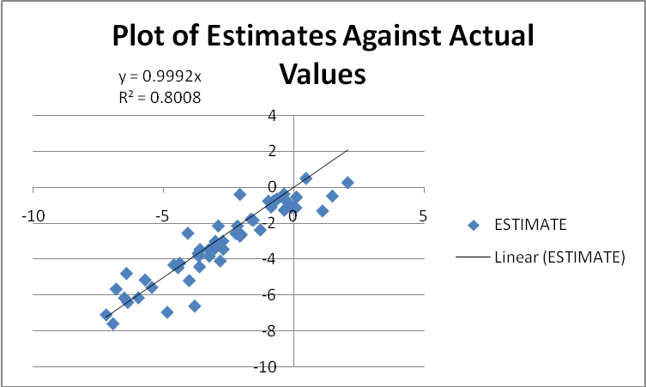
Figure 12 Plot of Estimates vs. Actual Values

As indicated by the equation for the fit line, the estimates correspond with nearly a unit slope to the actual values. The R-squared is approximately .8, indicating a good fit.
If we had not forced the y-intercept of the linear regression to zero, the results vary slightly.

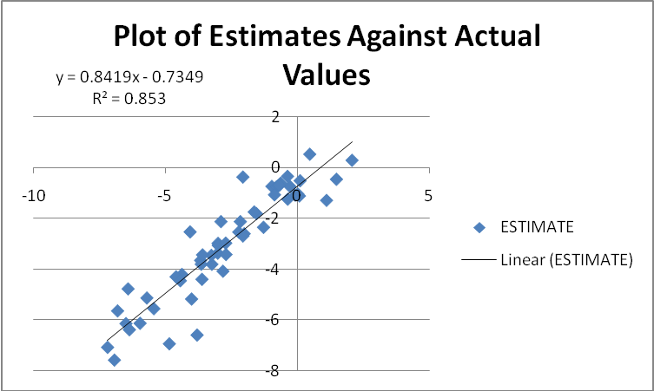
Figure 13 Plot of Estimates vs. Actual Values

In this case, the fit of the regression model is slightly better (.85 compared to .8). Nonetheless, it is difficult to reject the observation that a linear regression with nearly unit slope models well the relationship betweeen actual and predicted values.
To further analyze the predicted results, some summary analysis of the estimates was performed. The results are detailed in the chart below.

Max Error | Min Error | Mean Absolute Error | Mean Square Error
1.683491796 | -2.778205633 | 0.646543367 | 0.885780614

A histogram of the errors is detailed below.

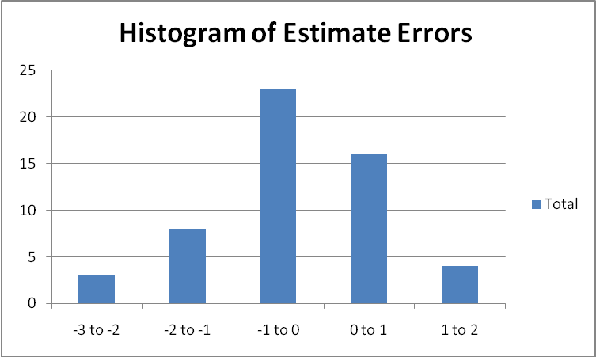
Figure 14 Histogram of Errors

The histogram of the errors appears similar to a Gaussian distribution. This histogram suggests that the errrors are approximately normally distributed.
A Q-Q plot of residual quantiles to standard normal quantiles as well as a scatterplot of residual as a function of actual targetg values are depicted below.

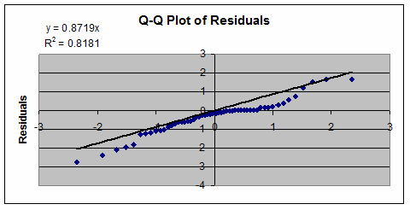
Figure 15 Q-Q Plot of Residuals

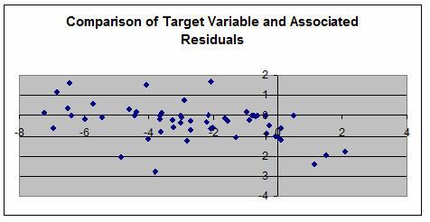
Figure 16 Comparison of Residuals

The quantiles of the residuals exhibit an approximately linear relationship with the quantiles associate with the standard normal distribution. The residuals do not appear to exhibit any functional relationship with the values of our target variable. This suggests that our residuals are in fact random and normally distributed.

The quality of the estimates with respect to the actual values coupled with the distribution of the errors suggest that the regression model created in MARS is a good piecewise linear model of our target variable, the natural logarithm of the relative rate of violent incidents, with respect to the predictor variables mentioned above.

It is worth noting, however, that the errors are in the natural logarithm of the relative rate of violent incidents. If we transform the errors, the range of variation shifts from [-3,2] to [e⁻³,e²] or approximately [.05 ,7.39]. The transformed errors are much larger than the logarithmic errors because rather than the error being ‘x – y’, the error is e^{x}-e^{y}.

Observations, Conclusions and Next Steps

Making judgments from historical perspective can be difficult, especially when comparing the insurgencies of today with those of the past. In this analysis, we considered each of these insurgencies essentially equal. Moreover, we considered each data point from all of the insurgencies independent. In doing so, we greatly simplified our model, minimizing the interactions among what could be considered key variables and the multi-dimensional nature of insurgencies. Instead of aggregating data, a more practical approach may be a time-series analysis to better understand the lead and lag among the inputs of troop densities and the outcome of violent incidence. Our MARS model does bear out a time relation between violence rates in consecutive years. This relationship does indicate that a logical next step in this analysis would be a time series analysis.

In both the initial data exploration and the MARS analysis, troop density was positively correlated to violent incidents. In the initial stages of the project, it was thought there would be a negative correlation between the viability of an insurgency and the size of the force countering it. But, in hindsight, these two variables are generally positively correlated. In the face of deteriorating security conditions as measured by increased attacks against the populace, restoral of services will not occur without an increase in security forces. As conditions improve, it is expected that the security forces would withdraw. We are not suggesting causality between these variables, as it seems that there are many underlying factors—for many of which we did not have data. Development of a much more nuanced model of the causes and cessation of violence in insurgencies would be a beneficial task.

While we were ultimately unable to identify any predictive relationship between troops and violence, we were able to identify other factors that impact violence. Chief among these factors are foreign support for insurgency, which increases violence, and population composition, with larger urban populations exhibiting less violence.

It might appear common-sense that foreign meddling would increase violence. However, just as we were not able to identify a relationship between troop density, which includes the provision of foreign intervening counter-insurgent forces, it might not necessarily be the case that simply funding, training and equipping an insurgent force would result in more violence. However, our analysis does support the notion that insurgencies supported by foreign agents do, in fact, exhibit higher rates of violence.

One possible explanation for this exhibition of violence lies in the relationship between supporter and supported. It may be that foreign nations provide support in instances where the supporting nation has an interest in the outcome of the insurgency or potentially stands to benefit from the conditions created by rampant violence. Given that the support might be offered in exchange for creating chaotic conditions, it is no surprise that those being supported by the insurgents would oblige their supporters by engaging in campaigns of violence.

This propensity for increased violence when foreign support for insurgents is present does suggest a potential course of action for reducing violence. By engaging the supporting nations diplomatically, it might be possible to offer the supporting nation benefits that outweigh the benefits of their support for insurgency, in exchange for the cessation of that support.

It is interesting that in the beginning of this project, we sought to determine how many troops it takes to lower violence. While the efficacy of troops in reducing violence is unclear, it is clear that reducing foreign support would go some way toward reducing violence. This is not to suggest that force plays no role in reducing violence, only that any effects of force on reducing violence are not immediately clear, and not supported by this particular analysis on this particular collection of data.

The CAA database did not provide any measure of the quality of a soldier. In this study the soldier quality is assessed as being equal for all operational forces. Nor was any data available that quantifies, much less qualifies, the training level of the troops involved in the insurgencies studied.

While the categorical variable “Rule of Engagements of Intervening Force” was considered in the data exploration and analysis, the classification of this variable did not provide sufficient insight whether troops actually adhered to the rules. O’Neill cites two examples from the 1980’s—Sri Lanka and Peru—in which the armed forces were responsible for large-scale violence against civilians.

One of the more interesting insights from our analysis was the relationship between urban population and violence. It appears counter-intuitive that higher urban populations would exhibit lower rates of violence in insurgency. After all, in many of the nations where much of the population lives in urban areas, these populations are not affluent; the populace in these urban areas tends to be poor, living in relative squalor, in conditions that are often cited as being fruitful recruiting territory for insurgents. The conventional wisdom is that disaffected people are more likely to become insurgents than those that are relatively well off.
In discussions with our stakeholder, COL Manago, a possible explanation for this seeming counter-intuitive result was suggested. The suggestion concerns the different lifestyles of urban and rural people. It was suggested that generally speaking, rural populations are much more self-sufficient than urban populations. Urban populations rely on public transit, on the local supermarket, for provisions; rural people provide for themselves, farming the land, creating what they need to survive. Thus, urban populations are more able to be controlled. By controlling the supply of essential goods and services, i.e. waste collection, electricity, food and water, to name a few, to urban populations, governments can exhibit some level of control over the action of the people. In particular, a government that is able to provide these basic needs is better able to control its urban populations. By the same token, an opportunistic insurgent could at once disrupt the supply of essential services and then fill the service gap created by their own disruptive activities. This would serve to both discredit the governments ability to provide security and services and gain some level of control over the population by then providing these lacking service, albeit for a much more violent end than would typically be sought by the standing government using the same means. This allegiance to whomever can provide goods and services supports the notion that the populace is a strategic center of gravity for both insurgents and counter-insurgents. Counter-insurgency may well be best won by winning “hearts and minds.”

Appendix A: Work Breakdown and Earned Value Management
This is the work breakdown used to track the progress of this project:
Project Proposal | 2/7/2008 | 2/14/2008 | 52.00
Prototype 1 | 2/7/2008 | 2/21/2008 | 100
Data Collection | 2/7/2008 | 2/21/2008 | 20
Basian Network Development | 2/7/2008 | 2/21/2008 | 20
Stochastic Analysis | 2/7/2008 | 2/21/2008 | 20
Deterministic Analysis | 2/7/2008 | 2/21/2008 | 20
Final Analysis | 2/7/2008 | 2/21/2008 | 20
Prototype 2 | 2/21/2008 | 3/20/2008 | 100
Data Collection | 2/21/2008 | 3/6/2008 | 20
Basian Network Development | 2/21/2008 | 3/6/2008 | 20
Stochastic Analysis | 3/6/3008 | 3/20/2008 | 20
Deterministic Analysis | 3/6/3008 | 3/20/2008 | 20
Final Analysis | 3/6/3008 | 3/20/2008 | 20
Prototype 3 | 3/20/2008 | 4/17/2008 | 100
Data Collection | 3/20/2008 | 4/3/2008 | 20
Basian Network Development | 3/20/2008 | 4/3/2008 | 20
Stochastic Analysis | 4/3/2008 | 4/17/2008 | 20
Deterministic Analysis | 4/3/2008 | 4/17/2008 | 20
Final Analysis | 4/3/2008 | 4/17/2008 | 20
Final Report | 3/13/2008 | 5/1/2008 | 117.00
Produce draft report | 3/13/2008 | 4/17/2008 | 52.00
Revise report | 4/17/2008 | 5/1/2008 | 26.00
Submit final report | 5/1/2008 | 5/1/2008 | 26.00
Produce Website | 2/1/2008 | 5/8/2008 | 13.00
Briefings | 2/7/2008 | 5/9/2008 | 78.00
Develop Final Briefing | 4/18/2008 | 4/24/2008 | 15.60
Rework Final Briefing | 4/24/2008 | 5/8/2008 | 15.60
Practice Final Briefing | 4/24/2008 | 5/8/2008 | 15.60
Briefings to Col. Manago | 2/7/2008 | 5/9/2008 | 15.60
Briefings to Class | 2/21/2008 | 5/9/2008 | 15.60

The PEACE project used a highly iterative process which involved frequent presentations to our clients at CAA; the feedback and guidance we received in return was crucial to guide the evolution of the project.

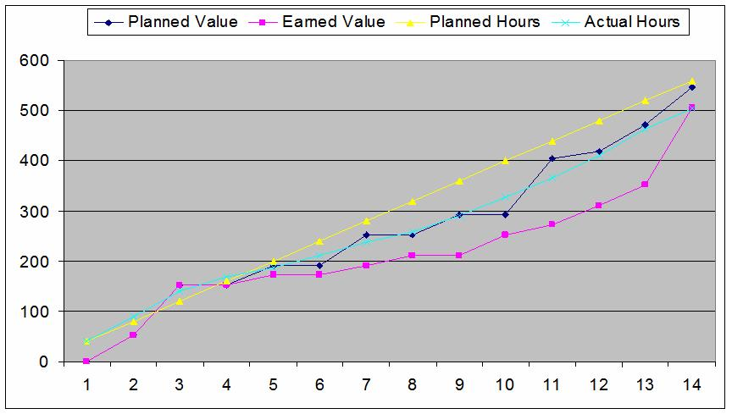
Figure 17 Project Tracking

In Figure 7, Planned Value and Planned Hours were project at the beginning of the project. Earned Value and Actual hours where accrued as the project evolved. An examination of Figure 7 shows our actual totals ended up slightly lower than the projected values. A 0/100 policy (0 credit accrued until the task is 100% complete) was used to track progress.

Bibliography

Field Manual 3-24. Counterinsurgency. Headquarters, Department of the Army, Washington D.C., 2006.

Galula, David. Counterinsurgency Warfare: Theory and Practice. Westport, CT: Praeger Security International, 2006.

Laskey and Mahoney. “Network Engineering for Agile Belief Network Models”, IEEE Transactions on Knowledge and Data Engineering, Vol. 12, Issue 4 – July/Aug 2000.

McGrath, John J. “Boots on the Ground: Troop Density in Contingency Operations.” Ft. Leavenworth, KS: Combat Studies Institute Press, 2006.
Available online at: <http://cgsc.leavenworth.army.mil/carl/download/csipubs/mcgrath_boots.pdf>

O’Neill, Bard E. Insurgency and Terrorism: From Revolution to Apocalypse. Washington, D.C.: Potomac Books Inc., 2005.

Quinlivan, James T. “Force Requirements in Stability Operations.” Parameters: United States Army War College Quarterly, Winter 1995.
Available online at: <http://www.carlisle.army.mil/usawc/parameters/1995/quinliv.htm>

Quinlivan, James T. “Burden of Victory: The Painful Arithmetic of Stability Operations.” Rand Review: Summer 2003.
Available online at: <http://www.rand.org/publications/randreview/issues/summer2003/burden.html>

Galula, David. Counterinsurgency Warfare: Theory and Practice. Westport, CT: Praeger Security International, 2006
Field Manual 3-24. Counterinsurgency. Headquarters, Department of the Army, Washington D.C., 2006.
Field Manual 3-24. Counterinsurgency. Headquarters, Department of the Army, Washington D.C., 2006.
Quinlivan, James T. “Force Requirements in Stability Operations.” Parameters: United States Army War College Quarterly, Winter 1995.
Quinlivan, James T. “Force Requirements in Stability Operations.” Parameters: United States Army War College Quarterly, Winter 1995.
McGrath, John J. “Boots on the Ground: Troop Density in Contingency Operations.” Ft. Leavenworth, KS: Combat Studies Institute Press, 2006.
Laskey and Mahoney. “Network Engineering for agile Belief Network Models”, IEEE Transactions on Knowledge and Data Engineering, Vol. 12, Issue 4 – July/Aug 2000

