Optimization of Airline Flight Cancellation Decisions Project Proposal

Mona Kamal
Mary Lee
Brittlea Sheldon
Tom Van Dyke
Bedis Yaacoubi

OR 680
Capstone Project Course
2/14/2008
Background
With the number of flights traveling throughout the United States today, it is inevitable that schedule changes must be made. Flights are typically scheduled months in advance, taking many factors into consideration. Crew member schedules, air space, gate availability, as well as many other factors are essential constituents used to determine an optimal flight schedule given the projected information. Despite careful planning, delay or cancelation decisions must be made due to weather conditions, ground traffic at each airport, airport infrastructure construction, and other flight delays.
For the scope of our project, only flight cancelations will be considered. One example of a case in which a departing flight must be cancelled would be in the case of a mechanical problem. In this case, that airplane would be removed from service and the airline may decide which canceled flight would be the least disruptive to the overall daily schedule. On the arrival end, sometimes it is necessary to cancel incoming flights (before they have departed from the origin airport) because an airport is overscheduled and cannot accommodate each incoming flight. In each of these scenarios, the flight schedule must be examined to determine the relative impact of the options for flight cancellation.

Airline Operations controllers (AOC) adjust flights schedules dynamically throughout the day. This adjusting process is, however, based to a great extent on controllers’ intuitions and acquired domain knowledge. Therefore, a more sophisticated strategy for schedule recovery is needed to optimize the controllers’ decisions and therefore avoid unnecessary costs to the airline. Once this system is implemented, controllers will have access to an automated decision support tool allowing them to reach Optimal judgments.

Problem Statement
Given a network itinerary for an airline, the team will determine the down path impact of canceling a scheduled flight. The team will develop an algorithm/tool to prioritize flights to be cancelled by minimizing the airline’s downstream schedule disruption.

Preliminary Requirements/Scope
The team will begin by examining the connectedness of each flight in a one-day schedule for a single airline by considering each destination-origin leg as the connection criteria. After examining the data, the team will refine the definition of connectedness. The team will focus on the planned schedule vs. the actual (real time) schedule to provide a tool for optimizing cancellation decisions. The main objective while cancelling flights will be minimizing the overall network disruption.

Technical Approach
The team will write a Visual Basic program to take a one-day schedule for a single airline and identify flights arriving at an airport within a two hour time window before the departure of another flight from that same airport and indicate that they are connected. In the end, a value will be provided for each flight that indicates the number of future flights to which it has direct and indirect connections. The team will use the resulting values to determine “connectedness” between flights coming after it. A network will be produced to indicate which flights will cause a greater disruption for future flights if cancellations occur.

Throughout the stages of the project, the team will be enhancing the definition of connectedness as well as focusing on a specific and realistic airline’s strategy. Space, time or class identification diagrams will be used to analyze how changing the definition of a connecting flight may alter the results. It is anticipated that many of the earlier flights will have connections to most of the later flights. Therefore, a sensitivity analysis will be conducted to formulate the most realistic definition of a connecting flight. The sensitivity analysis will include an examination of the connection window time by increasing it from 2.0 hours to 2.5, 3.0, 3.5 and 4.0 hours. We will also change the analysis assumption by only including a fraction of the flights that depart within the connection window as connections rather than all of them.

Once a realistic method for determining connectedness has been established, the disruption index will be formulated. The disruption index will specify the estimated magnitude of disruption for a specific flight cancellation to the overall system for the rest of the day. The greater the value of the disruption index for a flight, the greater the affect the cancellation of that flight will have on the schedule for the rest of the day. The indices will most likely have a direct relationship to the connectedness values attained earlier. The method for attaining connectedness values will be used as a starting point in developing a generic method for formulating disruption indices that can be provided to any flight on any airline given the details of this flight.

Once the disruption indices are developed, they can be implemented in integer programs to determine which flights cancellations are likely to cause the least disruption. The structure of the integer program is still not definite and will probably change based on the results in the first part of the project. The anticipated program will consist of an objective function minimizing the overall disruption in the system. A binary variable will be used to determine whether a flight will be canceled (1) or not (0). The objective function will consist of the sum of the products of the disruption index for each flight multiplied by this binary variable. The constraints will include the number of flights that must be canceled to satisfy scheduling constraints, possibly the number of passengers on the flight, the size of the aircraft and other factors that are yet to be determined. As previously mentioned, the construction of the program will not be finalized until the data has been analyzed and the results have been obtained.

Expected Results
At the conclusion of this project, we aim to have an algorithm/tool that any airline can easily use to optimally determine which flights to cancel, given flight schedule restrictions.

Initial Project Plan
To complete this project in the allotted time frame, a schedule has been constructed with the breakdown of the tasks and expected start and completion times (Figure 1 below).
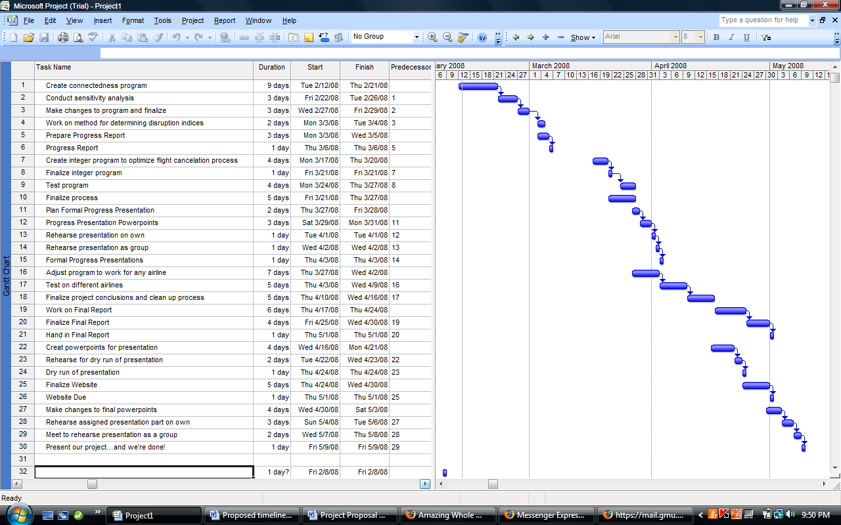
Figure 1: Schedule of tasks to be done to complete the flight cancellation project

Although most of the tasks will be completed by all the team members, task leads have been assigned. Thomas Van Dyke will take the lead role in creating the program to come up with the connectedness values. Mary Lee will be working closely with him since they both have a strong programming background. In addition, they will both be creating the project website, with Mary Lee taking the lead in this case. Bedis Yaacoubi will take the lead in managing the project and assuring effective communication with our sponsor. He will also look into factors that may not have been considered initially to include within our final definition of connectedness as well as factors to include in the integer program constraints. Both Brittlea Sheldon and Mona Kamal will work simultaneously in creating the integer program and testing its effectiveness. They will also be working together on the initial drafts of the final paper and presentations throughout the semester. An hourly breakdown of the tasks has also been produced (Figure 2) to be used to create earned value management charts once the project has been completed. The approximate times in the chart are the sums for all team members working on the each task. Figure 3 below also shows the work breakdown schedule.
Task | Hrs | Task | Hrs | Total
Create connectedness program | 50 | Formal progress presentation | 30 | 582
Conduct sensitivity analysis | 25 | Adjust program to be more generic | 40
Make changes to program and finalize | 15 | Test on different airlines | 25
Work on method for determining disruption indices | 15 | Finalize conclusions and process | 30
Prepare progress report | 20 | Work on final report | 35
Progress report presentation | 10 | Finalize report | 15
Create integer program | 40 | Create PowerPoint presentation | 15
Finalize integer program | 25 | Rehearse for dry run of presentation | 15
Test program | 15 | Dry run presentation | 30
Finalize process | 20 | Finalize website | 10
Plan formal progress report | 30 | Make changes to PowerPoint | 10
Progress report presentation | 20 | Rehearse assigned presentation part on own | 10
Rehearse presentation on own | 2 | Rehearse as group | 20
Rehearse as group | 5 | Present | 5

Figure 2: Hourly breakdown of tasks needed to complete project

Figure 3: Work breakdown schedule for tasks to be completed

