Cancellation Disruption Index Tool (CanDIT)

Mona Kamal
Mary Lee
Brittlea Sheldon
Thomas Van Dyke
Bedis Yaacoubi

Sponsor: Center for Air Transportation Systems Research (CATSR)
Sponsor Contact: Dr. Lance Sherry

George Mason University
Spring 2008
Table of Contents

Executive Summary………………………………………………………………….
Introduction
Background
Problem statement
Proposed Solution
Study Objectives
Operational Concept
Scope
Methodology
General Method
Method Part 1: Defining and refining connectivity factors
Method Part 2: Calculation of the passenger reassignment factor
Method Part 3: Formulating the disruption index
Results & Sensitivity analysis
Results for 100% connectivity
Sensitivity analysis, increasing the connectivity window
Results for connectivity, considering the % connectivity
Analysis of passenger reassignment factor
Final decision making tool
Functionality Test
Conclusions
Summary of work
Recommendations Future work
Appendices
Appendix A: Integer program
Appendix B: Data compilation tool
Appendix C: Visual Basic code
Appendix D: Project Management (WBS, Gantt chart schedule, EVM, Roles & responsibilities
Key Terms and Acronyms
References
EXECUTIVE SUMMARY
Despite careful planning, changes must be made to airport schedules due to weather conditions, ground traffic at each airport, airport infrastructure construction, and other flight delays. Currently, Airline Operations Center (AOC) dispatchers make these decisions based on examining flight schedules, and are limited to viewing a snapshot of the network per page. The decision is ultimately based upon the dispatchers’ intuition from prior experience. This decision making mechanism may lead to inefficiencies or challenges in the future, especially when it comes to training new dispatchers with less of the intuitive network knowledge which may take years to develop. A cancellation may disrupt the flight schedule for the remainder of the day and also cause inconvenience to passengers, as well as incurring other costs to the network.

Our Study Group used a single day’s flight schedule to develop a methodology for calculating network disruption based on the number of flights that could be affected later in the day and on the ease of reassigning passengers to other flights. We began by examining network connectivity. The Study Group calculated connectivity factors by determining the later number of flights a designated flight is connected to. This was done by defining connection windows and counting the number of flights departing within each connection window. We also calculated a passenger reassignment factor to determine the difficulty of reassigning passengers to other flights, based on the ratio of passengers on the cancelled flight to the number of available seats in flights of the same origin-destination pair. The connectivity factor and passenger reassignment factor were combined in a weighted equation to calculate the disruption index.

By determining the disruption indices, flights may be ranked to prioritize for cancellation. Flights with high disruption indices would be highly recommended against cancellation, while flights with low disruption indices would be less disruptive to the schedule to cancel, and therefore would be the first chosen. Our final product was an automated decision support tool that will use a single day’s flight schedule to calculate disruption indices and prioritize flights for cancellation based on the user designated constraints which may include: departure time, arrival time, destination, or origin.

INTRODUCTION
Background
With the number of flights traveling throughout the United States each day, it is inevitable that schedule changes must be made. Flights are typically scheduled months in advance, taking many factors into consideration. Crew member schedules, air space, gate availability, as well as many other factors are essential constituents used to determine an optimal flight schedule given the projected information. Despite careful planning, changes must be made to these schedules due to weather conditions, ground traffic at each airport, airport infrastructure construction, and other flight delays.
Problem Statement
Airline Operations Centers (AOCs) adjust flight schedules dynamically throughout the day. “To protect system balance of the original schedule, they may have to intentionally delay large numbers of flights and cancel flights that could be operated” (p. 410). This adjusting process is based to a great extent on AOC dispatchers’ intuition and acquired domain knowledge. The decision must be made by AOCs in a limited amount of time. This decision process is complex due to the large number of flights to consider and the short period of time in which the decision must be made. A longer decision process increases the potential for further delays or cancellations downstream. A more sophisticated strategy for schedule recovery is needed to aid the AOC dispatchers’ decisions and therefore reduce unnecessary costs to the airline.
Proposed Solution to the Problem
The Study Group proposed to develop a decision support tool to compare the disruption caused by canceling different flights. This tool would take into account a single day’s schedule to aid AOC dispatchers in their cancellation decisions.
Study Objectives
The Study Group planned to examine the potential disruption caused by flight cancellation and develop a tool to prioritize flights based on disruption for cancellation decisions. The disruption was to be based on a single day’s flight schedule and the potential impact a cancelled flight could have on passengers connecting to flights and the reassignment of passengers to different flights.

Operational Concept
Flight cancellation was to be considered in the context of two possible scenarios. In the first case, a departing flight must be cancelled due to a mechanical problem. In this case, the decision to cancel a flight is initiated by the airline. The airline may compare all departing flights within a specified time range and decide which flight would be the least disruptive to the airline’s schedule if cancelled. In this case, the airline may consider other flights of comparable aircraft size at the same airport to cancel, rather than cancelling the flight scheduled to use the plane with the mechanical error.

In an example scenario examining arriving flights, it is sometimes necessary to cancel incoming flights (before they have departed from the origin airport) because an airport is overscheduled and cannot accommodate each incoming flight. “When weather conditions deteriorate, the Federal Aviation Administration (FAA)…may determine that the number of planned arrivals at an airport will exceed the airport’s capacity…The FAA sends messages to all system users (i.e. airlines) specifying the (revised) arrival rates and arrival times…This usually leads to excessive delays for a large number of flights…If an airline cancels a flight, it is allowed to give the allocated time slot of the canceled flight to another of its flights which will arrive later…thus reducing its delay…This process is called slot swapping” ¹(p. 408). Therefore, the airline is able to restore the current schedule as close to the initial planned schedule as possible and choose less disruptive flights to eliminate.

In each of the example flight cancellation scenarios, the flight schedule must be examined to determine the relative impact of each option for flight cancellation. Given a network itinerary for an airline, the team intended to determine the down path impact of canceling a selected flight. The team also worked to develop an algorithm/tool to prioritize flights to be cancelled based on minimal disruption of the airline’s downstream schedule.

SCOPE
The Study Group’s focus involves two disruption factors. The first factor is the effect a canceled flight could potentially have on other flights the same day. The second is the need to reassign passengers on a canceled flight to other flights later on that same day. The Study Group limited the calculation to data for the same day of the canceled flight and not subsequent schedules.

METHODOLOGY
General Methodology
The Study Group developed a methodology to determine the potential disruption canceling a flight may have on flights later in the day. Two metrics of disruption were used: a connectivity factor and a passenger reassignment factor. To compare the impacts of canceling various flights, the Study Group first decided it was necessary to determine the impact a single flight cancellation would have on an airline’s schedule for the remainder of the day (connectivity factor). Secondly, the Study Group examined how passengers would be affected in general by the cancellation of a single flight, and how they would have to be rescheduled (passenger reassignment factor). The connectivity factor and passenger reassignment factor were combined to develop a broad based disruption index tool which could then be modified and used for any airline. A higher value of the disruption index indicates that a flight has a higher impact on flights departing later in the day, ranking the flight as higher priority such that cancellation should be avoided if possible. An overview of the proposed decision making process implementing our decision tool is displayed below in Figure 1 for each of the previously mentioned cancellation scenarios.

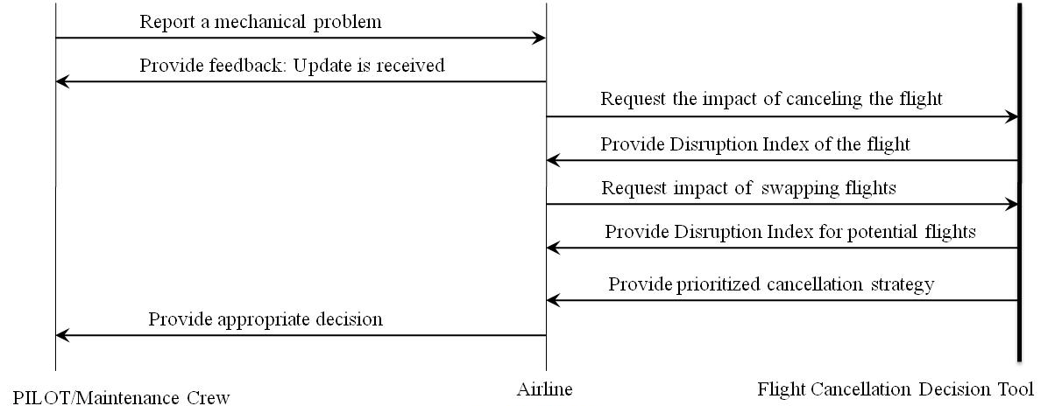
(a)
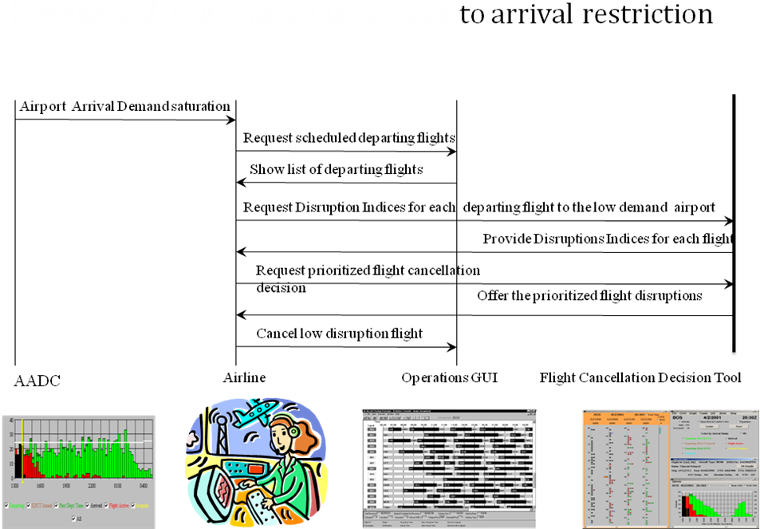
(b)
Figure 1. Proposed cancellation process when a departing flight must be cancelled due to (a) mechanical problems and (b) arrival restrictions

Methodology Part 1: Defining and Refining Connectivity Factors
The Study Group began by investigating a broad schedule-based definition of connectivity. A flight tree is developed to show connections to departing flights in a designated time window at the arrival airport. This definition counts the number of connecting flights in a flight tree. This connectivity time window was defined using a minimum value for connections considering that passengers must be able to physically transfer from one flight to another. The maximum connection time was also varied to determine a realistic connection window and to perform sensitivity analysis. This definition would be appropriate under the assumption that at least one passenger or crew member will connect to one of the flights within the specified time period. By configuring this flight tree, the Study Group’s intention was to determine the number of down-path flights that could potentially be impacted by the cancellation of a single flight. Figure 2, below, depicts a Space-Time diagram used to develop Connectivity Factors.
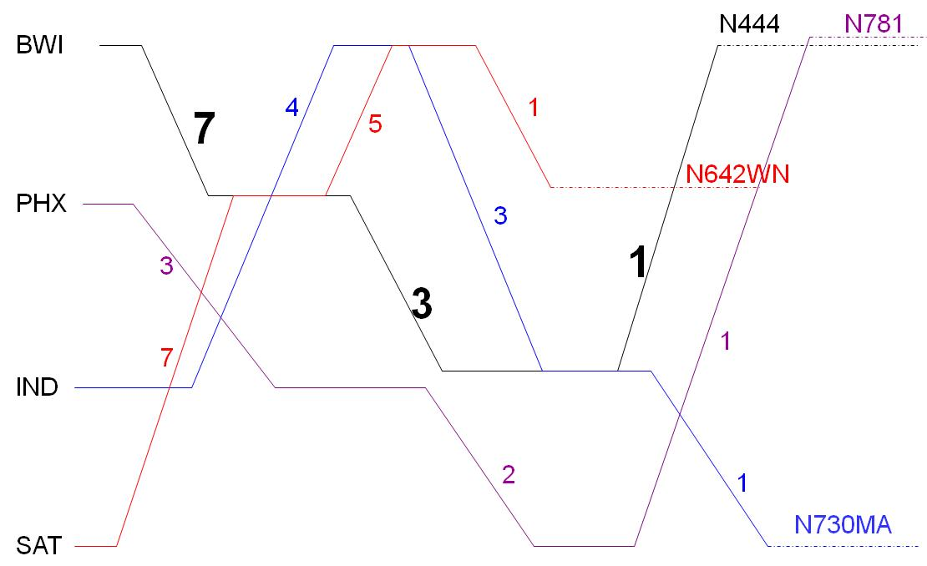
Figure 2. A Space-Time Diagram Depicting the Connectivity Factors of Flights

Figure 2 depicts the connectivity factors for each flight leg. The early flight departing from BWI, arriving at PHX has a connectivity factor of 7. This connectivity factor counts connecting flights as the three legs of the same tail number (from BWI to PHX, from PHX to IND, and from IND to BWI), two flights connecting to those legs (PHX to BWI and IND to SAT), and two flights connecting to the other connecting legs (BWI to IND and the later flight from BWI to PHX).

A Macro was developed using Microsoft Excel 2003 which allows the user to select a time window after a flight arrival to consider as connecting flights. The Macro counts all the connecting flights to each scheduled flight to obtain the initial connectivity factors for each flight. The Study Group’s intent in comparing different connection windows was to determine which window represents the most realistic definition of a connection window, for analysis purposes, and whether some ranges could be eliminated based on unreasonable results. This Macro will also allow different airlines to designate a connection window suited to their systems. In this Study, one window was ultimately used for analytical purposes, with the understanding that an airline may change this based on its system. The different ranges considered for connection windows in the sensitivity analysis are provided in Table 1. The minimum time was chosen to be 45 minutes for all connection windows as the minimum amount of time it would take for passengers to physically transfer at the airport. The maximum values were varied between 120 minutes and 240 minutes to cover a broad range of potential connection windows.

Table 1. Connection Windows
Minimum Time (Minutes) | Maximum Time (Minutes)
45 | 120
45 | 150
45 | 180
45 | 210
45 | 240

To refine the definition of connectivity, the Study Group decided to include other factors in the calculation of connectivity. The Study Group realized that often the departure of a plane to its next destination did not fall within the designated connection windows. Many planes are scheduled to depart again within 20 minutes of their arrival while a few remain at an airport past the designated transfer period. Including the flight path of the same aircraft is essential to attain an accurate and realistic definition of connectivity. The algorithm was therefore altered so that flights with the same tail numbers (i.e. same aircraft) were always considered to be connecting regardless of their next departure time.

As noted above, our initial definition of connectivity implicitly assumed that each flight departing from the airport within the specified time window was considered to be a connection. In reality, only some of these flights carry passengers or crew from the arriving flight. Some airports are major connecting airports, while others are usually a passenger’s final destination. In an attempt to make the definition of connectivity more realistic, a percentage of potential connecting flights was considered based on research findings. Additionally, the assumption that crew members connect to departing flights within the designated time window was relaxed. The original 100% connectivity factors provide an upper bound for analysis purposes.

Airline analyst Darryl Jenkins conducted a study on the connection trend of passengers on Southwest Airlines in 2002. He calculated the percentage of arriving passengers at each airport that connected to another flight, referred to as airport percent connectivity (APC). The Study Group used this data as a rough estimate to establish percent values of flight connections within a connection window for each airport for Airline A. Airports found to have greater than 15% passenger connectivity were connected to 100% of the flights within the connection window, while those with less than 2% APC connected to 0% of the flights within the connection window. Values in between were assigned an percentage value based on a linear function connecting a floor of 2% and a ceiling of 15%. A linear function was appropriate for Airline A because each aircraft has an equivalent capacity of passengers; therefore, the number of passengers arriving at each airport would be close to uniform. The linear function used is as follows:
% Flight Connections within the connection window = $\frac{\text{\%}\text{of transferring passengers for airport}−0\text{.}\text{02}}{\text{13}}×\text{100}$
These percentages were incorporated into the connectivity algorithm so that only the calculated percent of the departing flights within the designated time window at an airport are considered and chosen. For example, airport D typically has a connectivity rate of 50%. A flight arrives at this airport where 10 flights are departing within the designated connection window. Only 5 of the flight legs will be chosen as connections for that flight. Instead of using a random connecting flight selection process, the algorithm counts the earliest flight within the time window first, then the second earliest until the percent of connecting flights in the time window matches the calculated percent as closely as possible. This method was reasonable for study purposes since passengers would be more likely to get on the earlier flights in the connection window rather than wait a few hours for a connecting flight. However, it also produces a near-random effect since not every consecutive flight is counted.

Methodology Part 2: Calculating the Passenger Reassignment Factor
The second factor considered in determining the disruption index was termed the passenger reassignment factor. This factor considers the number of passengers on a flight as well as the available seats on flights departing later that day with the same flight pattern (origin and destination). If a flight were to be canceled, an airline is expected to reassign each passenger to another flight so that each eventually reaches his final destination. A penalty factor was created which took the ratio of the number of passengers on a flight to the number of available seats on flights later on in the day with the same flight pattern.
Passenger reassignment factor =

Ideally, this ratio would be less than one, meaning that there are at least enough seats to cover the reassignment of all passengers on this flight. In reality though, the passenger reassignment factor could be greater than one and passengers would therefore have to wait for availabilities the following day, which would cause disruption to the passenger as well as the next day’s schedule. The smaller the passenger reassignment factor is, the easier it would be for the airline to get passengers who were on a canceled flight to their intended destinations. In deciding which flight would be least disruptive to cancel, the airline would prefer flights with lower passenger reassignment factors.

For this study, the number of passengers on each flight and the total number of available seats were based on a random number generator. Although Airline A has a fleet of aircraft of equivalent sizes, the exact data on number of passengers and seats is unknown.

Methodology Part 3: Formulating the Disruption Index
The connectivity factor and passenger reassignment factor form the definition of the disruption index. Because the calculations of these two factors produces two distinct ranges of values a scaling factor, α, is multiplied by each passenger reassignment factor so that both factors fall in the same range of values. The scaling factor α is calculated by taking the ratio of the maximum connectivity factor to the maximum passenger reassignment factor (See appendix A for a detailed calculation of α). By re-scaling, the maximum passenger reassignment factor is equivalent to the maximum connectivity factor. Another approach that was considered was to scale both factors so that they range between zero and one. Although it would make the range of values comparable between airlines, it was concluded by the Study Group that fractional values may be unappealing to the user and that it would be much more pleasing to the eye to compare integers (decimal values would be rounded to the nearest integer).

Data was not made available for the number of passengers or available seat for individual flights. For analysis purposes, values were generated, randomly within a specified range, for the capacity of each flight. The values for the number of passengers on a flight were also generated as a random percentage (between 70% and 100%) of the capacity. Although this data was notional, the algorithm is fully functional and allows the airline to input its actual values.

The two scaled factors (connectivity factor and passenger reassignment factor) are combined as a weighted sum to calculate a single disruption index to be used by the airline. The weight given to each factor can be manipulated based on the emphasis each airline gives to each factor. The only restriction is that the sum of the two weights is equal to one. The weight will be permanently set by the airline based on the degree they would like each factor to be considered in the cancellation process.
Disruption Index = Weight₁ × (Connectivity Factor) + Weight₂ × (α) × (Passenger reassignment factor)

Methodology Part 4: Developing the Disruption Index Tool
Once finalized, the disruption indices can be input into an algorithm which prioritizes flights to cancel given a set of constraints. Two tools have been developed to do so.
Spreadsheet Tool
The first tool prioritizes the flights using the data given in the spreadsheet by performing a sort. The columns of the spreadsheet consist of flight number, departure city, arrival city, departure time, arrival time and the disruption index for that flight. The user can use the sort feature in Excel to organize the data in numerous ways depending on the given constraints. For example, a user given the data in Figure 3 (a) below may want consider only at flights departing from Phoenix Sky Harbor International Airport (PHX), between 5:30 and 6:00 to determine which flights would be preferable to cancel. A sort would be conducted to look first at flights departing from PHX and then those departing between the specified time window. The user could then see which flights have the lowest disruption indices to aid in the final decision on which flight to cancel (Figure 3b).

FlightID | Tail Number | Origin | Destination | Departure Time | Arrival Time | Disruption Index
1 | N215 | PHX | HOU | 5:30 | 10:05 | 215
2 | N382SW | PHX | MCI | 5:45 | 10:25 | 337
3 | N718SW | PHX | MDW | 5:45 | 11:00 | 290
4 | N379SW | PHX | ONT | 5:55 | 7:05 | 266
5 | N355 | IND | PHX | 6:00 | 7:35 | 557
6 | N606SW | PDX | OAK | 6:00 | 7:45 | 489
12 | N447 | OAK | SAN | 6:00 | 7:30 | 162
13 | N693SW | PHX | LAX | 6:00 | 7:15 | 256
14 | N468 | OAK | LAX | 6:00 | 7:15 | 209
15 | N640SW | PHX | LAS | 6:00 | 7:00 | 394
29 | N753 | PHX | SAN | 6:10 | 7:15 | 198
33 | N683 | PDX | RNO | 6:15 | 7:35 | 359
34 | N621SW | MDW | CLE | 6:15 | 8:25 | 375
35 | N414 | PHX | BUR | 6:15 | 7:35 | 69
38 | N657SW | PHX | ABQ | 6:15 | 8:20 | 327
39 | N327 | PHX | ELP | 6:20 | 8:30 | 300
(a)

FlightID | Tail Number | Origin | Destination | Departure Time | Arrival Time | Disruption Index
5 | N355 | IND | PHX | 6:00 | 7:35 | 557
34 | N621SW | MDW | CLE | 6:15 | 8:25 | 375
12 | N447 | OAK | SAN | 6:00 | 7:30 | 162
14 | N468 | OAK | LAX | 6:00 | 7:15 | 209
6 | N606SW | PDX | OAK | 6:00 | 7:45 | 489
33 | N683 | PDX | RNO | 6:15 | 7:35 | 359
1 | N215 | PHX | HOU | 5:30 | 10:05 | 215
2 | N382SW | PHX | MCI | 5:45 | 10:25 | 337
3 | N718SW | PHX | MDW | 5:45 | 11:00 | 290
4 | N379SW | PHX | ONT | 5:55 | 7:05 | 266
13 | N693SW | PHX | LAX | 6:00 | 7:15 | 256
15 | N640SW | PHX | LAS | 6:00 | 7:00 | 394
29 | N753 | PHX | SAN | 6:10 | 7:15 | 198
35 | N414 | PHX | BUR | 6:15 | 7:35 | 69
38 | N657SW | PHX | ABQ | 6:15 | 8:20 | 327
39 | N327 | PHX | ELP | 6:20 | 8:30 | 300

(b)
Figure 3 (a) An example list of flights and their associated disruption indices (b) The flights after the sort and the optimal solution based on the given constraints. The highlighted flights are those that meet the constraints

Integer Program Tool
The second tool is an integer program which provides a supposed optimal solution given the input data and constraints (Appendix A). The integer program determines the optimal number of flights to cancel and which specific flights would be the least ‘harmful’ to cancel with regards to disruption. It consists of an objective function minimizing the sum of the disruption indices for the canceled flights subject to given constraints. The cancellation variables are binary variables where a value of “1” is given to canceled flights and “0” otherwise.

The integer program consists of multiple constraints, of which some are optional, allowing each airline to select those that best suit its intentions. The first constraint sets a lower limit on the minimum number of flights that must be canceled as specified by the airline. The second constraint consists of two options where one or both of them may be used. As previously mentioned, the two main reasons flights are canceled are due to mechanical issues at the departure airport or limited space at the arrival airport. In the first case, the airline may use Constraint 2a to represent a set of flights to consider departing within the specified departure time window. Constraint 2b, on the other hand, represents a set to consider for flights arriving at a specified arrival time window. If the airline decides to compare flights that depart and arrive within a specified time window, both constraints can be used.

The third constraint consists of two parts where the airline may include one or both parts depending on the method they choose to use in canceling flights. This constraint specifies which flights to consider depending on the origin (3a) or destination (3b) of the flight. Constraints four and five may be used if the airline wishes to specify flights that must be canceled or to consider for cancellation. The first of the two makes sure that specific flights are definitely canceled while the second specifies a list of flights to consider for cancellation where a subset of them must be canceled. The final constraint involves the passenger reassignment factor for each flight. The objective function therefore consists of the sum of the products of the binary variables and their respective disruption indices, which is composed of the weighted sum of the passenger reassignment factors and connectivity factors. The airline can vary the weights as desired.

Methodology Part 5: Testing the Functionality of the Spreadsheet Tool
A data compilation tool was created for the spreadsheet method which calculates disruption indices and sorts the data so that only the desired flights and their respective disruption indices are displayed. The user inputs flight specifications, such as departure or arrival airports, range of departure or arrival times and so on. The user also determines the connection time window, the weights given to each of the connectivity and passenger reassignment factors, and other specifics of how the connectivity factors are calculated, based on what most closely matches the airlines trends. The resulting spreadsheet displays all the flights matching the constraints specified and ranks them based on the disruption index (from lowest to highest). The tool is user friendly and simplifies the data compilation process. Appendix B shows the tool and gives a brief tutorialexplaing how it can be used.
The algorithm was tested for functionality using historical data of different airlines and flight dates. The functionality test also showed how the airline would use the algorithm and the generated results. The data used was extracted from the Bureau of Transportation Statistics website. Three airlines schedules, each of a different date, were used in this analysis. For each of the daily schedules of the three airlines, the connectivity factors, the passenger reassignment factors and in turn the disruption indices were calculated. Initially, one actual canceled flight for each airline was to be chosen to specify the cancellation scenarios. A sort would have been done so that the flights considered for cancelation departed/arrived from the same airport as the canceled flight and within two hours of its departure/arrival. Unfortunately, the information regarding the departure and arrival times of canceled flights is not available. Therefore, an alternate method was used where flights departing from or arriving to larger airports were chosen. This allows for a greater number of flights that meet the given constraints and in turn, more flights to choose from for cancellation. For two of the airline schedules, the constraints were set based on the departure time and airport and for the last airline schedule, the constraints were set based on the arrival time and airport.

One thing to note is that this test was done to analyze the functionality of the tool and not to justify its accuracy. With the data made available to the group, it would have been impossible to replicate any of the cancellation scenarios for any of the flights. As previously stated, data regarding the number of passengers on the plane was not available and had to be generated randomly. That factor alone would greatly affect the disruption index for each flight. In addition, the Study Group used a default connection time window and connectivity calculation method rather than the method that best suits the airline.

RESULTS
Results for 100% Connectivity
The initial connectivity factor results for Airline A, using 100% connectivity, showed a general decrease, with the flights earlier in the day typically displaying the highest connectivity. These results are displayed in Figure 4 which shows Connectivity Factors vs. Arrival Times for a single Airline A. The top 3 flights are connected to 55% of the 1,853 scheduled flights throughout the day, connecting through Midway. Flights with lower connectivity factors may be accounted for due to transfers at airports with a lower departure frequency. For instance, a flight arriving at 6:55 at Portland International Airport (PDX) is connected to 29% of the scheduled flights. Most of the graphing and analysis in this section focuses on the destination airport and arrival time rather than origin airport and arrival time because the connectivity factor is largely dependent on when and where each flight lands.

Figure 4. 100% Flight Connectivity (45 minutes, 120 minutes)
Generally, flights have a higher Connectivity Factor earlier on in the day, meaning more flights later in the day are likely to be impacted by the cancellation of a flight. This pattern is not surprising, considering a flight leaving early in the day has a greater number of flights to potentially connect to later in the day. These results also indicate it is important to investigate other factors, such as passenger connections to better differentiate between the connectivity and priority of flights.

Sensitivity Analysis, Increasing the Connection Window
Figures 5 shows the sensitivity analysis results based on expanding the connection window. Changing the connection window did not affect the overall results. The most significant difference as the connection window is expanded, is that there are fewer points with connectivity factors of 1. These points occur for airports with less frequent departures; therefore, expansion of the connection window allowed for at least one direct flight connection. Since flight trees have a polynomial trend, allowing for one direct connection expands the potential for more indirect connections down the line.
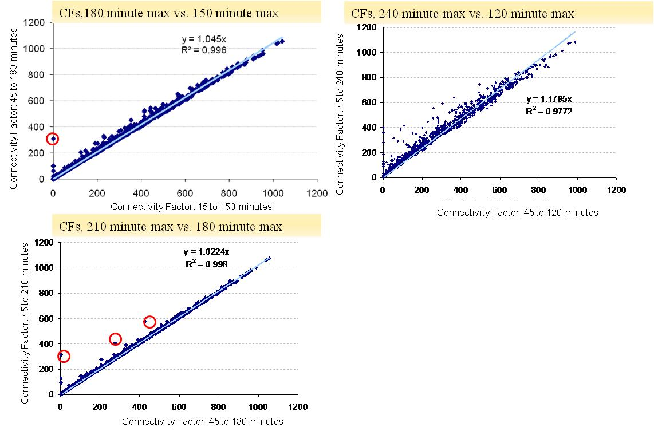
Figure 5. Scatter Plot Matrix [may do full scatter plot matrix eventually on its own page]
Since most of these graphs are close to the line y=x, there is generally a small difference based on expanding the connection window by half an hour. This correspondence shows that these connectivity factors are robust based on expansion of the connection window. For analysis purposes, the 45 to 180 minute time window was chosen.
Results for Connectivity, Considering the Passenger % Connections
The Study Group compared the change in the connectivity factors using a varying percent connectivity, rather then a set 100%. Because adding these varying percentages did alter the final outcome, they were used. Adding in the factor for the percent passenger connections enabled a better differentiation between flight connectivity, as seen in the graphs below, many connectivity factors significantly decreased as a result of incorporating passenger connections. However, there were also many connectivity factors that hardly changed at all, as seen by the points close to the dotted line representing y=x. The graph also shows that as the Connectivity Factors increase, there is a closer linear correlation. This indicates that higher connectivity values are more robust values, these are flights that are traveling directly to high traffic destinations and will therefore be making a significant number of direct connections. These values were more robust given passenger connectivity (Figure 6). Accounting for the passenger connectedness research creates a wider range amongst connectivity factors. Table 2 below also shows how these calculations may alter the analytical results. In this schedule, the flight from RNO to PDX has a significantly larger connectivity factor than the flight to SEA. However, taking passengers into account, not only lessens the gap, but additionally alters the result so that the flight to SEA has the larger connectivity factor. Some of the original values also are shown to be more robust, for example both flights landing in LAS show less than a 13% decrease when this method is applied.
Figure 6. Connectivity Factor Assuming 100% Connectivity vs. Accounting for Passenger Connections
Table 2. Connectivity Factors for Flights Departing RNO, Comparing 100% and APC Methods
Tail # | Leg # | Origin | Destination | Departure  Time | Arrival Time | Connectivity Factor  (100%) | Connectivity Factor (APC)
N683 | 2 | RNO | LAS | 8:00 | 9:10 | 527 | 462
N632 | 2 | RNO | PDX | 8:05 | 9:25 | 292 | 118
N617 | 2 | RNO | SEA | 8:30 | 10:15 | 250 | 127
N687 | 3 | RNO | LAX | 9:10 | 10:35 | 378 | 228
N649 | 1 | RNO | SLC | 10:05 | 12:25 | 238 | 182
N651 | 3 | RNO | LAS | 10:15 | 11:25 | 312 | 280

Analysis of Passenger reassignment factor
It was initially assumed that the passenger reassignment factor would display a reversed pattern compared to the connectivity factor. The passenger reassignment factor is based largely on the number of available seats with the same origin and destination pair as a particular flight. As the day progresses, the number of remaining flights decreases and in turn so do the number of available seats. It seems that it would therefore be more difficult to reassign passengers on flights canceled later on in the day. The passenger reassignment factors were graphed with the time of day in the x-axis and the passenger reassignment factor value in the y-axis (Figure 7). It was anticipated that the graph of the data as a whole would look similar to an exponential curve with the flights later in the day having a higher passenger reassignment factor. Contrary to the Study Group’s initial assumption, the graph doesn’t display as clear of a pattern as the one produced by the passenger reassignment factors. However, there is a clustering pattern, where most of the passenger reassignment factors lie between 600 and 1000, and large number of passenger reassignment factors lie between 0 and 200. It also appears that the density of the 0 to 600 range of passenger reassignment factors increases as the day continues, indicating that it will be more difficult to reassign passengers to other flights. Note these passenger factors have been scaled to match the range of the connectivity factors. A value of 7 in the graph corresponds to a ratio of number of passengers to available seats equal to 1.0. Therefore, all the values above 7 represent cases in which there is not enough room on the remaining flights to hold all the additional passengers if the flight is cancelled, therefore most of these flights would have difficulty in reassigning passengers if cancelled.
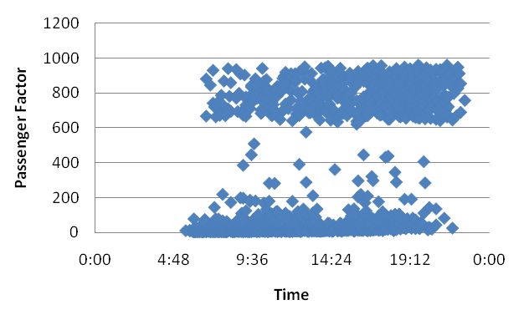
Figure 7. Graph of passenger reassignment factors vs. departure time

Final Decision Making Tool
After weighing the pros and cons of the spreadsheet method versus the integer program, the Study Group concluded that the use of an integer program may have some drawbacks. The integer program may produce an “optimal” solution and is fairly simple to run, but it may also produce infeasible solutions if the constraints are too restrictive. A user may not have the background to know why an infeasible solution has been produced and may abandon the tool and deem it useless. On the other hand, the spreadsheet method gives the user the ability to view a prioritized list of flights. This allows one to compare the algorithmic “optimal” solution with other flights that may produce disruption indices nearly as low. In some instances, airlines may have preferences to canceling one flight over another for reasons that may not have been incorporated into the disruption index calculation. They are therefore able to compare flights that have disruption indices within a close range of the lowest calculated disruption index and choose the one that best meets their needs. Therefore, the Study Group opted to concentrate functionality tests on the spreadsheet method. Although it was not used, the integer program helped to determine the calculations of the factors for the spreadsheet method. The integer program has been made available though in Appendix A, and is functional. This was done so that if this method was used and modified by an airline to be more complex, the basic integer program is still available if it is deemed beneficial.

Functionality Test
Figures 8 through 10 show the results of the functionality test. For the first flight schedule scenario (Figure 6), the constraints were set so that only flights departing from St. Paul International Airport (MSP) between 9:00 AM and 10:00 AM were considered. There were a total of 36 flights matching those constraints. For this particular airline, the range of disruption indices was not very broad. The values ranged between 1 and 35, with 34 of those values falling in the 1-8 range. The weighted connectivity factors and passenger reassignment factors are also displayed so that one has a better understanding of how much of an effect each one of those factors had on the final disruption index.

Tail # | Origin | Destination | Departure  Time | Arrival  Time | DI |  | Weighted CF | PF | Weighted Scaled PF
N343NB | MSP | SLC | 9:11 | 11:04 | 1 |  | 0.5 | 2.4 | 0.4
N301US | MSP | MCO | 10:21 | 14:19 | 1 |  | 0.5 | 2.6 | 0.5
N313US | MSP | SMF | 9:16 | 11:07 | 1 |  | 0.5 | 2.8 | 0.5
N596NW | MSP | PDX | 9:30 | 11:20 | 2 |  | 1.5 | 1.5 | 0.3
N362NB | MSP | IAH | 9:10 | 11:53 | 2 |  | 1.5 | 1.9 | 0.3
N348NB | MSP | EWR | 10:47 | 14:17 | 2 |  | 1.5 | 2.1 | 0.4
N327NW | MSP | SJC | 10:20 | 12:23 | 2 |  | 0.5 | 7.9 | 1.4
N375NC | MSP | RSW | 10:18 | 14:28 | 2 |  | 1.5 | 3.6 | 0.6
• | • | • | • | • | • |  | • | • | •
• | • | • | • | • | • |  | • | • | •
N378NW | MSP | TPA | 10:23 | 14:12 | 6 |  | 5.0 | 4.1 | 0.7
N777NC | MSP | MEM | 10:14 | 12:07 | 6 |  | 6.0 | 1.0 | 0.2
N8925E | MSP | MKE | 10:08 | 11:08 | 6 |  | 6.0 | 1.2 | 0.2
N780NC | MSP | DTW | 10:06 | 12:52 | 8 |  | 7.5 | 0.5 | 0.1
N338NW | MSP | PSP | 9:20 | 11:01 | 26 |  | 2.0 | 135.1 | 24.5
N303US | MSP | MIA | 10:30 | 14:48 | 35 |  | 14.0 | 116.5 | 21.1

Figure 8: Table showing the feasible solutions of the first functionality test. Highlighted values have the lowest calculated Disruption Indices

In an example in which the airline starts off with 36 flights that match the constraints, by ranking the data based on the disruption indices, the decision is narrowed to three potential choices. The results of the tool recommend that One of the flights with a disruption index of 1 would be chosen for cancellation due to being the lowest disruption index, although any of the flights with a disruption index of 2 would also be considered reasonably low and would be recommended for consideration for cancellation by the airline. The last two flights with disruption indices of 26 and 35 respectively should not be recommended for cancellation. For the flight with a disruption index of 26, it is evident that the main factor playing a role in the final disruption index is the passenger reassignment factor. It is interesting that although this flight departs fairly early in the morning, it would still be difficult to accommodate all the passengers on this flight and reassign them to other flights had this flight been canceled. This is most likely attributed to the fact that the arrival airport, Palm Springs Municipal Airport (PSP), is fairly small and does not receive many flights.

The second flight schedule shows a similar trend to the first. In this case, the flights considered for cancellation were scheduled to arrive at Dallas/Fort Worth International Airport (DFW) between 13:00 and 15:00 hours. A total of 37 flights match the criteria with disruption indices ranging between 1 and 15. The range of disruption indices in this case is not as broad as with the previous airline. The airline is may consider canceling the three flights with the lowest disruption indices. They also have the option of considering flights with disruption indices near to the lowest values, such as those with a disruption index of 3. Again, the tool suggests narrowing the decision from 37 options for cancellation to only three (or eight if a slightly higher disruption index is also considered)

Tail # | Origin | Destination | Departure Time | Arrival Time | DI |  | Weighted CF | PF | Weighted Scaled PF
N377AA | LAS | DFW | 8:52 | 13:11 | 2 |  | 1.0 | 1.0 | 0.6
N468AA | DEN | DFW | 12:10 | 14:58 | 2 |  | 1.5 | 0.8 | 0.5
N428AA | DCA | DFW | 12:51 | 15:00 | 2 |  | 1.5 | 1.6 | 1.0
N5DJAA | MIA | DFW | 11:41 | 13:46 | 3 |  | 1.5 | 1.8 | 1.1
N590AA | BNA | DFW | 12:38 | 14:33 | 3 |  | 1.5 | 2.1 | 1.3
N4XJAA | DTW | DFW | 11:43 | 14:25 | 3 |  | 1.5 | 2.3 | 1.4
N4XMAA | LGA | DFW | 12:15 | 14:58 | 3 |  | 9.0 | 1.3 | 0.8
N503AA | CLT | DFW | 11:36 | 13:39 | 3 |  | 1.5 | 3.2 | 2.0
N454AA | ELP | DFW | 12:05 | 14:45 | 4 |  | 1.5 | 3.3 | 2.0
N582AA | ATL | DFW | 12:31 | 13:56 | 4 |  | 2.5 | 1.9 | 1.1
• | • | • | • | • | • |  | • | • | •
• | • | • | • | • | • |  | • | • | •
N5EHAA | LAX | DFW | 9:29 | 14:18 | 9 |  | 9.0 | 0.5 | 0.3
N457AA | AUS | DFW | 12:20 | 13:20 | 11 |  | 10.5 | 0.9 | 0.6
N5CEAA | FLL | DFW | 10:59 | 13:07 | 11 |  | 8.5 | 2.3 | 2.9
N5DGAA | MCO | DFW | 11:36 | 13:32 | 11 |  | 11.0 | 4.1 | 0.5
N513AA | ATL | DFW | 12:26 | 13:52 | 13 |  | 12.0 | 1.7 | 1.0
N563AA | COS | DFW | 11:20 | 14:01 | 14 |  | 9.5 | 1.3 | 4.3
N453AA | ELP | DFW | 11:11 | 13:51 | 15 |  | 13.5 | 0.5 | 1.2
Figure 9. Table showing the feasible solutions of the second functionality test. Highlighted values have the lowest calculated Disruption Indices

The results of the final example differ slightly from the previous two examples. The constraints were set to consider flights departing from Charlotte Douglas Airport (CLT) between 8:00 and 10:00 AM. 30 Matches were found with disruption indices ranging between 12 and 189. The range of disruption indices is much greater than with the previous two cases. In addition, the data results in a single lowest disruption index, with a few flights that are close to the lowest disruption index. The decision making process would be fairly simple to the airline since their options are very limited. If they feel that this flight should not be canceled because of reasons not considered in the disruption index calculation, the tool also recommends considering canceling slightly more disruptive flights that may be preferable to them to cancel.

Tail # | Origin |  | Destination |  | Departure Time | Arrival Time | DI |  | Weighted CF | PF | Weighted PF
N171US | CLT | SFO |  | 9:16 |  | 12:03 | 12 |  | 1.5 | 3.1 | 10.8
N514AU | CLT | ORF |  | 9:26 |  | 10:29 | 13 |  | 3.5 | 2.8 | 9.7
N449US | CLT | BUF |  | 9:19 |  | 10:47 | 17 |  | 12.0 | 1.5 | 5.2
N525AU | CLT | SRQ |  | 9:24 |  | 11:12 | 23 |  | 2.0 | 6.0 | 20.5
N439US | CLT | MIA |  | 9:54 |  | 12:01 | 24 |  | 20.5 | 1.1 | 3.7
N749US | CLT | DEN |  | 9:38 |  | 11:31 | 27 |  | 23.5 | 1.1 | 3.8
N453UW | CLT | BWI |  | 8:03 |  | 9:22 | 29 |  | 26.5 | 0.8 | 2.8
N426US | CLT | JAX |  | 9:45 |  | 10:59 | 32 |  | 28.5 | 1.0 | 3.4
N530AU | CLT | DFW |  | 9:28 |  | 11:20 | 35 |  | 28.5 | 1.9 | 6.4
N459UW | CLT | PBI |  | 9:37 |  | 11:43 | 35 |  | 28.5 | 1.9 | 6.6
• | • | • |  | • |  | • | • |  | • | • | •
• | • | • |  | • |  | • | • |  | • | • | •
N918UW | CLT | LAS |  | 9:47 |  | 11:24 | 71 |  | 66.5 | 1.4 | 4.9
N533AU | CLT | DFW |  | 8:09 |  | 9:55 | 72 |  | 66.5 | 1.5 | 5.1
N939UW | CLT | MCO |  | 9:58 |  | 11:36 | 79 |  | 77.0 | 0.6 | 2.1
N922UW | CLT | TPA |  | 9:52 |  | 11:37 | 79 |  | 75.0 | 1.2 | 4.2
N457UW | CLT | PHL |  | 9:30 |  | 10:58 | 82 |  | 79.0 | 0.8 | 2.9
N721UW | CLT | BOS |  | 8:08 |  | 10:14 | 94 |  | 91.0 | 0.8 | 2.9
N574US | CLT | CMH |  | 9:59 |  | 11:16 | 189 |  | 2.0 | 54.2 | 187.2

Figure 10. Table showing the feasible solutions of the first functionality test. Highlighted values have the lowest calculated Disruption Indices

Conclusions
Summary of work
Airlines cancel flights on a daily basis due to unanticipated and uncontrollable events. A tool to aid in the cancellation decision making process was developed to rank flights based on the disruption their cancellation will cause to the rest of the days schedule. An index was created which assigned a numerical value to each flight ranking it based on the disruption it causes to the system. This value, a disruption index, is composed of two factors, connectivity and passenger reassignment factors. The connectivity factor considers the number of flight legs a flight is connected to later on in the day. The passenger reassignment factor considers the fact that passengers need to be reassigned to other flights if their flight is cancelled.

A user friendly tool was developed to calculate the disruption indices for the flights and rank them based on constraints set by the airline and each flight’s disruption index. The airline has control over the weights each one of the previously mentioned factors counts for in the calculation based on the importance they place on each. They are also able to adjust different settings on how the disruption index is calculated to closely match how the airline functions. The tool can also easily be modified to incorporate other factors not previously considered in the disruption index calculations.

This tool can potentially aid AOC’s in making a more knowledgeable decision on which flight to cancel. This will in turn reduce unnecessary costs to the airline caused by making uninformed cancellation decisions and improve customer satisfaction.

Recommendations and Future work
In the limited time given to the Study Group, some factors were not included in the disruption index calculation. Other factors, such as crew connectivity and flight interconnectivity, were considered but not incorporated into the algorithm. The partial connectivity factors were based on the percentage of passengers connecting to later flights. In reality, crew connectivity would also play a role in the connectivity of flights. A small airport which would most likely be a passenger’s final destination may not be a crew member’s final destination. Also, in addition to reassigning passengers to flights to get them to their final destination, crew members would also need to be reassigned as to reduce disruption to their flight schedule.

Flight interconnectivity is also a factor which could increase the accuracy of the disruption indices of flights. Flight interconnectivity considers how the cancellation of one flight would affect the connectivity of other flights and would recalculate the connectivity factors for the flights for the rest of the day. This would be useful if multiple flights need to be cancelled at a time and instead of basing one’s decision solely on individual flight’s connectivity, one would also consider how it would affect the connectivity of other flights which could potentially be considered for cancellation. These are two factors the Study Group considered but was not able to incorporate into the project since they fell beyond the scope. Individual airlines may also feel that factors specific to their airlines that may affect their overall decision may also need to be incorporated.

To broaden the span of the disruption index, multiple day schedules can also be considered. In the current calculation of disruption, flights departing later in the day are considered to have low connectivity since there are fewer flights to connect to. Realistically, flights in the following day’s schedule are likely to be affected if a flight late in the previous day is cancelled. The passenger factor can also be affected by considering more than just a single day schedule.

A suggested method to attain real time data and quicken the decision making process would be to link the tool to the internet. The airline would therefore be able to monitor potential changes and the disruption indices would automatically readjust with cancellations.

Appendix A
Integer Program used in determining optimal flight to cancel

Variables:
- $x_{i}=\begin{aligned}\left\{1\text{ if flight i is canceled} | \right.\end{aligned}$
i = 1, 2, …, n where n = number of flight legs during a day

Data:
- DI_{i} = Disruption Index for flight i
- CF_{i} = Connectivity Factor of flight i
- F_{i} = # of available seats later on in the day on flights with the same origin and destination as flight i
- N_{i} = Number of Passengers on flight i
- P_{i} = Passenger reassignment factor for flight i
- W₁ = weight in objective function for Connectivity Factors
- W₂ = weight in objective function for Load Factors
- DT_{i} = Departure time of flight i
- AT_{i} = Arrival time of flight i
- O_{i} = Origin of flight i
- D_{i} = Destination of flight i

Model:

Min $W_{1}\sum_{i=1}^{n}{{\text{CF}}_{i}x_{i}}+W_{2}\sum_{i=1}^{n}{P_{i}x_{i}}=\sum_{i=1}^{n}{{\text{DI}}_{i}x_{i}}$
s.t.
1) Minimum number of flights that must be canceled, where n = number of flight legs during a day:
$\sum_{i=1}^{n}{x_{i}}≥A$ for i = 1, 2, …, n A is given by airline operators
2) Time window where flights need to be canceled:
a) Based on Departure Time:
$\begin{aligned}C≥x_{i}D_{i} \\ x_{i}D_{i}+D\left(1−x_{i}\right)≥D\end{aligned}$ C and D are given by airline operators
AND/OR
b) Based on Arrival Time:
$\begin{aligned}E≥x_{i}A_{i} \\ x_{i}A_{i}+F(1−x_{i})≥F\end{aligned}$ E and F are given by airline operators
3) Specifies origin or destination:
a) Origin:
O_{i} = H Airport H is specified by airline operators
AND/OR
b) Destination:
D_{i} = J Airport J is specified by airline operators

4) Specific flights that need to be canceled:
$x_{i}=1$ i is a flight number that must be canceled
5) Specific flights to consider where G of them need to be canceled:
$\sum_{i∈S}{x_{i}}=G$ G is given by airline operators,
S is the set of flights to consider

6) Calculation of Passenger reassignment factor:

$α\left({N_{i}}/{F_{i}}\right)=P_{i}$ for i = 1, 2, …, n

Calculation of $α$: $α$×Max $\left(\frac{N_{i}}{F_{i}}\right)$ = Max (CF_{i})
=> $α$= Max (CF_{i}) / Max $\left(\frac{N_{i}}{F_{i}}\right)$
So, Max (P_{i}) = Max (CF_{i})
Appendix B

The Cancellation Disruption Index Tool, CanDIT, allows airlines to quickly set the parameters for specific flight cancellation needs. The following pages consist of screenshots which explain how this tool may be specified for the individual airline’s needs.

When the CanDIT tool is opened, a window pops up to allow the user to specify the parameters for the cancelled flight. This window contains five tabs: Disruption, Connectivity, Update, Airports, and Advanced.

The Disruption Tab
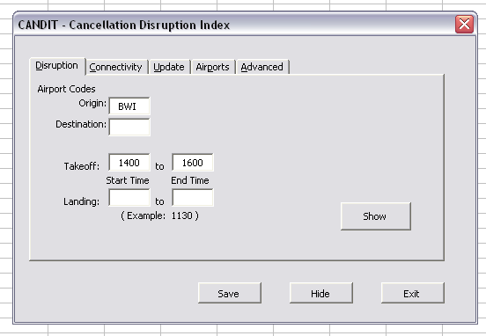
The Disruption Tab allows the user to set the Origin and/or Destination airport, by typing in the Airport Code. The user may also specify takeoff or landing time windows. In this example, BWI is designated BWI as the origin airport with takeoff times of 1400 to 1600. Once the “Show” button is clicked, a list of all flights departing from BWI is generated in the Excel spreadsheet, including the Disruption Indices, Connectivity Factors, and Passenger Reassignment Factors. The user may use normal Excel functions in the spreadsheet. The user may particularly wish to use the “sort” function to rank individual factors such as connectivity factors and passenger factors.
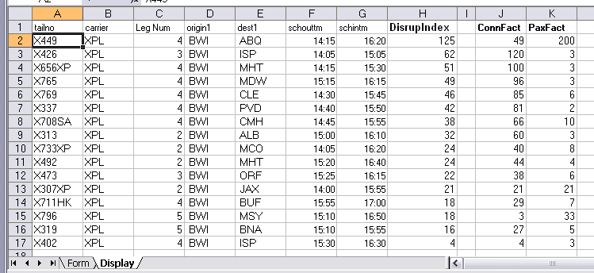
By clicking on the “Form” tab in the lower left, the user may return to the Form menu to select other parameters.

Upon returning to the Form menu, the user may click on “Hide” to return to the spreadsheet data.

The Connectivity Tab
The Connectivity Tab allows the user to select a constraint for connections.
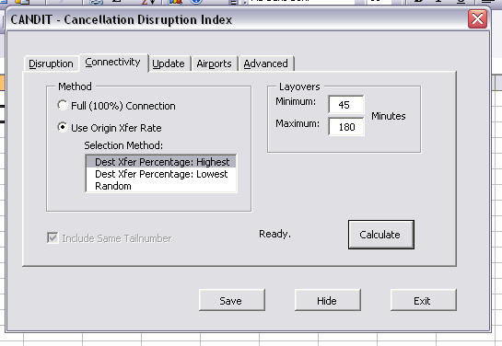
In the “Method” pane, the user may select the desired strategy for connecting flights. By selecting Full (100%) Connection, the flights will follow the 100% Connectivity Definition, in which all flights within the designated connection window are selected to be connecting flights. By selecting “Use Origin Xfer Rate”, only a percentage of the flights will be considered as connecting flights. (This percentage may be set under the Airports Tab, which is explained later). Under the Use Origin Xfer Rate, the user may designate one “Selection Method” for selecting which flights to consider for transferring flights. By selecting “Dest: Xfer Percentage: Highest,” the flights will be connected to destinations of higher connectivity. By selecting “Dest: Xfer Percentage: Lowest,” the flights will be connected to destinations with the lowest connectivity, by selecting “Random” the connecting flights will randomly be selected.

The Layovers pane allows the user to designate the connection window, where “Minimum” represents the minimum passenger time and “Maximum” represents the maximum wait for a connecting flight.
The Update Tab
The Update Tab allows the user to update the tool with new data.
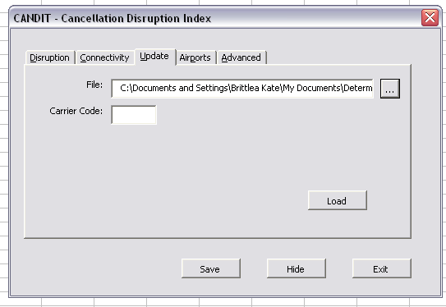
The user may choose a file to upload by selecting the “…” button, and opening the file to be used in analysis. This file must contain the standard schedule format, described in the section below. The user must also enter the “Carrier Code” in the appropriate box. When the user clicks “Load,” this new information will be uploaded.

Required input data format
For CanDIT to be able to read and process the schedule data, the data in the worksheet to be opened needs to be contained in "Sheet1". CanDIT will only copy those rows that have a matching Carrier value, any others will be excluded. Each line may have up to 10 origin/destination pairs, and must have data in columns A,B,C,D,E, and F.

The required format for the input data in the Excel spreadsheet is given in Tables B1 and B2. Table B2 shows optional data (additional legs) which may be repeated for further origins and destinations.

Table B1. Required data inputs for CanDIT
Column | Value | Comment
A | Tail Number | Mix of letters and numbers
B | Carrier | 3 characters
C | Origin1 | 3 characters
D | Destination1 | 3 characters
E | ScheduledTakeoff1 | Time (HH:MM)
F | ScheduledLand1 | Time (HH:MM)
G | ActualTakeoff1 | Not used
H | ActualLanding1 | Not Used

Table B2. Optional data inputs for CanDIT(Format may repeat)
Column | Value | Comment
I | Origin2 | 3 characters
J | Destination2 | 3 characters
K | ScheduledTakeoff2 | Time (HH:MM)
L | ScheduledLand2 | Time (HH:MM)
M | ActualTakeoff2 | Not used
N | ActualLanding2 | Not Used

The Airports Tab
The Airports Tab allows the user to update the percent connection data to determine the number of passengers that will transfer at the airport.
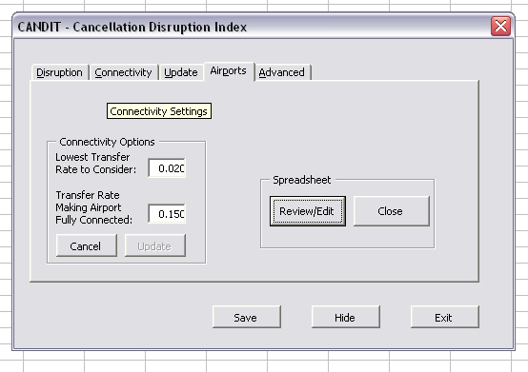
The Airports Tab allows the user to enter the “Lowest Transfer Rate to Consider” and the “Transfer Rate Making Airport Fully Connected.” These two values are to be combined in a linear equation to calculate the percent flights to consider for transfer
% Flight Connections within the connection window = $\frac{\text{\%of transferring passengers for airport}−\text{Lowest Transfer Rate}}{\text{Transfer Rate Making Airport Fully Connected}}×\text{100}$
By selecting “Review/Edit,” the user may view the Passenger Transfer Rates and Flight Connection Ratio. If the airline does not wish to use the above equation for calculating the Flight Connection Ratio, the user may directly select the Flight Connection Ratio within the Spreadsheet.

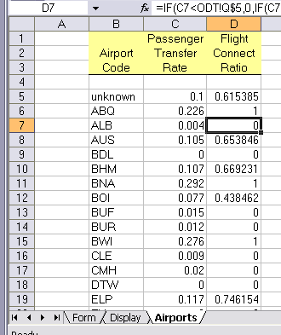
By clicking “Close” under the Airport tab, the user will hide the Airports tab on the Spreadsheet, so that the focus will be on the actual flights.
The Advanced Tab
Under the Advanced Tab, the airline may select the weights for the Connectivity Factor and Load Factor for calculating the Disruption Index.
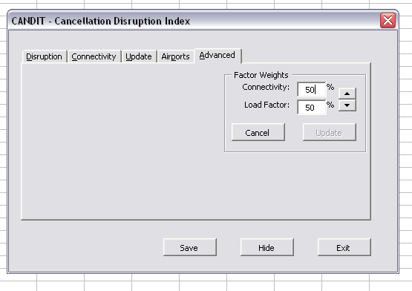
The Advanced Tab may be used by the airline to select the appropriate weights these factors will be given in the calculation of disruption. The values will always be updated to sum to 100%.
Appendix C. Visual Basic for Applications (VBA) Code for CANDIT

The code that follows is organized into one form (CandiMain.frm), one module (Module1.bas), one workbook (thisworkbook.cls) and one worksheets: sheet8.cls.

CandiMain.frm
VERSION 5.00
Begin {C62A69F0-16DC-11CE-9E98-00AA00574A4F} frmCandiMain
Caption = "CANDIT - Cancellation Disruption Index"
ClientHeight = 4875
ClientLeft = 45
ClientTop = 435
ClientWidth = 7845
OleObjectBlob = "frmCandiMain.frx":0000
ShowModal = 0 'False
StartUpPosition = 1 'CenterOwner
End
Attribute VB_Name = "frmCandiMain"
Attribute VB_GlobalNameSpace = False
Attribute VB_Creatable = False
Attribute VB_PredeclaredId = True
Attribute VB_Exposed = False
' ====================================================================
' CanDIT - Cancellation Disruption Index Tool
' ver. 1.0 May 2008
'
' George Mason University
' System Engineering and Operations Research Dept.
'
' Team: M. Kamal
' M. C. Lee
' B. Sheldon
' T. Van Dyke
' B. Yaacoubi
'
' Faculty Sponsors:
' Dr. Laskey
' Dr. Sherry
'
' ====================================================================
' Module: frmCandiMain
' Object Name: frmCandiMain
' ====================================================================

Private Sub cmdAdvancedUpdate_Click()
Sheet7.Cells(3, 17) = Me.txtConnectPct / 100#
Sheet7.Cells(4, 17) = Me.txtLoadPct / 100#
Me.cmdAdvancedUpdate.Enabled = False
Sheet7.Calculate
MsgBox "Done."
End Sub

Private Sub cmdAirportFactors_Click()
Sheet10.Visible = xlSheetVisible
Sheet10.Activate
End Sub

Private Sub cmdAirportHide_Click()
Sheet10.Visible = xlSheetHidden
End Sub

Private Sub cmdCalcConn_Click()
Dim iMethod As Integer
If Me.optFull Then
iMethod = 2
Else
If Me.lbMethod.ListIndex = 0 Then
iMethod = 4
ElseIf Me.lbMethod.ListIndex = 1 Then
iMethod = 5
Else
iMethod = 3
End If
End If

Sheet6.Cells(6, 14) = Me.txtMinimum
Sheet6.Cells(7, 14) = Me.txtMaxLayover
Sheet6.Cells(8, 14) = iMethod

calcFactors

makeflightcounts

End Sub

Private Sub cmdCancel_Click()
Unload Me
' Application.Quit
End Sub

Private Sub cmdConnOptCancel_Click()
Me.txtXferLow = Format(Sheet7.Cells(5, 17), "0.000")
Me.txtXferHigh = Format(Sheet7.Cells(6, 17), "0.000")
Me.cmdConnOptUpdate.Enabled = False
End Sub

Private Sub cmdConnOptUpdate_Click()
Me.cmdConnOptUpdate.Enabled = False
If Not IsNull(Me.txtXferLow) Then
If check0to1(Me.txtXferLow) Then
If Not IsNull(Me.txtXferHigh) Then
If check0to1(Me.txtXferHigh) Then
If Me.txtXferLow < Me.txtXferHigh Then
savexferrates
MsgBox "Airport Data has been updated. Disruption calculations have NOT been updated."
End If
End If
End If
End If
End If
End Sub

Private Sub cmdExit_Click()
Application.Quit
End Sub

Private Sub cmdFileList_Click()
Application.FindFile
Me.txtInputFile.Text = Workbooks(2).FullName
Workbooks(1).Activate
Me.Show
End Sub

Private Sub cmdLoadData_Click()
Dim blnOk As Boolean

blnOk = True

If Sheet1.UsedRange.Rows.Count > 1 Then
If Len(Trim(Sheet1.Cells(2, 2))) > 0 Then
blnOk = transferfromotherworkbook
End If
End If

If blnOk Then
If Sheet1.UsedRange.Rows.Count > 1 Then
If Len(Trim(Sheet1.Cells(2, 2))) > 0 Then
blnOk = makeleglist
End If
End If
End If

If blnOk Then
makeLegCalcData
Else
MsgBox "Failed to load new data."
End If

End Sub

Private Sub cmdSave_Click()
Application.SaveWorkspace
End Sub

Private Sub cmdShow_Click()
Dim iRow As Integer
Dim iDispRow As Integer
Dim aHours(4) As Single
'Dim aMinutes(4) As Integer

Sheet9.Range(Sheet9.Cells(1, 1), Sheet9.Cells(2000, 20)).Clear

If Me.txtStartTime = "" Then
Me.txtStartTime = "0000"
End If

'Titles
Sheet7.Range(Sheet7.Cells(1, 1), Sheet7.Cells(1, 7)).Copy
Sheet9.Range(Sheet9.Cells(1, 1), Sheet9.Cells(1, 7)).PasteSpecial
Sheet7.Range(Sheet7.Cells(1, 15), Sheet7.Cells(1, 15)).Copy
Sheet9.Range(Sheet9.Cells(1, 8), Sheet9.Cells(1, 8)).PasteSpecial
Sheet7.Range(Sheet7.Cells(1, 13), Sheet7.Cells(1, 14)).Copy
Sheet9.Range(Sheet9.Cells(1, 10), Sheet9.Cells(1, 11)).PasteSpecial

iDispRow = 1

If Me.txtStartTime.Value = "" Then
Me.txtStartTime = "0000"
End If
If Me.txtTakeOffEnd.Value = "" Then
Me.txtTakeOffEnd = "0100"
End If
If Me.txtLandingStart.Value = "" Then
Me.txtLandingStart = "0000"
End If
If Me.txtLandingEnd.Value = "" Then
Me.txtLandingEnd = "0200"
End If

aHours(1) = Int(CInt(Me.txtStartTime.Value) / 100) + CInt(Right(Me.txtStartTime.Value, 2)) / 60#
aHours(2) = Int(CInt(Me.txtTakeOffEnd.Value) / 100) + CInt(Right(Me.txtTakeOffEnd.Value, 2)) / 60#
aHours(3) = Int(CInt(Me.txtLandingStart.Value) / 100) + CInt(Right(Me.txtLandingStart.Value, 2)) / 60#
aHours(4) = Int(CInt(Me.txtLandingEnd.Value) / 100) + CInt(Right(Me.txtLandingEnd.Value, 2)) / 60#

If aHours(2) < 3 Then
aHours(2) = aHours(2) + 24
End If
If aHours(4) <= 3 Then
aHours(4) = aHours(4) + 24
End If

For iRow = 2 To 2000
If Not IsEmpty(Sheet7.Cells(iRow, 1)) Then
If Trim(Sheet7.Cells(iRow, 4)) = Trim(Me.txtAirportCode) Or (Me.txtAirportCode.Text & "." = ".") Then
If Trim(Sheet7.Cells(iRow, 5)) = Trim(Me.txtDestination) Or (Me.txtDestination.Text & "." = ".") Then
'If Hour(Sheet7.Cells(iRow, 6)) >= aHours(1) Then
If time2hrs(Sheet7.Cells(iRow, 6)) >= aHours(1) Then
If time2hrs(Sheet7.Cells(iRow, 7)) >= aHours(3) Then
If time2hrs(Sheet7.Cells(iRow, 6)) <= aHours(2) Then
If time2hrs(Sheet7.Cells(iRow, 7)) <= aHours(4) Then

iDispRow = iDispRow + 1
Sheet7.Range(Sheet7.Cells(iRow, 1), Sheet7.Cells(iRow, 7)).Copy
Sheet9.Range(Sheet9.Cells(iDispRow, 1), Sheet9.Cells(iDispRow, 7)).PasteSpecial
Sheet7.Range(Sheet7.Cells(iRow, 15), Sheet7.Cells(iRow, 15)).Copy
Sheet9.Range(Sheet9.Cells(iDispRow, 8), Sheet9.Cells(iDispRow, 8)).PasteSpecial (xlPasteValues)
Sheet9.Range(Sheet9.Cells(iDispRow, 8), Sheet9.Cells(iDispRow, 8)).PasteSpecial (xlPasteFormats)
Sheet7.Range(Sheet7.Cells(iRow, 13), Sheet7.Cells(iRow, 14)).Copy
Sheet9.Range(Sheet9.Cells(iDispRow, 10), Sheet9.Cells(iDispRow, 11)).PasteSpecial (xlPasteValues)
Sheet9.Range(Sheet9.Cells(iDispRow, 10), Sheet9.Cells(iDispRow, 11)).PasteSpecial (xlPasteFormats)

End If
End If
End If
End If
End If
End If
End If
Next

'Sort
Sheet9.Range(Sheet9.Cells(2, 1), Sheet9.Cells(iDispRow, 11)).Sort _
Key1:=Sheet9.Columns("H"), _
Header:=xlGuess

Me.Hide
Sheet9.Activate
SendKeys "^{HOME}"
SendKeys "{DOWN}"

End Sub

Public Function time2hrs(dtIn) As Single
time2hrs = Hour(dtIn) + (Minute(dtIn) / 60#)
End Function

Private Sub cmdWeightCancel_Click()

Me.txtConnectPct = 100# * Sheet7.Cells(3, 17)
Me.txtLoadPct = 100# * Sheet7.Cells(4, 17)
Me.cmdAdvancedUpdate.Enabled = False
End Sub

Private Sub optAirportXfer_Click()
Me.lbMethod.Enabled = True
Me.lblMethod.Enabled = True
Me.lbMethod.BackColor = vbWhite
Me.lbMethod.ForeColor = Me.lblMethod.ForeColor
End Sub

Private Sub optFull_Click()
Me.lblMethod.Enabled = False
Me.lbMethod.Enabled = False
Me.lbMethod.BackColor = Me.lblMethod.BackColor
Me.lbMethod.ForeColor = 177# * 256# * 256# + 177# * 256# + 177# 'A nice shade of gray
End Sub

Private Sub spnWeights_SpinDown()
Me.txtLoadPct.Value = Me.txtLoadPct.Value + 1#
If Me.txtLoadPct.Value > 100# Then
Me.txtLoadPct.Value = 100#
End If
Me.txtConnectPct.Value = 100# - Me.txtLoadPct.Value
End Sub

Private Sub spnWeights_SpinUp()
Me.txtConnectPct.Value = Me.txtConnectPct.Value + 1#
If Me.txtConnectPct.Value > 100# Then
Me.txtConnectPct.Value = 100#
End If
Me.txtLoadPct.Value = 100# - Me.txtConnectPct
End Sub

Private Sub txtAirportCode_Change()
Me.txtAirportCode.Text = Left(UCase(Me.txtAirportCode.Text), 3)
End Sub

Private Sub txtConnectPct_Change()
If Not IsNumeric(Me.txtConnectPct.Value) Then
MsgBox "Entry in box must be 0.0 to 100.0"
ElseIf Me.txtConnectPct.Value > 100# Then
Me.txtConnectPct.Value = 100# - Me.txtLoadPct.Value
ElseIf Me.txtLoadPct.Value < 0# Then
Me.txtConnectPct.Value = 100# - Me.txtLoadPct.Value
ElseIf Right(Me.txtConnectPct.Text, 1) = "." Then
Else
Me.txtConnectPct.Value = Int(10# * Me.txtConnectPct.Value) / 10#
Me.txtLoadPct.Value = 100# - Me.txtConnectPct.Value
End If
Me.cmdAdvancedUpdate.Enabled = True
End Sub

Private Sub txtDestination_Change()
txtDestination.Text = Left(UCase(txtDestination.Text), 3)
End Sub

Private Sub txtLoadPct_Change()
If Not IsNumeric(Me.txtLoadPct.Value) Then
MsgBox "Entry in box must be 0.0 to 100.0"
ElseIf Me.txtLoadPct.Value > 100# Then
Me.txtLoadPct.Value = 100# - Me.txtConnectPct.Value
ElseIf Me.txtLoadPct.Value < 0# Then
Me.txtLoadPct.Value = 100# - Me.txtConnectPct.Value
ElseIf Right(Me.txtLoadPct.Text, 1) = "." Then
Else
Me.txtLoadPct.Value = Int(10# * Me.txtLoadPct.Value) / 10#
Me.txtConnectPct.Value = 100# - Me.txtLoadPct.Value
End If
Me.cmdAdvancedUpdate.Enabled = True
End Sub

Private Sub txtXferHigh_Change()
Me.cmdConnOptUpdate.Enabled = True
End Sub

Private Sub txtXferLow_Change()
Me.cmdConnOptUpdate.Enabled = True
End Sub

Private Function check0to1(ByVal tc As String) As Boolean
check0to1 = False
If Not IsNull(tc) Then
If IsNumeric(tc) Then
If CSng(tc) >= 0# Then
If CSng(tc) <= 1# Then
check0to1 = True
End If
End If
End If
End If
End Function

Private Sub savexferrates()
Sheet7.Cells(5, 17) = CInt(1000# * CSng(Me.txtXferLow) + 0.0001) / 1000
Sheet7.Cells(6, 17) = CInt(1000# * CSng(Me.txtXferHigh) + 0.0001) / 1000
End Sub

Private Sub UserForm_Activate()
fillinvalues
End Sub

Private Sub fillinvalues()
If IsNull(frmCandiMain.lbMethod.List(1)) Then
frmCandiMain.lbMethod.List = Array("Dest Xfer Percentage: Highest", _
"Dest Xfer Percentage: Lowest ", _
"Random ")
frmCandiMain.lbMethod.ListIndex = 0
End If
'frmCandiMain.txtConnectPct = 50#
'frmCandiMain.txtLoadPct = 50#
frmCandiMain.txtConnectPct.Value = 100# * Sheet7.Cells(3, 17)
frmCandiMain.txtLoadPct.Value = 100# * Sheet7.Cells(4, 17)
frmCandiMain.txtXferLow = Format(Sheet7.Cells(5, 17), "0.000")
frmCandiMain.txtXferHigh = Format(Sheet7.Cells(6, 17), "0.000")

End Sub

Private Sub UserForm_Initialize()
fillinvalues
Me.cmdConnOptUpdate.Enabled = False
End Sub

Module1.bas
Attribute VB_Name = "Module1"
' ====================================================================
' CanDIT - Cancellation Disruption Index Tool
' ver. 1.0 May 2008
'
' George Mason University
' System Engineering and Operations Research Dept.
'
' Team: M. Kamal
' M. C. Lee
' B. Sheldon
' T. Van Dyke
' B. Yaacoubi
'
' Faculty Sponsors:
' Dr. Laskey
' Dr. Sherry
'
' ====================================================================
' Module: Module1
' Object Name: Module1
' ====================================================================

Public Function transferairline() As Boolean

Dim iRow As Integer
Dim iCount As Integer

iCount = 0

For iRow = 1 To Sheet2.UsedRange.Rows.Count
If Sheet2.Cells(iRow, 2) = "SWA" Or iRow = 1 Then
Sheet2.Range(Sheet2.Cells(iRow, 1), Sheet2.Cells(iRow, 81)).Copy
'Sheet2.Copy
Sheet1.Range(Sheet1.Cells(iCount + 1, 1), Sheet1.Cells(iCount + 1, 81)).PasteSpecial
'Sheet1.Paste
iCount = iCount + 1
End If
Next

MsgBox " Records found: " & iCount
End Function

Public Function transferfromotherworkbook() As Boolean

Dim iRow As Integer
Dim iCount As Integer
Dim wb As Workbook
Dim cName As String
Dim shtTo As New Worksheet
Dim shtFrom As New Worksheet

iCount = 0

strCarrier = UCase(Trim(frmCandiMain.txtCarrierCode))
If IsNull(strCarrier) Then
MsgBox "Must enter a carrier."
transferfromotherworkbook = False
Exit Function
ElseIf Len(strCarrier) <> 3 Then
MsgBox "Carrier must be 3 letters."
transferfromotherworkbook = False
Exit Function
End If

Set shtTo = InRaw 'Sheet1

For Each wb In Application.Workbooks

If wb.Name = Application.Workbooks(2).Name Then
Set shtFrom = wb.Worksheets(1)

For iRow = 1 To shtFrom.UsedRange.Rows.Count
If Trim(shtFrom.Cells(iRow, 2)) = strCarrier Then
shtFrom.Range(shtFrom.Cells(iRow, 1), shtFrom.Cells(iRow, 81)).Copy
'Sheet2.Copy
shtTo.Range(shtTo.Cells(iCount + 1, 1), shtTo.Cells(iCount + 1, 81)).PasteSpecial
'Sheet1.Paste
iCount = iCount + 1

'Perform the following if we can turn off the update cell display
'frmCandiMain.lblDataLoadStatus.caption = cstr(iCount) & " tail numbers"
End If
Next
wb.Close
MsgBox "Done: " & CStr(iCount - 2) & " tail numbers"
End If
Next

End Function

Public Function makeleglist() As Boolean

Dim iRow As Integer
Dim iLeg As Integer
Dim iLegCount As Integer
Dim iStartRow As Integer

iLegCount = 0

If Sheet1.Cells(1, 2) = Sheet1.Cells(2, 2) Then
Sheet3.Cells(1, 1) = "Tail"
Sheet3.Cells(1, 2) = "Carrier"
Sheet3.Cells(1, 3) = "LegNum"
Sheet3.Cells(1, 4) = "Origin"
Sheet3.Cells(1, 5) = "Dest"
Sheet3.Cells(1, 6) = "SchOutTm"
Sheet3.Cells(1, 7) = "SchInTm"
Sheet3.Cells(1, 8) = "ActOutTm"
Sheet3.Cells(1, 9) = "ActInTm"
iStartRow = 1
Else
Sheet1.Range(Sheet1.Cells(1, 1), Sheet1.Cells(1, 2)).Copy
Sheet3.Range(Sheet3.Cells(1, 1), Sheet3.Cells(1, 2)).PasteSpecial
Sheet3.Cells(1, 3) = "Leg Num"
Sheet1.Range(Sheet1.Cells(1, 3), Sheet1.Cells(1, 8)).Copy
Sheet3.Range(Sheet3.Cells(1, 4), Sheet3.Cells(1, 9)).PasteSpecial
iStartRow = 2
End If

Sheet3.Activate
For iRow = iStartRow To Sheet1.UsedRange.Rows.Count
For iLeg = 1 To 10
If Not IsEmpty(Sheet1.Cells(iRow, iLeg * 6 - 3)) Then
iLegCount = iLegCount + 1
Sheet3.Cells(iLegCount + 1, 1) = Sheet1.Cells(iRow, 1)
Sheet3.Cells(iLegCount + 1, 2) = Sheet1.Cells(iRow, 2)
Sheet3.Cells(iLegCount + 1, 3) = iLeg
Sheet1.Range(Sheet1.Cells(iRow, iLeg * 6 - 3), Sheet1.Cells(iRow, iLeg * 6 + 2)).Copy
Sheet3.Range(Sheet3.Cells(iLegCount + 1, 4), Sheet3.Cells(iLegCount + 1, 9)).PasteSpecial
End If
Next
Next
Sheet8.Activate

MsgBox "Leg count: " & iLegCount

End Function

Public Function makestoplist()

Dim iRow As Integer
Dim iLeg As Integer
Dim iLegCount As Integer
Dim iStopCount As Integer
Dim strNextPlace As String
Dim strNextArrive As String

Dim shtTarget As New Worksheet

Set shtTarget = Sheet4
iLegCount = 0

Sheet1.Range(Sheet1.Cells(1, 1), Sheet1.Cells(1, 2)).Copy
shtTarget.Range(shtTarget.Cells(1, 1), shtTarget.Cells(1, 2)).PasteSpecial
shtTarget.Cells(1, 3) = "StopNum"
shtTarget.Cells(1, 4) = "Airport"
shtTarget.Cells(1, 5) = "SchInTm"
shtTarget.Cells(1, 6) = "SchOutTm"

For iRow = 2 To Sheet1.UsedRange.Rows.Count
iLegCount = iLegCount + 1
shtTarget.Cells(iLegCount + 1, 1) = Sheet1.Cells(iRow, 1) 'tail
shtTarget.Cells(iLegCount + 1, 2) = Sheet1.Cells(iRow, 2) 'airline
shtTarget.Cells(iLegCount + 1, 3) = 0
shtTarget.Cells(iLegCount + 1, 4) = Sheet1.Cells(iRow, 3) 'start place
shtTarget.Cells(iLegCount + 1, 5) = "Start"
shtTarget.Cells(iLegCount + 1, 6) = Sheet1.Cells(iRow, 5) 'Departure time
strNextPlace = Sheet1.Cells(iRow, 4)
strNextArrive = Sheet1.Cells(iRow, 6)

For iLeg = 1 To 10
If Not IsEmpty(Sheet1.Cells(iRow, iLeg * 6 + 3)) And Len(strNextPlace) > 0 Then
iLegCount = iLegCount + 1
shtTarget.Cells(iLegCount + 1, 1) = Sheet1.Cells(iRow, 1)
shtTarget.Cells(iLegCount + 1, 2) = Sheet1.Cells(iRow, 2)
shtTarget.Cells(iLegCount + 1, 3) = iLeg
shtTarget.Cells(iLegCount + 1, 4) = Sheet1.Cells(iRow, iLeg * 6 - 2) 'start place
shtTarget.Cells(iLegCount + 1, 5) = strNextArrive
shtTarget.Cells(iLegCount + 1, 6) = Sheet1.Cells(iRow, iLeg * 6 + 5) 'Departure time
strNextPlace = Sheet1.Cells(iRow, 4)
strNextArrive = Sheet1.Cells(iRow, iLeg * 6 + 6)

' Sheet1.Range(Sheet1.Cells(iRow, iLeg * 6 - 3), Sheet1.Cells(iRow, iLeg * 6 + 2)).Copy
' shtTarget.Range(shtTarget.Cells(iLegCount + 1, 4), shtTarget.Cells(iLegCount + 1, 9)).PasteSpecial
ElseIf Len(strNextPlace) > 0 Then
iLegCount = iLegCount + 1
shtTarget.Cells(iLegCount + 1, 1) = Sheet1.Cells(iRow, 1) 'tail
shtTarget.Cells(iLegCount + 1, 2) = Sheet1.Cells(iRow, 2) 'airline
shtTarget.Cells(iLegCount + 1, 3) = iLeg
shtTarget.Cells(iLegCount + 1, 4) = Sheet1.Cells(iRow, iLeg * 6 - 2) 'start place
shtTarget.Cells(iLegCount + 1, 5) = strNextArrive 'Last arrival time
shtTarget.Cells(iLegCount + 1, 6) = "End" 'End
strNextPlace = ""
strNextArrive = ""

End If
Next
Next

MsgBox "Stop count: " & iLegCount

End Function

Public Sub makeeventsbyairport()
'not used, was never functional

Dim iRow As Integer
Dim iLeg As Integer
Dim iEventCount As Integer
Dim aAptList(100) As String

aAptList(1) = ""
makeairportlist (aAptList)
For iRow = 2 To Sheet3.UsedRange.Rows.Count

Next
MsgBox "Done."
End Sub

Public Sub makeairportlist(ByRef aAL())
'not used, was never expanded
aAL(1) = "ORD"
End Sub

Public Sub makeSTdiagramdata()
'no longer used

Const maxRow = 10 '416
Dim iRow As Integer
Dim strTail As String
Dim blnNewPlane As Boolean
Dim iDispRow As Integer
Dim strArpts As String

Dim shtSource As New Worksheet
Set shtSource = Sheet3 'Legs
Dim shtFill As New Worksheet
Set shtFill = Sheet2

strTail = "XXXX"
iDispRow = 2
strArpts = ""

For iRow = 2 To maxRow
If strTail <> shtSource.Cells(iRow, 1) Then
strTail = shtSource.Cells(iRow, 1)
blnNewPlane = True
End If
If blnNewPlane Then
iDispRow = iDispRow + 2
shtFill.Cells(iDispRow, 2) = strTail
shtFill.Cells(iDispRow, 3) = 5
'shtFill.Cells(iDispRow, 3) = DateAdd("h", -1, shtSource.Cells(iRow, 6))
'shtFill.Cells(iDispRow, 3) = shtSource.Cells(iRow, 6) - 1
shtFill.Cells(iDispRow, 4) = getAptNumber(Trim(shtSource.Cells(iRow, 4)), strArpts)

End If

iDispRow = iDispRow + 1
shtFill.Cells(iDispRow, 2) = strTail
shtFill.Cells(iDispRow, 3) = Hour(shtSource.Cells(iRow, 6)) + Minute(shtSource.Cells(iRow, 6)) / 60
shtFill.Cells(iDispRow, 4) = getAptNumber(Trim(shtSource.Cells(iRow, 4)), strArpts)
blnNewPlane = False

iDispRow = iDispRow + 1
shtFill.Cells(iDispRow, 2) = strTail
shtFill.Cells(iDispRow, 3) = Hour(shtSource.Cells(iRow, 7)) + Minute(shtSource.Cells(iRow, 7)) / 60
shtFill.Cells(iDispRow, 4) = getAptNumber(Trim(shtSource.Cells(iRow, 5)), strArpts)
Next

End Sub

Public Function getAptNumber(ByVal strAirport As String, ByRef strArpts As String) As Integer

getAptNumber = Int((InStr(strArpts, "." + strAirport + ".") + 5) / 6)
If getAptNumber = 0 Then
strArpts = strArpts + "." + Left(strAirport + "..", 5)
getAptNumber = Len(strArpts) / 6
End If
End Function

Public Sub makeLegCalcData()

Dim iRow As Integer
Dim iMax As Integer
Dim iNewRow As Integer

Dim iMaxLandLeft As Integer
Dim dMaxLandLeft As Date

Dim aTail(2000) As String
Dim aTakeoff(2000) As Date
Dim aLanding(2000) As Date
Dim aOrigin(2000) As String
Dim aDest(2000) As String
Dim aUsed(2000) As Integer

Dim shtFill As New Worksheet
Set shtFill = Sheet6 'LegCalc

'Load data
iMax = 0
For iRow = 1 To Sheet3.UsedRange.Rows.Count ' or 2000, whichever is minimum
If IsEmpty(Sheet3.Cells(iRow + 1, 1)) Then
If iMax = 0 Then
iMax = iRow - 1
End If
Else
aTail(iRow) = Sheet3.Cells(iRow + 1, 1)
aOrigin(iRow) = Sheet3.Cells(iRow + 1, 4)
aDest(iRow) = Sheet3.Cells(iRow + 1, 5)
aTakeoff(iRow) = Sheet3.Cells(iRow + 1, 6)
aLanding(iRow) = Sheet3.Cells(iRow + 1, 7)
If aLanding(iRow) < aTakeoff(iRow) Then
aLanding(iRow) = DateAdd("h", 24, aLanding(iRow))
End If
'iMax = iRow
End If
aUsed(iRow) = 0
Next

shtFill.Activate

For iNewRow = 1 To iMax
dMaxLandLeft = DateAdd("h", -48, aTakeoff(1))
iMaxLandLeft = 0
For iRow = 1 To iMax
If aUsed(iRow) = 0 Then
If aLanding(iRow) > dMaxLandLeft Then
iMaxLandLeft = iRow
dMaxLandLeft = aLanding(iRow)
End If
End If
Next
aUsed(iMaxLandLeft) = 1

'Put it in the new sheet
'If iNewRow < 100 Then
Sheet3.Range(Sheet3.Cells(iMaxLandLeft + 1, 1), Sheet3.Cells(iMaxLandLeft + 1, 9)).Copy
shtFill.Range(shtFill.Cells(iNewRow + 1, 1), shtFill.Cells(iNewRow + 1, 9)).PasteSpecial
'End If

'debugging
'If iNewRow > (iMax - 10) Then
' MsgBox "imaxlandleft = " & iMaxLandLeft & " dmaxlandleft = " & dMaxLandLeft
'End If
Next
Sheet8.Activate
MsgBox "Rows put in Calculation form: " & CStr(iMax)
End Sub

Public Sub calcFactors()

Dim iRow As Integer
Dim iMax As Integer
Dim iNewRow As Integer
Dim iArpt As Integer

'Dim iMaxLandLeft As Integer
'Dim dMaxLandLeft As Date
Dim iScore As Long
Dim blnGotOne As Boolean
Dim blnInRange As Boolean
Dim blnAddIt As Boolean

Dim strLowArpts As String
Dim strHiArpts As String
Dim strMidArpts As String
Dim aArptConn(100) As Single
Dim aArptFliConn(100) As Single
Dim sPct As Single
Dim sPctLow As Single
Dim sPctHigh As Single
Dim lngConnects As Long
Dim lngConnectNots As Long
Dim lngTotalConnects As Long
Dim lngConnectsGoal As Long
Dim dblFlightPct As Double

Dim iMinLay As Integer
Dim iMaxLay As Integer
Dim dtWindowStart As Date
Dim dtWindowEnd As Date
Dim iMethod As Integer
Dim iCurrentArpt As Integer
Dim iDestArpt As Integer

Dim aTail(2000) As String
Dim aTakeoff(2000) As Date
Dim aLanding(2000) As Date
Dim aOrigin(2000) As String
Dim aDest(2000) As String
Dim aUsed(2000) As Integer
Dim aScore(2000) As Long
Dim aDesConn(2000) As Single
Dim aMark(2000) As Single

Dim shtFill As New Worksheet
Set shtFill = Sheet6 'LegCalc

'Debug info
Dim lngHighGoal As Long
Dim strHighInfo As String
iRowDebug = -1
lngHighGoal = 0

iMinLay = shtFill.Cells(6, 14)
iMaxLay = shtFill.Cells(7, 14)
iMethod = shtFill.Cells(8, 14)

'set up airports
strLowArpts = "."
strHiArpts = "."
strMidArpts = "."
sPctLow = Sheet10.Cells(2, 7)
sPctHigh = Sheet10.Cells(3, 7)

iRow = 5
iArpt = 0
While iRow < 100
If Not IsNull(Sheet10.Cells(iRow, 3)) Then
If Not IsEmpty(Sheet10.Cells(iRow, 3)) Then
sPct = Sheet10.Cells(iRow, 3)
If sPct <= sPctLow Then
strLowArpts = strLowArpts & Trim(Sheet10.Cells(iRow, 2)) & "."
ElseIf sPct >= sPctHigh Then
strHiArpts = strHiArpts & Trim(Sheet10.Cells(iRow, 2)) & "."
Else
If iArpt > 0 Then
strMidArpts = strMidArpts & "." & Trim(Sheet10.Cells(iRow, 2))
End If
aArptConn(iArpt) = sPct
' aArptFliConn(iArpt) = 0# + ((100# / 13#) * (aArptConn(iArpt) - 0.02))
aArptFliConn(iArpt) = Sheet10.Cells(iRow, 4)
iArpt = iArpt + 1
End If
iRow = iRow + 1
Else
iRow = 100
End If
Else
iRow = 100
End If
Wend

'For iArpt = 0 To iArpt - 1
' aArptFliConn(iArpt) = 0# + ((100# / 13#) * (aArptConn(iArpt) - 0.02))
'Next

'Load flight data
iMax = 0
For iRow = 1 To Sheet1.UsedRange.Rows.Count ' or 2000
If IsEmpty(shtFill.Cells(iRow + 1, 1)) Then
If iMax = 0 Then
iMax = iRow - 1
End If
Else
aTail(iRow) = shtFill.Cells(iRow + 1, 1)
aOrigin(iRow) = shtFill.Cells(iRow + 1, 4)
aDest(iRow) = shtFill.Cells(iRow + 1, 5)
aTakeoff(iRow) = shtFill.Cells(iRow + 1, 6)
aLanding(iRow) = shtFill.Cells(iRow + 1, 7)
If aLanding(iRow) < aTakeoff(iRow) Then
aLanding(iRow) = DateAdd("h", 24, aLanding(iRow))
End If
End If
'aUsed(iRow) = 0
If iMethod > 1 Then
If iMethod = 2 Then
aDesConn(iRow) = 1#
Else
iDestArpt = Int((InStr(strHiArpts, "." + Trim(aDest(iRow)) + ".") + 3) / 4)
If iDestArpt > 0 Then
aDesConn(iRow) = 1#
Else
iDestArpt = Int((InStr(strLowArpts, "." + Trim(aDest(iRow)) + ".") + 3) / 4)
If iDestArpt > 0 Then
aDesConn(iRow) = 0#
Else
iDestArpt = Int((InStr(strMidArpts, "." + Trim(aDest(iRow)) + ".") + 3) / 4)
aDesConn(iRow) = aArptConn(iDestArpt)
End If
End If
End If
End If
Next

'Method 1 -- simple addition of connecting flights' CF -- no longer an option
If iMethod = 1 Then
'private sub method1(aOrigin, aDest, aTakeOff, aLanding, aScore, iMinLay, iMaxLay)
For iRow = 1 To iMax
iScore = 1
For iNewRow = 1 To iRow - 1
If aOrigin(iNewRow) = aDest(iRow) Then
If aTakeoff(iNewRow) >= DateAdd("n", iMinLay, aLanding(iRow)) Then
If aTakeoff(iNewRow) <= DateAdd("n", iMaxLay, aLanding(iRow)) Then
iScore = iScore + aScore(iNewRow)
End If
End If
End If
Next
aScore(iRow) = iScore
shtFill.Cells(iRow + 1, 10) = iScore
Next
'end sub
End If

'Method 2 -- tree method
'Method 3 -- partial tree by airport rate
'Method 4 -- partial tree - High pct destinations
'Method 5 -- partial tree - Low pct destinations
If iMethod >= 2 And iMethod <= 5 Then

'debug info
strShow = ""

'For each flight leg, starting with latest
For iRow = 1 To iMax

'Initialize score and used values
iScore = 1
For iNewRow = 1 To iRow - 1
aUsed(iNewRow) = 0
Next
aUsed(iRow) = 1

'Keep looping until no legs are added
blnGotOne = True
While blnGotOne
blnGotOne = False

'Start at the current record and go up (later)
For iNewRow = iRow To 2 Step -1

'Only evaluate this record if it's already been connected
If aUsed(iNewRow) = 1 Then

'(re)initialize stats used for method 3
lngConnects = 0
lngConnectNots = 0

'Calculate flight connection rate
If iMethod = 2 Then
dblFlightPct = 100#
Else
'if Airport Rate is "Low"
If Int((InStr(strLowArpts, "." + Trim(aDest(iNewRow)) + ".") + 3) / 4) > 0 Then
dblFlightPct = 0#

'if Airport Rate is "High"
ElseIf Int((InStr(strHiArpts, "." + Trim(aDest(iNewRow)) + ".") + 3) / 4) > 0 Then
dblFlightPct = 1#
Else
iCurrentArpt = Int((InStr(strMidArpts, "." + Trim(aDest(iNewRow)) + ".") + 3) / 4)
'dblFlightPct = 0# + Sqr((100# / 13#) * (aArptConn(Int((InStr(strMidArpts, "." + _
'Trim(aDest(iNewRow)) + ".") + 3) / 4)) - 0.02))
'dblFlightPct = 0# + ((100# / 13#) * (aArptConn(iCurrentArpt) - 0.02))
dblFlightPct = aArptFliConn(iCurrentArpt)
End If
End If

dtWindowStart = DateAdd("n", iMinLay, aLanding(iNewRow))
dtWindowEnd = DateAdd("n", iMaxLay, aLanding(iNewRow))

'do not do following loop if already done or doing first iteration
blnInRange = (aScore(iNewRow) > 1) Or iNewRow = iRow

If iMethod = 4 Or iMethod = 5 Then

If iNewRow = iRowDebug Then
MsgBox "Debugging stop"
End If

lngTotalConnects = 0
For iRowToAdd = (iNewRow - 1) To 1 Step -1

aMark(iRowToAdd) = -1#

'only consider flights leaving the airport of our current connection window
If aOrigin(iRowToAdd) = aDest(iNewRow) Then

blnAddIt = False
'If flight has same tail number, use it
If aTail(iRowToAdd) = aTail(iNewRow) Then
blnAddIt = True
aMark(iRowToAdd) = 2#

'else if flight is in desired connection window
ElseIf aTakeoff(iRowToAdd) <= dtWindowEnd Then
If aTakeoff(iRowToAdd) >= dtWindowStart Then
aMark(iRowToAdd) = aDesConn(iRowToAdd)
lngTotalConnects = lngTotalConnects + 1
End If
End If
End If
Next

If lngTotalConnects > 1 Then
lngConnectsGoal = CLng(Int(0.7 + (lngTotalConnects * dblFlightPct)))
If lngConnectsGoal < 1 Then
lngConnectsGoal = 1
End If
Else
lngConnectsGoal = lngTotalConnects
End If

If lngConnectsGoal < lngTotalConnects Then
Call meth4adjust(iMethod, aMark, lngConnectsGoal, lngTotalConnects, iNewRow - 1)
End If

'debug info
If dblFlightPct < 1# And lngConnectsGoal > lngHighGoal Then
lngHighGoal = lngConnectsGoal
strHighInfo = "iNewRow: " & CStr(iNewRow) & ", iRowToAdd: " & CStr(iRowToAdd)
End If
End If

'First row to consider is one up from current row
iRowToAdd = iNewRow - 1

'In this case, "in range" means going up to top, stop at 0
While blnInRange

'only need to consider rows that aren't used so far
If aUsed(iRowToAdd) = 0 Then

'only consider flights leaving the airport of our current connection window
If aOrigin(iRowToAdd) = aDest(iNewRow) Then

'Default: don't add this flight to CF
blnAddIt = False

'If flight has same tail number, use it
If aTail(iRowToAdd) = aTail(iNewRow) Then
blnAddIt = True
'update stats for method 3
lngConnects = lngConnects + 1

'debug info
'If iRow = iRowDebug Then
' MsgBox "same tail =" & aTail(iNewRow) & " aTakeOff(iRowToAdd) = " & aTakeoff(iRowToAdd)
'End If

'else if flight is in desired connection window
ElseIf aTakeoff(iRowToAdd) >= dtWindowStart Then
If aTakeoff(iRowToAdd) <= dtWindowEnd Then
If dblFlightPct > 0.999 Then
blnAddIt = True
ElseIf iMethod >= 4 Then
blnAddIt = (aMark(iRowToAdd) > -1#)
ElseIf dblFlightPct > 0# Then
blnAddIt = eval_method3(lngConnects, lngConnectNots, strLowArpts, strHiArpts, _
aOrigin(iRowToAdd), dblFlightPct)
Else
'blnAddIt already 0.
End If
End If
End If

'Add leg into Connection Factor
If blnAddIt Then

'debug info
If iRow = iRowDebug Then
strShow = strShow & iNewRow & ", " & iRowToAdd & vbCrLf
End If

aUsed(iRowToAdd) = 1
blnGotOne = True
iScore = iScore + 1
End If
End If

Else 'leg is already in Connection Factor

If iMethod = 3 And aOrigin(iRowToAdd) = aDest(iNewRow) Then
'update stats for method 3
If aTakeoff(iRowToAdd) >= dtWindowStart Then
If aTakeoff(iRowToAdd) <= dtWindowEnd Then
lngConnects = lngConnects + 1
End If
End If
End If
End If

'Increment and check if still in range
iRowToAdd = iRowToAdd - 1
If iRowToAdd < 1 Then
blnInRange = False
' ElseIf aLanding(iRowToAdd) >= DateAdd("n", iMaxLay, aLanding(iNewRow)) Then
' blnInRange = False
End If
Wend

'Do not evaluate this row again
aUsed(iNewRow) = 2
End If
Next

Wend

'Store CF for this row
aScore(iRow) = iScore

'Display CF
shtFill.Cells(iRow + 1, 10) = iScore

'Update progress counter
'shtFill.Cells(4, 15) = "" & iRow & " | " & Int((100# * iRow) / iMax) & "%"
frmCandiMain.lblStatus.Caption = "" & iRow & " | " & Int(100# * (iRow ^ 4) / (iMax ^ 4)) & "%"
frmCandiMain.Repaint

If iRow = iRowDebug Then
' MsgBox strShow
End If

'If iRow = 500 Or iRow = 1000 Or iRow = 1500 Then
' MsgBox "Calculated rows so far: " & iRow
'End If
Next

'When done, clear progress stat area
'shtFill.Cells(4, 15) = ""
frmCandiMain.lblStatus.Caption = "Ready."
End If

MsgBox "Done."

If iRowDebug > 0 Then
MsgBox "High Goal = " & CStr(lngHighGoal)
MsgBox "High Info: " & strHighInfo
End If
End Sub

Private Function eval_method3(ByRef lngConnects As Long, ByRef lngConnectNots As Long, _
ByVal strLowArpts As String, ByVal strHiArpts As String, ByVal strOrigin As String, _
ByVal dblFlightPct) As Boolean

Dim blnAddIt As Boolean
blnAddIt = False

blnAddIt = cf_blnAddIt(lngConnects, lngConnectNots, dblFlightPct)

eval_method3 = blnAddIt

End Function

Private Function cf_blnAddIt(ByRef lngConnects As Long, ByRef lngConnectNots As Long, _
ByVal dblFlightPct As Double) As Boolean

Dim blnAddIt As Boolean

If lngConnects < 1 Then
'if this is first flight to connect
blnAddIt = True
Else

'Decide whether to use this flight - simulating randomness
'blnAddIt = Sqr(7.1 * (aArptConn(Int((InStr(strMidArpts, "." + Trim(aOrigin(iRowToAdd)) + ".") + 4) / 5)) - 0.02 ) > _
' ((1# * lngConnects) / (1# * (lngConnects + lngConnectNots + 1)))

blnAddIt = dblFlightPct > ((1# * lngConnects) / (1# * (lngConnects + lngConnectNots + 1)))

End If

'Update inclusion counts
If blnAddIt Then
lngConnects = lngConnects + 1
Else
lngConnectNots = lngConnectNots + 1
End If
cf_blnAddIt = blnAddIt
End Function

Private Sub meth4adjust(ByVal iMethod As Integer, ByRef aMark() As Single, lngGoal As Long, _
lngConn As Long, iMax As Integer)
Dim iPick As Integer
Dim iLoop As Integer
While lngGoal < lngConn

'Find one to remove
iPick = 1
For iLoop = 2 To iMax
If aMark(iPick) < 0# Or aMark(iPick) >= 1.9999 Then
iPick = iLoop
Else
If aMark(iLoop) > -1# And aMark(iLoop) < 1.9999 Then
If iMethod = 4 Then
If aMark(iPick) > aMark(iLoop) Then 'Method 4 - Smallest ArptConns
iPick = iLoop
End If
ElseIf iMethod = 5 Then
If aMark(iPick) < aMark(iLoop) Then 'Method 5 - Largest ArptConns
iPick = iLoop
End If
End If
End If
End If
Next

'Remove it
aMark(iPick) = -1#
lngConn = lngConn - 1
Wend
End Sub

Public Sub makeflightcounts()
Dim iCount As Integer
Dim iMax As Integer
Dim iRow As Long
Dim lngList1 As Long
Dim lngList2 As Long

Dim lngTier1 As Long
Dim lngTier2 As Long
Dim lngTierTop As Long

Dim strOrigDest As String
Dim intODCount As Integer
Dim intCapacity As Integer

Dim aTail(2000) As String
Dim aTakeoff(2000) As Date
Dim aLanding(2000) As Date
Dim aOrigin(2000) As String
Dim aDest(2000) As String
'Dim aUsed(2000) As Integer
'Dim aScore(2000) As Long
Dim aIndex(2000) As Long
Dim iNewIndex(2000) As Long
Dim aComp(2000) As String
Dim aLeg(2000) As Long
Dim aAirline(2000) As String
Dim aCF(2000) As Long

Dim shtOrig As New Worksheet
Set shtOrig = Sheet6

Dim shtFill As New Worksheet
Set shtFill = Sheet7

'Load data
iMax = 0
For iRow = 1 To 2000
If IsEmpty(shtOrig.Cells(iRow + 1, 1)) Then
If iMax = 0 Then
iMax = iRow - 1
End If
Else
aTail(iRow) = shtOrig.Cells(iRow + 1, 1)
aAirline(iRow) = shtOrig.Cells(iRow + 1, 2)
aLeg(iRow) = shtOrig.Cells(iRow + 1, 3)
aOrigin(iRow) = shtOrig.Cells(iRow + 1, 4)
aDest(iRow) = shtOrig.Cells(iRow + 1, 5)
aTakeoff(iRow) = shtOrig.Cells(iRow + 1, 6)
aLanding(iRow) = shtOrig.Cells(iRow + 1, 7)
aCF(iRow) = shtOrig.Cells(iRow + 1, 10)
If aLanding(iRow) < aTakeoff(iRow) Then
aLanding(iRow) = DateAdd("h", 24, aLanding(iRow))
End If
aIndex(iRow) = iRow
aComp(iRow) = aOrigin(iRow) + aDest(iRow) + Str(10 + Hour(aTakeoff(iRow))) + Str(Minute(aTakeoff(iRow)))
End If
'aUsed(iRow) = 0
Next

'compare and sort
'each merge
For iLoop = 0 To 12 '2^12 = 4096

lngSortSize = 2 ^ iLoop
If lngSortSize < iMax Then

For iDivision = 1 To iMax Step (lngSortSize + lngSortSize)
lngTier1 = iDivision
lngTier2 = lngTier1 + lngSortSize
lngTierTop = lngTier2 + lngSortSize - 1
If lngTierTop > iMax Then
lngTierTop = iMax
End If

lngList1 = lngTier1
lngList2 = lngTier2

For iCount = lngTier1 To lngTierTop

If lngList1 < lngTier2 Then
If lngList2 <= lngTierTop Then
If aComp(aIndex(lngList1)) <= aComp(aIndex(lngList2)) Then
iNewIndex(iCount) = aIndex(lngList1)
lngList1 = lngList1 + 1
Else
iNewIndex(iCount) = aIndex(lngList2)
lngList2 = lngList2 + 1
End If
Else
iNewIndex(iCount) = aIndex(lngList1)
lngList1 = lngList1 + 1
End If
Else
iNewIndex(iCount) = aIndex(lngList2)
lngList2 = lngList2 + 1
End If

Next
Next
For iCount = 1 To iMax
' ?? cOrig = aOrigin(iRow)
aIndex(iCount) = iNewIndex(iCount)
Next

End If
Next

'make list of orig-dest
'For iCount = 1 To iMax
'Next

'make list of orig-dest-time
'For iCount = 1 To iMax
'Next

'make list of orig-dest-time-later
strOrigDest = "......"
intODCount = 0
For iCount = 1 To iMax
shtFill.Cells(1 + iCount, 1) = aTail(aIndex(iCount))
shtFill.Cells(1 + iCount, 2) = aAirline(aIndex(iCount))
shtFill.Cells(1 + iCount, 3) = aLeg(aIndex(iCount))
shtFill.Cells(1 + iCount, 4) = aOrigin(aIndex(iCount))
shtFill.Cells(1 + iCount, 5) = aDest(aIndex(iCount))
shtFill.Cells(1 + iCount, 6) = aTakeoff(aIndex(iCount))
If Hour(aLanding(aIndex(iCount))) >= 24 Then
shtFill.Cells(1 + iCount, 7) = DateAdd("h", -24, aLanding(aIndex(iCount)))
Else
shtFill.Cells(1 + iCount, 7) = aLanding(aIndex(iCount))
End If
shtFill.Cells(1 + iCount, 8) = aCF(aIndex(iCount))

'If Load Factor is used
'If Left(Trim(aOrigin(aIndex(iCount))), 3) + Left(Trim(aDest(aIndex(iCount))), 3) = strOrigDest Then
' intODCount = intODCount + 1
'Else
' intODCount = 1
' strOrigDest = Left(Trim(aOrigin(aIndex(iCount))), 3) + Left(Trim(aDest(aIndex(iCount))), 3)
'' + aDest(aindex(icount)) = strComp then
'End If
'shtFill.Cells(1 + iCount, 9) = intODCount

'Passenger Reassignment Factor (random for now)
intCapacity = 100 + Round(50 * (0.7 + 0.3 * Rnd()), 0)
shtFill.Cells(1 + iCount, 10) = intCapacity
shtFill.Cells(1 + iCount, 9) = Round(intCapacity * (0.7 + 0.3 * Rnd()), 0)
Next
End Sub

Public Sub reinit_airports()
'this routine is not yet used

'strLowArpts = ".ALB.BDL.BUF.BUR.CLE.CMH.CRP.DTW.FLL.HRL.IAH.IND.ISP.JAN. " & _ "LBB.MAF.MHT.OMA.ORF.PBI.PVD.RDU.SNA.TUS."
'strHiArpts = ".ABQ.BNA.BWI.DAL.HOU.LAS.MCI.MDW.PHX.STL."
'strMidArpts = ".AMA.AUS.BHM.BOI.ELP.GEG.JAX.LAX.LIT.MCO.MSY.OAK.OKC. " & _ "ONT.PDX.RNO.SAN.SAT.SDF.SEA.SJC.SLC.SMF.TPA.TUL."
'aArptConn(0) = 0.1 'Unknown airport
'aArptConn(1) = 0.023 'AMA
'aArptConn(2) = 0.105 'AUS
'aArptConn(3) = 0.107 'BHM
'aArptConn(4) = 0.077 'BOI
'aArptConn(5) = 0.117 'ELP
'aArptConn(6) = 0.021 'GEG
'aArptConn(7) = 0.11 'JAX
'aArptConn(8) = 0.046 'LAX
'aArptConn(9) = 0.03 'LIT
'aArptConn(10) = 0.093 'MCO
'aArptConn(11) = 0.134 'MSY
'aArptConn(12) = 0.056 'OAK
'aArptConn(13) = 0.037 'OKC
'aArptConn(14) = 0.024 'ONT
'aArptConn(15) = 0.044 'PDX
'aArptConn(16) = 0.075 'RNO
'aArptConn(17) = 0.033 'SAN
'aArptConn(18) = 0.08 'SAT
'aArptConn(19) = 0.021 'SDF
'aArptConn(20) = 0.057 'SEA
'aArptConn(21) = 0.064 'SJC
'aArptConn(22) = 0.09 'SLC
'aArptConn(23) = 0.044 'SMF
'aArptConn(24) = 0.121 'TPA
'aArptConn(25) = 0.032 'TUL

End Sub

Thisworksheet.cls
VERSION 1.0 CLASS
BEGIN
MultiUse = -1 'True
END
Attribute VB_Name = "ThisWorkbook"
Attribute VB_GlobalNameSpace = False
Attribute VB_Creatable = False
Attribute VB_PredeclaredId = True
Attribute VB_Exposed = True
' ====================================================================
' CanDIT - Cancellation Disruption Index Tool
' ver. 1.0 May 2008
'
' George Mason University
' System Engineering and Operations Research Dept.
'
' Team: M. Kamal
' M. C. Lee
' B. Sheldon
' T. Van Dyke
' B. Yaacoubi
'
' Faculty Sponsors:
' Dr. Laskey
' Dr. Sherry
'
' ====================================================================
' Module: ThisWorkbook
' Object Name: ThisWorkbook
' ====================================================================

Private Sub Workbook_Open()
Sheet8.Activate
frmCandiMain.cmdAdvancedUpdate.Enabled = False
frmCandiMain.Show
End Sub

Sheet8.cls
VERSION 1.0 CLASS
BEGIN
MultiUse = -1 'True
END
Attribute VB_Name = "Sheet8"
Attribute VB_GlobalNameSpace = False
Attribute VB_Creatable = False
Attribute VB_PredeclaredId = True
Attribute VB_Exposed = True
' ====================================================================
' CanDIT - Cancellation Disruption Index Tool
' ver. 1.0 May 2008
'
' George Mason University
' System Engineering and Operations Research Dept.
'
' Team: M. Kamal
' M. C. Lee
' B. Sheldon
' T. Van Dyke
' B. Yaacoubi
'
' Faculty Sponsors:
' Dr. Laskey
' Dr. Sherry
'
' ====================================================================
' Module: Sheet8
' Object Name: Form
' ====================================================================

Private Sub Worksheet_Activate()
frmCandiMain.Show
End Sub

Private Sub Worksheet_SelectionChange(ByVal target As Range)
frmCandiMain.Show
End Sub
Appendix D
Project Management Charts
WBS
Gantt
EVM
Responsibilities
Key Terms and Acronyms
AOC - Airline Operations Center
APC - Airport Percent Connectivity, this is the percent of passengers that are connecting at a given airport.
Connectivity Factor – The number of flights a single flight is connected to later in the day.
Disruption Index - A value to represent the magnitude of disruption caused by the cancellation of a single flight. A high disruption factor indicates that canceling the flight would be highly disruptive to the system and should be avoided.
FAA – Federal Aviation Administration
Passenger Reassignment Factor – A ratio of the number of passengers on a cancelled flight to the available seats for the same destination in the remainder of the day.
References
(!) Yu, Gang. (1998). Operations Research in the Airline Industry. Boston: Kluwer Academic Publishers.
Many of the below articles may be found at the Center for Air Transportation Systems Research Website: http://catsr.ite.gmu.edu/pubs.html
Laskey, K.B., Xu, Ning, and C. Chen. Propogation of Delays in the National Airspace System. CATSR. August 2006.
Jenkins, Darryl. Southwest Airlines: An In-Depth Review. http://www.erau.edu/research/BA590/index.htm. Accessed on May 1, 2008
Sherry, Lance and D. Wang. Trend Analysis of Airline Passenger Trip Delays. CATSR. April 2007.
Smith, David and L. Sherry. Decision Support Tool for Predicting Ground Delay Programs (GDP) and Airport Delays from Weather Forecast Data. CATSR. February 2008.
Xu, N., Laskey, K.B., Chen, C., Williams, S.C., and L. Sherry. Bayesian Network Analysis of Flight Delays. January 2007.
Xu, N., Sherry, L., and K.B. Laskey. Multi-Factor Model for Predicting Delays at U.S. Airports. CATSR. January 2008
Bureau of Transportation Statistics (www.bts.gov) was used to obtain general airline and air traffic statistics

