Concept of Operations (CONOPS)

MMOCMMOC

Date
MMOC

Release Table

Revision | Date | Change Number | Authorizing Board | Description
A | 3/7/06 |  |  | Initial release

TBX Table

TBX # | Location | Description | Action Needed | POC | ECD

TABLE OF CONTENTS

1.0 INTRODUCTION 1
1.1 Identification 1
1.2 Scope 1
1.3 MMOC Program Overview 1
1.4 MMOC System Center Element Overview 1
1.5 Document Overview 1
1.6 Assumptions and Limitations 2
1.7 Standards Based Compliance 2
2.0 APPLICABLE DOCUMENTS 3
2.1 Government Documents 3
2.2 Industry Documents 3
2.3 MMOC Documents 4
2.4 Corporate Documents 4
3.0 BACKGROUND AND OVERVIEW 6
3.1 Background 6
3.2 Overview 6
3.3 Ownership and Control 7
3.4 CONOPS Intent 7
3.5 Architecture Intent 7
3.6 Capabilities Intent 7
4.0 ORGANIZATIONAL ARCHITECTURE 9
4.1 Organizational Overview 9
4.2 DoD - Warfighter 9
4.3 Air Force 10
4.4 MAJCOM - Air Force Space Command 13
4.5 MMOC System 14
4.6 Contractor Logistics Support 15
4.7 System Center Positional Areas and Staffing 17
5.0 INFORMATION EXCHANGE & REPORTING 24
5.1 Overview 24
6.0 FUNCTIONAL ARCHITECTURE 26
6.1 Functional Architecture Overview 26
6.2 Service Desk 36
6.3 Incident Management 40
6.4 Problem Management 49
6.5 Configuration Management 51
6.6 Change Management 53
6.7 Release Management 54
6.8 Availability Management 56
6.9 Capacity Management 58
6.10 Service Level Management 60
6.11 Service Continuity Management 62
6.12 Security Management 63
6.13 Table of Services 64
7.0 PHYSICAL ARCHITECTURE 67
7.1 Physical Architecture Overview 67
7.2 General Layout 67
7.3 Floorplan 68
7.4 Positions 69
7.5 Video 70
7.6 Audio 71
7.7 Lighting 72
7.8 Physical Storage 73
7.9 HVAC 74
7.10 Power 75
8.0 TECHNICAL ARCHITECTURE (TBS – From HLDD) 76
8.1 Technical Architecture Overview 76
8.2 Data 76
8.3 Systems 76
8.4 Transport 76
8.5 Wide Area Network 76
8.6 Local Area Network 76
8.7 Hosts 77
8.8 Appliances 77
8.9 Storage 77
8.10 Video 77
8.11 Voice 77
8.12 Security 77
8.13 Communications Security 80
8.14 Identification & Authentication 80
8.15 Integrity 80
8.16 Marking 80
8.17 Passwords 81
8.18 Situational Awareness 82
8.19 External Systems 82
9.0 LOGISTICS, SUPPORT AND TRAINING 82
9.1 Logistics 82
9.2 Training 83
9.3 System Upgrades 84
10.0 STRATEGIC ROADMAP (TBS) 85
11.0 DEFINITION OF TERMS (TBS) 86
11.1 Elements & Entities 86
11.2 Mission Operations Types 86
11.3 Data Formats 86
11.4 Data Nature 86
11.5 Data Classification 87
11.6 Communications and Networks 87
APPENDIX A 88

INTRODUCTION

Identification
This Concept of Operations (CONOPS) establishes the high level functional architecture, organization, roles, responsibilities, processes, metrics and strategic plan and associated with the MMOCMMOCMaintenance Mission Operations Center

Scope
This CONOPS is considered a living document that details the concepts and processes by which the MMOC will perform Maintenance Operations MMOCfunctions within an IT services organization and the roadmap for it’s development. It is recognized that, as the MMOCMaintenance requirements grow for 15 program and matures this CONOPS will be revisited, revised, and updated to reflect the dynamic nature of the system and this element.

MMOCProgram Overview

MMOCMMOC Rewrite MMOCSystem Center Element Overview
, the MMOC will provide continuous, centralized service support and service delivery functions for the entire enterprise information technology (IT) infrastructure, communications links and network elements that support the MMOCmaintenance missions. MMOCMMOCThe tentative primary MMOC will be located in Suffolk, VA. Back-up locations need to be determined. The intent of the MMOC is to allow for access to MMOC central management system from a node at each Depot. MMOCMMOCdsMMOCThe MMOC will be under the direct control of the MMOCDirector of Maintenance Mission Operations for the Space Command and Control (SC2) Division to ensure Operational Mission accomplishment. The MMOC will be operated and maintained by Contractor Logistic Support (CLS) personnel and will act as the Single Point of Contact (SPOC) for IT related services and functions. Primary System Center functions include incident management, network operations and management, performance analysis, fault resolution, maintenance coordination, configuration management, system administration, and security management. Additionally, the MMOC will participate in problem, change, availability, release, service continuity, service level, and capacity management functions as necessary.
The MMOC will be deployed incrementally in Phases, and will eventually support all MMOCSC2 elements, including MCS, RGS, Factory, Development, Training and Exercise environments, and External Interfaces. Additionally, the MMOC will interface with Commercial and Government Service Providers, along with other Network Operations Centers as appropriate.
The MMOC also provides an opportunity to integrate many separate program developments into a single centralized function. The MMOC Add constratints
Document Overview
This CONOPS illustrates the architectures and describes the functional and physical interface requirements, protocols, and data exchanged between the MMOC and External Users.
Section 1: Scope and Overview
Section 2: Applicable Documents.
Section 3: Background and Overview of the MMOC Architecture
Section 4: Definition of Terms
Section 5: Organizational Architecture
Section 6: Functional Architecture
Section 7: Physical Architecture
Section 8: Technical Architecture
Section 9: Strategic Roadmap
Section 10: Appendix A

Assumptions and Limitations
This CONOPS is intended to be a living document, subject to changes and updates as appropriate. This document is intended to be utilized as statements of intent and purpose, and is not to be used for formal requirement. Neither the government nor the contractor will use this CONOPS as a contractual vehicle.

Standards Based Compliance
This CONOPS document is based upon service management, service support and service delivery best-practice functions as outlined in the Information Technology Infrastructure Library (ITIL). Roles, Functions, Processes and Procedures are defined to conform with the International Standards Organization (ISO) IT Service Management standard (ISO 20000) and the Information Security Management standard (ISO 17779). A graphical representation of how these standards models apply is shown below.

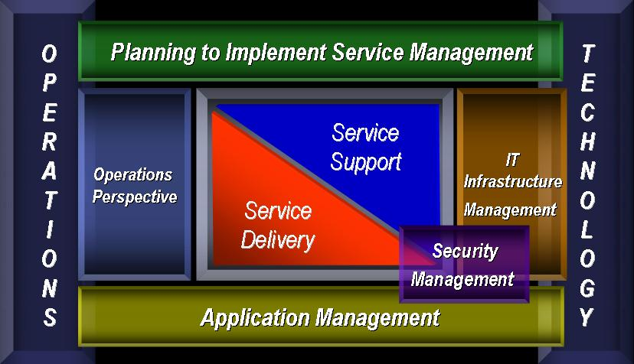
Figure 1-1 - ITIL Service Framework

APPLICABLE DOCUMENTS
The following documents are referenced or used as a basis for this CONOPS.

Government Documents
Document Number | Title
N/A | MMOC User Validation and Verification Process
 | Air Force Instruction 33-115 Vol I, Network Management, 15 Nov 02
 | Air Force Enterprise Management Capability (EMC) CONOPS (Draft), Ver. 1.2, HQ AFCA/GCLO, 12 Jul 00
 | Air Force Enterprise Network Operations (ENO) CONOPS, Version 2 (Draft), HQ AFCA/GCLO, 1 Jul 01
 | Air Force Network Operations Center (AFNOC) and Network Operations and Security Center (NOSC) Requirements (Draft), Ver 1.5, HQ AFCA/GCLD, 12 Will 00
 | CONOPS for Network Operations and Security Centers (NOSCs) (Draft), HQ AFCA/GCLO, 25 Aug 98
 | CONOPS for the NOSC, HQ ACC/SCN, 15 Oct 98
 | CONOPS for Systems Operations at Cheyenne Mountain Air Force Station (Draft), 2 Jul 01
 | Air Force Space Command Instruction 10-606, Development and Use of Conceptual Documents, 2 Will 96
DOD 5200.2-R, | Personnel Security Program, January 1987 w/Change 1, February 12, 1990; Change 2, July 14, 1993, and Change 3, February 23, 1996
DODI 8500.2 | Information Assurance (IA) Implementation, February 6, 2003
AFMAN 33-223 | Identification and Authentication
AFI10-206_14AFSUP1 | Operational Reporting
DCID 6/3

Industry Documents

Document Number | Title
 | MMOC
ANSI/IEEE Std 802.3, 1996 Edition | Information Technology—Local and Metropolitan Area Networks—Part 3: Carrier Sense Multiple Access with Collision Detection (CSMA/CD) Access Method and Physical Layer Specifications.
 | Classification Guides for all the systems connecting
 | MMOC
ANSI/IEEE Std 802.3, 1996 Edition | Information Technology—Local and Metropolitan Area Networks—Part 3: Carrier Sense Multiple Access with Collision Detection (CSMA/CD) Access Method and Physical Layer Specifications.

MMOC15 Program Documents

Document Number | Title
 | MMOC
 | MMOC
 | MMOC
 | MMOC
 | MMOC
 | MMOC

Corporate Documents

Document Number | Title

BACKGROUND AND OVERVIEW

Background
Successful MMOCmission operations are highly dependent on two main factors, infrastructure reliability and infrastructure support. To be effective both the components and their caretakers are required to function seamlessly and efficiently across the MMOCenterprise. This includes the ability to collect data, disseminate information, maintain state, possess awareness, assure information, scale appropriately, respond accordingly, and measure effectively.MMOC Due to new requirements and program maturation the systems have now grown and evolved by an order of magnitude with an Information Technology (IT) architecture that supports over hundreds of elements and is comprised of thousands of end systems, mission Local Area Networks (LANs), a high speed Metropolitan Area Network (MAN), message and data distribution Wide Area Networks (WANs), and several high capacity point-to-point paths. This architecture provides both the technical and support infrastructure for Operations amongst data sources, mission processing facilities, mission development facilities, and system users.
The current MMOCsystems’ sustainment concepts employs a two tiered support architecture for hardware and software, consisting of local Tier 1 (Organization) and system Tier 2 (Depot) personnel. Engineering and/or vendor support are utilized when needed. A centralized Tier 1/Tier 2 MMOC service type function was not provided per the government accepted system design.
The continuing system development, changes in system operations, and associated growth in IT connectivity presents the maintenance organization, government customers, and mission operators with an increasingly complex IT environment. In order to address this the MMOC program will move away from the current service paradigm of localized element support and adopt a network-centric enterprise model for centralized, integrated service support and service delivery. MMOCOverview
The MMOC will provide the monitoring and control capability for the MMOCmaintenance mission IT services. Demonstration through a proof-of-concept development at the Sufflok, VA facility, the MMOC will be deployed in the 15 Depots supporting the 15 separate programs and will follow a phased capability approach. The MMOC will provide 24/7/365 centralized service functions, along with monitoring and controlling all of the IT systems and network elements that support the MMOCmaintenance missions.
The MMOC provides a centralized IT service function for monitoring, performance analysis, fault isolation, maintenance coordination, intrusion detection, configuration management, and system administration. The MMOC is the IT single point of contact for internal or external technicians or operations personnel.
The primary capabilities for the MMOC are extracted from and aligned with AFI 33-115, Volume 1, Network Management, which defines the required network management services for supporting critical AF communications and information networks. Additional MMOC capabilities, roles, and responsibilities will be derived from the 15 programs System Specification requirements, customer and MMOC Operating Instructions (OIs), and industry best practices (ITIL).
The MMOC is an integrated element that provides a real-time network and system information and control mechanisms to ensure completion of the MMOCmaintenance mission. The MMOC is the combination of hardware and software tools, personnel, and processes used to monitor, manage, and control the MMOC IT architecture. The MMOC capability is acquired through a phased implementation approach starting with the establishment of the primary element in Virginia. More details of this approach can be found in Section 9 – Strategic Roadmap.
This initial version of the MMOC is a foundational configuration needed to support the current IT interfaces and monitor all communications-networks in MMOC. The delivery criterion for this version is the complete definition of the formal MMOC. The customer is expected to conduct periodic assessment of this effort to decide on incremental-capability to be integrated into the MMOC in the future. Operational processes and procedures supporting this CONOPS will be developed in Phase 1 of the effort. Government and Contractors will develop detailed operational procedures.
The MMOC will include the capability to efficiently implement changes to the IT-network architecture as new mission and development connectivity is added, as node equipment is changed, and as new functionality is added to the IT architecture.

Ownership and Control

REWRITE

CONOPS Intent
The MMOC concept intends to formalize and centralize the paradigm by which the MMOC missions and systems are supported. To this end the MMOC functions will support all SC2 mission areas, elements, increments, and interfaces. The MMOC architectures will be specified in this Concept of Operations. This CONOPS will be formally controlled as a SC2 capability independent of Program Increments, Missions, or Capabilities. This CONOPS will be reviewed on an annual basis or earlier if changes are required. Any changes to the CONOPS will be coordinated through proper staff channels for approval. Under the spiral development process and with planned integration of mission systems for MMOC, this document is considered a living document under periodic revision until the FOC system architecture is achieved.

Architecture Intent

Organizational
The MMOC will align closely with the customers’ organization (civil and government), structure, and design. This will allow for standardization of crews, positions, functions, terminology, training, and reporting with the intent of providing both immediate net-ops homogeneity and supporting larger customer initiatives in the future.

Functional
.
The MMOC is general in nature and is not associated specifically with a specific baseline for any of the SC2 systems.

Physical
TBS

Technical
The MMOC system will be designed and constructed with hardware and software common to the SC2 systems in order to promote operational simplicity and reduce sustainment costs.

Capabilities Intent
In order to better understand the function of the MMOC System Center the concept of “Mission Assurance” will be defined. Mission Assurance is the summation of three elements:
- Operations Assurance – Ensuring the persistence of Mission Operations across the enterprise
- Information Technology Assurance – Providing a secure and robust enterprise infrastructure
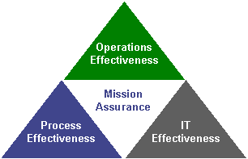
- Processes, Policies, and Procedures Assurance – Delivering service in support of the above elements in a repeatable, predictable, efficient and effective manner
Based on this concept, the MMOC System Center architecture provides for the following:
- Centralized element for mission support functions
- Consolidation of individual site maintenance concepts
- Improved organizational workflow
- Increased mission success ability
- Risk Reduction of Mission Operations
- Scalability of MMOC support
- Response to customer Initiatives
- Operational Situational Awareness and support
- MMOC Systems Situational Awareness and support

ORGANIZATIONAL ARCHITECTURE

Organizational Overview
As stated in the previous sections, the MMOC is aligned with numerous organizational hierarchies, including customer and corporate organizations. The diagram below shows where and how the MMOC supports the following constructs. Specific are detailed in the subsections that follow.
Figure 4-2: AV1-MMOC High Level Organizational Construct

Figure 4-3: OV1 - DOD Network Operations Perspective

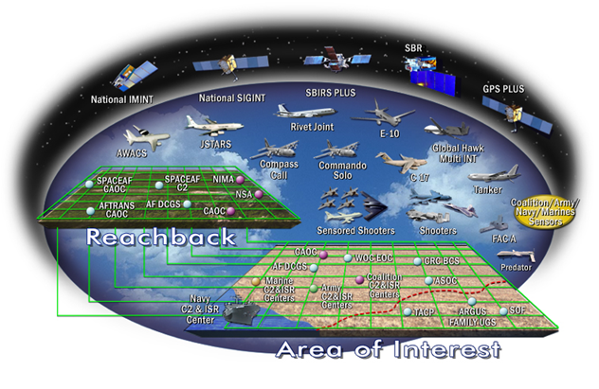
Figure 4-4: OV2 - ConstellationNet High Level Architecture

Relationships, Roles, & Responsibilities

MMOC System

MMOC Functional Structure
MMOC operations are listed here to provide a standard set of operations that the MMOC provides. The figure below depicts the MMOC functional structure. This figure does not depict organizational structure; however, it does capture the functions performed within the organization supporting the MMOC.
These functions are centralized within the MMOC but are also mirrored at the MMOC Functional Awareness Cells. The Network Ops, Mission Systems, and Ops Support areas represent the supporting functions to the MMOC.
fs

Network Operations
The Network Operations element consists of the Network Management, Event Management and Information Assurance areas. Event Management incorporates multiple work sections because events happen in all areas. Together Network Operations and Network Management work hand in hand to operate, trend, defend and respond to events that affect the theater network. Mission Systems
The Mission Systems element consists of the network administration (NA), database management and event management. These elements provide operating system, application, and messaging administration. They are also responsible for server consolidation efforts and maintaining C2, functional, and theater unique systems. They manage and respond to events with respect to their areas of responsibility. Event management incorporates multiple work sections because events happen in all areas. In other words, the event can be infrastructure related (router down), systems related (server crashed), or even IA related (antivirus needs updated). So in effect event management is everyone's responsibility. Operations Support
The Operations Support element provides support to the MMOC in the areas of training, standardization/evaluation, engineering (system integration), planning and scheduling.

Contractor Logistics Support
As part of the MMOC, the MMOC is an integral part of a tiered support structure. This arrangement provides for enterprise wide service operations and service delivery functions and is structured to allow for readily available resources and escalating technical support. The four tiers of this structure are depicted and described below.

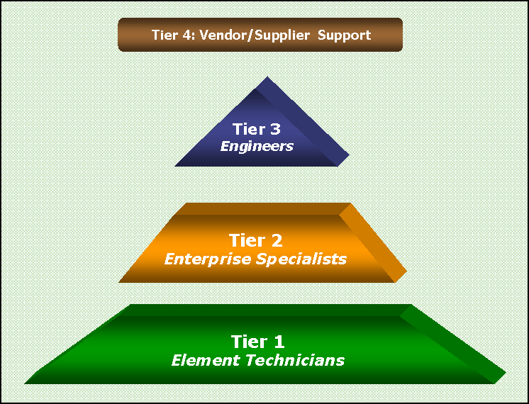
Figure 4-5 Tiered Support Concept

Tier 1 – Element Technician
Tier 1, Element Technicians, are considered the “First Responders” and consist of both on-site CLS maintenance personnel and the MMOC Service Desk. This tier is concerned primarily with Service Support activities and is specifically focused on Incident Management. Incident Management activities within this tier are reactive in nature and are generally limited to basic fix and/or repair issues, general troubleshooting and non-invasive corrective actions. The Service Desk will act as the entry point for any and all incidents across the system, and will act as a coordinator and director for immediate response activities. If the Service Desk or on-site CLS maintenance personnel are unable to resolve an issue, or the issue requires a greater degree of expertise, the incident is escalated to Tier 2. Reference the appendices of this CONOPS for more information on Incident Management and other Service Support functions and processes. Specific procedures for Tier 1 activities and actions are documented in the Collaborative Online OASES Procedures (CO-OP) Wiki tool on the MMOC Support Network (MSN).

Tier 2 – Enterprise Specialists
Tier 2, Enterprise Specialists, are considered the second line of technical support and consist of both Depot support personnel and MMOC service specialists. This tier provides an enterprise wide level of support for both Service Support and Service Delivery functions, and typically possesses a greater degree of domain and/or system knowledge than Tier 1. As such, this tier handles issues that cannot be resolved by Tier 1, proactive tasks such as bandwidth monitoring or audit analysis, and activities that span across the MMOC system (software drops, logistics, sparing, etc…). If either the Depot support personnel and/or MMOC service specialists are unable to resolve an escalated issue, or the issue requires a greater degree of expertise, the incident is escalated to Tier 3. Reference the appendices of this CONOPS for more information on Incident Management and other Service Support functions and processes. Specific procedures for Tier 2 activities and actions are documented in the Collaborative Online OASES Procedures Tool (CO-OPT) wiki on the MMOC Support Network (MSN).

Tier 3 – Engineers
Tier 3, Engineers, are considered the third line of technical support and consists of both Depot support personnel and Operations Engineers. This tier provides an enterprise wide level of support for generally Service Support, but primarily Service Delivery functions, and typically possesses the greatest degree of domain and/or system knowledge. As such, this tier handles issues that cannot be resolved by Tier 2 along with major upgrade or new deployment activities that span across the MMOC system. If the Engineers are unable to resolve an escalated issue, or the issue requires a greater degree of expertise, the incident is escalated to Tier 4. Reference the appendices of this CONOPS for more information on Incident Management and other Service Support functions and processes. Tier 4 – Vendor / Supplier Support
The final tier of support is comprised of vendors, manufacturers, and suppliers of the hardware and software that is utilized in the system.

System Center Positional Areas and Staffing

Staffing Overview
MMOC Operators are defined as CLS personnel with on site authority to manage MMOC IT. As a 24x7x365 entity the MMOC will operate on a shift basis, always maintaining a minimum staff. Generally more staff will be present during day shift to handle aperiodic operations as defined in Section 6.
MMOC staff will have completed the necessary training to support the MMOC activities. The contractor will provide training on the system functionality, configuration overview, and maintenance instruction.

Mission Areas

Systems and Network Management (S&NM)
The S&NM mission area includes the range of computing hosts and applications connected by transmission systems, both wired and wireless, that carry voice, data, sensor, and video throughout the MMOC enterprise. It includes switched, fiber channel, routed, video teleconferencing (VTC), communications, and networks. f

FCAPS management
This mission area is focused on Assured Resource (System and Network) Availability and on Assured Information Delivery. The objectives of this focus are achieved by configuring and allocating MMOC enterprise system and network resources; ensuring effective and efficient processing, connectivity, routing, and information flow; accounting for resource usage; and maintaining robust MMOC enterprise capabilities in the face of component or system failure and/or adversarial attack.

Information Dissemination Management (IDM)
The IDM mission area provides the right information to the right person in the right format at the right place and time in accordance with commander's information dissemination policies while optimizing the use of information infrastructure resources. IDM, a subset of information management, provides services that address awareness, access, and delivery of information. It involves the operations of compiling, cataloguing, caching, distributing, and retrieving data. It also manages the information flow to users and enables execution of the commander’s information policy IDM relies on information awareness, information access, delivery management, and dissemination support.
This mission area is focused on Assured Information Protection and Assured Information Delivery whose objectives are achieved through the efficient movement of information into, within, and out of the MMOC enterprise, the secure storage of information, and the capacity to rapidly compile and catalogue new collections of information for availability to prospective users. Decisions regarding availability must be guided by Warfighter needs, access commensurate with information security requirements, and the most efficient and effective modes of information delivery and retrieval.

Information Assurance Computer Network Defense (IACND)
The IACND mission area helps ensure the availability, integrity, identification, authentication, confidentiality, and nonrepudiation of friendly information and information systems while denying the adversaries access to the same information/information systems. It also provides end-to-end protection to ensure data quality and protection against unauthorized access and inadvertent damage or modification.
This mission area is focused on Assured Resource (Systems and Networks) Availability and on Assured Information Protection. The objectives of this focus are achieved by instituting agile capabilities to resist adversarial attacks, through recognition of such attacks as they are initiated or are progressing, through efficient and effective response actions to counter the attack and safely and securely recover from such attacks; and by reconstituting new capabilities from reserve or reallocated assets when original capabilities are destroyed.

System Center Positional Areas

Overview
Crew members coordinate with personnel at their tier or other tiers as necessary in order to provide Core Services to their customers and ensure the availability and security of the MMOC enterprise. The next section identifies the basic crew positions located at each tier of the network hierarchy. Crew members will use standardized tools and software approved for customer-wide use Legacy software tools may also be used, but organizations need to plan how they are going to migrate to the standardized tools.
The figure below depicts the crew force relationships within a MMOC. The Crew Commander, Operations Controller, Enterprise Controller, Network Defense Controller, and Voice Controller positions are the foundation of the MMOC. These crew positions monitor and report on events affecting their theater network. Additionally, certain crew positions (Network Defense Controller and Enterprise Controller) direct the actions of those crew positions subordinate to them. The MMOC is responsible for maintaining operational awareness of the entire theater network and conducting situational reporting, coordinating event response and network change implementation as necessary. Event management is also depicted here because events happen in all areas.
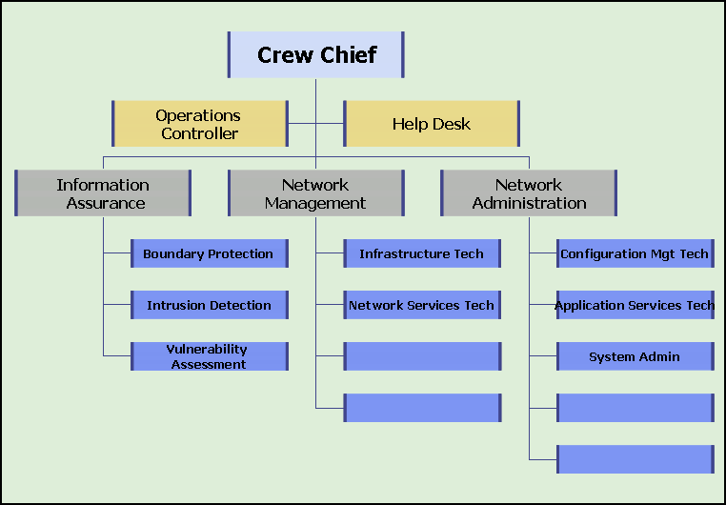

This attachment identifies the crew positions located at each network operations level. The Table illustrates the relationship between tiered-level crew positions and specific MMOC Mission Areas. Crew positions are grouped into three functional areas. These areas are Network Defense (ND), Network Management (NM), and Network Administration (NA).

Crew Positions Definitions

Crew Chief
Crew Chief is responsible include successful mission execution, maintaining crew integrity, and ensuring crew members are trained and certified. Crew Chiefs conduct changeover briefings and prepare daily standup briefings. They coordinate with wing/base-level Operations Security (OPSEC) and counterintelligence (AFOSI) personnel on defense counter-information (DCI) plans/operations, and deconflict NetD activities with on-going aerospace operations and missions. Additionally, they maintain daily logs, coordinate with external customers, and review SITREPs, OPREP3s, INFOCONs, TCNOs, and C4 NOTAMs. Crew Chiefs maintain restoration and recovery plans and procedures and ensure positive control over network defense operations. In short, they maintain tactical and operational control over their assigned crew.

Job Control
TBS

Service Desk Technician
Service Desk technicians are in essence event managers. They utilize a standard trouble ticketing database for inputting, assigning, resolving and closing trouble tickets. Event managers are responsible for maintaining a real-time view of the MMOC network for the ability to perform its designed functions. Service Desk technicians also prepare monthly metrics showing operational performance. Service Desk technicians must be certified in at least one crew position. Service Desk Technicians function at the Tier-1 (DOD 8500.2) and ADP-1 (DOD 5200.2-R) level.

Network Administrator (NA)
This functional area is responsible for central management of server hardware, operating systems and applications. Responsibilities include some of the core services (as outlined in Chapter 6) provided by the MMOC/NCC to the base or MAJCOM populace. The individuals assigned to this functional area are the base experts in system administration and also provide technical assistance to FSAs and CSAs who provide administration support from their servers to their end-user workstations. NA positions cover two three functional areas: Configuration Management, Application Services, and Client Support Administration.
- Configuration Management Responsibilities - Installs and configures the network operating system for all servers to Air Force specifications. Establishes print services and maintains standardized file storage directory structures. Creates user accounts in accordance with Air Force standard naming conventions and provides file, print, and messaging access. Maintains directory services supporting the Air Force Directory, performs preventive maintenance and ensures data recovery capability through proper data backup scheduling and execution.

Application Services Responsibilities - Installs, configures, operates, and maintains network-launched user applications and the trouble ticketing system and its database.

Client Support Administrator Responsibilities - Installation, configuration, and operation of client/server devices. Enterprise Controller

Network Management (NM)
This functional area provides proactive and reactive management of resources by monitoring and controlling the network infrastructure, available bandwidth, hardware, and distributed software resources. Responsibilities include some of the core services provided by the MMOC to the MMOC enterprise. NM responds to detected security incidents, network faults (errors) and user reported outages. Network Management is divided into two primary functional areas, Enterprise Control and Network Management:
- Enterprise Control Responsibilities - Oversee network administration and network management operations for the MMOC enterprise. Responsible for monitoring network management software and generating ad hoc queries for network assistance, and directing courses of action. Enterprise controllers maintain a “watch” on network performance characteristics and infrastructure centers of gravity, and recommend adjustments. They centrally monitor server, user, and server-launched applications to ensure efficient use. They also create and report appropriate metrics within their area of responsibility.
- Network Management Responsibilities - Maintains the NM systems to include backup of these systems. Responsible for collecting and archiving the data necessary to conduct detailed infrastructure mapping and analysis, producing time-sensitive displays and threshold alerts, and developing course of action scenarios. Controls all base IP address space through use of DHCP, or static configuration. Maintains DNS servers for internal and external name resolution. Modifies switch, router, and hub configurations to ensure optimum network performance. Configures access control lists to grant/restrict network access to authorized users and processes. Uses approved NM software and tools to perform their tasks. Infrastructure technicians are experts in operating and configuring routers and switches, in addition to a variety of hubs and transmission media.

Network Defense (ND)
This functional area oversees intrusion detection, boundary protection and vulnerability assessment operations to defend the MMOC enterprise. Network defense controllers develop a network defense visibility display, direct time sensitive adjustments to the network security posture to minimize or counter operational risk, and collect and store the data and metrics necessary to conduct Operational Risk Management (ORM). They also direct security measures such as identification/authentication controls, internal encryption, and intrusion detection for the MMOC under Information Protection Operations.
- Network Defense Responsibilities - Implements and enforces national, DOD, and Air Force security policies and directives. Provides proactive security functions established to assist Air Force organizations in deterring, detecting, isolating, containing, and recovering from information system (IS) and network security intrusions. Monitor, and direct proactive and reactive network information protection defensive measures to ensure the availability, integrity, and reliability of enterprise networked and stand-alone information resources. Uses Air Force standard automated security tools to deter, detect, isolate network intrusions, and recover compromised systems after attack. Performs internal network security assessments, using Air Force standard automated security tools to minimize and/or eliminate threat of network intrusion by proactively probing network defenses to identify vulnerabilities. Ensures systems are compliant with TCNO requirements and updates/reports status. Determines and reports the information protection posture of the base network. Ensures all current network security tools and patches are implemented across all internal base systems. Base will maintain ability to monitor, detect, analyze, summarize report, control, isolate, contain, recover and correct vulnerabilities. Installs, configures, and maintains the MMOC IA suite. Operates and maintains firewall(s), web proxy and caching servers, and E-mail gateway server to protect information resources from internal and external threats.

Voice Controller
Voice Controllers are responsible for operating, managing, and maintaining the VoIP platform and help provide situational awareness of all voice networks Voice Controllers develop VPS security policies, custom report development, recurring and ad-hoc report generation, moves/adds/changes associated with VPS policy, troubleshooting and system maintenance, upgrades system backups, and regular administrative reporting. They are also responsible for coordinating VPS-related issues with individual bases.
Position | General Responsibilities | Primary  Tier | Secondary  Tier | Tertiary  Tier
Crew Chief | MMOC Oversight, Operations Coordination | 2 | 1 | 3
Service Desk | Incident Response, Trouble Ticketing, Tracking, Metrics Generation, Coordination | 1 | 2 | 3
Job Control | PMI Coordination, Scheduling, Logistic support | 1 | 2 | 3
Network Management | Circuit and SONET Monitoring, Outage/Installation Oversight, Crypto Maintenance, Service Provider Interface, WAN/LAN/FW/BW Monitoring,  Outage/Installation Oversight | 2 | 1 | 3
Network Admin | Account Management/Maint/BU, DB Management/Maint/Monitor, Ground System Engineering, Custom and COTS Applications Technical support, Install Ovrsght | 2 | 1 | 3
Network Defense | Intrusion Detection/Security Monitoring, TCNO, SSP Enforcement, Performance Metrics Collection & Reporting | 2 | 1 | 3

Staffing Requirements
The following table describes the shift staffing requirements necessary to operate the MMOC.
Position | # of Personnel Per Shift
Position | Days | Swings | Mids
Crew Chief | 1 | 1 | 1
Service Desk | 1 | .5 | .5
Maintenance Control | 1 | .25 | .25
Transport Services | 1 | .25 | .25
IP Services | 1 | .25 | .25
System / Database Admin | 1 | .5 | .5
Security / Performance Analyst | 1 | .25 | .25
Enterprise Applications Tech | 1 | 1 | 1
Shift Totals | 8 | 4 | 4

Staff Training
Introduction: The objective of this program is to train all network professionals to standardized criteria. Network professionals are those military, DoD civilians, contractors, or local nationals (see paragraph 7.8.4.1.5.), who perform one of the following functions: network administration, information protection operations, network management, crew commander, and WM (if assigned to the NCC/ NOSC/AFNOSC and Communications Squadron). The program ensures network professionals maintain a demonstrable knowledge level and a set of core skills across the customer sets. The certification process outlines knowledge training, performance tasks, and evaluation requirements network professionals must complete to receive position certification. Award of position certification is achieved by completing all knowledge-level training, qualification and certification of performance tasks, and successfully completing training standardization evaluations as outlined in paragraph 7.7. Network Operations Standardization/Evaluation (Stan/Eval) Program (NOSEP). Contractors as Network Professionals. Contractors who provide professional network services (all crew positions) to the customer are bound by the requirements stated in contractual agreements. Contractor personnel assigned to perform specific Network Operations (MMOC) tasks are subject to evaluation. All future contracts (including modifications to existing multiyear contracts) for MMOC tasks, subsequent to this instruction, must cite this instruction and state contractor personnel are subject to evaluation. When results show more training is required, the contract Quality Assurance Evaluator will discuss requirements with the appropriate contracting officer and prepare a proper course of action. Contractor personnel are to be trained in all aspects of the performance for the contract prior to contract award. Measure contractors on their knowledge, skills, and abilities by performance metrics associated with the network services and support to the major command (MAJCOM)/wing/base customers.
Process. Supervisors will use Position Certification for Network Professionals, as the baseline to train network professionals. Other Position Certifications will be used as applicable (e.g., Position Certification for Workgroup Managers;, Position Certification for Network Controllers). These certifications identify Initial Qualification Training (IQT) requirements and crew position-specific Mission Qualification Training (MQT) requirements. Depots may add locally unique training requirements to ensure position certification is comprehensive and meets mission needs. All network professionals must complete the network user licensing program (paragraph 5.) before beginning the appropriate crew-position certification curriculum.
Figure 1. depicts the Network Professional Certification Program process – UPDATE AS REQUIRED
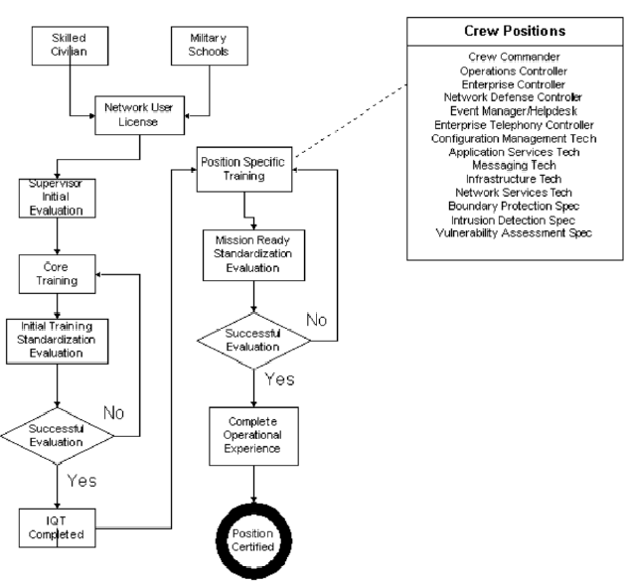

Maintaining Technical Orders (TO)
The purpose of the Air Force Technical Order (TO) system is to provide concise and clear instructions for safe and effective operation and maintenance of centrally-acquired and managed Air Force military systems. All Air Force personnel are responsible for controlling and using TOs as organizational property in conjunction with official duties. Compliance with Air Force TOs is mandatory.
Technical publications are essential for network support to function properly and to provide the operations activity with accurate information. Technical publications include TOs, commercial manuals, and specialized publications. Set up and maintain these publications according to AFPD 21-3, Technical Orders, and 00-5 series technical orders.
Publications Manager.
AFNOSC, theater NOSCs, base NCCs, and any other organizations utilizing CITS equipment will appoint a primary and alternate publications manager. This function could be consolidated with Maintenance Support Flight if available as identified in AFI 21-116, Maintenance Management of Communications-Electronics.
The publications manager will be responsible for:
Establishing an independent TO account with the base Technical Order Distributing Office (TODO). Ensure that the account is on requirement for all the TOs and any associated TCTOs.
Maintaining those TOs required for support of all CITS equipment. Maintain additional TOs required for training and deploying. Ensuring TOs are adequate, accurate and readily available to Network Professionals (TO 00-5-1, Air Force Technical Order System) and maintaining sufficient requirement to support operational load. TOs should not be removed from the primary work locations simply to accommodate the staff.
Identifying any errors, contradictions, or procedures requiring clarification, by following specific procedures in TO 00-5-1. See TO 00-5-1 for specific guidance on preparing AFTO IMT 22, Technical Manual (TM) Change Recommendation and Reply.
Ensuring TCTOs are managed and issued in accordance with procedures in TO 00-5-15, Air Force Time Compliance Technical Order Process. TCTOs are military orders issued by order of the Secretary of the Air Force and as such, shall be complied with as specified in the TCTO.
Utilizing AFMQCC 200-6 (current version) Technical Order Control Check Sheet and other applicable guidance to aid units in maintaining technical order programs.

INFORMATION EXCHANGE & REPORTING

Overview
Air Force network operations organizations exchange information internally, between each other, and with external agencies. Information is exchanged to facilitate the maintenance and operation of the MMOC ENTERPRISE, to provide situational awareness, to facilitate integrated Defensive Counter-Information, and to provide commanders with a common operating picture. The picture is developed from information obtained while conducting MMOC. Generally, the root source of this information comes from “raw” FCAPS data. FCAPS data is monitored, collected, analyzed, processed and reported by the AFNOSC, NOSC, and NCC using software tools that provide a complete view of the AF-GIG. The primary organizations exchanging information are depicted in Figure 5-1.
TO BE SUPPLIED
Figure 5-6: OV-3 Information Exchange & Reporting

Reporting Requirements

Network Status and Management Reports.
Network status and management actions will be reported via scheduled and unscheduled reports. Unscheduled reports focus on the immediate status of the network and are generally tied to events or incidents. Scheduled reports are associated with information exchange and long-term metric analysis.

Reports and Notifications.
Information may be exchanged by network operations organizations internally, between each other, and with external agencies using several types of NTOs, reports, and/or notices. OPREP3, SITREP, TCNO, and C4 NOTAM are some examples of these. (NOTE: AFNOSC/NOSC/NCCs may pass informational copies of OPREP3s or SITREPs, but the issuing authority for OPREP3s is the wing command post.) Manually reported information completes the data collection function and provides the critical human element in the network equation. The human element and the need for timely, accurate information are essential. NM software could potentially automate some manual exchanges, as long as network professionals still maintain positive control over the MMOC enterprise.

Operational Event/Incident Reports (OPREP3).
OPREP3s are reported using operational channels, e.g., Command Posts, to notify commanders immediately of any event or incident that may attract international, national, US Air Force, or significant news media interest. They provide immediate up-channel notification of local network intrusions and probes, INFOCON level changes, and network degradations. They are generally tied to events. An NCC may notify the wing command post of the need to send an OPREP3, and draft the verbiage, but NCCs do not issue OPREP3s. They only forward the draft to the command post and request it be sent. For detailed OPREP3 reporting instructions see AFI 10-206.

Situation Report (SITREP).
SITREPs are submitted through Command and Control channels and are used to report significant outages. This is a narrative report that keeps addressees informed, and enables higher levels of command to prepare for potential effects of ongoing situations. They are submitted at daily, weekly, or monthly intervals, or as directed. Like OPREP3s, an NCC may notify the wing command post of the need to send a SITREP, and draft the verbiage, but NCCs do not issue SITREPs. They only forward the draft to the wing command post and request it be sent. For detailed SITREP reporting instructions see AFI 10-206.

Information Operations Condition (INFOCON).
INFOCONs are used to define a defense posture and response based on the status of information systems, military operations, and intelligence assessments of adversary capabilities and intent. The INFOCON system is a DOD methodology providing a structured approach to react and defend against adversarial attacks on DOD computers and telecommunications systems. This is accomplished by directing actions to establish a heightened or reduced defensive IA posture based on assessed threats or hostilities. INFOCON levels are: NORMAL (normal activity), ALPHA (increased risk of attack), BRAVO (specific risk of attack), CHARLIE (limited attack), and DELTA (general attack). DOD-wide INFOCONs are declared by the Commander, United States Strategic Command (USSTRATCOM), and disseminated by the JTF-GNO to the COMAFFOR to JTF-GNO via AMHS or voice message. The Air Force-wide INFOCON normally mirrors the DOD-wide INFOCON, but may exceed it if conditions warrant. The Air Force Chief of Staff has delegated the authority to set Air Force-wide INFOCONs to the COMAFFOR to JTF-GNO. Official notification for INFOCON changes come through operational reporting channels in the form of INFOCON Change Alert Messages (ICAM), NTOs or OPREP3s. The NOSCs use TCNOs to implement actions to attain INFOCON protection measures. INFOCON level attainment is officially reported by NCCs using SITREPs through command post channels; it is also reported in response to the NOSCs via C4 NOTAM or TCNO compliance.
The SITREP is the official operational report, not the TCNO or C4 NOTAM.
Theater NOSCs will ensure subordinate bases comply with NTOs, directed INFOCON actions via TCNO and track compliance. AFNOSC will compile an Air Force-wide report and forward it to the COMAFFOR to JTF-GNO as appropriate. Subordinate Air Force units (e.g., MAJCOM, NAF, wing, or base level) may declare a higher INFOCON if local conditions warrant.

Time Compliance Network Order (TCNO)
TCNOs are downward-directed operations, security, or configuration management-related orders issued by the AFNOSC or theater NOSCs. The TCNO provides a standardized mechanism to issue one "order" from the AFNOSC to NOSCs/MSCs/NCCs/FACs directing changes to the AF-GIG. TCNOs do not replace INFOCONs, OPREP3s, SITREPs, or Time Compliance Technical Orders (TCTO).
TCNOs may be generated internally to direct the implementation of an operational or a security vulnerability risk mitigation procedure or fix action (e.g., software patch), or issued in response to DISA-generated Information Assurance Vulnerability Alerts (IAVA). TCNOs are used to address Air Force or theater wide incidents/problems and not for isolated internal incidents unless impact is determined to be system-wide. See AFI 33-138 for TCNO reporting and compliance details and formats.

Command, Control, Communications, and Computers Notice to Airmen (C4 NOTAM).
C4 NOTAMs are informative in nature and are not used to direct actions. They are used by all organizations within the MMOC hierarchy. They are the primary means of tracking compliance and disseminating network information that does not require specific actions. However, in some cases, acknowledging receipt of a C4 NOTAM may be required. There are four types of C4 NOTAMs. They are: Informative, Scheduled Event, Unscheduled Event, and Summary. For descriptions of each type of C4 NOTAM and procedures on use refer to AFI 33-138.

FUNCTIONAL ARCHITECTURE

Functional Architecture Overview
The MMOC will perform network management monitoring on all equipment operated or maintained by SC2. When technically possible enable SNMP on all enterprise infrastructure devices, network management servers, security management servers, web proxy servers, firewalls, DNS servers, domain controllers, DHCP servers, and Active Directory servers. Ensure that SNMP connectivity between operational elements, support elements, and external interfaces is fully functional.
When technically possible, develop and enable access control lists or other methods to prevent unauthorized read and write privileges from illicit or rogue management stations.
Disable or remove SNMP on devices if not managed (e.g., printers, plotters, print servers, workstations, etc.) when technically possible.
Ensure SNMP vulnerability scans are run monthly within the theater using vulnerability assessment tools to analyze base networks under NOSC/NCC control.

Continuous Operations Overview

Basic Network Management Services
- Operate 24-hours-a-day, 7-days-a-week
- Network Management - provide data integrity assurance, upgrade control, and configuration management capabilities. Network Fault Resolution – provides fault detection, troubleshooting support, restoration status, and lab support.
- Network Services – provision new communications links, completes all acceptance testing, accepts service, and certifies the new service end-to-end.
- Centralized Control – provide the coordination of rehoming of communications links, call-in of essential personnel, support Job Control/Help Desk activities, coordinate communications problem resolution with external communications agencies/centers, and function as single point of contact on communications for the mission commander.
- Network Performance Analysis - provides performance metrics, trend analysis, and data storage.
- Network Security Administration – provide access control and intrusion detection, and handle information assurance items such as Advisory Compliance Messages, Virus notices and bulletins.
- Interact with DISA, JTF-GNO, theater NOSCs, and the commercial sector to identify and correct anomalies in MMOC networks, systems, and applications.
- Perform Information Dissemination Management.
- Issue NTOs as well as track, document, and report compliance with TCNOs according toAFI 33-138, directing all AF-GIG operational, security, and configuration based changes. Ensure two-person compliance procedures are followed according to AFI 33-138 when implementing TCNOs. Issue Air Force-level C4 NOTAMs according to AFI 33-138.
- Direct all AF-GIG operational, security, and configuration based changes.
- Draft SITREPs according to AFI 10-206, Operational Reporting. Draft Operational Event/Incident Reports (OPREP3) according to AFI 10-206 to document and report significant network events affecting Defense Information Systems Network (DISN) connections not previously reported in SITREPs.
- Provide Help Desk services to theater NOSCs as a focal point for AF-GIG problem resolution.
- Document and track trouble calls to final resolution.
- Utilize Network Common Operating Picture (NETCOP) to consolidate NOSC up-channeled metrics of C4 systems and report overall AF-GIG metrics to SAF/XC, and other senior leaders as required.
- Monitor and report status and critical metrics of MMOCIT services, as defined by the AF-CIO, NIPRNET, SIPRNET, and JWICS connections to senior leaders and theater NOSC, MSC, FAC, and base NCCs as needed or required.
- Supply data to program offices, DISA, JTF-GNO, and other agencies, as required, ensuring systemic Air Force-level problem areas are tracked and fixed.
- Provide status of on-going law enforcement investigations related to computer security incidents to COMAFFOR to JTF-GNO.
- Report to JTF-GNO COMAFFOR validated NetAs, suspicious activities, and security incidents to DOD CERT, GNOSC, Air Force Office of Special Investigations (AFOSI), Information Warfare Flights, theater NOSCs, NCCs, and other activities, in accordance with DOD and Air Force guidelines.

System and Network Management Specifics
- Perform continuous voice, video and data network monitoring and analysis of operations for identification of network availability or degradation events.
- Ensure situational awareness of CITS equipment is maintained and respond/report any system degradation events.
- Manage MMOC level (af.mil and af.smil.mil) DNS, naming convention for the Air Force, maintain a Name Server (NS) record for all MMOC name servers in the af.mil zone and provide technical support for the af.mil and af.smil.mil domain and sub-domains.
- Monitor Air Force-level Internet Protocol (IP) address space.
- Manage the Tactical Internet Protocol (TAC-IP) Program to provide temporary IP address space for deployed units.
- Administer and maintain Air Force-level system capabilities as negotiated in SLAs.
- Manage the USAF Circuit Upgrade Program, identify and report circuits that exceed established thresholds to the Systems Network (AFSN) office.
- Provide and manage external DNS service to assigned bases, and internal DNS service for IT services that are consolidated, and coordinate with AFNOSC Net Operations Division on Air Force-level DNS issues.
- Manage theater-level (theater.af.mil, theater.ds.af.mil, theater.af.smil.mil, and theater.ds.af.smil.mil) DNS and assigned IP addresses. Those theater NOSCs that manage base-level IP addresses will follow guidance in the following paragraphs.
- Perform distributed control of remote access services for the theater. Follow guidance in paragraph
- Provide theater level Core Services (as defined in paragraph 6.4.) to assigned bases.
- Provide Network Time Protocol (NTP) management. NOSCs will use NTP on all systems within the CITS Network Management and Network Defense (NM/ND) boundary to synchronize system clocks with a local Global Positioning System (GPS) receiver. Additionally, ensure that as a minimum NTP is enabled on all core servers and backbone equipment.
- Detect, respond, and report network events affecting operational availability of theater network, user service levels, support to critical applications, and core services to the AFNOSC and others as appropriate.
- Provide technical assistance to assigned NCCs.
- Perform system backup and disaster recovery procedures on NOSC managed core services.
- Maintain capability to filter web sites to meet operational requirements, e.g., MINIMIZE.
- Establish local procedures for notification of MINIMIZE according to Allied Communications Publication (ACP) 121/United States Supplement (US SUP)-1, (C) Communication Instructions General (U).
- Monitor and manage Core Services via tools provided by the CITS Program Management Office.
- Manage internal base DNS if not centrally managed by the theater NOSC.
- Manage all base IP address space through utilization of Dynamic Host Configuration Protocol (DHCP). DHCP will allocate dynamic IP addresses for:
- All noncritical workstations connected to the internal base network. Noncritical workstations will have a lease of 30 days applied to them; this ensures, with relative certainty that the same IP is assigned to a workstation each time a new reservation is issued. In instances where there is a documented IP address shortage for a DHCP scope (e.g., more than 80 % utilization), the lease time can be adjusted to a shorter lease duration for that particular scope so that IP addresses can be recovered more quickly. Remote Access Clients. The use of a remote access modem will be accomplished according to AFI 33-202, Volume 1.
- In coordination with the NOSC, provide and control all remote dial-in/dial-out communications access services. Place the communications server capable of handling dial-in and dial-out services within the CITS network battle management/network defense (NBM/ND) boundary to prevent the possibility of back-door access. This means that organizations will not connect external access devices to the base network. The NCC controls all remote dial-in/dial-out communications services. The NCC will place all remote dial-in/dial-out communications servers (remote access servers) on an alternate interface (not the internal or external interface) of the firewall. If an alternate interface is not available the remote access server will be placed off the external interface of the firewall. ANG NCC. CITS does not provide ANG NCCs with NBM/ND equipment.
- ANG purchases firewalls (CITS supported) for each NCC. The NCC controls all remote dial-in/dial-out communications services. The NCC will place all remote dial-in/dial-out communications servers (remote access servers) on an alternate interface (not the internal or external interface) or the firewall.
- The ANG NCC will use NTP on all systems within the security boundary to synchronize system clocks with a local GPS receiver or approved DOD source. Additionally, ensure that as a minimum NTP is enabled on all core servers and backbone equipment capable of using NTP. Preferably do not allow external NTP sources through the NBM/ND boundary due to inherent security problems. However, ANG NCCs that receive NTP from their upper level ROSC may permit NTP through the firewall by exception only (e.g., IP address to IP address).
- Provide NTP management. NCCs will use NTP on all systems within the CITS NBM/ND boundary to synchronize system clocks according to NCC technical order (TO). Additionally, ensure that as a minimum NTP is enabled on all core servers and backbone equipment capable of using NTP. Do not allow external NTP sources through the NBM/ND boundary due to inherent security problems.
- Provide messaging services to base-level users [e.g., AMHS and Simple Mail Transfer Protocol (SMTP) electronic mail]. NCCs are not required to do this if the NOSC is performing these duties.
- All MMOC users will have an E-mail address. This is a mandatory compliance issue.
- E-mail accounts will remain active and available for 60 days following a member’s permanent change of station (PCS) or separation.
- All client devices using the base wireless infrastructure will meet the requirements specified in AFI 33-202, Volume 1.

Information Assurance/Network Defense Specifics
- Perform continuous network monitoring operations for identification of on-going attacks against the network or interconnected systems.
- Provide real-time analysis, response and reporting according to AFI 33-138 for network attacks and security incidents.
- Correlate network events with supporting network data, threat data, and technical vulnerability information.
- Maintain global situational awareness of events threatening MMOC networks.
- Manage MMOC long-haul user VPN.
- Maintain secure communications with NOSCs.
- Update Access Control Lists on SDP routers.
- Analyze MMOC security posture using security management software tools such as intrusion detection and vulnerability assessment.
- Analyze customer impact of all network incidents, problems and alerts, and develop corrective actions or management changes.
- Require network defense countermeasures and other defensive or corrective actions in response to command direction, INFOCONs, or vulnerability alerts.
- Develop and/or exercise contingency plans to continue operations in at least one location in the local area and at least one location outside the local area in the event of natural or unnatural disaster, utilities failure, and contractor issues.
- Conduct NetA assessments, correlate incidents, conduct spot check compliance, and conduct on-line surveys for suspicious activities (internal and external) across MMOC network domains. Notify COMAFFOR and the JTF-GNO of attacks and suspicious activities. Conduct trend analysis to determine patterns of attack.
- Conduct and manage MMOC vulnerability analysis and assistance functions in accordance with AFI 33-207, Computer Security Assistance Program. Notify COMAFFOR to JTF-GNO of technical vulnerabilities impacting MMOC computers and computer networks.
- Provide situational awareness and status to leaders at all levels based on their operational needs.
- Serve as the MMOC single point-of-contact for receiving reports from and reporting computer security incidents and vulnerabilities to organizations external to the Air Force.
- Assist the AFNOSC (and DISA when requested through the AFNOSC) with ensuring presence of on-site personnel when requested by AFNOSC Net Operations Division to perform troubleshooting procedures to restore faulty, MMOC owned and operated, WAN transmission equipment and circuits.
- Establish SLA, MOA, or MOU with Main Operating Bases (MOB), GSUs, tenant units, Air Force, and MAJCOM functional communities of interest defining agreed upon levels of support.
- Additionally, maintains SLA, MOA, or MOU with other NOSCs for providing back–up services as needed.
- Centrally operate and manage boundary protection and intrusion detection tools for all bases within their respective theater. This can be accomplished by either physically consolidating the servers at the NOSC or using remote management.
- Protect against unauthorized intrusions and malicious activities; monitor and report intrusion detection activity according to AFI 33-138.
- Monitor, detect, and implement NetD actions.
- Maintain secure communications with customers who require it.
- Use vulnerability assessment software tools to analyze base networks under NOSC control for potential vulnerabilities and research/recommend appropriate protective measures. Report suspected vulnerabilities and recommended protective measures to the customers’ Net Security Division. Ensure vulnerability scans are run quarterly within their theater of responsibility.
- Assists in developing a theater-level network security policy according to AFI33-202,Volume 1.
- Provide any network reports requested by the theater IA office required for Certification and Accreditation (C&A) of theater unique systems.
- Analyze customer impact, within the theater, of all network incidents, problems and alerts, and develop corrective actions or management changes.
- Manage desktop services (paragraph 6.4.4.), consolidating services to the NOSC as best fits the operational mission.
- Any new applications and their server(s), core services, network services, or desktop services and storage requirements shall meet the intent of the server consolidation architecture using remote management, co-location or shared hosting consolidation as appropriate to the operational mission in their initial operational capability and full operational capability.
- Provide visibility of the theater network (NIPRNET and SIPRNET) to theater commanders and directors.
- Provide NCCs, within the respective theater, visibility into NOSC-managed devices for local situational awareness.
- Oversee implementation of policies, procedures, and special instructions to NCCs.
- Support deployable operations and maintain joint capabilities.
- Provide engineering guidance to plan, install, operate, and maintain base network hardware and software.
- Perform NOSC-level systems control, maintenance, and administration functions within the theater network.
- Perform Telephony Management and Voice Protection.
- Provide centralized management and administration of the enterprise-wide Enterprise Telephony Management (ETM) platform.
- Modify the active security policy (rule set) in the ETM platform as directed by higher headquarters to react to events, anomalies, and emergencies.
- Maintain trained FSAs proficient in maintaining the server’s operating system and ETM platform specific software.
- Utilize platform to generate command-wide reports (as needed) and ensure real time visibility of voice networks.
- Perform all management tasks for Fault, Configuration, Accounting, Performance, and Security (FCAPS).
- Fault management tasks include but are not limited to detection, documentation and resolution of, application system faults, system detected telecommunication faults and supporting infrastructure faults.
- Configuration management tasks include but are not limited to collection, configuration and identification of technical information of the VPS and the system’s infrastructure, (e.g., IPs and network IDs, firewall exceptions, Telco Trunk nomenclatures, telephone numbers and switching items, etc.)
- Accounting management tasks include but are not limited to control and maintenance of user accounts, system access passwords, telephony authorized control list (ACL) and firewall exceptions request.
- Performance management tasks include but are not limited to control, manipulation, report generation and analysis of system collected data for base, theater and MMOC level management decision.
- Security management tasks include but are not limited to detection, documentation, reporting and denial of access to unauthorized telephony exploitation.
- Provide capability to automatically and continually capture, store, archive, and retrieve network topology and application traffic data for the purposes of all engineering functions listed in this document.
- Achieve full operational capability within 4 hours after notification in situations requiring increased operations tempo surge manning.
- Partner with the customer records manager to ensure records management procedures are implemented and sustained for all enterprise storage services.
- Operate 24-hours-per-day, 7-days-per-week (with either continuous manning or on-call after-hours response capability).
- Ensure presence of on-site personnel when directed by customers.
- Perform vulnerability assessments to test and validate security of networks and systems. If vulnerabilities are discovered, provide appropriate systems administrators, unit commanders, DAA, wing and theater IA offices, and AFNOSC with test results and recommendations. Report vulnerabilities found according to AFI 33-138.
- Conduct daily traffic analysis, identify and characterize incidents, and generate incident reports with Air Force approved intrusion detection tools. Investigate each item to clarify and resolve suspicious activity. Report validated suspicious activity according to AFI 33-138. The NCC does not need to perform this function if it is done at the theater NOSC. (Does not apply to ANG NCC. ANG ROSC performs this function.)
- Review AFNOSC advisories and verify systems under NCC control are protected against documented vulnerabilities.
- Notify information systems security officers (ISSO), CSAs, FSAs, and/or users when their computers have weak configurations, vulnerabilities, and when they have been accessed, exploited, or destroyed by unauthorized persons or machines.
- Put users of MMOC computer systems, including computers connected to a network, stand-alone computers on notice that their use constitutes consent to monitoring as specified in AFI 33-219, Telecommunications Monitoring and Assessment Program (TMAP).
- Equip all servers within the CITS NBM/ND boundary with host-based intrusion detection and network security analysis and scanning tools.
- Identify weak configurations and security holes by auditing and monitoring events occurring on the network.
- Monitor and trend audit and error logs for security violations.
- Test and validate network security to establish and maintain a target baseline for MMOC owned systems.
- Identify and secure computer systems on an affected network. Identify computers with exploited vulnerabilities.
- Provide any network reports requested by the wing IA office required for C&A of base networks and systems.
- Coordinate on all base unique System Security Certification & Accreditation packages or requests.
- Develop local procedures to report and respond to computer security and virus incidents. . Work with the customers’ IA office to identify internal actions such as local reporting channels, criteria for determining who is notified, etc.
- Perform local NetD actions and respond to NOSC or AFNOSC direction.
- Analyze customer impact, within the base, of all network incidents, problems and alerts, and develop corrective actions or management changes.

Information Dissemination Management Specifics
- Implement, track, document, and report compliance with TCNOs.
- Issue NTOs, implement, track, document and report compliance with TCNOs.
- Ensure two-person compliance procedures are followed according to AFI 33-138 when implementing TCNOs.
- Issue and review all C4 NOTAMs for applicability to all theater unique information systems according to AFI 33-138.
- Draft SITREPs according to AFI 10-206. Draft OPREP3s according to AFI 10-206 to document and report significant network events affecting theater-level systems.
- Provide Service Desk services to NCCs and other NOSC customers for the theater; forward lessons learned and situations requiring additional assistance to next upper level tier Help Desk.
- Draft SITREPs according to AFI 10-206. Draft OPREP3s according to AFI 10-206 to document and report significant network events affecting base-level systems.
- Provide Service Desk services to MMOC users and serve as focal points for network, to include MMOC IT services, problem resolution. Forward lessons learned and situations requiring additional assistance to next upper level tier Service Desk.

Network Operations Requirements
- Provide a core set of office automation application support services.
- Implement software patches and security fixes as required by the SC2
- Report events not previously detected .
- In coordination with NOSC, plan, install, operate, and maintain base network hardware and software.
- Perform regular day-to-day system backup and recovery operations on MMOC managed servers. At a minimum of once a quarter, test recovery procedures to ensure procedures are accurate and operational.
- Develop local restoral and contingency operations plans from existing operations/ war plans. Validate restoral plans by testing them on at least a biannual basis.
- Maintain network and facility configuration, migration, and upgrade plans.
- Perform fault management for the local base network.
- Dispatch technicians to unmanned or user and subscriber locations when required to test, troubleshoot, and restore service.
- Coordinate with job control subscribers, local and distant support agencies, and contractors to isolate faults, restore service, and make repairs.
- Ensure a trouble-call process is established.
- Provide network and small computer maintenance support to CSAs and FSAs.
- Provide technical support to FSAs and CSAs when requested and maintain an electrostatic discharge maintenance area. See TO 00-25-234, Chapter 7, for guidance.
- Perform fault isolation to the line replaceable unit (LRU) and line item equipment level. Fault isolation methods include automated diagnostics and sound troubleshooting techniques.
- Perform configuration management for the local base network. Work with the functional on base for implementation of systems. Provide a database of ports, protocol and services that are associated with a particular system..
- Prepare and update network maps and facility equipment listings.
- Establish a maintenance contract and warranty plan according to Chapter 10.
- Establish a license management program according to AFI 33-114, Software Management, to ensure authorized usage for base network software.
- Perform information technology (IT) equipment custodian (EC) duty for MMOC equipment
- Provide assistance, when needed, and perform cryptographic equipment updates on devices under the control of the MMOC.
- Provide network/MMOC hardware and software installation service.
- Hardware: NCCs install and configure network servers, routers, hubs, bridges, repeaters, and servers. They test and document equipment installation acceptance testing. The ANG shall follow NOSC direction for centrally managed enterprise systems (AD, Exchange, etc).
- Software: NCCs receive and inventory network software according to AFI 33-114, test and validate new software applications and network operating systems.
- Distribute and install network software releases and updates, and assist customers with software installation and customization.
- Install and configure SMTP hosts, relays, and gateways.
- Review site license agreements and remove software from systems when no longer required or authorized. Dispose or redistribute excess software according to AFI 33-114.

Resource Scheduling / Job Control
TBS

Aperiodic Operations Overview

Account Management
TBS

Network Management Planning
- Collate local and long-haul customer telecommunications circuit information.
- Verify current network configurations against other agency databases and forward corrections as required. (May be performed in your circuit actions office.)
- Perform customer-wide configuration standardization and interface engineering.
- Prepare and update in-station system block diagrams, network maps, and facility equipment listings; maintain network and facility configuration plans; perform minor network engineering; monitor management information base variables; and advise and make recommendations on new systems to customers.
- Review Project Support Agreements (PSA) and coordinate corrections with the appropriate agencies.
- Coordinate with Engineering and Installation (EI) teams and/or commercial vendors prior to arrival and prepare the facility for installation team.
- Escort and assist team chiefs with installation or upgrade projects.
- Complete DD Form 250, Material Inspection and Receiving Report; AFIMT 1261, Communications and Information Systems Acceptance Certificate; and EI critiques for customers with this requirement.
- Perform contract management for customer network support.
- Consolidate and evaluate customer-wide MMOC-managed network and system components as candidates for contract maintenance support.
- .
- Assist the plans function in the preparation of quality assurance surveillance plans and perform contract quality assurance evaluation functions as identified.
- Perform customer network budget planning.
- Develop/submit budget input and request higher-level funding for all MMOC requirements and operations functions.
- Monitor customer network funds availability.
- Remotely perform the functions and duties of a Defense Communications System (DCS) Primary Systems Control Facility (PSCF), patch and test facility, DCS switching center, or other DCS operations function, when it is technically and economically feasible and does not degrade quality of service in accordance with DISA procedures., the NCC takes over the responsibility and authority of the PSCF for DCS service control.

Performance Management
- Consolidate enterprise network performance data, security data, and analysis reports, pulling information from the Air Force MMOC hierarchy as needed. Use the consolidated information to identify causes of service, performance, and security flaws. On the basis of the aggregated analysis, recommend changes in network configurations, hardware or software, procedures, and staff training.
- Monitor and optimize network performance.
- Coordinate installation, acceptance testing, quality assurance, fault isolation, and restoration of the infrastructure with the base’s other communications unit functions.
- Maintain capability to filter web sites to meet operational requirements (e.g., MINIMIZE).
- Establish individual circuit and system parameters on non-DCS circuits. Develop the parameters according to DISAC 300-175-9, DCS Operating Maintenance Electrical Performance Standards, supplemented by commercial-leased equipment and circuit performance standards.
- Establish initial performance thresholds according to systems and circuit operation specifications and operational or mission requirements.
- Remotely test subscriber equipment, end-to-end circuits, systems, and networks to verify the services provided and input and output signals meet standards.
- Adjust remote network element equipment to optimize service.
- Record configuration data, test data, failure symptoms, coordination efforts, fault isolation steps performed, and any other useful information. Use this information to evaluate and control operations, service capabilities, and service quality.
- Report to management on quality of infrastructure services.
- Perform system diagnostics and set global alarm thresholds and system parameters.
- Utilize performance tools to ensure optimum network operation, monitor system logs, analyze bandwidth utilization, and set global parameters to prevent adverse effects to the overall communications network. Core systems must have critical path redundancy.
- Perform network/circuit Quality Control (QC) testing and evaluation.
- Generate and update QC schedules.
- Plan, provide, coordinate, and verify alternate service during QC testing.
- Access and monitor Preventative Maintenance Inspection (PMI) schedules published by the maintenance control work center.
- Coordinate in-service/out-of-service QC testing and performance of PMIs with affected work centers and external agencies.
- Coordinate and deactivate alternate service once testing/PMIs are completed and original circuit/equipment is verified operational.
- Analyze QC performance trend analysis data (collected through in-service/ out-of-service QC testing) to identify trends or patterns of circuit/system/network degradation, dispatch to and from user locations when required, and generate and analyze outage reports.
- Submit DD Form 1368, Modified Use of Leased Communication Facilities, when required, and research, prepare, and submit QC waiver requests when necessary, in the absence of a systems control facility.
- Conduct security management for the local base network.
- Conduct Information Protection Operations (IPO) according to applicable security publications and TTPs.
- Install and set up audit tools.

Security Auditing

Backups / Disaster Recovery

Operational Transition Support

Service Desk

Service Desk Overview
The MMOC Service Desk provides a strategic, centralized entry point for Mission Operations and supports the Incident Management process by providing an operational single point of contact to manage incidents to resolution.

Service Desk Description
The Service Desk is the single point of contact between the OASES sustainment organization and MMOC Users, on a day-to-day basis. It is also the entry point for reporting Incidents and making service requests. As such, the Service Desk will keep Users informed of service events, actions and opportunities that are likely to impact their ability to pursue day-to-day Operational activities. The Service Desk handles incidents and service requests, as well as providing an interface with users for other Service Management activities such as Change, Problem, Configuration, Release, Service Level and IT Service Continuity Management. The MMOC Service Desk examples include acting as the focal point for Change Requests from Users, issuing Change Schedules on behalf of Change Management, and keeping Users informed of progress on Changes. Though not a process, the Service Desk is an important function within the service support set. It is the first, and generally, single point of contact (SPOC) for users.
To the service desk, Mission Operations and users are the entry point to the process model. They get involved in service support by:
• Asking for changes
• Needing communication, updates
• Having difficulties, queries.
The Service Desk is the single contact point for Mission Operations to record their problems. It will try to resolve it, if there is a direct solution or will create an incident. Incidents initiate a chain of processes: Incident Management, Problem Management, Change Management, Release Management and Configuration Management (see following sections for details). This chain of processes is tracked using the Configuration Management Database (CMDB), which records each process, and creates output documents for traceability (Quality Management).
The MMOC Service Desk also seeks to facilitate the integration of Operations processes into the Service Management infrastructure. In addition to actively monitoring and owning Incidents, user questions and providing the communications channel for other Service Management disciplines with the user community, the Service Desk also provides an interface for other activities such as Mission Operations Change requests, third parties (e.g. maintenance contracts), and software licensing.
The Service Desk plays an important role in user support. A full blown Service Desk serves as the front office for the other IT areas, and can deal with many Mission Operations queries without needing to contact specialist personnel.
At the heart of a Service Desk operation is a sophisticated database that contains all the information necessary to handle events. The Service Desk assists CLS providing end-user support, The Service Desk is actually a global repository of information or knows where to retrieve information about customers, vendors, hardware, software, locations, networks, SLAs, problems, and solutions. The database also identifies the interrelationships among these items.
The Service Desk will provide network assistance and trouble resolution and will be based on a fully integrated trouble ticketing system. The trouble ticketing system will be able to automatically assign priorities and set response times and escalation timelines based on the criticality of the system being reported on. The trouble ticketing system will be able to share and communicate fix actions across all three network tiers.
The primary process is Incident Management as many incidents are recorded (logged) and monitored by the Service Desk, and many Service Desk calls are related to incidents. This includes coordinating third-party activities involved in incident handling.
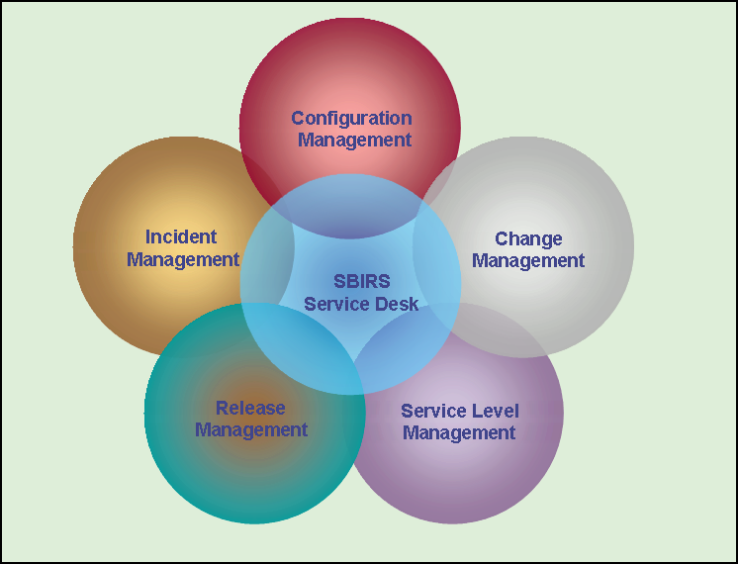
Figure 6-7 MMOC Service Desk Relationships

The Service Desk will undertake activities concerning standard requests, such as installing LAN connections and relocating workstations in which case it will contribute to the evaluation of changes and be involved in Change Management.
By serving as an initial point of contact, the Service Desk reduces the workload on other IT departments by intercepting irrelevant questions and questions which are easily answered. The Service Desk acts as a filter that only lets calls through to second and third-line support where this is actually necessary. As an initial point of contact it always acts professionally when dealing with users and ensures that they do not have to search endlessly for a solution.
One of the major tasks of the Service Desk is ensuring the accessibility of the IT organization. Users will be encouraged to call the Service Desk if they have any questions or need any support. The way calls are processed can be monitored with reports produced by the PABX.
To make a reliable impression, the Service Desk will be consistent and efficient in Mission Operations contacts. This will be supported by procedures based on questionnaires and standard responses.
A number of different media will be used to improve accessibility (SSN, Classified Voice, Unclassified Voice, Unclass e-mail, etc…).
Calls will be divided into incidents concerning the technical infrastructure, incidents and questions about the use of an application, questions about the status of the services (incident progress), standard changes, and other requests.

Service Desk Objectives
The objective of the Service Desk is to support the provision of the services that have been agreed upon by guaranteeing access to the IT organization and undertaking a range of support activities (from various processes).
By serving as an initial point of contact, the Service Desk reduces the workload on other IT departments by intercepting irrelevant questions and questions which are easily answered. The Service Desk acts as a filter that only lets calls through to second and third-line support where this is actually necessary. As an initial point of contact it always acts professionally when dealing with users and ensures that they do not have to search endlessly for a solution.

Service Desk Functions &Goals
- Dedicated Service Desk Function Owner
- Centralized function for incident and request handling
- Ongoing monitoring and management of Mission Operations satisfaction
- Strong levels of incident communications and ownership
- Right level of support and Mission Operations care skills among Service Desk staff and management

Service Desk Roles & Responsibilities
The two main focuses of the Service Desk are: Incident Control and Communication.

The common Service Desk role functions include:
- Receiving calls, first-line Mission Operations liaison
- Recording and tracking incidents and complaints
- Keeping Mission Operations informed on request status and progress
- Making an initial assessment of requests, attempting to resolve them or refer them to someone who can
- Monitoring and escalation procedures relative to the appropriate requirements / agreements
- Identifying problems
- Closing incidents and confirmation with the Mission Operations
- Coordinating second-line and third line support when necessary

Responsibilities of the Service Desk are:
- Providing a single (informed) point of contact for Mission Operations
- Facilitating the restoration of normal operational service with minimal Operations impact on the Mission Operations within agreed levels and Operations priorities.
- The Service Desk will have access to a Knowledge Base, which will contain a list of known solutions for common incidents. Queries or incidents can be solved by the Service Desk staff without taking time from skilled IT technicians.
- A Service Catalogue will be available which lists all of the services that IT provides to the Operations. This catalogue will list the services from a Users perspective.
- The Service Desk will be given delegation to implement Changes to circumvent Incidents within its sphere of authority. The scope of such Changes will be predefined and the Change Management function will be informed about all such Changes. Prior approval of Change Management is essential before Changes of specification of any CI are implemented.

Service Desk Key Activities
The key activities for this the Service Desk are:
- Provide advice and guidance to Mission Operations
- Communicate and promote IT services
- Manage and control service communications to Mission Operations, suppliers and the Operations
- Coordinate Incident Management activities
- Manage people, processes and technologies that form the contact infrastructure
- Provide management information about Service Desk quality and operations

Service Desk Specific Activities

Responding to calls
A call means that a user contacts the Service Desk. All calls will be logged to facilitate progress monitoring and provide metrics for process control.
There are two call categories:
- Incidents: in essence all calls, except those relating to standard changes:
- Error reports: true faults and complaints about the service
Service Requests: Service Requests are classified in ITIL as incidents, but do not involve a failure in the IT infrastructure. Service Requests also do not fall into the Change Management category. Examples include, "How do I?" questions, requests for information, e.g. status inquiries, documentation or advice, requests for password resets, batch job runs, file restores or database extracts, requests for consumables (including replacement of a mouse, keyboard, etc., if these are not CIs), supply of documentation eg. user manuals, etc.
Changes: in most cases these will be standard Requests For Change (RFC). In some cases, the Service Desk will also be responsible for relocating hardware. A standard change is in fact a routine change to the infrastructure that follows an established path, and is the accepted solution to a specific requirement or set of requirements. Examples include an upgrade of a PC in preparation for the use of specific software, setting up PC, software and network connections for new hires, straightforward standard installations and standard orders for workstations, peripherals and local applications. The key difference between a Service Request and a standard change is that the former is a request for service logged as an incident that does not involved a change to the IT Infrastructure, whereas the latter is logged as a change and does involve a change to the infrastructure.

Providing information
The Service Desk will serve as the main source of information to users. This can be done passively (e.g. by providing a bulletin board), or actively (e-mails, on-screen log-in messages, or screen saver messages). All efforts will be made to inform users about current or expected errors, preferably before they are affected. The Service Desk will also provide information about new and existing services, provisions of the Service Level Agreements (SLAs) and order procedures and costs.

Supplier liaison
The Service Desk is often responsible for contacts with maintenance suppliers. This covers the repair and replacement of printers, workstations and, in some cases, telecommunications equipment. This type of maintenance will be involved in handling incidents in the pure sense (disturbances) as well as incidents in terms of changes and service requests.

Operational Support management tasks
Ops Support management tasks include making back-ups and restores, providing LAN connections, disk space management on local servers, creating accounts, authorizing and resetting passwords.

Infrastructure monitoring
On the Service Desk, tools can be used to estimate the impact of faults affecting essential equipment, such as routers, servers and gateways, mission-critical systems, applications, and databases. Often, these tools can detect faults and inform Incident Management automatically when a fault has occurred or is threatening. It is not necessary that these tools are used at the Service Desk, since this is a primary task of "Operations” that will be feeding the information to the Service Desk.

Service Desk Critical Success Factors
The Critical Success Factors (CSFs) are:
- Ensure long term Mission Operations satisfaction
- Assist in the identification of Operations opportunities
- Reduce support costs by the efficient use of resource and technology

Service Desk Key Performance Indicators
- Ensure Long Term Mission Operations Satisfaction
- Percent Of Mission Operations Given Satisfaction Surveys
- Mission Operations Satisfaction Rating Of Service Desk
- Percent Of Caller Hold Times Within Service Targets
- Percent Of Calls Responded To Within Service Targets
- Number Of Incident Records Not Yet Closed
- Number Of Calls Abandoned
- Assist In The Identification Of Operations Opportunities
- Number Of Calls Referred To Sales Organization
- Dollar Value Of Referred Calls To Sales Organization
- Reduce Support Costs By Efficient Use Of Resources and Technologies
- Percent Of Calls Resolved At The Service Desk Without Escalation
- Staff Turnover Rate
- Overall Cost Per Call

Service Desk Reporting & Metrics
The Service Desk will regularly verify if it meets the defined standards. Appropriate metrics include:
- Percentage of incidents which will be closed without resorting to other levels such as second or third-line support or suppliers.
- The number of calls handled per workstation/user and the total for the Service Desk.
- Average incident resolution time, by impact, or time to realize a service request. Both the cycle time and the time actually spent on the case will be specified.
- PABX reports on the average answer time, number of calls prematurely terminated by users, average call duration, and relative metrics per Service Desk agent.
Standards can be set for those metrics, which are then used to monitor improvement or deterioration of the service. The Service Desk effectiveness can also be measured through regular surveys in the Mission Operations organization.

Incident Management

Incident Management Overview
The objective of Incident Management is to restore normal operations as quickly as possible with the least possible impact on either the Operations or the user, at a cost-effective price.

Incident Management Description
An 'Incident' is any event which is not part of the standard operation of the service and which causes, or will cause, an interruption or a reduction of the quality of the service.
Inputs for Incident Management mostly come from users, but can have other sources as well like management Information or Detection Systems. The outputs of the process are RFC’s (Requests for Changes), resolved and closed Incidents, management information and communication to the Mission Operations.
There is close interface between the Incident Management process and the Problem Management and Change management processes, as well as the function of Service Desk. If not properly controlled, Changes will introduce new Incidents. A way of tracking back is required. Therefore, incident records will be held on the same CMDB as the Problem, Known Error and Change records, or at least linked without the need for re-keying, to improve the interfaces and easy interrogation and reporting.
Incident priorities and escalation procedures need to be agreed as part of the Service level Management process and documented in the SLAs.
The Problem Management process requires the accurate and comprehensive recording of Incidents in order to identify and efficiently the cause of the Incidents and trends. Problem Management also needs to liaise closely with the Availability Management process to identify these trends and instigate remedial action
'Real World' definition of Incident Management: IM is the way that the Service Desk puts out the 'daily fires'.

Incident Management Objectives
For the MMOC System as a whole:
- More timely resolution of incidents resulting in reduced Operations impact.
- Improved user productivity.
- Independent, Mission Operations-focused incident monitoring.
- Availability of SLA-focused production information.
For the IT organization:
- Improved monitoring, allowing performance against SLAs to be more accurately measured.
- Useful management and SLA reporting by effective use of the available information.
- Better and more efficient use of personnel.
- No lost or incorrectly registered incidents and service requests.
- More accurate CMDB, as it is essentially being audited while incidents are registered in relation to CIs.
- Improved user and Mission Operations satisfaction.

Incident Management Functions & Goals
Functions of the Incident Management process:
- Incident detection and recording
- Classification and initial support
- Investigation and diagnosis
- Resolution and recovery
- Incident closure
- Incident ownership, monitoring, tracking and communication
Goals of the Incident Management process:
- ITIL-aligned Incident Management Policies, Processes and Procedures
- Incident escalation standards
- Dedicated Incident Management Process Owner
- Incident classification categories
- Incident reports
- Incident communications and education for IT staff

Incident Management Roles & Responsibilities
Processes cut horizontally across the hierarchy of the organization. This is only possible if the responsibilities and authorities associated with the implementation are clearly described. To provide flexibility it will be useful to use an approach based on roles. In smaller organizations, or to reduce costs, roles will be combined for example Change Management and Configuration Management.

Incident Manager
The role of the Incident Manager is assigned to the Service Desk. The Incident Manager is responsible for:
- Monitoring the effectiveness and efficiency of the process
- Controlling the work of the support groups
- Making recommendations for improvement
- Developing and maintaining the Incident Management system

Support group personnel
- First-line support is responsible for recording, classifying, matching, routing, resolving and closing incidents.
- The other support groups are primarily involved in investigation, diagnosis, and recovery, all within the set priorities.

Incident Management Process
Incident acceptance and Recording - the call is accepted and an incident record is created.
Classification and initial support - the incident is coded by type, status, impact, urgency, priority, SLA, etc. The user will be given suggestions to solve the issue, even if only temporarily.
If the call concerns a Service Request the relevant procedure is initiated.
- Matching - it is investigated if the incident is known, and possibly related to a problem or known error, and if there is a solution or a work-around.
- Investigation and Diagnosis - if there is no known solution then the incident is investigated.
- Resolution and Recovery - once the solution has been found, the issue can be resolved.
- Closure - the user is asked if they are satisfied with the solution and then the incident can be closed.
- Progress monitoring and tracking - the entire incident cycle is monitored, if it appears that an incident cannot be resolved in time, then escalation will occur.

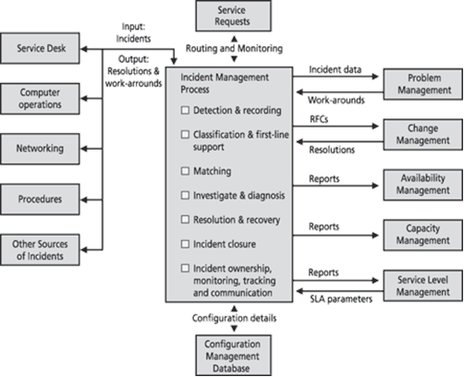
Figure 6-8 Incident Management High Level Process

Incident Management Severity Codes
An adjudication board will convene to establish the severity of a DR after it has been submitted. Examples of such boards are the MMOC Software Control Board (SWCB) and the MMOC Hardware Control Board (HWCB). The discrepancy severity codes are defined as follows:

Sev 1 Critical “System Abort”
Prevents the accomplishment of an operational mission-essential capability; Jeopardizes safety of system, vehicle, payload or personnel

Sev 2 High “System Degraded - No work-around”
Adversely affects the accomplishment of an operational or mission-essential capability for which no alternative work-around solution is known. Program restarts/reboots are not acceptable work-around solutions.

Sev 3 Medium “System Degraded - Work-around exists”
Adversely affects the accomplishment of an operational or mission-essential capability but a work-around solution is known.

Sev 4 Minor “System not degraded”
Results in user/operator/maintainer inconvenience or annoyance but does not degrade a required operational mission-essential capability.

Sev 5 Cosmetic “Minor Change”
Any other change is classified as severity level 5. Many documentation changes are considered severity level 5.

Incident Management Terminology

Incident
An incident is any event which is not part of the standard operation of a service and which causes, or will cause an interruption to, or a reduction in the quality of that service. Incidents include not only hardware and software errors, but also Service Requests, defined as requests from a user for support, delivery, information, advice or documentation, not being a failure in the IT infrastructure.
Examples of Service Requests:
- Functional question or request for information
- Status inquiry
- Password reset
- Requests for batch jobs, restores and password authorizations
- Database extraction
It is important to note that a Service Request is not the same as a Request For Change (RFC):
Request For Change-Form, or screen, used to record details of a request for a change to any Configuration Item (CI) within an infrastructure or to procedures and items associated with the infrastructure.
An RFC is completed when changes to the infrastructure are made, e.g. the replacement of registered components, installation of a PC, etc. These are not incidents but changes.

Impact, urgency and priority
When several incidents are being dealt with at the same time, priorities have to be set. These priorities are based on the seriousness of the error to the Operations and the user. In consultation with the user, and in accordance with the provisions of the SLA, the Service Desk assigns the priority, which determines the order in which incidents are dealt with. When incidents are escalated to second-line (tier two), third-line (tier three) or higher level support, then the same priority is maintained, or it will be adjusted in consultation with the Service Desk.
Of course, each user will think that their incident has the highest priority, but user requirements are often subjective. To make an objective assessment, the following criteria are discussed with the user:
Impact of the incident: extent of the deviation from the normal service level, in terms of the number of users or Operations processes affected.

Urgency of the incident: the acceptable delay to the user or Operations process.
The priority is determined on the basis of urgency and impact. The number of people and the amount of resources that can be devoted to an incident are defined for each priority. For incidents with the same priority, the required effort can determine the order in which they are dealt with. For example, an incident that is easily resolved will be dealt with before an incident requiring a greater effort.
Incident Management has options for reducing the impact or urgency, such as swapping hardware or assigning another print queue. The impact and urgency will also change during the life of an incident, for example when it affects more users or during critical periods.
Impact and urgency is combined in the Escalation matrix depicted below.

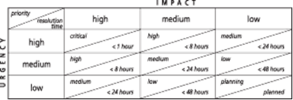
Figure 6-9 Incident Escalation Matrix

Escalation
If an incident cannot be resolved by first-line support within the agreed time, then more expertise or authority will have to be involved. This is known as escalation, which is determined by the priorities and resolution times discussed above.

Functional escalation (horizontal)
functional escalation means involving more specialist personnel or access privileges (technical authority) to solve the incident, and departmental boundaries will be exceeded.

Hierarchical escalation (vertical)
hierarchical means that a vertical move is made (to higher levels) throughout the organization because the authority (organizational authority, powers) or resources required for resolution are insufficient.
The Incident Manager aims to reserve capacity in advance for functional escalation in the line organization, so that incident resolution does not require regular hierarchical escalation. In all cases, the line organization has to provide adequate resources for the process.

First-, second- and Nth-Tier support
Incident routing, or functional escalation, was introduced above. The routing is determined by expertise, urgency and authority. First-line support (also known as tier 1 support) is normally provided by the Service Desk, second-line by the management departments, third-line by the software developers and architects, and the fourth-line support by suppliers. The smaller the organization, the fewer escalation levels there are. In larger organizations, the Incident Manager will appoint Incident Coordinators in relevant departments to support him or her. For example, the Coordinators act as the interface between the process and the line organization. They each coordinate their own support teams. Figure 4.3 illustrates the escalation process.

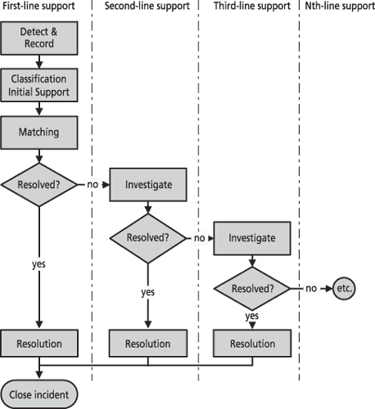
Figure 6-10: Incident Management High Level Escalation Process

Incident Management Key Activities
The key activities for this process are:
- Detect and record incidents
- Classify incidents
- Provide initial incident support
- Prioritize incidents based on impact and urgency
- Investigate and diagnose incidents
- Resolve incidents and recover service per agreed service levels
- Close incidents
- Maintain ownership, monitoring, tracking and communications about incidents
- Provide management information about Incident Management quality and operations

Incident Management Specific Activities

Incident Sources
Incidents can be noticed as follows:
- Noticed by a user: who reports the incident to the Service Desk.
- Detected by a system: when an application or technical infrastructure event is trapped, such as when a critical threshold is exceeded, the event is logged as an incident in the incident recording system, and where necessary routed to a support group.
- Noticed by a Service Desk agent
- Noticed by someone in another IT department: who records the incident in the incident recording system or reports it to the Service Desk.

Acceptance and recording
In most cases incidents will be recorded by the Service Desk where they are reported. All incidents will be recorded immediately when they are reported, for the following reasons:
- Recording backlogs are rarely correctly caught up with.
- The progress of an incident can only be monitored if it is recorded.
- Recorded incidents assist with the diagnosis of new incidents.
- Problem Management can use recorded incidents to uncover the causes.
- It is easier to determine the impact if all calls have been recorded.
- Without recording, compliance with the agreed service levels cannot be monitored.
- Recording incidents immediately can prevent situations where either several people are working on the same problem, or nobody is doing anything to progress the incident to closure.
- Recording the same incident twice will be avoided. Hence, when recording an incident it is checked if there are similar open incidents:
- If so (and they concern the same incident), the incident information is updated or the incident is recorded separately and linked to the main incident; the impact and priority can be amended if necessary and information about the new user is added.
- If not (not the same as an open incident), then a new incident is recorded.
- In both cases, the rest of the process is the same, although the following steps in first case are much simpler.

Recording Details
- Assigning an incident number: in most cases the system automatically assigns a unique incident number. The user is often informed of the number so they can refer to it in later communications.
- Recording basic diagnostic information: time, symptoms, user, person dealing with the issue, location and information about the affected service and/or hardware.
- Supplementing incident information: with other relevant information about the incident (e.g. from a script or interview procedure) or from the CMDB (generally on the basis of the relationship defined in the database).
- Alerting: if there is an incident with a high impact, such as failure of an important server, then the other users and management departments are warned.

Incident Classification
Incident classification aims to determine the incident category to facilitate monitoring and reporting. The more extensive the classification options, the better. However, this also demands a higher level of commitment from personnel. Sometimes it is attempted to combine several classification aspects in a single list, such as type, support group and origin. This is often confusing. It is better to use several short lists. This section addresses issues relevant to classification.

Category
First, incidents are assigned to a category and subcategory, for example on the basis of the suspected origin of the incident or relevant support group:
- Central processing - access, system, application.
- Network - router, segment, hub, and IP address.
- Workstation - monitor, network card, disk drive, keyboard.
- Use and Functionality - service, capacity, availability, back-up, manual.
- Organization and Procedures - order, request, support, communication.
- Service Request - request by the user to the Service Desk for support, delivery, information, advice or documentation. This will be covered by a separate procedure or dealt with in the same way as real incidents.

Priority
Next, the priority is assigned, to ensure that the support groups will pay the required attention to the incident. Priority is a number based on the Urgency (How fast does it need to be fixed?) and Impact (How much damage will there be, if not fixed soon). Priority = Urgency * Impact.

Service
A list will be used to identify the service(s) related to the incident, with reference to the relevant SLA. This list will also supply the escalation times for the related service as determined by the SLA.

Support group
If the Service Desk cannot solve the incident immediately, it is determined which support group will deal with the incident. This routing is often based on the category. When defining the categories, the structure of the support groups will have to be considered. Appropriate incident routing is essential for effective Incident Management. One of the Key Performance Indicators for quality of the Incident Management Process will therefore be "the number of calls routed incorrect".

Timelines
On the basis of the priority and the SLA, the caller will be informed about the estimated maximum time to resolve the incident (cycle time), and when they can call again. These timelines are recorded in the system.

Incident reference number
The caller is informed of the incident number for future reference.
Workflow position (Status)
The incident status indicates its position in the incident workflow. Examples of categories include:
- New
- Accepted
- Planned
- Assigned
- Active
- Suspended
- Resolved
- Closed

Matching
After classification it is investigated if a similar incident has occurred previously, and if there is a solution or work-around. If the incident has the same symptoms as a problem or a known error, then the incident can be linked to it.

Investigation and Diagnosis
The Service Desk or support team routes incidents, for which no solution is available or which go beyond the expertise of the agent, to another support team with more expertise and technical competence. The support group will then investigate and resolve the incident, or route it to another support group.
During the resolution process, different agents can update the incident record with the current status and information about the actions, reviewed classification, time, and agent identification.

Resolution and Recovery
After successfully completing the analysis and solving the incident, the agent records the solution in the system. For some solutions, a Request For Change (RFC) will have to be submitted to Change Management. In the worst case, if no solution is found, then the incident remains open.

Closure
Once a solution, which is satisfactory to the user, has been implemented, the support group routes the incident back to the Service Desk. The person who reported the incident is then contacted to verify that it has indeed been resolved. The incident can be closed if they confirm that it is solved correctly; otherwise the process is restarted at the appropriate place.
During closure, the final category, priority, affected service(s), and causative component (CI) will also be updated.

Progress tracking and monitoring
In most cases, the Service Desk, as the owner of all incidents, is responsible for progress monitoring. In that case, the Service Desk will also inform the user about the status of their incident. User feedback will be appropriate after a status change, such as further routing, a change in the expected cycle time, and escalation. During tracking and monitoring there will be functional escalation to other support groups, or hierarchical escalation to force decisions on the resolution.

Incident Management Critical Success Factors
- Maintaining IT Service Quality
- Maintaining Mission Operations Satisfaction
- Resolving Incidents Within Established Service Times
- An up-to-date CMDB to estimate the impact and urgency of incidents.
- A Knowledge Base and what solutions and work-arounds are available. This may also include supplier databases.
- An adequately automated system for recording, tracking and monitoring incidents.
- Close ties with Service Level Management to ensure appropriate priorities and resolution times.

Incident Management Key Performance Indicators
Assessment of the process performance requires clearly defined parameters and measurable objectives, which are often referred to as Performance Indicators. These are reported on regularly to produce historical data that can be used to identify trends.
Key Process Performance Indicators (KPIs) are shown in the list below.
- Total number of incidents
- Average resolution time
- Average resolution time, by priority
- Averages resolved within the SLA
- Percentage of incidents resolved by first-line support (without routing)
- Average support cost per incident
- Resolved incidents per workstation or per Service Desk agent
- Incidents resolved without visiting the user
- Number of incidents (or percentage) with initial incorrect classification
- Number of incidents (or percentage) routed incorrect
- Maintaining IT Service Quality
- Number of Severity 1 incidents (total and by category)
- Number of Severity 2 incidents (total and by category)
- Number of other incidents (total and by category)
- Number of incidents incorrectly categorized
- Number of incidents incorrectly escalated
- Number of incidents bypassing Service Desk
- Number of incidents not closed/resolved with workarounds
- Number of incidents resolved before Mission Operations notice
- Number of incidents reopened
- Maintaining Mission Operations Satisfaction
- Number of User/Mission Operations surveys sent
- Number of User/Mission Operations surveys responded to
- Average User/Mission Operations survey score (total and by question category)
- Average queue time waiting for Incident response
- Resolving Incidents Within Required Service Times
- Number of incidents logged
- Number of incidents resolved by Service Desk
- Number of incidents escalated by Service Desk
- Average time to restore service from point of first call
- Average time to restore Severity 1 incidents
- Average time to restore Severity 2 incidents

Incident Management Reporting & Metrics
The Service Desk is responsible for these reports, and also for drawing up a distribution list and a reporting calendar. The reports will be sufficiently detailed to show the following data:
- Number of reported and recorded incidents.
- Number of resolved incidents, subdivided by resolution time.
- Status of unresolved incidents and the number of unresolved incidents.
- Incidents by period, Mission Operations group, support group and resolution in accordance with the SLA.
- Incidents by category and priority, by support group.
- Identifying missing links in the process
- Identifying conflicts with agreements
- Keeping track of the process
- Identifying trends
- Report for the support group management
- Facilitate control within each department. This requires information about:

Problem Management

Problem Management Overview
The objective of Problem Management is to minimize adverse impacts of incidents and problems in the Operations environment caused by errors in the IT infrastructure and initiate actions to prevent recurrence of incidents related to those errors. Problem Management plays an important role in the detection of and providing solutions to problems (work arounds & known errors) and prevents their reoccurrence.

Problem Management Description
Problem Management deals with resolving the underlying cause of one or more Incidents. The focus of Problem Management is to resolve the root cause of errors and to find permanent solutions. Although efforts will be made to resolve the problem as quickly as possible this process is focused on the resolution of the problem rather than the speed of the resolution. This process deals at the enterprise level.
The difference Between Incident Management and Problem Management is that Incidents and Service Requests are formally managed through a staged process to conclusion, with the objective of Incident Management is to restore the service as quickly as possible.
The Problem Management function is intended to reduce the number and severity of incidents and problems to Operations, and report it in documentation to be available for the first-line and second line of the help desk.

MMOC Support to Problem Management Activities
The MMOC will support problem management functions and processes in the following manner:

Reactive responsibilities:
- Identifying and recording problems by analyzing incident details
- Investigating problems based on their priority
- Raising RFCs
- Monitoring the progress of eliminating known errors
- Detailing Incident Management work-arounds and quick fixes.

Proactive responsibilities:
- Identifying trends
- Raising RFCs
- Preventing problems spreading to other systems

Supporting Problem Management Key Performance Indicators
- Avoiding Repeated Incidents
- Number of repeat incidents
- Number of existing Problems
- Number of existing Known Errors
- Minimizing Impact Of Problems
- Average time for diagnosis of Problems
- Average time for resolution of Known Errors
- Number of open Problems
- Number of open Known Errors
- Number of repeat Problems
- Number of Major Incident/Problem reviews

Supporting Problem Management Reporting & Metrics
- The reduction in the number of incidents, by resolving problems
- The reduction of time needed to resolve problems
- Decrease of other costs incurred associated with resolution
- Process parameters reported for internal management purposes, to assess and control the efficiency of Problem Management.
- Time reporting: divided into Problem Control, Error Control and Proactive Problem Management and by support group and supplier.
- Product quality: the incident, problem and known error details can be used to identify products affected by frequent errors, and to determine if suppliers will have relevant contractual obligations.
- Effectiveness of Problem Management: details about the number of incidents, before and after solving a problem, recorded problems, number of RFCs raised, and resolved known errors.
- Relationship between reactive and proactive Problem Management: increasing proactive intervention instead of reacting to incidents shows an increasing maturity of the process.
- Quality of the products being developed: products handed over from the development environment will be of a high quality; otherwise they will introduce new problems. Reports about new products and their known errors are relevant for quality monitoring.

Configuration Management

Configuration Management Overview
The objective of Configuration Management is to identify record and report on configuration items and their relationships that underpin IT services and to provide information on the IT infrastructure to all other processes and IT management.

Configuration Management Description
Configuration Management is a process that tracks all of the individual Configuration Items (CI) in the MMOC system. Configuration Management is an integral part of all other Service Management processes and an enabler for control of the infrastructure by monitoring and maintaining information on all the resources needed to deliver services
Configuration Management aims to provide reliable and up-to-date details about the IT infrastructure. Importantly, these details include not just details on specific items in the infra-structure (Configuration Items, or CIs), but how these CIs relate to one another. These relationships form the basis for impact analysis.
The Configuration Management system identifies relationships between an item that is to be changed and any other components of the infrastructure, thus allowing the owners of these components to be involved in the impact assessment process. Whenever a Change is made to the infrastructure, associated Configuration Management records will be updated in the CMDB. Where possible, this is best accomplished by use of integrated tools that update records automatically as Changes are made.
Configuration Management checks if changes in the IT infrastructure have been recorded correctly, including the relationships between CIs, and monitors the status of the IT components, to ensure that it has an accurate picture of the versions of Configuration Items (CIs) in existence.
All CIs are included in the Configuration Management Database (CMDB). The CMDB keeps track of all IT components and the relationships between them. The CMDB will be made available to the entire Service Support group so that Incidents and Problems can be resolved more easily by understanding the possible cause of the failing component. The CMDB will also be used to link the Incident and Problem records to other appropriate records such as the failing Configuration Item (CI) and the User.
The CMDB will not be confused with databases for stock management programs or auditing tools. Stock management programs only provide limited information about active hardware and software, network components and environment components. However, the CMDB also shows what the infrastructure will be like if everything is done as planned (see also Change Management), including the documentation. The data in the CMDB is in fact an administration of the authorized configuration of the infrastructure

MMOC Support to Configuration Management
The MMOC will support problem management functions and processes in the following manner:

Responsibilities
- Enforcing control of MMOC COTS, GOTS, and Program software baselines
- Assisting in creating a parts list of every CI (hardware or software) in the system.
- Assisting in defining the relationship of CIs in the system
- Assisting in tracking of the status of each CI, both its current status and its history.
- Assisting in tracking all Requests For Change to the system.
- Assisting in verifying and ensuring that the CI parts list is complete and correct.
- Support to CM Planning, including strategy, policy, scope, objectives, roles and responsibilities, the Configuration Management processes, activities and procedures, the CMDB, relationships with other processes and third parties, as well as tools and other resource requirements.
- Support to CM Identification, including the selection, identification and labeling of all CIs, establishing ownership, relationships, versions and unique identifiers.
- Support to CM Control, to ensure only authorized and identifiable CIs are accepted and recorded from receipt to disposal. This includes elements added, modified, replaced or removed.
- Support to Status Accounting, including the reporting of all current and historical data concerned with each CI throughout its life-cycle for the purposes of tracking of their records through various statuses.
- Support to Verification and Audit, including reviews and audits that verify the physical existence of CIs, and that they are correctly recorded in the CMDB. This also includes the process of verifying Release and Configuration documentation before changes are made to the live environment.

Supporting Configuration Management Key Performance Indicators
- Managing Configuration Item Information
- Number of Configuration Items logged and tracked
- Number of Configuration Items with attribute failures
- Number of changes to Configuration Item attributes
- Number of additional Configuration Items
- Number of deletions of Configuration Items
- Number and frequency of exceptions in configuration audits
- Providing Capability To Perform Risk Analysis Of Changes and Releases
- Number of incidents caused by inaccurate configuration data
- Percentage of Services tracked with Configuration Items versus known products and services

Supporting Configuration Management Reporting & Metrics
- Number of observed differences between the records and the situation found during an audit (deltas)
- Number of occasions on which a configuration was found to be unauthorized
- Number of occasions on which a recorded configuration will not be located
- Attribute level differences uncovered by audits
- Time needed to process a request for recording information
- List of CIs where more than a given number of incidents or changes were recorded
- Growth data and other information about IT infrastructure developments
- Summaries, reports and proposals for improvement, like recommendations for changes in the scope and level of CIs tracked by Configuration Management, due to Operations, technical, market price, and other relevant changes

Change Management

Change Management Overview
The objective of Change Management is to standardize, coordinate and control all changes to IT services to facilitate efficient and prompt handling and to minimize adverse impacts of those changes to Operations and Users.

Change Management Description
The Change management process depends on the accuracy of the configuration data to ensure the full impact of making Changes is known. There is therefore a very close relationship between Configuration Management, Release Management and Change Management.
The goal of Change Management is to ensure that standardized methods and procedures are used for efficient and prompt handling of all changes in order to minimize the impact of Change-related incidents upon service quality and consequently to improve the the day-to-day operations of the organization.
Details of Changes need to be made known to the Service Desk. Even with comprehensive testing there is an increased likelihood of difficulties occurring following Change implementation either because the Change is not working as required or expected, or because of queries on the Change in functionality.
To ensure that Change Management and Configuration Management cooperate effectively, the changes and related information for the CMDB have to be recorded. It will be assumed that a number of routine management tasks, which are clearly defined and covered by procedures (standardized), need not be controlled by Change Management.

MMOC Support to Change Management
The MMOC will support change management functions and processes in the following manner:

Responsibilities
- Participate in prioritization and classification of changes
- Participate in change impact assessment
- Participate in coordination and approval of changes
- Participate in coordination and scheduling of changes
- Participate in coordination and implementation of changes
- Participate in conducting post implementation reviews
- Participate in conducting information about Change Management quality and operations

Supporting Change Management Key Performance Indicators
- Controlling Changes
- Number of RFCs processed
- Number of RFCs rejected
- Number of unauthorized changes detected
- Number of RFCs implemented on schedule
- Number of RFCs requiring reschedules
- Making Quick and Accurate Changes Based On Operations Priorities
- Number of RFCs marked as URGENT
- Number of RFCs not tested prior to implementation
- Number of RFCs that failed
- Number of RFCs without Operations case
- Number of RFCs bypassing CAB or CAB/EC
- Protecting Services When making Changes
- Number of SEV1 incidents caused by RFC implementation
- Number of SEV2 incidents caused by RFC implementation
- Number of other incidents caused by RFC implementation
- Number of RFCs without a backup strategy

Release Management

Release Management Overview
The objective of Release Management is to implement changes to IT services taking a holistic (people, process, technology) view which considers all aspects of a change including planning, designing, building, testing, training, communications and deployment activities.

Release Management Description
Release Management is used for distribution of software and hardware, including license controls across the entire IT infrastructure. Proper Software and Hardware Control ensure the availability of licensed, tested, and version certified software and hardware, which will function correctly and respectively with the available hardware. Quality control during the development and implementation of new hardware and software is also the responsibility of Release Management. This guarantees that all software can be conceptually optimized to meet the demands of the Operations processes. This discipline of OASES is the management of all software configuration items within the organization. It is responsible for the management of software development, installation and support of an organization’s software products.
Release Management aims to ensure the quality of the production environment, by using formal procedures and checks when implementing new versions. Release Management is concerned with implementation, unlike Change Management that is concerned with verification. Release Management works closely with Configuration Management and Change Management, to ensure that the common CMDB is updated with every release. Release Management also ensures that the contents of releases in the software library are updated. The CMDB also keeps track of hardware specifications, installation instructions, and network configurations.
The procedures for achieving secure, managed rollout will be closely integrated with those for Change Management and Configuration Management. Release procedures will also be an integral part of Incident Management and Problem Management, as well as being closely linked to CMDB in order to maintain up-to-date records.
To support Release Management, the CMDB will contain details about:
- Contents of planned releases, including hardware and software CIs with reference to the original RFC
- Hardware and software CIs which will be impacted by a release
- Details of the physical location of hardware covered by the release
- Release Management manages and distributes software and hardware versions used for production, which are supported by the IT department, to provide the required service level.

MMOC Support to Release Management Activities

Responsibilities
- Participate in release planning
- Participate in design, building and configuring of releases
- Participate in release acceptance
- Participate in rollout planning
- Participate in release communications, preparations and training activities
- Participate in distribution and installation of releases
- Provide information about Release Management quality and operations

Supporting Release Management Key Performance Indicators
- Producing Operable Solutions
- Number of implementations bypassing Change Management
- Number of implementations utilizing non-standard components
- Number of implementations utilizing non-licensed components
- Number of implementations non-authorized
- Number of incidents caused by releases
- Number of failed Releases
- Controlling Releases Into Production
- Number of Releases implemented without a corresponding RFC
- Number of urgent releases
- Number of releases implemented but not adequately tested
- Number of releases implemented without operational assurance
- Implementing Releases Into Production On Time
- Number of Releases implemented
- Number of Releases implemented late

Availability Management

Availability Management Overview
The objective of Availability Management is to provide a cost-effective and defined level of availability of the IT service that enables the Operations to reach its objectives. Availability Management ensures that the achieved availability levels are measured, and, where necessary, improved continuously. This means that the process includes both proactive and reactive activities.

Availability Management Description
Availability Management is concerned with design, implementation, measurement and management of IT services to ensure the stated Operations requirements for availability are consistently met. Availability Management requires an understanding of the reasons why IT service failures occur and the time taken to resume service. Incident Management and Problem Management provide a key input to ensure the appropriate corrective actions are being progressed.
The measurements and reporting of IT availability ensures that the level of availability delivered meets the SLA. Availability Management supports the Service Level Management process in providing measurements and reporting to support service reviews.

The introduction of Availability Management is essential for obtaining a high degree of Mission Operations satisfaction. Availability and reliability determine to a large extent how the Mission Operationss perceive the service provided by an organization.
There will always be faults, despite a high degree of availability. Availability Management is largely responsible for a professional response to such undesirable situations.
The design of the process demands not only a thorough understanding of IT, but also an appreciation of the processes and services of the Mission Operations. The objectives can be realized by combining these two aspects.
Availability Management has a broad scope and includes both new and existing services to Mission Operations, relationships with internal and external suppliers, all infrastructure components (hardware, software, networks, etc.) and organizational aspects which will affect availability, such as the expertise of personnel, management processes, and procedures and tools.

MMOC Support to Availability Management

Responsibilities
- Assist in Planning
- Assist in Determining the availability requirements
- Assist in Designing for availability
- Assist in Designing for recoverability
- Assist in Security issues
- Assist in Maintenance management
- Assist in Developing the Availability Plan
- Assist in Monitoring
- Assist in Measuring and reporting
- Assist in Determining downtime
- Recording historical information
- Generating reports
- Assist in Statistical analysis
- Assist in Impact analysis
- Assist in Determine availability requirements
- Assist in Compile availability plans
- Monitor availability
- Monitor maintenance obligations
- Provide information about Availability Management quality and operations

Supporting Availability Management Key Performance Indicators
- Number of incidents caused by hardware failures
- Number of incidents caused by maintenance failures
- Number of incidents caused by resilience failures
- Number of incidents caused by security failures
- Number of incidents caused by operational failures
- Number of incidents caused by application failures
- Number of incidents caused by data issues/problems
- Number of incidents caused by lack of support skills
- Number of incidents caused by Mission Operations actions
- Percentage of delivery cost per Mission Operations related to availability activities
- Percentage of delivery cost per Mission Operations related to resiliency measures implemented
- Number of Service Improvement Initiatives (SIPs) in place
- Number of SIPs completed on time
- Number of SIPs not yet staffed/started

Supporting Availability Management Reporting & Metrics
- Detection times
- Response times
- Repair times
- Recovery times
- Successful use of appropriate methods (CFIA, CRAMM, SOA)
- Extent of process implementation: services, SLAs and Mission Operations groups covered by SLAs
- Some metrics can be determined for each service, team or infrastructure domain (network, computer center, and workstation environment).
- Percentage availability (uptime) per service or group of users
- Downtime duration
- Downtime frequency

Capacity Management

Capacity Management Overview
The goal of capacity management is to ensure that all current and future capacity and performance aspects of the IT infrastructure are provided to meet Operations requirements at acceptable cost.

Capacity Management Description
Capacity Management is directly related to the Operations requirements and is not simply about the performance of the system's components, individually or collectively. Capacity Management is involved in Incident resolution and Problem Identification for those difficulties relating to capacity issues.
Capacity Management is the discipline that ensures IT infrastructure is provided at the right time in the right volume at the right price, and ensuring that IT is used in the most efficient manner.
Capacity Management activities raise Requests for Change (RFCs) to ensure the appropriate capacity is available. These RFCs are subject to the Change Management process, and implementation will affect several CIs, including hardware, software and documentation, requiring effective Release management.
Capacity Management will be involved in evaluating all Changes, to establish the effect on capacity and performance. This will occur both when changes are proposed after they are implemented. Capacity Management will pay regular attention to the cumulative effect of Changes over a period of time. The negligible effect of single Changes can often combine to cause degraded response times, file storage problems, and excess demand for processing capacity.
Important concepts in Capacity Management include:
- Performance Management: measuring, monitoring and tuning the performance of IT infrastructure components.
- Application Sizing: determining the hardware or network capacity to support new or modified applications and the predicted workload.
- Modeling: using analytical or simulation models to determine the capacity requirements of applications and determine the best capacity solutions. Modeling allows various scenarios to be analyzed and the "what-if" questions addressed.
- Capacity Planning: developing a Capacity Plan, analyzing the current situation (preferably using scenarios) and predicting the future use of the IT infrastructure and resources needed to meet the expected demand for IT services.

MMOC Support to Capacity Management Activities

Responsibilities
- Assist in demand management for Operations, service and resource capacity activities
- Assist in modeling for Operations, service and resource capacity activities
- Assist in application sizing for Operations, service and resource capacity activities
- Assist in capacity plans for Operations, service and resource capacity activities
- Assist in capacity monitoring, analysis and tuning activities
- Assist in Implement capacity-related changes
- Assist in Control storage of capacity data for capacity activities
- Provide information about Capacity Management quality and operations

Supporting Capacity Management Key Performance Indicators
- Total dollars in unplanned capacity expenditures
- Total dollars in unused capacity expenditures
- Percent of capacity forecasts that were accurate
- Number of inaccurate Operations forecast inputs provided
- Number of incidents related to capacity/performance issues
- Number of SLA performance targets missed due to capacity

Supporting Capacity Management Reporting & Metrics
- Discrepancies between the actual and planned capacity utilization
- Trends in the discrepancies
- Impact on service levels
- Expected increase/decrease of the capacity utilization in the short term and long term
- Thresholds that, when reached, will require the acquisition of additional capacity.

Service Level Management

Service Level Management Overview
The purpose of Service Level Management is to plan, coordinate, negotiate, report and manage the quality of IT services at acceptable cost.

Service Level Management Description
Service Level Management is the process of negotiating, defining, measuring, managing and improving the quality of IT services at an acceptable cost. All of this will take place in an environment of rapidly changing Operations needs and rapid changes in technology. Service Level Management aims to find the right balance between quality supply and demand, Mission Operations-friendliness, and cost of IT services. This is formalized by designing, agreeing, and maintaining the Memorandums of Agreement (MOA), Memorandums of Understanding (MOU), Project Support Agreement (PSA), or Service Level Agreements (SLAs) found in Interface Control Documents (ICDs) and Requirements Interface Description Documents (RIDDs).
The documents listed above are generally an agreement between the MMOC organization and Mission Operations, which details the service or services to be provided. The document describes the services in non-technical and technical terms, in line with the perception of the Mission Operations, and during the term of the agreement it serves as the standard for measuring and adjusting the IT services. Some of these documents may also be an agreement with an internal IT department detailing the agreements about the provision of certain elements of a service, such as an network availability or the availability of print servers.
Service Level Management ensures that the IT services required by Mission Operations are continuously maintained and improved. This is accomplished by agreeing, monitoring and reporting about the performance of the IT organization, in order to create an effective Operations relationship between the IT organization and its Mission Operations.
Effective Service Level Management improves the performance of the Mission Operations and results in greater Mission Operations satisfaction. The goal for SLM is to maintain and improve on service quality through a constant cycle of agreeing, monitoring, reporting and improving the current levels of service. It is focused on the Operations and maintaining the alignment between the Operations and IT.

MMOC Support to Service Level Management

Responsibilities
- Assist in identifying IT services and service requirements
- Assist in defining, building and managing the IT Service Catalog
- Assist in defining, building and negotiating Service Level Agreements (SLAs) or similar
- Assist in Monitor and manage SLAs, and similar documents
- Initiate service improvement actions
- Provide information about Service Level Management quality and operations

Support Service Level Management Key Performance Indicators
- Service elements included in SLAs
- Elements of the SLA supported by OLA and UCs
- Elements of the SLAs which are monitored, and where shortcomings are reported
- Elements of the SLAs which are regularly reviewed
- Elements of the SLAs where the agreed service levels are fulfilled
- Shortcomings which are identified and covered by an improvement plan
- Actions which are taken to eliminate these shortcomings
- Trends identified with respect to the actual service levels
- Mission Operations satisfaction score/rating
- Average time to implement SLA requests
- Number of SLAs in renegotiation
- Number of SLAs requiring changes (targets not attainable, etc.)
- Number of SLA issues logged
- Number of SLA targets missed
- Number of SLA targets threatened
- Current cost per Mission Operations for delivery of services
- Percentage improvement in delivery cost per Mission Operations
- Number of OLA issues logged
- Number of Underpinning Contract issues logged

Supporting Service Level Management Reporting & Metrics
- Number of SLAs concluded
- Number of times an SLA was not fulfilled
- Cost of measuring and monitoring the SLAs
- Mission Operations satisfaction, based on survey complaints
- Statistics about incidents, problems and changes
- Progress of improvement actions

Service Continuity Management

Service Continuity Management Overview
Support Operations continuity management functions by ensuring that IT services can be recovered in the event of a major Operations disruption within required timescales.

Service Continuity Management Description
The objective of IT Service Continuity Management is to support the overall Operations Continuity Management (BCM) by ensuring that required IT infrastructure and IT services, including support and the Service Desk, can be restored within specified time limits after a disaster. Service Continuity Management Functions & Goals
IT service Continuity Management is concerned with managing an organization's ability to continue to provide a pre-determined and agreed level of IT Services to support the minimum Operations requirements following an interruption to the Operations. The Service Desk has an important role to play if Operations continuity is invokes.
Continuity management is the process by which plans are put in place and managed to ensure that IT Services can recover and continue will a serious incident occur. It is not just about reactive measures, but also about proactive measures - reducing the risk of a disaster in the first instance.
A disaster is an Operations interruption. That means that all or part of the Operations is not "in Operations" following a disaster. Familiar disasters include fire, lightning, water damage, large-scale power outages, and hardware failure. Where the traditional contingency planning process was primarily reactive (what to do in the event of a disaster), the IT Service Continuity Management process emphasizes prevention, i.e. avoiding disasters.
Continuity management involves the following basic steps:
- Prioritizing the Operations to be recovered by conducting a Operations Impact Analysis (BIA)
- Performing a Risk Assessment (aka Risk Analysis) for each of the IT Services to identify the assets, threats, vulnerabilities and countermeasures for each service.
- Evaluating the options for recovery
- Producing the Contingency Plan
- Testing, reviewing, and revising the plan on a regular basis
- Continuity Management and Contingency Planning Information & Resources

MMOC Support to Service Continuity Management Activities

Responsibilities
- Assist in defining scope of IT Service Continuity Management
- Assist in conducting Operations Impact Analysis
- Assist in conducting IT Risk Assessment
- Assist in defining IT Service Continuity Strategy in line with Operations Continuity strategy
- Assist in performing IT Service Continuity organization and implementation planning activities
- Assist in implementation of standby arrangements and risk reduction measures
- Develop IT recovery plans and procedures
- Perform Testing of IT recovery plans and procedures
- Review and audit IT recovery plans and procedures
- Perform IT Service Continuity educational training and awareness activities
- Assess impact of IT changes on IT Service Continuity plans and processes
- Validate ongoing ability of IT Service Continuity strategies to meet Operations requirements
- Provide management information about IT Service Continuity Management quality and operations

Supporting Service Continuity Management Key Performance Indicators
- Percentage of Vital Operations Functions covered by IT Service Continuity Plans
- Percentage of Vital Operations Functions covered by annual IT Continuity tests
- Number of annual IT Service Continuity Plan testing failures
- Number of 3rd party recovery support contracts not agreed
- Number of audits performed on IT Service Continuity Plan
- Number of Operations issues logged against IT Service Continuity.

Supporting Service Continuity Management Reporting & Metrics
- In the event of a disaster reports about its cause and effect
- Any observed weaknesses will be addressed in improvement plans
- Evaluation reports of recovery plan tests
- Reports about the number of changes to recovery plans

Security Management

Security Management Overview
To prevent the occurrence of security-related incidents by managing the confidentiality, integrity and availability of IT services and data line with Operations requirements at acceptable cost.

Security Management Description
Security Management aims to ensure that the security aspects of services are provided at the level agreed with the Mission Operations at all times. Security is now an essential quality aspect of management.
Security Management comes under the umbrella of Information Security, which aims to ensure the safety of information. Safety refers to not being vulnerable to known risks, and avoiding unknown risks where possible.
Confidentiality: protecting information against unauthorized access and use.
Integrity: accuracy, completeness and timeliness of the information.
Availability: the information will be accessible at any agreed time. This depends on the continuity provided by the information processing systems.
Security Management aims to ensure that effective Information Security measures are taken at the strategic, tactical and operational levels.

MMOC Support to Security Management Activities

Responsibilities
- Assist in planning for Security Management in line with service and policy requirements
- Assist in coordinating implementation of Security Management process and technologies
- Assist in executing Security Management control activities
- Assist in evaluating and auditing the Security Management supporting infrastructure
- Assist in maintaining Security Management processes and technical infrastructure
- Provide information about Security Management quality and operations

Supporting Security Management Key Performance Indicators
- Number of incidents caused by internal security failures
- Number of incidents caused by external security failures
- Number of security audit and testing failures
- Percentage of delivery cost per Mission Operations related to security management activities
- Percentage of delivery cost per Mission Operations related to security measures implemented
- Number of Security Improvement Initiatives in place.
- Number of Security Improvement Initiatives completed on time
- Number of Security Improvement Initiatives not yet staffed/started
- Number of Security incidents related to non-current security maintenance.

Supporting Security Management Reporting & Metrics
TBS

Table of Services
MMOC Services | Functional Tasks
MMOC Services | Configuration/  Change/Asset Management | Fault Management | Performance Management | Security  Management
Network Management  Active and reactive network management through installation, configuration, and employment of automated tools to accomplish the following network tasks:  - Monitor network status and performance  - Detect, diagnose, and resolve network problems  - Project future network capacity needs | Develop network and system configuration information to manage and track effects of network ops from various versions of system hardware and software elements  Manage enterprise system network by maintaining a documented, and controlled network baseline  Implement process and procedures to support the mission  Direct configuration management through the use of system databases and coordination with MMOC sustainment | Establish processes and procedures for the detection, isolation, correction (test against critical subsystems), and recording of system network problems  Develop and implement process and procedures for the management interface and capability to perform the fault management task for the Mission Enterprise network  Establish escalation processes with mission partners | Develop processes and procedures to analyze and control network and system performance  Optimize mission resources by establishing system network performance metrics  Develop thresholds that allow the MMOC to recognize degradation events  Provide agent/alarm mechanisms for MMOC to initiate actions to maintain full operational capability  Incorporate security operations and mission required security / integrity constraints | Implement processes and procedures to control access to Mission Enterprise network resources and information.  Identify sensitive network resources and eliminate security vulnerabilities  Enforce compliance with security policies  Establish system configurations to detect unauthorized intrusions  Protect mission critical data  Maintain integrity and availability of the mission enterprise
Network Services  Provision new comm links  Test comm links  Test new/modified services end-to-end  Certify new service meets standards and user req’mts | Ensures implementation IAW applicable standards  Develop test plans  Conduct lab testing | Perform development and acceptance testing | Provide analysis to support certification  Develop certification plan | Confirm all DAA actions completed to support certification
Network Operations  Monitor network, available bandwidth, associated network hardware and mission nodes | Implement process and procedures for configuration control parameters established by network management  Monitor enterprise network  Manage enterprise network  Implement coordinated response actions established through the coordination with the crew commander and GSO  Monitor network management measurements for proper network utilization  Establish control mechanisms to restore mission network upon change of status alert(s) | Implement emergency procedures to react when service degradation is noticed  Implement process and procedures to react to dual failure (the initial fault and the inability of the network to correct itself) with immediate emergency procedures  Implement process and procedures for a Quality Assurance Program that records network faults, fault analysis, and fault resolution  Implement information exchange policies and procedures | Implement network performance metrics  Monitor network performance metrics  Implement emergency procedures to react when service degradation is noticed | Develop and implement process and procedures to provide network:  Boundary protection  Intrusion detection  Vulnerability assessment  Develop and implement process and procedures for:  Internal network Rules of Engagement (ROE)  Network countermeasures  Information Operations Conditions (INFOCON)  Emergency procedure response
Security Operations  Implemented and operated as a TBD classified system and protected IAW security documents |  |  | Ensure that security objectives comply with mission requirements  Establish, coordinate and implement escalation processes to maximize response time, reduce mission impacts and readily adapt to changing environments | Develop and implement process and procedures for:  Physical security  Administrative security  Personnel security  Procedural controls  Environmental  Communications security  Emissions security  ADP security  Emergency procedures
System Administration  Manage the hardware and software computing resources of the mission enterprise network | Develop and implement system resource utilization metrics from system performance metrics data  Develop and implement database updates  Develop and implement software updates  Develop and implement hardware upgrades | Develop and implement process and procedures for a Quality Assurance Program that records system & database faults, fault analysis, and fault resolution | Develop and implement system resource performance metrics for system & applications  Determine baseline levels  Determine appropriate performance thresholds  Establish alert generation procedures when performance metrics exceed thresholds  Develop and implement emergency procedures to react when a degradation of service is noticed | Develop and implement process and procedures to provide network:  Boundary protection  Intrusion detection  Vulnerability assessment  Develop and implement process and procedures for:  Internal network Rules of Engagement (ROE)  Network countermeasures  Information Operations Conditions (INFOCON)  Emergency procedure response
Test, Exercise, and Training Support  Provide an integrated test, training, and exercise capability | Configure test, exercise, and training equipment | Recovery actions |  | Ensure separation of test, training, and exercise data from real-world operational data

PHYSICAL ARCHITECTURE

Physical Architecture Overview
TBS – From High Level Design Document

General Layout
The MMOC physical layout mirrors the is tailored to provide additional capabilities and co-located access to all necessary functions and tools. The floor plan also gives MMOC personnel the ability to participate in group discussions and have white boarding sessions at the conference table located in the back of the room. Documents and item storage is also provided. The diagram below depicts a rendering of the MMOC.

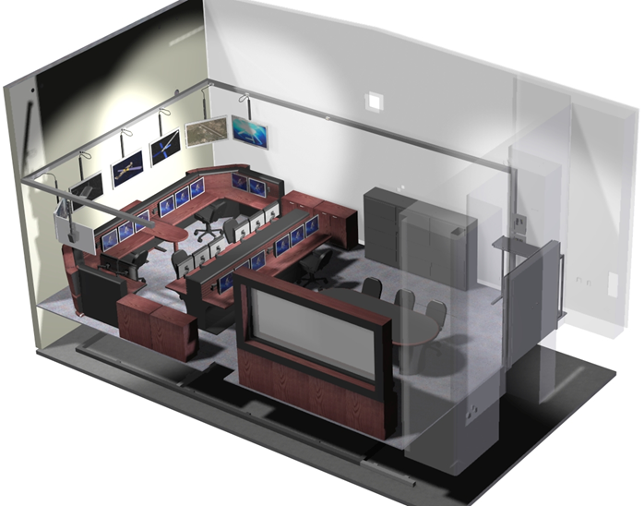

Figure 7-11: MMOC Physical Layout

Floorplan
The floorplan design is the following
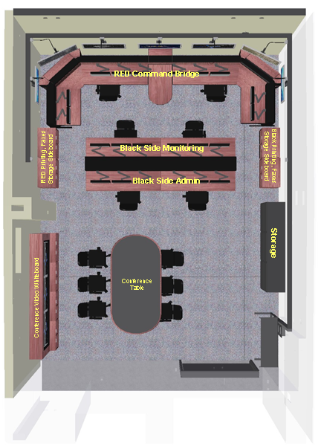

Positions
TBS

Video
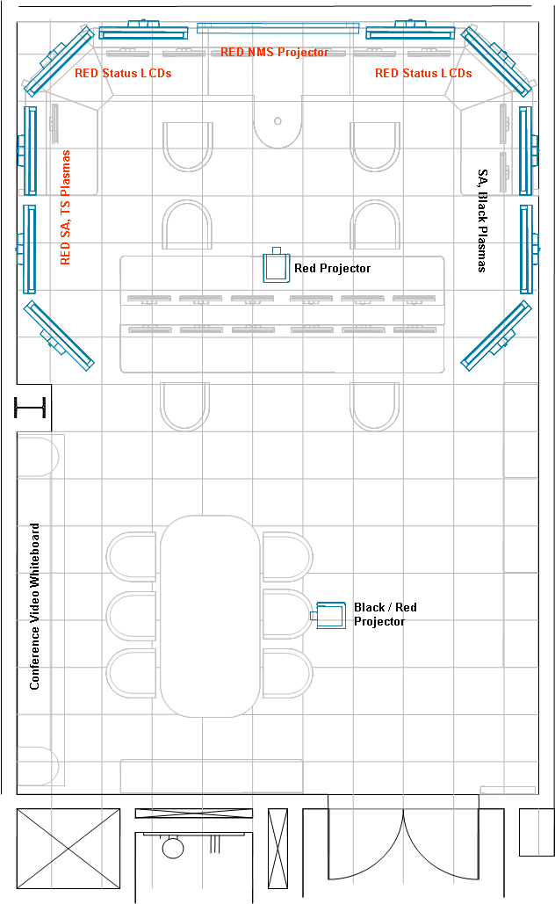

Audio

Lighting
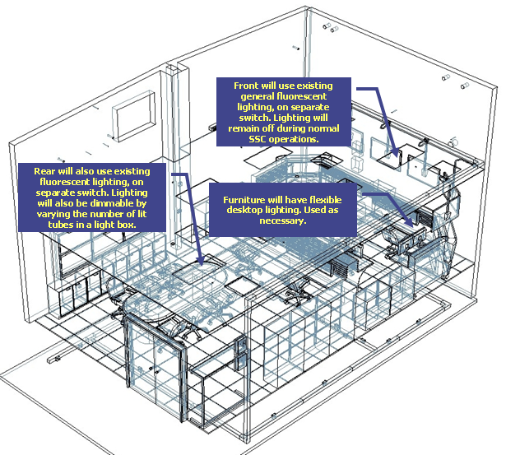

Physical Storage

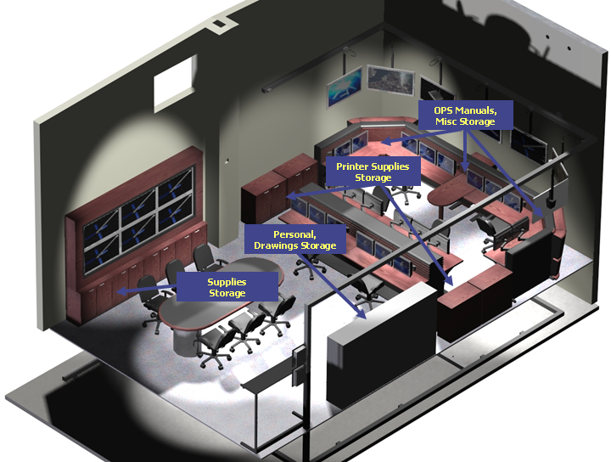

HVAC
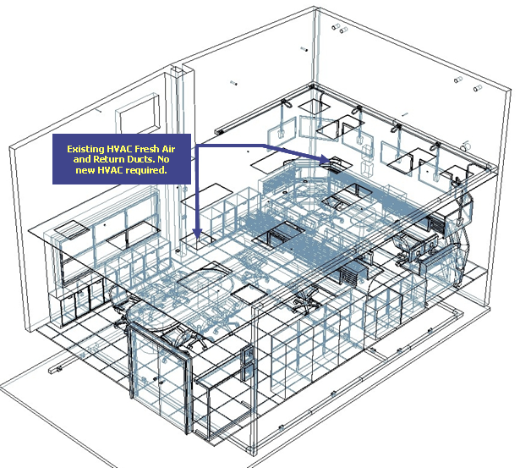

Power
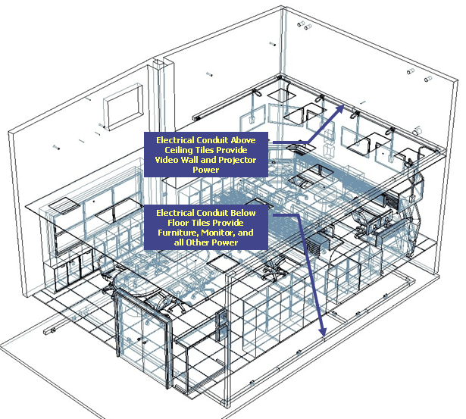

TECHNICAL ARCHITECTURE (TBS – From HLDD)

Technical Architecture Overview
TBD

Data

Types

Collection Methods

Systems

Elements

Networks

Transport

Transport Architecture

Transport Tools & Applications

Wide Area Network

WAN Architecture

WAN Tools & Applications

Local Area Network

LAN Architecture

LAN Tools & Applications

Hosts

Host Architecture

Host Tools & Applications

Appliances

Appliance Architecture

Appliance Tools & Applications

Storage

Storage Architecture

Storage Tool & Applications

Video

Video Architecture

Video Tools & Applications

Voice

Voice Architecture

Voice Tools & Applications

Security

Security Architecture

Security Tools & Applications

System Security

Processor/Computer Operating System Security

Access Control

Access Control Granularity
The MMOC access controls will be capable of including or excluding access to the granularity of a single user.

User Account Access Control
A user’s account (password and user ID) will be deactivated if the user has three (3) consecutive log-on authentication failures.

Reactivation of User Account
Reactivation of a user's account will be performed by authorized personnel.

Assigning Access Privileges
Assigning or removing access privileges to a DoD or MMOC system, or object (e.g., files, programs, etc.), will only be performed by authorized personnel.

Object Protection
The MMOC operating system access control will, either by explicit user action or by default, provide that objects are protected from unauthorized access.

Access Control Between Named Users and Named Objects
The Trusted Computing Base will define and control access between named users and named objects (e.g., files and programs) in the system. The enforcement mechanism (e.g., self/group/public controls, access control lists) will allow users to specify and control sharing of those objects by named individuals, or defined groups of individuals, or by both

Limitation of Access Propagation
The access control enforcement mechanism will provide controls to limit propagation of access rights.

Access Permission Authorization
Access permission to an object by users not already possessing access permission will only be assigned by authorized users.

Modification of System Memory
The operating system will provide the capability to authorized personnel to access and modify system memory and system files.

Unauthorized Requests
The system will be configured so it will not provide information concerning users in response to requests originating from unauthorized systems.

Authorization of Functional Privileges
The capability will be provided to selectively control and modify functional privileges available to each authorized user. The privileges for each user will be set uniquely.

User Access To Entitled Information
The system will function so that each user has access to information to which the user is entitled (by virtue of clearance, formal access approval), but to no more.

Approval for Connectivity
Approval for connectivity will be obtained from each DAA prior to connection of systems.

Accreditation
No system will send data to another system that is not accredited to receive that data.

Assurance

Trusted Computer Base (TCB) Domain
The TCB will maintain a domain for its own execution that protects it from external interference or tampering (e.g., by modification of its code or data structures). Resources controlled by the TCB will be a defined subset of the subjects and objects in the system. The TCB will isolate the resources to be protected so that they are subject to the access control and auditing requirements.

Periodic Validation of Hardware and Software
Hardware and/or software features will be provided that can be used to periodically validate the correct operation of the on-site hardware and firmware elements of the TCB.

Audit Log Maintenance Duration
Audit logs will be maintained for [one] year.

Audit Trail Classification
Audit trail information will be classified and protected according to the security classification level of the information contained in the product.

Other Security Logs
The following additional records or logs will be maintained:
Maintenance and repair of system hardware, including installation or removal of equipment, devices, or components.
Transaction receipts, equipment sanitization, and release records.
Significant system changes
Printer output jobs

Disclosure Of Classified Information Due To Failure
The system will be designed so that no single failure will result in the disclosure of classified information.

Auditing

Audit Trail Entries
- Audit trail entries will include:
- Date and time,
- USERID,
- System ID (as applicable),
- Type of event
- Success or Failure
- Workstation ID (as applicable),
- Application ID (as applicable)

Audit Trail Events
- Audit trail events will include:
- Login/logout (unsuccessful and successful)
- Use of privileged commands
- Application and session initiation
- Use of print command
- Access control permission modifications
- Export to media
- Unauthorized access attempts to critical files
- System startup/shutdown
- Deletion of objects (e.g., files and programs)
- Actions taken by computer operators and system administrators and/or system security officers
- Any override of system generated, human readable output markings.
- Activities that might modify, bypass, or negate safeguards controlled by the system.)
- Events which ensure end-to-end accountability.

Audit Report of User Account
The MMOC Ground Segment will be able to create, record and provide an audit report of a current or deactivated user’s account to the System and Security Administrators.

Audit Trail Of Accessed Objects
The TCB will be able to create, maintain, and protect from modification or unauthorized access or destruction an audit trail of accesses to the objects it protects.

Object Introduction or Deletion
For events that introduce an object into a user’s address space and for object deletion events the audit record will include the name of the object.

Audit Actions Based On Identity
The system administrator will be able to selectively audit the actions of any one or more users based on individual identity.

Limited Access to Audit Data
The audit data will be protected by the TCB so that read access to it is limited to those who are authorized for audit data.

Individual Accountability
The TCB will be able to enforce individual accountability by providing the capability to uniquely identify each individual system user.

Auditable Actions
The TCB will provide the capability of associating each system user with all auditable actions taken by that individual, thereby, holding each individual accountable for his or her actions on the system.

Audit Trail Detail
Audit trails will be of sufficient detail to reconstruct events in determining the cause or magnitude of compromise will a security violation or malfunction occur.

Communications Security

COMSEC Equipment
All voice and data communications links/networks processing classified and sensitive unclassified information which are not carried on a Protected Distribution System will be protected by state-of-the-art NSA approved COMSEC equipment.

RED/BLACK Interfaces

Decryption of Received Encrypted Data

Data Security Levels

Emanations

Identification & Authentication

Positive Identification
The identity of each user-authorized access to the system will be established positively before authorizing access.

Authentication of the User’s Identity
The TCB will use a protected mechanism (e.g., passwords) to authenticate the user’s identity.

Integrity

Data Safeguards
There will be safeguards in place to detect inadvertent modification or destruction of data, and detect and prevent malicious destruction or modification of data.

Software Preservation
Original software will be write-protected and preserved in a secure location. A trusted duplicate copy of this software that has been write-protected will be used for installation.

Marking

Classified and Unclassified Dataset Identification
The MMOC will provide the capability for an authorized operator to distinguish between classified and unclassified datasets.

Logon Warning Banner on MMOC Equipment
A logon warning banner is required on all networked and standalone Department of Defense (DOD) interest computer systems (government and contractor).

Logon Display Interaction
The logon warning banner will be displayed before a successful logon and will include an option that allows halting of the logon process by the user.

Logon Warning Banner
The system warning banners will state the following:

MMOC Terminal Labels
A standard U.S. Government warning label will be placed on the top border edge of each terminal of each system. Local production of labels with the same exact wording is authorized if U.S. Government warning label stock is not available. The labels contain the following:
THIS SYSTEM IS SUBJECT TO MONITORING AT ALL TIMES. USE OF THIS SYSTEM CONSTITUTES CONSENT TO MONITORING.

Output Marking
Classified and sensitive unclassified output will be marked to accurately reflect the sensitivity of the information.

Media Marking
All media (and containers) will be marked and protected commensurate with the requirements for the highest security classification level and most restrictive category of the information stored until the media is declassified (e.g., degaussed or erased) using a DoD-approved methodology set forth in the DoD AIS Security Manual, DoD 5200.28-M, or unless the information is declassified or downgraded in accordance with DoD 5200.1-R.

Object Reuse
All authorizations to the information contained within a storage object will be revoked prior to initial assignment, allocation, or reallocation to a subject from the TCB's pool of unused storage objects. No information, including encrypted representations of information, produced by a prior subject's actions is to be available to any subject that obtains access to an object that has been released back to the system.

Passwords

Factory and Maintenance Passwords
Factory and maintenance passwords will be removed from the system upon the start of operations.

Password Duration
A password will be changed when it has been compromised or has been in use for up to 90 days, whichever occurs first.

Password Length
Passwords will be at least eight alphanumeric characters long.

Password Shadowing
Password shadowing will be invoked on all systems when possible.

Password File Protection
Password files will be protected, handled, and stored according to established requirements for protecting the highest classification level of information on the system.

Unauthorized Access To Password Files
System password files will be protected from unauthorized access and use.

Security Testing
Testing will be done to assure that there are no obvious ways for an unauthorized user to bypass or otherwise defeat the security protection mechanisms of the TCB.

Situational Awareness

Situational Awareness Architecture

Situational Awareness Tools & Applications

External Systems

External Systems Architecture

External Systems Tools & Applications

LOGISTICS, SUPPORT AND TRAINING

Logistics

General Description
Mission integrity cannot be maintained without the necessary logistics support to guarantee continuous operations. Under the MMOC program, logistics support for the MMOC will be provided by the CLS contract. Additional contractor manning will be required for this sustainment support.

FUNCTION | DESCRIPTION
Return to operations | Return system to operational status through the use of defined procedures.
Check operational capability | Perform operational testing to determine operational effectiveness and suitability of the system under realistic operational conditions and to determine if operational performance requirements as specified in the User RIDD are satisfied.
Modify operational databases | Maintain the databases that configure the system for specific operational uses or missions (does not include modifying the structure of the databases).
Preventative maintenance | Performs regularly scheduled preventative maintenance activities.
Identify problems | Identify symptoms, data, procedures, checklists, etc. that cause the system not to work or respond according to specifications.
Installation scheduling | Assist as required to prioritize, approve, and schedule the installation of modifications and releases for the system.

Maintenance Concept
Maintenance for the MMOC hardware and software will be via the CLS maintenance function and will provide 24/7/365-type support. All preventive maintenance inspections will be completed without interference to the operational mission. Maximum use of flexible, modular, mobile and easily transportable plug-in replaceable units that are tailored to support a rapid remove and replace maintenance capability is required. Maintenance data will be collected in a format suitable for use in determining reliability of the system.
MMOC and agreed upon External User equipment will be maintained at the same two levels that are commonly used throughout the MMOC program. These are defined as Level 1 (Organizational) maintenance and Level 2 (Depot) maintenance. Equipment installed as part of the core MMOC infrastructure (network, firewall, servers, etc.) will be maintained and sustained in accordance with the same practices used on the Operational system. For External User Equipment (EUE) collocated with an MMOC element the maintenance and sustainment practices will be divided into four phases.
For EUE the first O&M phase is defined as “Caretaker”, and begins with the equipment installation and lasts until the External User System becomes “operational”. The second O&M phase is defined as “Initial Operations”, and lasts from the point of initial operational capability until the time spare parts and trained Sustainment maintainers are in place. The third O&M phase is defined as “Evaluation” and lasts from the point that logistics and trained maintenance support are in place until the time the system is either formally promoted into the Operational system or is deactivated. The Final phase is defined as “Closeout” and is entered after the promotion or deactivation decision has been made. The four phases and the maintenance responsibilities for each phase are described in following sections.
Authorized outages for scheduled MMOC software build installations or preventative maintenance will be communicated to the appropriate MMOC site authorities. Software updates/patches to the MMOC servers are expected to average about four per year, and will be combined with scheduled updates to the Operational system whenever possible. Authorized outages for the EUE will be coordinated per agreement specified in the External User RIDD.

Level 1 Maintenance
Level 1- Organizational- maintenance includes corrective and preventative maintenance performed on-site. Level 1 corrective maintenance relates to the restoration of Equipment to normal operations as quickly as possible. Level 1 maintenance includes the removal and replacement of Line Replaceable Units (LRUs) and scheduling and performing periodic Preventative Maintenance and Inspection (PMI) tasks. The MMOC design makes extensive use of Commercial Off-The-Shelf (COTS) equipment and Level 1 maintenance for this equipment is at the highest LRU level possible, and never below the Circuit Card Assembly (CCA) level. Sustainment personnel will utilize the Sustainment On-Line Database (SOLD) system to track and maintain Equipment (i.e. spares inventory, and spares in-transit files).

Level 2 Maintenance
Level 2 – Depot maintenance includes facilitating the repair of LRUs and back-up maintenance support for Level 1 maintenance. These backup activities include consultation, parts support and as required, technical support. Support from the depot is available 24 hours a day during normal workweek hours, and by pager during the off hours to assist in failure analysis and repair.
Function Description
Anomaly resolution Identify causes of problems and determine proposed solutions
Develop technical solutions Provide proposed options, cost estimates, impacts to external systems, risks associated with proposed technical solutions to meet validated requirements. Convey results to the appropriate MMOC Mission Operations Site point of contact.
Develop and modify software Develop and maintain operational software to satisfy requirements, prevent system degradation, prevent or correct system failures, or improve overall system capabilities.
Maintain baseline documentation Update appropriate documentation (Ground Segment Design Document, Software Development Files, on-line help, test plans and procedures, etc.) to include software modifications or enhancements
Coordinate Level 2 Maintenance activities Provide the MMOC Site with notification of Level 2 Activities
Distribute software releases Provide the Mission Operations with an approved software release package, including version description, installation procedures, operator checklists, training documentation, results of development tests.
Perform configuration management Identify, control, track, and audit functional and physical baselines, interfaces and associated documentation.
Perform special studies Perform special studies, as requested
Maintain software support resources Perform functions necessary to maintain all MMOC software support resources and infrastructure to assure continued operations

Training
The MMOC training will consists of classroom, individual study, and hands-on training which spans an estimated time of 6 months. Each trainee will possess a complete architectural understanding of the managed systems and demonstrate emergency actions and troubleshooting techniques to receive full systems certification. Training occupies a significant portion of an individuals controlled tour; therefore there will be a constant flow of personnel through the training pipeline to meet certification requirements.
The initial cadre of personnel will be trained using a training plan developed under the MMOC contract. Follow-on training can be completed in the development suite as long as it exists, or will be accomplished on-site without impacting or being impacted by operations, software testing and development, or training exercises.
Future

System Upgrades
Depending upon the selected delivered MMOC capability, incremental upgrades will be required, and can be delivered as part of the spiral development process associated with the mission system. Modifications to hardware or software will be approved, tested, and validated through the normal ITWAA configuration control process.
The MMOC will be kept current with the communications-network architecture to effectively monitor and manage the program communications.
The MMOC applications suite will be kept current to effectively monitor and manage the program communications.
The MMOC at some time will require a TBD electronic interface to the ENOC to exchange TDB data, but only voice exchanges are expected until the ENOC is fully developed.

STRATEGIC ROADMAP (TBS)

DEFINITION OF TERMS (TBS)

Elements & Entities

Mission Control Station

Remote Ground Station

Factories

Development Labs

Training Centers

External Interfaces

Service Providers

Network Operations Security Center (NOSC)

Network Operations Center (NOC)

Mission Assurance Center (System Center)

MMOC System Center (MMOC)

Mission Operations Types

Internal Mission Operations
An External LAN User is defined as a consumer of MMOC data who is connected to the system via a Local Area Network Connection using the Ethernet protocol. This type of user is generally collocated with or physically nearby an MMOC element. (i.e. MCS). Examples of External LAN Users include STAR, SAHW, and TSC.

External Mission Operations
An External WAN User is defined as a consumer of MMOC data who is connected to the system via a Wide Area Network Connection using Transport (T-1, T-3, etc…) protocols. This type of user is generally not collocated with or physically nearby an MMOC element. (i.e. MCS). Examples of External WAN Users include Azusa, SWC, and the Boulder CDF.

Data Formats

Serial Data
Serial Data is defined as raw, encrypted (Black), unformatted, and unprocessed DSP Link 1/2 data.

Packetized Data
Packetized Data is defined as any data conforming to Internet Protocol (IP) standards.

Processed Data

Data Nature

Real-Time Data
Real-Time Data is defined as any format of data which has not been subject to delay beyond that which is intrinsic in the collection, processing, and dissemination of data in the System.

Near Real-Time Data
Near-Real Time Data is defined as any format of data which has been subject to minimal delay beyond that which is intrinsic in the collection, processing, and dissemination of data in the System.

Non Real-Time Data
Non Real-Time Data is defined as any format of data not meeting the criteria for Real-Time or Near Real-Time data.

Archived Data
Archived Data is defined as any format of Non-Real Time data that has been subject to management policies in order to provide long term storage, access, and retrieval capability.

Data Classification

Unclassified
Unclassified data is defined as any data or information which is not defined as classified by the security reference documents listed in Section 2 of this CONOPS.

Secret
Secret data is defined as any data or information which is classified as DoD Secret by the security reference documents listed in Section 2 of this CONOPS.

Communications and Networks

Demarcation Point
The Demarcation Point is defined as the physical boundary which separates the MMOC System from the External Users. The demarcation point is typically at a patch panel.

Availability
Availability is defined as a measure of the degree to which an item or system is in an operable state at any time.

Reliability
Reliability is defined as the ability of an item or system to perform its required functions under stated conditions for a specified period of time

Maintainability
Maintainability is defined as a measure of the ability of an item or system to be retained in, or restored to, a specified condition when maintenance is performed using prescribed procedures and technician skill levels.

Mean Time Between Failure (MTBF)
MTBF is defined as the average time between failures of a particular device based on statistical or anticipated experience.

Mean Time To Restore (MTTR)
MTTR is defined as the sum of corrective maintenance times divided by the total number of failures within an item. This represents the average time that it takes to fully repair a failed system. Typically includes fault isolation, remove and replacement of failed item(s) and checkout.

APPENDIX A

